

**EYESPIRE**

**Software Requirement Specification**

– Da Nang, June 2025 –

**Table of Contents**

**I. Record of Changes 5**

II. Software Requirement Specification 7

1. Product Overview 7

2. User Requirements 9

2.1 Actors 9

2.2 Use Cases 9

2.2.1 Diagram(s) 9

2.2.2 Descriptions 16

UC 01: View Appointment List. 22

UC 02: Reject Appointment 25

UC 03: Update Appointment 28

UC 04: Create Appointment. 31

UC 05: Edit doctor’s work schedule. 34

UC 06: Create doctor’s work schedule 37

UC 07: Filter appointment list 40

UC 08: Book an appointment. 43

UC 09: View my appointments. 46

UC 10: Sign In. 49

UC 11: Sign Out. 55

UC 12: Register. 58

UC 13: Forgot Password 63

UC 14: View Profile 67

UC 15: Change Password 71

UC 16: Delete Account 75

UC 17: Update Profile 79

UC 18: Send message 83

UC 19: Chat with ChatBox 87

UC 20 Search for services 91

UC 21: View service list. 95

UC 22: View service details. 98

UC 23: Give service feedback. 101

UC 24: Download medical records (PDF). 103

UC 25: View medical records. 106

UC 26: Cancel a service appointment. 109

UC 27: Order products. 113

UC 28: Search products. 117

UC 29: View product list. 121

UC 30: View product details. 124

UC 31: Add products to cart. 128

UC 32:Delete products from cart 131

UC 33: View order status 134

UC 34: View order detail 136

UC 35: Give order feedback 138

UC 36: View order List 140

UC 37: Update order status 141

UC 38: Add products to store 144

UC 39: Delete Products in store 146

UC 40: Edit product detail 147

UC 41: View order status 150

UC 42: Delete Feedback on Products 152

UC 43: Ban User Account 154

UC 44: Create Service 157

UC 45: Delete Medical Services 160

UC 46: Create Staff 164

UC 47: Delete Staff 167

UC 48: View Appointment Reports 170

UC 49: View Products Sales Statistics 173

UC 50: Create Patient Records 176

UC 51: View Service Feedback 179

UC 52: Update Patient Records 182

UC 53: View Patient Record History 185

UC 54: Give Appointment for Re-examination 188

UC 55: Add Service During Appointment 191

3. Functional Requirements 194

3.1 System Functional Overview 194

3.1.1 Screens Flow 194

3.1.2 Screen Descriptions 196

3.1.3 Screen Authorization 198

3.1.4 Non-Screen Functions 200

3.1.5 Entity Relationship Diagram 202

3.2 Appointment Management 203

3.2.1 View My Appointments 203

3.2.2 View patient appointments (Doctor Dashboard Screen) 205

3.2.3 View Patient appointment (Admin Dashboard Screen) 207

3.2.4 View Patient appointment (Receptionist Dashboard Screen) 209

3.3 Schedule Management 210

3.3.1 View Work Schedule 210

3.3.2 Manage Work schedule (Admin Dashboard Screen) 211

3.3.3 Manage Work schedule (Receptionist Dashboard Screen) 213

3.4 Medical Record management 215

3.4.1 View Medical Record 215

3.4.2 My Medical Record 216

3.5 Patient management 218

3.5.1 Patient Records Screen 218

3.6 Order Tracking 220

3.6.1 View My Orders 220

3.7 User management 222

3.7.1 View users 222

3.8 Payment History 223

3.8.1 My payment history 223

3.9 Store Management 225

3.9.1 View Product List 225

3.9.2 View Order List 227

3.10 Message 229

3.10.1 Send Message (Store manager Dashboard screen) 229

Screen Content 229

3.10.2 Send Message (Receptionist Dashboard screen) 230

Screen Content 230

3.11 Feedback 231

3.11.1 View Product FeedBack 231

3.11.2 Customer Feedback Screen 233

3.12 Personnel management 234

3.12.1 View personnels 234

3.13 Service management 236

3.13.1 View Services 236

3.14 Statistics 238

3.14.1 View statistics 238

3.15 Personal Profile 239

3.15.1 Personal Profile Screen (Doctor) 239

3.15.2 Personal Profile Screen (Receptionist) 241

3.15.3 Personal Profile Screen (Admin) 242

4. Non-Functional Requirements 244

4.1 External Interfaces 244

4.2 Quality Attributes 244

4.2.1 Usability 244

4.2.2 Reliability 245

4.2.3 Performance 245

5. Requirement Appendix 246

5.1 Business Rules 246

5.2 Common Requirements 250

5.3 Application Messages List 250

5.4 Other Requirements 252

# I. Record of Changes

| **Date** | **A* M, D** | **In charge** | **Change Description** |
| --- | --- | --- | --- |
| 05/24/2025 | A | AnNV | Add Use Cases |
| 05/24/2025 | A | TuanCM | Write II.1 - Product Overview |
| 05/24/2025 | A | MinhNPH | Write II.2.2.2 - Actors - Uses case - Descriptions |
| 05/30/2025 | A | PhuongTDD | Context Diagram |
| 06/02/2025 | A | PhuongTDD | Add UC 01 to UC 11 |
| 06/02/2025 | A | LuongTT | Add UC 45 to UC 57 |
| 06/02/2025 | A | AnNV | Add UC-34 to UC- 44 |
| 06/05/2025 | A | MinhNPH | Add UC-23 to UC-33 |
| 06/05/2025 | A | AnNV | Add 5.1 Business Rule |
| 06/06/2025 | A | PhuongTDD | Add 2.2.1 - Use case diagram |
| 06/06/2025 | A | PhuongTDD | Add 3.1.1 Screen Flows |
| 06/06/2025 | M | PhuongTDD | Modify Context Diagram |
| 06/06/2025 | A | PhuongTDD | Add 3.1.2 Screen Description, 3.1.3 Screen Authorization, 3.1.4 Non-screen Functions |
| 06/06/2025 | A | LuongTT | Add 3.2.2 View Patient Appointments, 3.3.1 View Work Schedule, 3.4.1 View Medical Record, 3.5.1 Patient Record Screen, 3.12.2 Customer Feedback Screen |
| 06/07/2025 | A | PhuongTDD | Add 4. Non-Functional Requirements |
| 06/07/2025 | A | PhuongTDD | Add 3.2.1- View My Appointments and 3.4.2 - My Medical Record |
| 06/07/2025 | A | LuongTT | Add 3.1.5 Entity Relationship Diagram |
| 06/07/2025 | A | LuongTT | Add 3.15.1 Personal Profile Screen(Doctor) |
| 06/08/2025 | A | PhuongTDD | Add 3.4.2 My medical Record, 3.8.1 My payment history. Add 5.2 Common Requirements, 5.3 Application Messages List, 5.4 Other Requirements |
| 06/08/2025 | A | MinhNPH | Add 3.2.3 View Patient appointment (Admin Dashboard Screen), 3.3.2 Manage Work schedule (Admin Dashboard Screen), 3.7.1 View users, 3.12.1 View personnels, 3.13.1 View Services, 3.14.1 View statistics, 3.15.3 Personal Profile Screen (Admin) |
| 06/08/2025 | A | AnNV | Add 3.9 Store Management, 3.10 Message, 3.11 Feedback |
| 06/08/2025 | A | TuanCM | Add 3.2.4 View Patient appointment (Receptionist Dashboard Screen), 3.3.3 Manage Work schedule (Receptionist Dashboard Screen), 3.10.2 Send Message (Receptionist Dashboard screen), 3.10.2 Send Message (Receptionist Dashboard screen), 3.15.2 Personal Profile Screen (Receptionist) |
| 06/08/2025 | A | TuanCM | Add UC 12 to UC 22 |
| 07/05/2025 | M | MinhNPH | Modified 2.2.2 Discriptions, 5.1 Business Rule |
| 07/06/2025 | M | AnNV | Modified activity Flow of UC 32 to 42 |

*A - Added M - Modified D - Deleted

# II. Software Requirement Specification

## 1. Product Overview

Eye appointment bookings are mainly conducted through manual methods such as phone calls or in-person visits, leading to inconveniences like long waiting times, scheduling conflicts, and inefficient management. This creates difficulties for patients and increases the workload for clinic staff. Users increasingly require a convenient online booking system that allows them to proactively choose appointment times, receive reminders, and reduce waiting time. Clinics also need an effective appointment management tool to enhance service quality and optimize resources.

We are developing an online eye appointment platform with a user-friendly interface, real-time schedule updates, automated reminders, and support for multiple user roles such as patients, receptionists, doctors, and administrators. The system allows easy booking, modification, and cancellation of appointments along with efficient clinic management.

The system offers 24/7 access through any internet-enabled device, allowing users to conveniently manage their appointments at any time. Real-time updates ensure that scheduling conflicts and errors are minimized, providing a smooth booking experience. Automated reminders sent via SMS and email help reduce the number of missed appointments. Additionally, the platform supports a multi-role permission system tailored to different types of users, including patients, receptionists, doctors, and administrators. Beyond appointment management, the system also integrates specialized eye care product sales, broadening the range of services available to patients and enhancing the overall functionality of the clinic.

The system faces several challenges, including ensuring stable operation and safeguarding sensitive patient data to maintain privacy and compliance. It is also essential to encourage users to transition smoothly from traditional booking methods to the new digital platform. Additionally, the solution must integrate seamlessly with existing clinic management systems to avoid disruption. Finally, maintaining high performance and responsiveness during peak usage periods with a large number of users is critical to providing a reliable service.

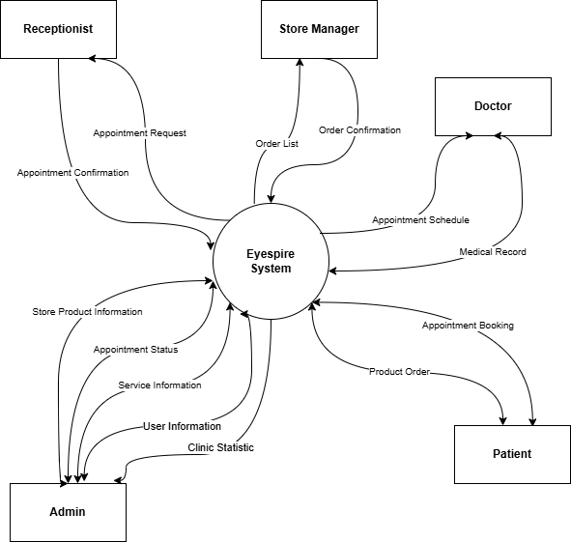

## 2. User Requirements

### 2.1 Actors

| **#** | **Actor** | **Description** |
| --- | --- | --- |
| 1 | Receptionist | View appointment lists, confirm or reject appointment requests, update appointment statuses, and arrange schedules for doctors. |
| 2 | Doctor | View personal appointments, create, edit, or delete patient medical records, review patient record history, schedule re-examination appointments, sign in or sign out, view and update personal profiles, and change passwords. |
| 3 | Patient | Search and view medical service details, book or cancel service appointments, view and download medical records as PDFs, order products, add or remove products from the cart, view order status and details, provide feedback on services or orders, sign in, sign out, view and update personal profile, and change password. |
| 4 | Store manager | View and update order statuses, add, delete, or edit product details, view and delete customer feedback on products, sign in, sign out, view and update personal profile, and change password. |
| 5 | Admin | Ban user accounts, create or delete medical services, create or delete staff accounts, view appointment reports and product sales statistics, and change passwords. |
| 6 | Guest | Search and view medical service details, and register for a new account. |

### 2.2 Use Cases

#### 2.2.1 Diagram(s)

**System overview use case diagram**

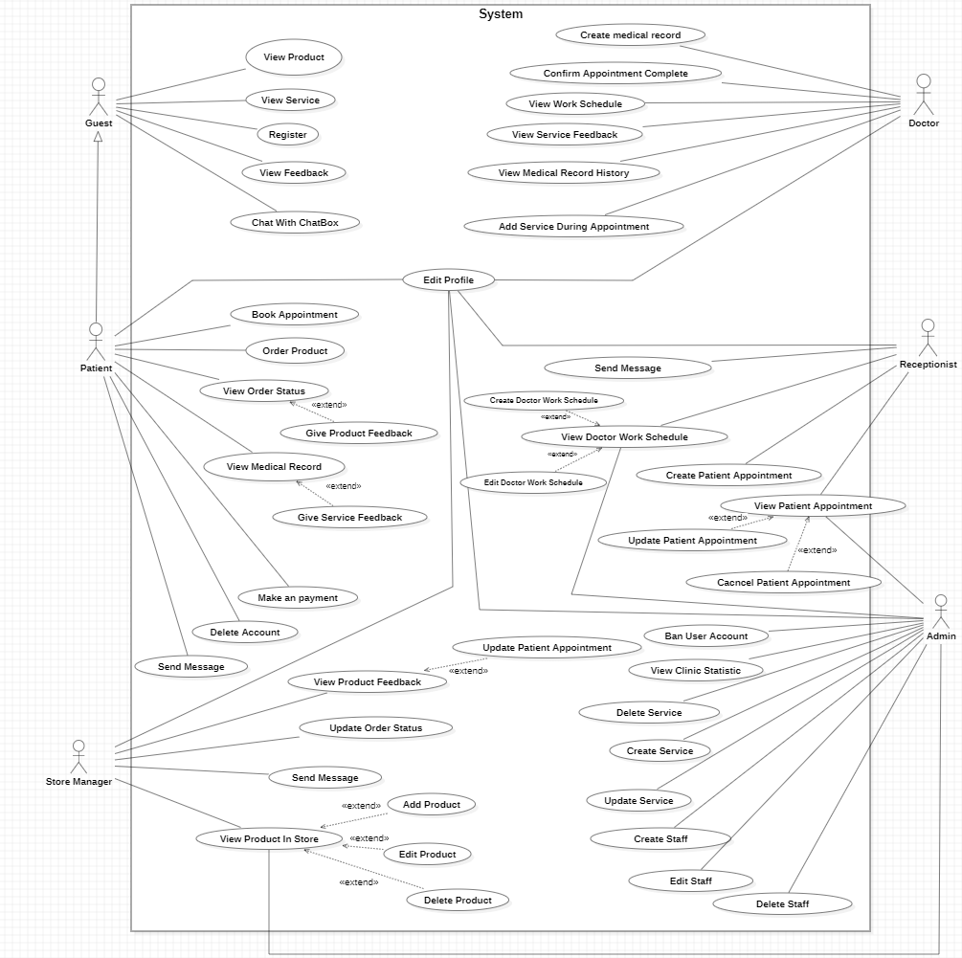

**Authentication use case diagram**

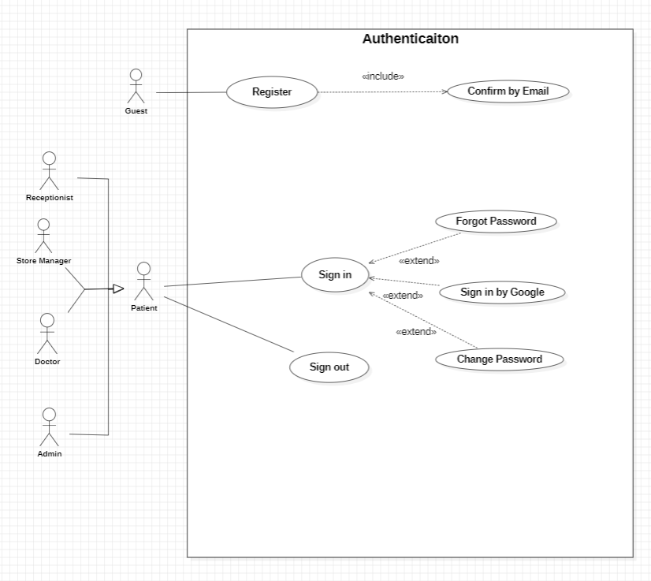

**Doctor use case diagram**

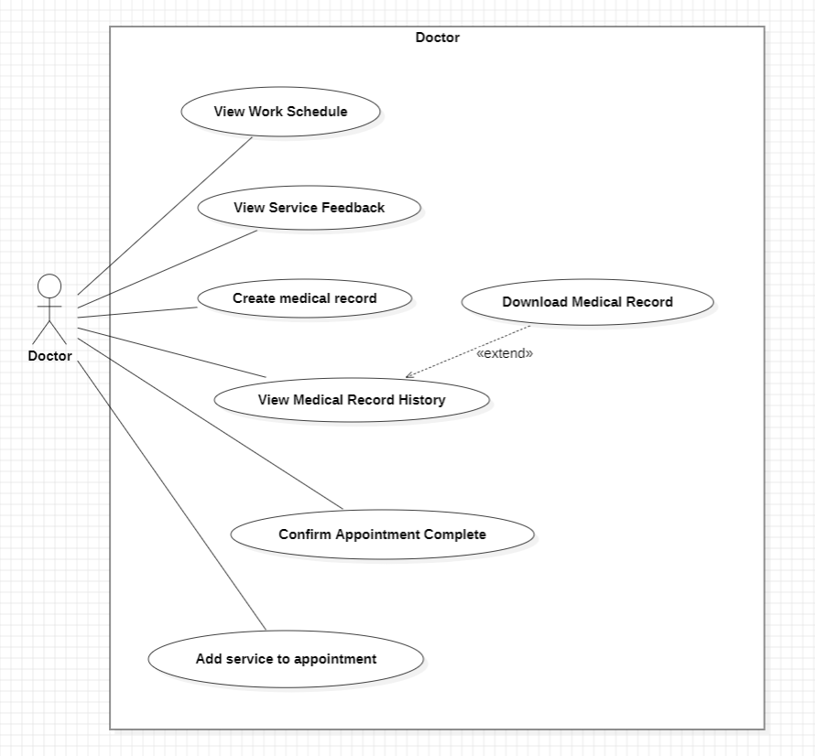

**Receptionist use case diagram**

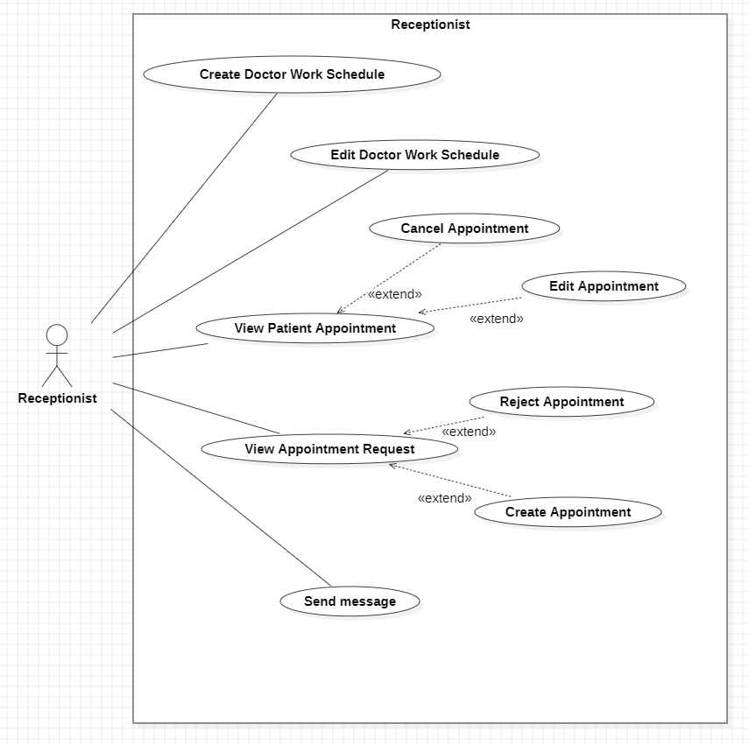

**Store Manager use case diagram**

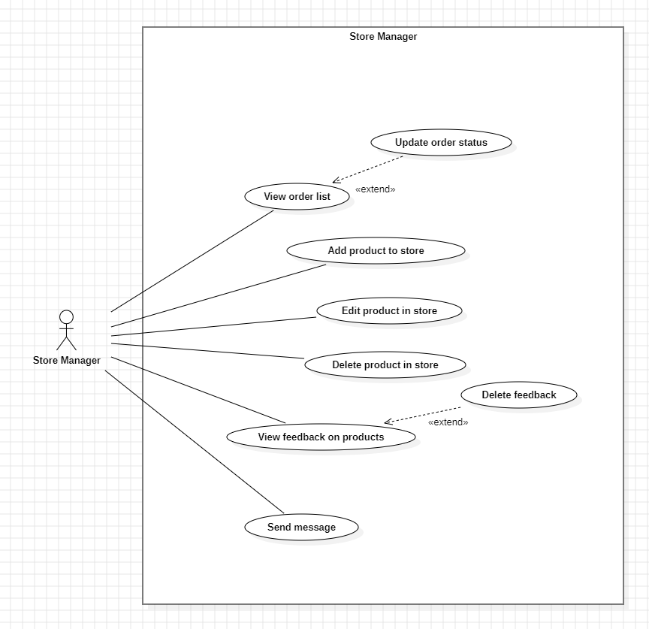

**Admin use case diagram**

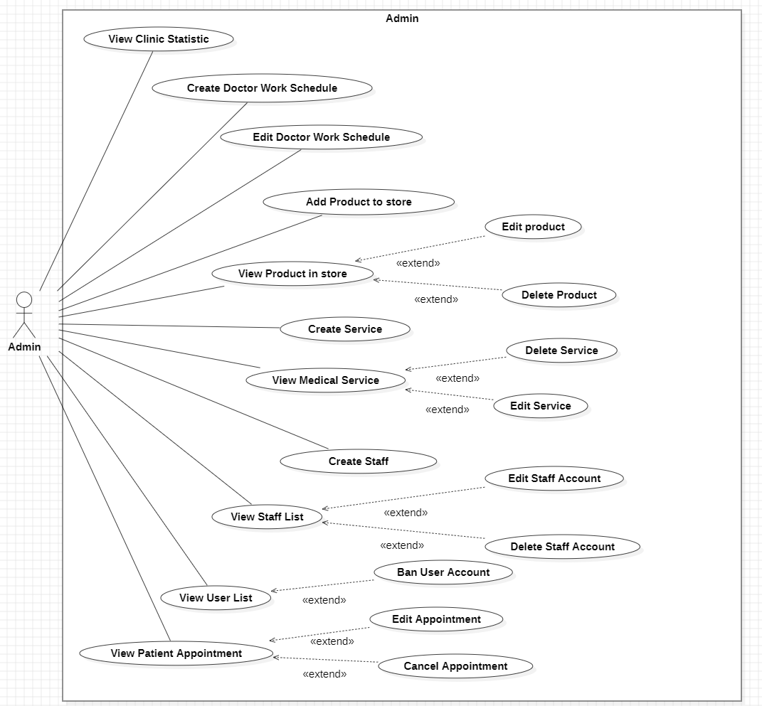

**Patient use case diagram**

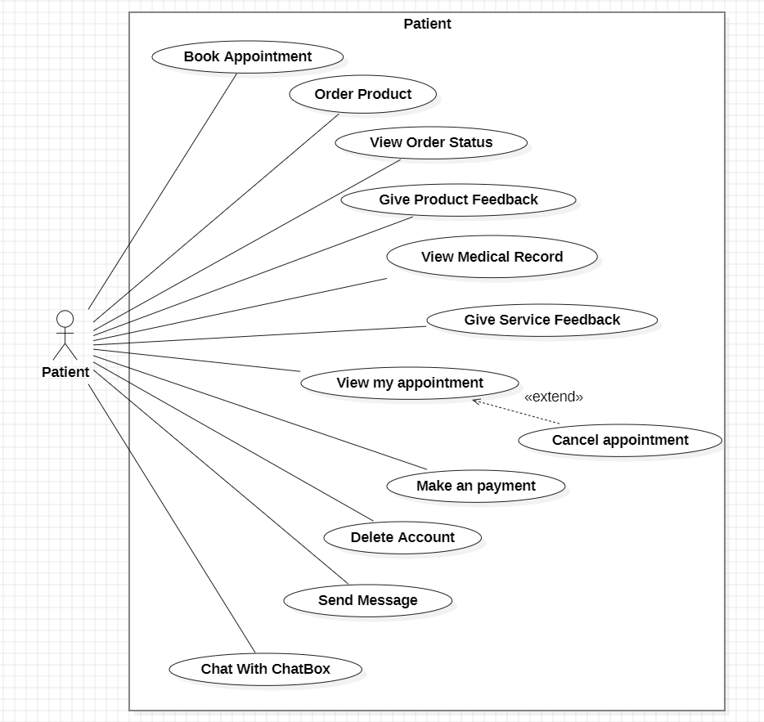

#### 2.2.2 Descriptions

| ID | Use case | Actor | Use case Description |
| --- | --- | --- | --- |
| 01 | View Patient Appointment | Receptionist, Admin | Views a list of all patients who have appointments with details (date, time, patient, doctor). |
| 02 | Reject appointments | Receptionist, Admin | Reject appointment requests from patients. |
| 03 | Update appointment details | Receptionist, Admin | The receptionist updates details of an appointment (e.g., note, doctor,...). |
| 04 | Create Appointment | Receptionist | Receptionist schedules appointments for doctors, chooses the time schedule of the appointment. |
| 05 | Edit doctor's work schedule | Admin, Receptionist | Edit a doctor’s work schedule (e.g., update working hours or days). |
| 06 | Create doctor's work schedule | Admin, Receptionist | Create a new work schedule for a doctor, defining available time slots. |
| 07 | Filter appointment list | Receptionist, Admin | Filter appointments by criteria (e.g., date, doctor, status) for easier management. |
| 08 | Book an appointment | Patient | The patient selects a doctor, time slot, and optional initial medical service when booking an appointment. |
| 09 | View my appointments | Patient | View a list of personal appointments with details (date, time, doctor/patient, note). |
| 10 | Sign in | Doctor, Patient, Store manager | The user logs into the system using their credentials (email/username and password). |
| 11 | Sign out | Doctor, Patient, Store manager | The user logs out of the system to end their session. |
| 12 | Register | Guest | Guest creates a new account by providing personal information and credentials. |
| 13 | Forgot Password | Doctor, Patient, Admin, Store Manager, Receptionist | User resets their password via a recovery process (e.g., email link). |
| 14 | View Profile | Doctor, Patient, Store manager, Admin, Receptionist | User views their profile details (e.g., name, contact info, role). |
| 15 | Change Password | Doctor, Patient, Store manager, Admin, Receptionist | The user updates their account password for security. |
| 16 | Delete Account | Patient | The user permanently deletes their account from the system. |
| 17 | Update Profile | Doctor, Patient, Store manager, Receptionist, Admin | User edits their profile information (e.g., contact details, preferences). |
| 18 | Send message | Patient | This use case allows a patient to send a message to the store manager via the system.  The message can be about product inquiries, order status, or other service-related issues.  The system facilitates communication between the patient and store manager, allowing for effective customer service and support. |
| 19 | Chat with ChatBox | Doctor | This use case allows the user (Patient, Guest) to engage with the ChatBox for automated assistance or inquiries.  The ChatBox provides responses to frequently asked questions, basic service information, or guides the user to relevant sections of the website, such as scheduling, product information, or medical service details. |
| 20 | Search for services | Patient, Guest | User searches for available medical services using keywords or filters. |
| 21 | View service list | Patient, Guest | User views a list of available medical services with basic details. |
| 22 | View service details | Patient, Guest | User views detailed information about a specific medical service. |
| 23 | Give service feedback | Patient | Patient submits feedback or a rating for a medical service received. |
| 24 | Download medical records (PDF) | Patient | The patient downloads their medical records in PDF format. |
| 25 | View medical records | Patient, Doctor | Patient views their medical records (e.g., diagnosis, treatment history).  Doctor views their customer medical records |
| 26 | Cancel a service appointment | Patient | The patient cancels a booked appointment for a medical service. |
| 27 | Order products | Patient | The patient places an order for medical products from the store. |
| 28 | Search products | Patient, Guest | Patient searches for products in the store using keywords or categories. |
| 29 | View product list | Patient, Guest | The patient views a list of available products in the store. |
| 30 | View product details | Patient, Guest | Patient views detailed information about a specific product (e.g., price, description). |
| 31 | Add products to cart | Patient | The patient adds selected products to their shopping cart for purchase. |
| 32 | Delete products from cart | Patient | The patient removes products from their shopping cart. |
| 33 | View order status | Patient | Patient checks the status of their product orders (e.g., processing, shipped). |
| 34 | View order details | Patient | Patient views detailed information about a specific order (e.g., items, total cost). |
| 35 | Give order feedback | Patient | Patient submits feedback or a rating for a completed product order. |
| 36 | View order list | Store manager | The Store Manager views a list of all product orders placed by patients. |
| 37 | Update order status | Store manager | Store Manager updates the status of product orders (e.g., shipped, delivered). |
| 38 | Add products to store | Store manager, Admin | The Store Manager adds new products to the store’s inventory. |
| 39 | Delete products from store | Store manager, Admin | The Store Manager removes products from the store’s inventory. |
| 40 | Edit product details | Store manager, Admin | Store Manager updates details of a product (e.g., price, description). |
| 41 | View feedback on products | Store manager | The Store Manager views feedback or ratings submitted by patients for products. |
| 42 | Delete feedback on products | Store manager | The Store Manager removes inappropriate or irrelevant product feedback. |
| 43 | Ban User Accounts | Admin | Admin suspends or bans user accounts for policy violations. |
| 44 | Create Services | Admin | Admin adds new medical services to the system (e.g., consultation, lab test). |
| 45 | Delete Medical Services | Admin | Admin removes medical services from the system. |
| 46 | Create Staff | Admin | Admin creates accounts for new staff members (e.g., doctors, receptionists). |
| 47 | Delete Staff | Admin | Admin deletes staff accounts from the system. |
| 48 | View appointment reports | Admin | Admin views reports summarizing appointment data (e.g., number, status). |
| 49 | View product sales statistics | Admin | Admin views statistics on product sales (e.g., revenue, popular items). |
| 50 | Create Patient Records | Doctor | The doctor creates new medical records for a patient (e.g., diagnosis, treatment). |
| 51 | View Service Feedback | Doctor | The doctor views feedback submitted by patients for medical services provided. |
| 52 | Update Patient Records | Doctor | The doctor updates existing patient medical records with new information. |
| 53 | View Medical Record History | Doctor | The doctor views the full history of a patient’s medical records. |
| 54 | Give Appointment for Re-examination | Patient, Receptionist | This use case allows a doctor to schedule a follow-up (re-examination) appointment for a patient after a consultation or treatment.  The patient may receive confirmation or reminders through the system. |
| 55 | Add Service During Appointment | Doctor | During the appointment, the doctor recommends or adds additional medical services (e.g., eye imaging, pressure test) based on diagnosis and available time. |

### UC 01: View Appointment List.

| **Use Case Specification** | | | |
| --- | --- | --- | --- |
| **Use Case ID and Name:** | UC-01 View Appointment List | | |
| **Created By:** | Trần Đình Duy Phương | **Date Created:** | June-02, 2025 |
| **Primary Actor:** | Receptionist/ Admin | **Secondary Actors:** | Doctor |
| **Trigger:** | A receptionist or admin wants to view the list of appointments booked by patients in order to manage clinic operations and doctor schedules. | | |
| **Description:** | This use case allows the receptionist/admin to view all patients with existing appointments (Confirmed, Completed, Cancelled). They can click on a patient to see appointment details and optionally update or cancel the appointment. | | |
| **Preconditions:** | **PRE-1:** The receptionist or admin is logged into the system with valid credentials.  **PRE-2:** At least one appointment has been booked in the system. | | |
| **Post–conditions:** | **POST-1:** List of patients with appointments is shown.  **POST-2:** Receptionist/Admin can view and optionally update/cancel each appointment. | | |
| **Normal Flow:** | 1. The receptionist or admin logs into the system. 2. Navigates to the "Patient Appointments" page.. 3. System displays a list of patients with appointments (Confirmed, Completed, Cancelled). 4. Receptionist selects a patient. 5. System displays their appointments. 6. Receptionists or admin can view, update details, or cancel. | | |
| **Alternative Flows:** | **1-AF**: No appointments in the system  a. System displays: “No appointments found.”  b. The use case ends. | | |
| **Exceptions:** | **1-EF**: Network or database failure  The system displays an error message: "Unable to load appointment list. Please try again later."" | | |
| **Priority:** | **High** | | |
| **Frequency of Use:** | **High** (used daily to manage clinic operations) | | |
| **Business Rules:** | **BR-19:** Users must have an account with a unique email/username and password, or a linked Gmail account.  **BR-1:** Only users with the role of "admin" or "receptionist" can view all appointments.  **BR-18:** The system must ensure appointment details are updated in real-time.  **BR-6:** Only receptionists or admins can update appointment details.  **BR-2:** Appointment data must be updated in real time.  **BR-61:** The system must notify relevant staff or update schedules after a cancellation. | | |
| **Other Information:** | Advanced filters and export options (e.g., Excel/PDF) can be provided. | | |
| **Assumptions:** | * The receptionist/admin is using a clinic-provided device with system access. * All appointment data is synced and stored reliably in the system. | | |

**Activities Flow**

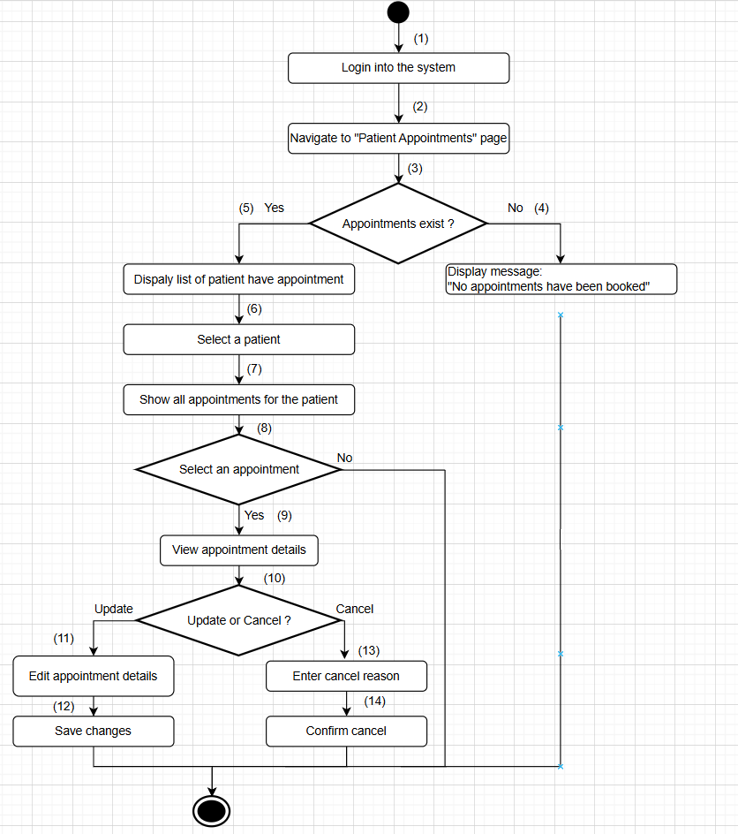

**Business Rules**

| **Step** | **BR Code(s)** | **Description** |
| --- | --- | --- |
| (1) | BR-19 | Users must have an account with a unique email/username and password, or a linked Gmail account. |
| (2) | BR-1 | Only users with the role of "admin" or "receptionist" can view all appointments. |
| (5) | BR-18 | The system must ensure appointment details are updated in real-time. |
| (10) | BR-6 | Only receptionists or admins can update appointment details. |
| (12) | BR-2 | Appointment data must be updated in real time. |
| (14) | BR-61 | The system must notify relevant staff or update schedules after a cancellation. |

### UC 02: Reject Appointment

| **Use Case Specification** | | | |
| --- | --- | --- | --- |
| **Use Case ID and Name:** | UC-02 Reject Appointment | | |
| **Created By:** | Trần Đình Duy Phương | **Date Created:** | June-02, 2025 |
| **Primary Actor:** | Receptionist | **Secondary Actors:** | Doctor |
| **Trigger:** | The receptionist wants to manage patient appointment requests by rejecting pending appointments. | | |
| **Description:** | This use case allows the receptionist to process pending appointments. The receptionist can reject it by providing a reason. The appointment status will be updated accordingly and moved to the patient’s appointment list. | | |
| **Preconditions:** | **PRE-1:** The receptionist is logged into the system with valid credentials. **PRE-2:** At least one pending appointment exists in the system. | | |
| **Post–conditions:** | **POST-1:** The appointment status is updated to “Cancelled”.  **POST-2:** The updated appointment appears in the patient’s appointment list. | | |
| **Normal Flow:** | 1. The receptionist logs into the system. 2. They navigate to the “Create Appointment” page. 3. The system displays a list of pending appointments. 4. The receptionist selects a pending appointment. 5. The receptionist decides to **reject**: 6. The system displays all booked appointments with the following information. 7. Rejecting 8. Enter a reason. 9. Reject the appointment. 10. The system updates the status to **Cancelled** and moves it to the patient’s appointment list. | | |
| **Alternative Flows:** | **2-AF:** No pending appointments in the system  a. The system displays the message: “No pending appointments.”  b. The use case ends. | | |
| **Exceptions:** | **2-EF:** Network or database failure  a. The system displays: “Unable to process appointments. Please try again later.” | | |
| **Priority:** | **High** | | |
| **Frequency of Use:** | **High** (used daily to manage clinic operations) | | |
| **Business Rules:** | **BR-19:** Users must have an account with a unique email/username and password, or a linked Gmail account.  **BR-1:** Only users with the role of "admin" or "receptionist" can view all appointments.  **BR-17:** Appointments must be marked "Pending" until reviewed by the receptionist.  **BR-4:** Only users with the role of “receptionist” can reject appointments.  **BR-18:** Rejection must include a reason (system update reflects in real-time). | | |
| **Other Information:** | Logging of decisions (rejection) should be retained for auditing.  A notification may be sent to the patient after confirmation or rejection. | | |
| **Assumptions:** | * Receptionist is using a clinic-authorized system with proper access. * Appointment and doctor availability data are synced and up to date. | | |

**Activities Flow**

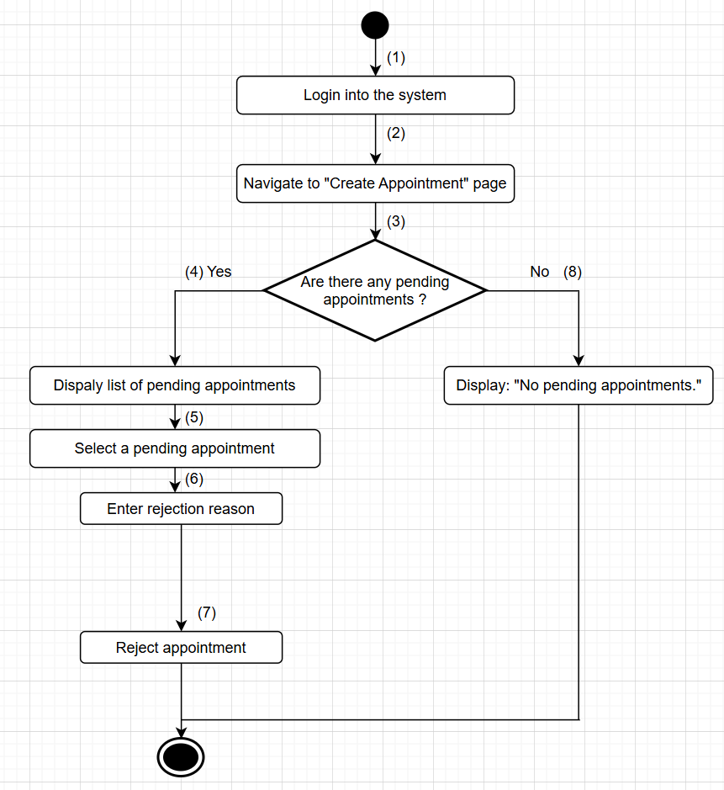

**Business Rules**

| **Step** | **BR Code(s)** | **Description** |
| --- | --- | --- |
| (1) | BR-19 | Users must have an account with a unique email/username and password, or a linked Gmail account. |
| (2), (4) | BR-1 | Only users with the role of "admin" or "receptionist" can view all appointments. |
| (3) | BR-17 | Appointments must be marked "Pending" until reviewed by the receptionist. |
| (5) | BR-4 | Only users with the role of “receptionist” can reject appointments. |
| (6) | BR-4, BR-18 | BR-4: Only users with the role of “receptionist” can reject appointments.  BR-18: Rejection must include a reason (system update reflects in real-time). |

### UC 03: Update Appointment

| **Use Case Specification** | | | |
| --- | --- | --- | --- |
| **Use Case ID and Name:** | UC-03 Update Appointment Details | | |
| **Created By:** | Trần Đình Duy Phương | **Date Created:** | June-02, 2025 |
| **Primary Actor:** | Admin, Receptionist | **Secondary Actors:** | Doctor |
| **Trigger:** | The receptionist wants to update the details of an existing appointment (e.g., assign a doctor, add notes, etc.). | | |
| **Description:** | This use case allows authorized users (receptionist/admin) to modify the details of a scheduled appointment. Updates can include doctor assignment, notes, time adjustments (if allowed), and patient-related comments. | | |
| **Preconditions:** | **PRE-1:** The user is logged in with a role of receptionist or admin.  **PRE-2:** The appointment exists and is in a modifiable state (e.g., not Completed or Cancelled, unless the user has special permission). | | |
| **Post–conditions:** | **POST-1:** The appointment details are updated successfully.  **POST-2:** The updated information is saved and reflected in the system. | | |
| **Normal Flow:** | 1. The receptionist/admin logs in. 2. Navigates to the “Patient Appointment” page. 3. The system displays all relevant appointments. 4. The user selects an appointment. 5. The system loads the appointment’s current details. 6. The user updates details (e.g., doctor, note, time). 7. The system saves and reflects the changes. 8. A confirmation message is displayed. | | |
| **Alternative Flows:** | **3-AF:** Appointment is not modifiable  a. The system shows a message: “This appointment cannot be modified.”  b. The use case ends. | | |
| **Exceptions:** | **3-EF:** Database or server failure  **a.** The system shows: “Unable to update appointments. Please try again later.” | | |
| **Priority:** | **Medium** | | |
| **Frequency of Use:** | **Medium** | | |
| **Business Rules:** | **BR-19:** Users must have an account with a unique email/username and password, or a linked Gmail account.  **BR-1:** Only users with the role of "admin" or "receptionist" can view all appointments.  **BR-17:** Appointments must be marked "Pending" until reviewed by the receptionist.  **BR-5:** Once rejected, appointments cannot be modified without special permissions  **BR-18:** The system must ensure appointment details are updated in real-time. | | |
| **Other Information:** | All changes should be logged for auditing purposes. | | |
| **Assumptions:** | * All system data is updated in real time. * Doctors and patients are assigned appropriately in the database. | | |

**Activities Flow**

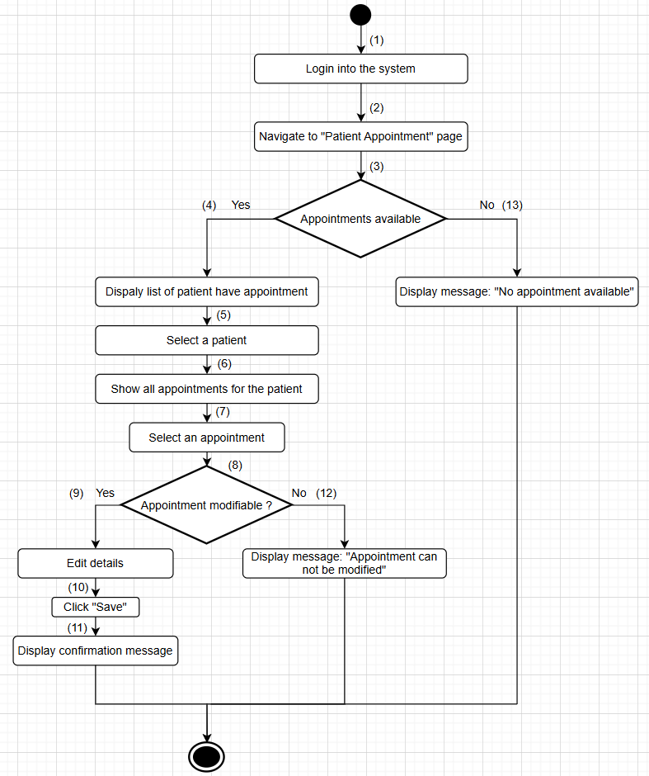

**Business Rules**

| **Step** | **BR Code(s)** | **Description** |
| --- | --- | --- |
| (1) | BR-19 | Users must have an account with a unique email/username and password, or a linked Gmail account. |
| (2) | BR-1 | Only users with the role of "admin" or "receptionist" can view all appointments. |
| (3) | BR-17 | Appointments must be marked "Pending" until reviewed by the receptionist. |
| (8) | BR-5 | Once rejected, appointments cannot be modified without special permissions |
| (11) | BR-18 | The system must ensure appointment details are updated in real-time. |

### UC 04: Create Appointment.

| **Use Case Specification** | | | |
| --- | --- | --- | --- |
| **Use Case ID and Name:** | UC-04 Create Appointment | | |
| **Created By:** | Trần Đình Duy Phương | **Date Created:** | June-02, 2025 |
| **Primary Actor:** | Receptionist | **Secondary Actors:** | Doctor |
| **Trigger:** | The receptionist wants to manage patient appointment requests by creating appointments from pending appointments. | | |
| **Description:** | This use case allows the receptionist to process pending appointments. The receptionist can confirm a pending appointment by assigning a doctor and optionally adding a note. The appointment status will be updated accordingly and moved to the patient’s appointment list. | | |
| **Preconditions:** | **PRE-1:** The receptionist is logged into the system with valid credentials. **PRE-2:** At least one pending appointment exists in the system. | | |
| **Post–conditions:** | **POST-1:** The appointment status is updated to “Confirmed”.  **POST-2:** The updated appointment appears in the patient’s appointment list. | | |
| **Normal Flow:** | 1. The receptionist logs into the system. 2. They navigate to the “Create Appointment” page. 3. The system displays a list of pending appointments. 4. The receptionist selects a pending appointment. 5. The receptionist decides to **create**: 6. The system displays all booked appointments with the following information. 7. Create 8. Select a doctor. 9. Enter note (Optional). 10. Create the appointment. 11. The system updates the status to **Confirmed** and moves it to the patient’s appointment list. | | |
| **Alternative Flows:** | **4-AF:** No pending appointments in the system  a. The system displays the message: “No pending appointments.”  b. The use case ends. | | |
| **Exceptions:** | **4-EF:** Network or database failure  a. The system displays: “Unable to process appointments. Please try again later.” | | |
| **Priority:** | **High** | | |
| **Frequency of Use:** | **High** (used daily to manage clinic operations) | | |
| **Business Rules:** | **BR-19**: Users must have an account with a unique email/username and password, or a linked Gmail account.  **BR-17**: Appointments must be marked "Pending" until reviewed by the receptionist.  **BR-8**: The assignment of a doctor must align with the doctor’s schedule.  **BR-6:** Time slots must not conflict with other appointments.  **BR-11**: Changes must not conflict with existing appointments (unless an override is allowed).  **BR-120**: Time slots must not conflict with other appointments. | | |
| **Other Information:** | The system may send a confirmation email to the patient upon successful booking.  Appointment booking form may include real-time availability lookup for doctors and services.  A calendar view or time slot picker helps users choose available dates/times. | | |
| **Assumptions:** | * Receptionist is using a clinic-authorized system with proper access. * Appointment and doctor availability data are synced and up to date. | | |

**Activities Flow**

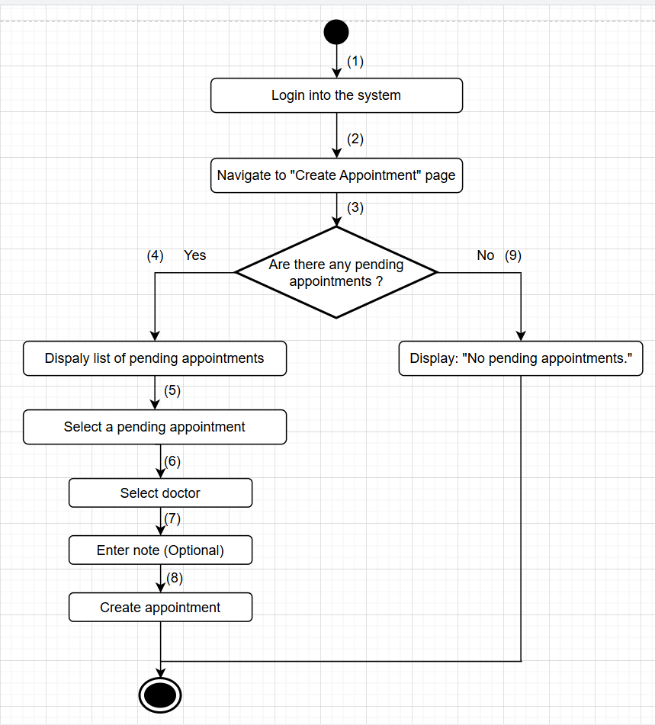

**Business Rules**

| **Step** | **BR Code(s)** | **Description** |
| --- | --- | --- |
| (1) | BR-19 | Users must have an account with a unique email/username and password, or a linked Gmail account. |
| (3) | BR-17 | Appointments must be marked "Pending" until reviewed by the receptionist. |
| (6) | BR-8 | The assignment of a doctor must align with the doctor’s schedule. |
| (8) | BR-6, BR-11, BR-120 | BR-6: Time slots must not conflict with other appointments.  BR-11: Changes must not conflict with existing appointments (unless an override is allowed).  BR-120: Time slots must not conflict with other appointments. |

### 

### UC 05: Edit doctor’s work schedule.

| **Use Case Specification** | | | |
| --- | --- | --- | --- |
| **Use Case ID and Name:** | UC-05 Edit doctor’s work schedule. | | |
| **Created By:** | Trần Đình Duy Phương | **Date Created:** | June-02, 2025 |
| **Primary Actor:** | Receptionist, Admin | **Secondary Actors:** | Doctor |
| **Trigger:** | The admin or receptionist wants to modify a doctor’s working hours or working days in the system. | | |
| **Description:** | This use case allows the admin or receptionist to manage and update a doctor’s work schedule, including editing working days and time ranges. The updated schedule will affect appointment availability for that doctor. | | |
| **Preconditions:** | **PRE-1:** The admin or receptionist is logged in with valid credentials.  **PRE-2:** The doctor exists in the system. | | |
| **Post–conditions:** | **POST-1:** The doctor’s work schedule is updated successfully.  **POST-2:** Future appointment booking reflects the updated schedule. | | |
| **Normal Flow:** | 1. Log into the system. 2. Navigates to “Manage Doctor Schedules”. 3. System displays a list of doctors. 4. Selects a doctor. 5. System shows the current schedule. 6. Updates working days/hours. 7. Click "Save". 8. System validates and updates the schedule. 9. A confirmation message is displayed. | | |
| **Alternative Flows:** | **5-AF:** Invalid time input  a. System displays error: "Invalid time range entered."  b. Admin re-enters time range. | | |
| **Exceptions:** | **5-EF:** System/database failure  a. System shows: “Unable to update schedule. Please try again later.” | | |
| **Priority:** | **High** | | |
| **Frequency of Use:** | **Medium** | | |
| **Business Rules:** | **BR-19:** Users must have an account with a unique email/username and password, or a linked Gmail account.  **BR-10:** Only Admin/ Receptionist is permitted to modify a doctor’s schedule.  **BR-13:** Duplicate scheduling with an existing schedule is not allowed.  **BR-8:** The assignment of a doctor must align with the doctor’s schedule.  **BR-9:** The selected doctor to confirm the appointment must be available at the designated time  **BR- 39:** Updated data must be validated (format checks, required fields, etc.). | | |
| **Other Information:** | The system may include schedule conflict detection, preventing double-booking or overlapping shifts.  Changes to the schedule can automatically update availability for new or existing appointments. | | |
| **Assumptions:** | * The admin has access to the doctor list. * Schedule changes are saved in real time and affect appointment logic. | | |

**Activities Flow**

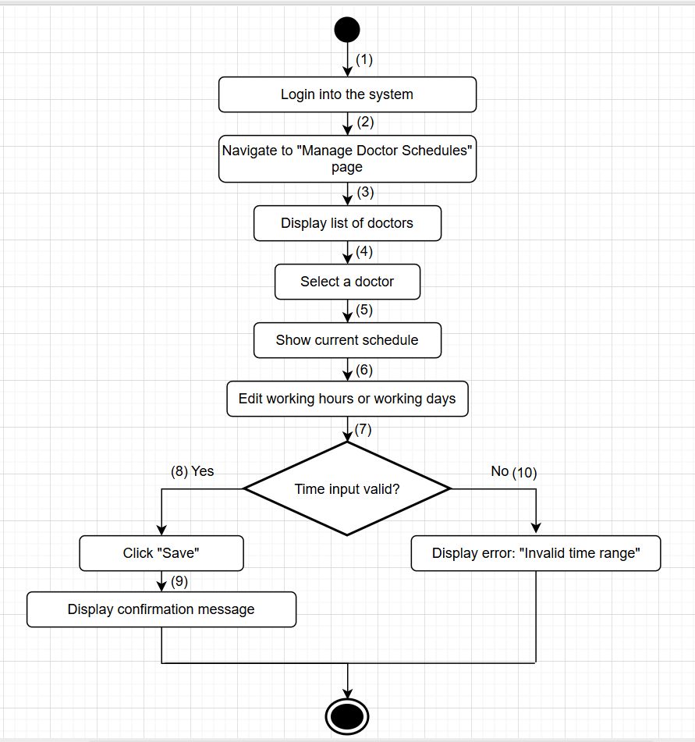

**Business Rules**

| **Step** | **BR Code(s)** | **Description** |
| --- | --- | --- |
| (1) | BR-19 | Users must have an account with a unique email/username and password, or a linked Gmail account. |
| (2) | BR-10 | Only Admin/ Receptionist is permitted to modify a doctor’s schedule. |
| (6) | BR-13, BR-8, BR-9 | BR-13: Duplicate scheduling with an existing schedule is not allowed.  BR-8: The assignment of a doctor must align with the doctor’s schedule.  BR-9: The selected doctor to confirm the appointment must be available at the designated time |
| (8) | BR- 39 | BR- 39**:** Updated data must be validated (format checks, required fields, etc.). |

### UC 06: Create doctor’s work schedule

| **Use Case Specification** | | | |
| --- | --- | --- | --- |
| **Use Case ID and Name:** | UC-06 Create Doctor’s Work Schedule. | | |
| **Created By:** | Trần Đình Duy Phương | **Date Created:** | June-02, 2025 |
| **Primary Actor:** | Admin / Receptionist | **Secondary Actors:** | Doctor |
| **Trigger:** | Admin or receptionist wants to create a work schedule for a doctor to manage availability for patient appointments. | | |
| **Description:** | This use case allows admin or receptionists to create a new schedule for a doctor, including available working days and time slots. | | |
| **Preconditions:** | **PRE-1:** Admin or receptionist is logged into the system with valid credentials.  **PRE-2:** The target doctor exists in the system. | | |
| **Post–conditions:** | **POST-1:** A new schedule is successfully saved and associated with the doctor.  **POST-2:** The doctor’s available time slots are visible in the system for patients to book. | | |
| **Normal Flow:** | 1. Log into the system. 2. Navigate to the “Doctor Schedules” or “Create Schedule” page. 3. Select a doctor from the list. 4. Define the working days and available time slots. 5. Submit the schedule. 6. The system saves the schedule and confirms the action. | | |
| **Alternative Flows:** | **6-AF:** Missing Required Fields   * The system highlights missing information and prevents submission. | | |
| **Exceptions:** | **6-EF:** Database or Server Error   * System shows error message: “Unable to save schedule. Please try again later.” | | |
| **Priority:** | **Medium** | | |
| **Frequency of Use:** | **Medium** | | |
| **Business Rules:** | **BR-19:** Users must have an account with a unique email/username and password, or a linked Gmail account.  **BR-10, BR-12:** Only Admin/Receptionist is permitted to modify or create a doctor’s schedule.  **BR-8:** The assignment of a doctor must align with the doctor’s schedule.  **BR-13:** Duplicate scheduling with an existing schedule is not allowed.  **BR-11**: Changes must not conflict with existing appointments (unless an override is allowed).  **BR-39:** Updated data must be validated (format checks, required fields, etc.). | | |
| **Other Information:** | Advanced scheduling options (e.g., repeating weekly, exceptions for holidays) can be added in future versions.  Integration with calendar sync (e.g., Google Calendar) is under consideration. | | |
| **Assumptions:** | * Admin or receptionist is using an authenticated clinic-provided device. * All schedule data is saved to a secure database. | | |

**Activities Flow**

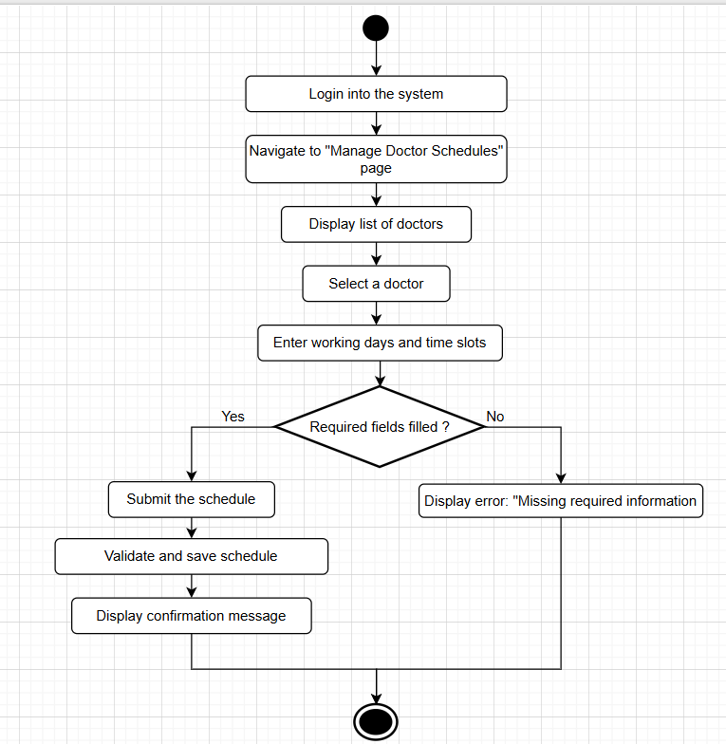

**Business Rules**

| **Step** | **BR Code(s)** | **Description** |
| --- | --- | --- |
| (1) | BR-19 | Users must have an account with a unique email/username and password, or a linked Gmail account. |
| (2) | BR-10, BR-12 | Only Admin/Receptionist is permitted to modify or create a doctor’s schedule. |
| (4) | BR-8 | The assignment of a doctor must align with the doctor’s schedule. |
| (6) | BR-13 | Duplicate scheduling with an existing schedule is not allowed. |
| (7) | BR-11 | Changes must not conflict with existing appointments (unless an override is allowed). |
| (8) | BR-39 | Updated data must be validated (format checks, required fields, etc.). |

### UC 07: Filter appointment list

| **Use Case Specification** | | | |
| --- | --- | --- | --- |
| **Use Case ID and Name:** | UC-07: Filter Appointment List | | |
| **Created By:** | Trần Đình Duy Phương | **Date Created:** | June-02, 2025 |
| **Primary Actor:** | Admin / Receptionist | **Secondary Actors:** | None |
| **Trigger:** | A receptionist or admin wants to quickly locate appointments based on certain criteria (e.g., date, doctor, status) to manage scheduling and patient flow more efficiently. | | |
| **Description:** | This use case allows the receptionist or admin to apply filters to the list of appointments. Filters may include appointment date, assigned doctor, medical service, or appointment status. This helps streamline operations and decision-making. | | |
| **Preconditions:** | **PRE-1:** The receptionist or admin is logged into the system.  **PRE-2:** There is at least one appointment available in the system. | | |
| **Post–conditions:** | **POST-1:** The appointment list is successfully filtered and displayed based on the selected criteria. | | |
| **Normal Flow:** | 1. The receptionist/admin logs into the system. 2. Navigate to the “View Appointments” page. 3. System displays the full list of appointments. 4. Selects one or more filter criteria (e.g., date, doctor, status). 5. Filters and updates the list of appointments. 6. Review the filtered results. | | |
| **Alternative Flows:** | **7-AF:** No matching results  a. The system displays the message: “No appointments match the selected criteria.”  b. The user can change filter criteria or reset the filter. | | |
| **Exceptions:** | **7-EF:** Filter function fails due to network or database error  -The system shows an error message: “Unable to apply filters. Please try again later.” | | |
| **Priority:** | **Medium** | | |
| **Frequency of Use:** | **Medium** | | |
| **Business Rules:** | **BR-19:** Users must have an account with a unique email/username and password, or a linked Gmail account.  **BR-39:** Filters (e.g., date, doctor, status) must be valid in format and required fields must be present.  **BR-14:** If no match, system returns real-time result. | | |
| **Other Information:** | Filters may support combined conditions (e.g., "Confirmed appointments by Dr. Smith today").  The system may provide a reset filter button to return to the full list. | | |
| **Assumptions:** | * The receptionist/admin has access to a stable internet connection. * The appointment list is pre-loaded or available in the system. | | |

**Activities Flow**

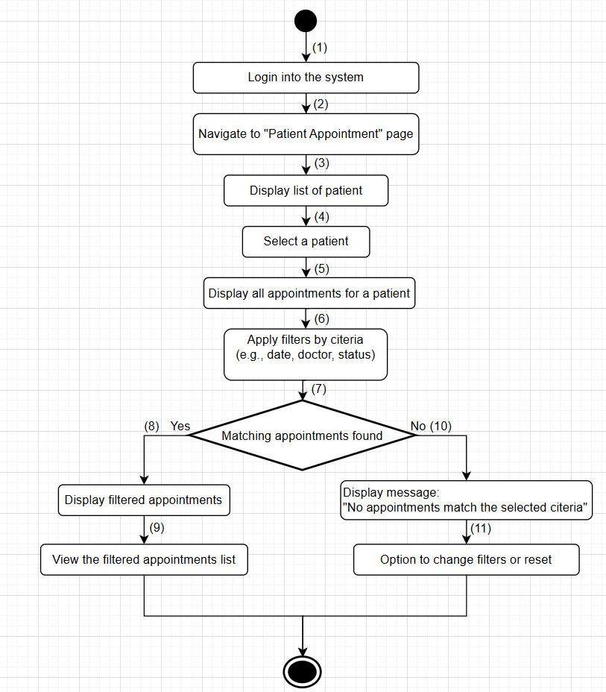

**Business Rules**

| **Step** | **BR Code(s)** | **Description** |
| --- | --- | --- |
| (1) | BR-19 | Users must have an account with a unique email/username and password, or a linked Gmail account. |
| (2) | BR-39 | Filters (e.g., date, doctor, status) must be valid in format and required fields must be present. |
| (10) | BR-14 | If there is no match, the system returns a real-time result. |

### 

### UC 08: Book an appointment.

| **Use Case Specification** | | | |
| --- | --- | --- | --- |
| **Use Case ID and Name:** | UC-08: Book an appointment | | |
| **Created By:** | Trần Đình Duy Phương | **Date Created:** | June-02, 2025 |
| **Primary Actor:** | Patient | **Secondary Actors:** | Receptionist |
| **Trigger:** | A patient wants to schedule a medical appointment by submitting personal details, preferred time, specific doctor and service. | | |
| **Description:** | This use case allows a patient to request an appointment by selecting a doctor, preferred services, time slot, and submitting personal information. Doctors may adjust or add services during consultation. | | |
| **Preconditions:** | **PRE-1:** The patient accesses the booking interface.  **PRE-2:** The doctor has an available schedule.  **PRE-3:** The selected services are available. | | |
| **Post–conditions:** | **POST-1:** Appointment is submitted and marked as "Pending".  **POST-2:** Receptionist is notified to confirm or adjust. | | |
| **Normal Flow:** | 1. Patient accesses booking interface.  2. Patient selects a preferred doctor.  3. System displays available time slots.  4. Patient selects a time slot.  5. Patient selects service(s).  6. Patient enters contact info and condition description.  7. Patient submits booking request.  8. System saves requests and notifies the receptionist. | | |
| **Alternative Flows:** | **8-AF:** Patient submits incomplete form  a. The system prompts the patient to complete all required fields. b. Patient resubmits the form**.** | | |
| **Exceptions:** | **8-EF:** System/database error during submission   * The system displays an error: “Unable to submit an appointment. Please try again later.” | | |
| **Priority:** | **High** | | |
| **Frequency of Use:** | **High** | | |
| **Business Rules:** | **BR-19:** Users must have an account with a unique email/username and password, or a linked Gmail account.  **BR-21:** Patients can choose date/time, doctor or service.  **BR-16:** Access rights are role-based (Doctor, Patient, Store Manager) and restrict users to their designated functionalities.  **BR-39:** Updated data must be validated (format checks, required fields, etc.). | | |
| **Other Information:** | Patients may receive confirmation emails or messages once the appointment is confirmed.  Optional CAPTCHA can be added to prevent spam submissions. | | |
| **Assumptions:** | Patients can choose a doctor and service from available options. | | |

**Activities Flow**

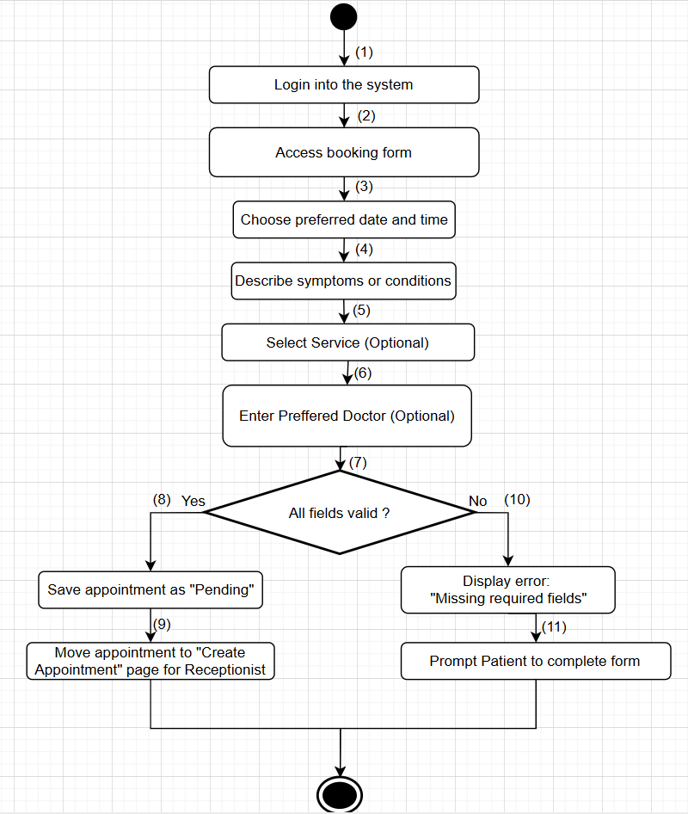

**Business Rules**

| **Step** | **BR Code(s)** | **Description** |
| --- | --- | --- |
| (1) | BR-19 | Users must have an account with a unique email/username and password, or a linked Gmail account. |
| (2) | BR-21, BR-16 | BR-21: Patients can choose date/time, doctor or service.  BR-16: Access rights are role-based (Doctor, Patient, Store Manager) and restrict users to their designated functionalities. |
| (4) | BR-39 | Updated data must be validated (format checks, required fields, etc.). |
| (10) | BR-39 | Display error: "Missing required fields" (MSG02) |

### 

### UC 09: View my appointments.

| **Use Case Specification** | | | |
| --- | --- | --- | --- |
| **Use Case ID and Name:** | UC-09 View My Appointments | | |
| **Created By:** | Trần Đình Duy Phương | **Date Created:** | June-02, 2025 |
| **Primary Actor:** | Patient | **Secondary Actors:** | None |
| **Trigger:** | The patient selects the option to view their appointments from the system. | | |
| **Description:** | This use case allows a patient to view a list of their personal appointments, including details such as date, time, doctor, patient, and any associated notes. | | |
| **Preconditions:** | **PRE-1**: The patient is logged into the system with valid credentials.  **PRE-2**: The patient has at least one scheduled appointment recorded in the system.  **PRE-3**: The system must be operational and accessible (e.g., website is online). | | |
| **Post–conditions:** | **POST-1**: The patient successfully views the list of their appointments with all relevant details.  **POST-2**: The displayed appointment details are accurate and up-to-date. | | |
| **Normal Flow:** | 1. The patient logs into the system and navigates to the "My Appointments" section. 2. The system retrieves the list of the patient’s scheduled appointments from the database. 3. The system displays the appointment list, including details such as date, time, doctor, patient, and any notes. 4. The patient reviews the appointment details. 5. The patient exits the section or proceeds with a related action (e.g., canceling an appointment per UC-28). | | |
| **Alternative Flows:** | **9.1-AF**: No appointments available  a. At step 2 of the Normal Flow, if the patient has no scheduled appointments, the system displays a message: "No appointments found."  b. The use case ends.  **9.2-AF**: System error during retrieval  a. At step 2 of the Normal Flow, if the system encounters an error while retrieving the appointments (e.g., database issue), the system displays an error message: "Unable to load appointments. Please try again later."  b. The patient acknowledges the error and may retry or exit the section. | | |
| **Exceptions:** | **9-EF**: System or network failure  At any time, if the system cannot connect to the database or there is a network issue, it displays an error message: "Unable to load appointments. Please try again later." | | |
| **Priority:** | **High** | | |
| **Frequency of Use:** | **Medium** (used regularly by Patients to check their appointment schedules). | | |
| **Business Rules:** | **BR-18:** The system must ensure appointment details are updated in real-time.  **BR-125:** Only authenticated patients can view their own appointments.  **BR-126:** If no appointments are scheduled, the system must inform the patient with an appropriate message.  **BR-127:** If the system fails to retrieve data, it must display a clear error and allow retry.  **BR-128:** Patients can freely exit the appointment view section or navigate back to previous sections without affecting session or data. | | |
| **Other Information:** | Appointment data is used to inform patients and may be analyzed to optimize scheduling (subject to privacy regulations). | | |
| **Assumptions:** | * The patient is authenticated and has a registered account with the system. * The patient is familiar with navigating the appointment interface. | | |

**Activities Flow**

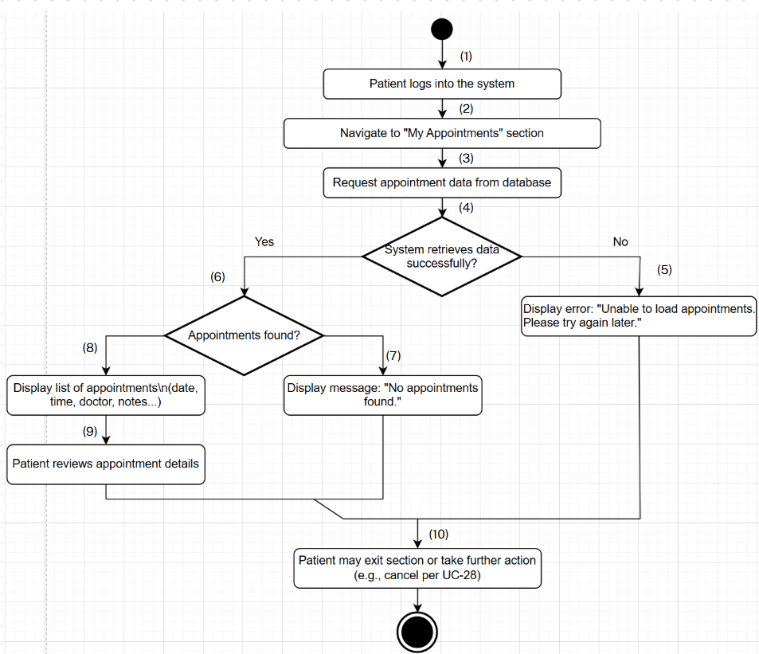

**Business Rules**

| **Step(s)** | **BR Code(s)** | **Description / Rule Enforcement** |
| --- | --- | --- |
| (1), (2) | BR-125 | BR-125: Only authenticated patients can view their own appointments. |
| (3), (4), (8), (9) | BR-125, BR-18 | BR-125: Only authenticated patients can view their own appointments.  BR-18: The system must ensure appointment details are updated in real-time. |
| (6) | BR-125, BR-18, BR-127 | BR-125: Only authenticated patients can view their own appointments.  BR-18: The system must ensure appointment details are updated in real-time. BR-127: If the system fails to retrieve data, it must display a clear error and allow retry. |
| (7) | BR-125, BR-126 | BR-125: Only authenticated patients can view their own appointments.  BR-126: If no appointments are scheduled, the system must inform the patient with an appropriate message. |
| (10) | BR-125, BR-128 | BR-125: Only authenticated patients can view their own appointments.  BR-128: Patients can freely exit the appointment view section or navigate back to previous sections without affecting session or data. |

### UC 10: Sign In.

| **Use Case Specification** | | | |
| --- | --- | --- | --- |
| **Use Case ID and Name:** | UC-10: Sign In | | |
| **Created By:** | Trần Đình Duy Phương | **Date Created:** | June-02, 2025 |
| **Primary Actor:** | Doctor, Patient, Store Manager | **Secondary Actors:** | Gmail Authentication Service |
| **Trigger:** | The user selects the sign-in option and chooses to log in using their credentials (email/username and password) or Gmail authentication. | | |
| **Description:** | This use case allows a user (Doctor, Patient, or Store Manager) to log into the system using their email/username and password or by authenticating via Gmail to access their respective functionalities. | | |
| **Preconditions:** | **PRE-1**: The user has a registered account with valid credentials in the system, or a Gmail account linked to their system profile.  **PRE-2**: The system must be operational and accessible (e.g., website is online).  **PRE-3**: The user has an active internet connection.  **PRE-4**: The Gmail Authentication Service is available and configured with the system. | | |
| **Post–conditions:** | **POST-1**: The user successfully logs into the system and is redirected to their designated dashboard or homepage.  **POST-2**: The system logs the login activity for security and auditing purposes.  **POST-3**: The user’s session is established with appropriate access rights based on their role (Doctor, Patient, or Store Manager). | | |
| **Normal Flow:** | 1. The user navigates to the login page of the system. 2. The user enters their email/username and password in the provided fields. 3. The user submits the login request by clicking the "Sign In" button. 4. The system validates the credentials against the database. 5. Upon successful validation, the system logs the user in and redirects them to their role-specific dashboard. 6. The system displays a welcome message (e.g., "Welcome, [User Role]!"). | | |
| **Alternative Flows:** | **10.1-AF**: Login with Gmail Authentication  a. At step 2 of the Normal Flow, the user selects the "Sign In with Gmail" option.  b. The system redirects the user to the Gmail Authentication Service login page.  c. The user enters their Gmail credentials and authorizes the system to access their Gmail profile.  d. The Gmail Authentication Service validates the credentials and sends an authentication token to the system.  e. The system verifies the token and matches the Gmail account to a registered user profile.  f. Upon successful validation, the system logs the user in and redirects them to their role-specific dashboard.  g. The system displays a welcome message (e.g., "Welcome, [User Role]!").  **10.2-AF**: Invalid credentials (Email/Username and Password)  a. At step 4 of the Normal Flow, if the credentials are incorrect, the system displays a message: "Invalid email/username or password. Please try again."  b. The user may re-enter credentials, select the "Forgot Password" option, or try Gmail authentication.  **10.3-AF**: Invalid Gmail authentication  a. At step d of 1-AF, if the Gmail credentials are incorrect or authorization fails, the Gmail Authentication Service returns an error to the system.  b. The system displays a message: "Gmail authentication failed. Please try again or use email/username and password."  c. The user may retry Gmail authentication or switch to email/username and password login.  **10.4-AF**: Account locked  a. At step 4 of the Normal Flow or step e of 1-AF, if the account is locked due to multiple failed attempts, the system displays a message: "Account locked. Please contact support."  b. The use case ends, and the user must contact support to unlock the account.  **10.5-AF**: System error during login  a. At step 4 of the Normal Flow or step e of 1-AF, if the system encounters an error (e.g., database issue), the system displays an error message: "Unable to process login. Please try again later."  b. The user acknowledges the error and may retry or exit the section. | | |
| **Exceptions:** | **10-EF**: System or network failure  At any time, if the system cannot connect to the database or the Gmail Authentication Service, it displays an error message: "Unable to process login. Please try again later." | | |
| **Priority:** | **High** | | |
| **Frequency of Use:** | **High** (frequently used by Doctors, Patients, and Store Managers to access the system). | | |
| **Business Rules:** | **BR-19**: Users must have a account with a unique email/username and password, or a linked Gmail account.  **BR-20**: The system must enforce password complexity and account security (e.g., multi-factor authentication if enabled).  **BR-21**: Access rights are role-based (Doctor, Patient, Store Manager) and restrict users to their designated functionalities.  **BR-22**: Gmail authentication must comply with the Gmail Authentication Service’s security protocols. | | |
| **Other Information:** | Login data is used for security tracking and may be analyzed to monitor user activity (subject to privacy regulations). | | |
| **Assumptions:** | * The user has previously registered and remembers their credentials or has a Gmail account linked to their profile. * The system supports role-based access control, secure authentication, and integration with the Gmail Authentication Service. | | |

**Activities Flow**

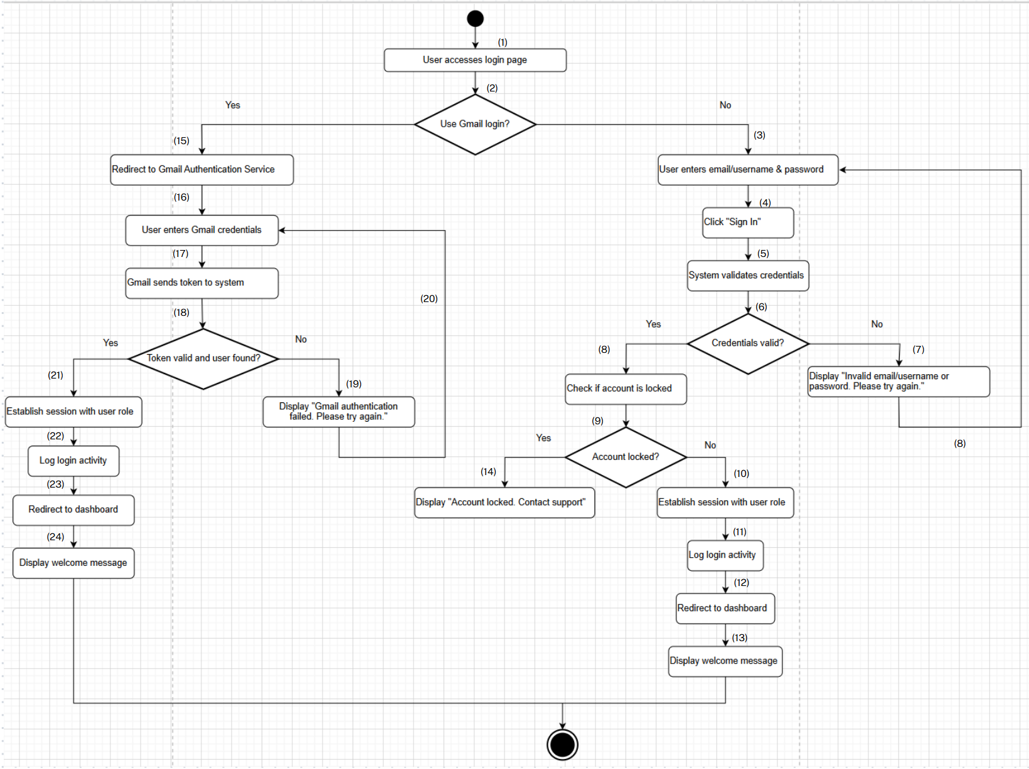

**Business Rules**

| **Step** | **BR Code(s)** | **Description / Rule Enforcement** |
| --- | --- | --- |
| (1) | BR-19, BR-20, BR-21 | BR-19: Users must have an account with a unique email/username and password, or a linked Gmail account.  BR-20: The system must enforce password complexity and account security (e.g., multi-factor authentication if enabled).  BR-21: Access rights are role-based (Doctor, Patient, Store Manager) and restrict users to their designated functionalities. |
| (2) | BR-19, BR-20, BR-21 | BR-19: Users must have an account with a unique email/username and password, or a linked Gmail account.  BR-20: The system must enforce password complexity and account security (e.g., multi-factor authentication if enabled).  BR-21: Access rights are role-based (Doctor, Patient, Store Manager) and restrict users to their designated functionalities. |
| (3) | BR-19, BR-20 | BR-19: Users must have an account with a unique email/username and password, or a linked Gmail account.  BR-20: The system must enforce password complexity and account security (e.g., multi-factor authentication if enabled). |
| (4) | BR-19, BR-20 | BR-19: Users must have an account with a unique email/username and password, or a linked Gmail account.  BR-20: The system must enforce password complexity and account security (e.g., multi-factor authentication if enabled). |
| (5) | BR-19, BR-20 | BR-19: Users must have an account with a unique email/username and password, or a linked Gmail account.  BR-20: The system must enforce password complexity and account security (e.g., multi-factor authentication if enabled). |
| (6) | BR-19, BR-20 | BR-19: Users must have an account with a unique email/username and password, or a linked Gmail account.  BR-20: The system must enforce password complexity and account security (e.g., multi-factor authentication if enabled). |
| (8) | BR-19, BR-20 | BR-19: Users must have an account with a unique email/username and password, or a linked Gmail account.  BR-20: The system must enforce password complexity and account security (e.g., multi-factor authentication if enabled). |
| (9) | BR-19 | BR-19: Users must have an account with a unique email/username and password, or a linked Gmail account. |
| (10) | BR-19 | BR-19: Users must have an account with a unique email/username and password, or a linked Gmail account. |
| (11) | BR-19, BR-21 | BR-19: Users must have an account with a unique email/username and password, or a linked Gmail account.  BR-21: Access rights are role-based (Doctor, Patient, Store Manager) and restrict users to their designated functionalities. |
| (12) | BR-19, BR-21 | BR-19: Users must have an account with a unique email/username and password, or a linked Gmail account.  BR-21: Access rights are role-based (Doctor, Patient, Store Manager) and restrict users to their designated functionalities. |
| (13) | BR-19, BR-21 | BR-19: Users must have an account with a unique email/username and password, or a linked Gmail account.  BR-21: Access rights are role-based (Doctor, Patient, Store Manager) and restrict users to their designated functionalities. |
| (15) | BR-22 | BR-22: Gmail authentication must comply with the Gmail Authentication Service’s security protocols. |
| (16) | BR-22 | BR-22: Gmail authentication must comply with the Gmail Authentication Service’s security protocols. |
| (17) | BR-22 | BR-22: Gmail authentication must comply with the Gmail Authentication Service’s security protocols. |
| (18) | BR-22 | BR-22: Gmail authentication must comply with the Gmail Authentication Service’s security protocols. |
| (21) | BR-22, BR-21 | BR-22: Gmail authentication must comply with the Gmail Authentication Service’s security protocols.  BR-21: Access rights are role-based (Doctor, Patient, Store Manager) and restrict users to their designated functionalities. |

### UC 11: Sign Out.

| **Use Case Specification** | | | |
| --- | --- | --- | --- |
| **Use Case ID and Name:** | UC-11 Sign Out | | |
| **Created By:** | Trần Đình Duy Phương | **Date Created:** | June-05, 2025 |
| **Primary Actor:** | Doctor, Patient, Store Manager | **Secondary Actors:** | None |
| **Trigger:** | The user selects the sign-out option from the system interface to end their session. | | |
| **Description:** | This use case allows a user (Doctor, Patient, or Store Manager) to log out of the system, terminating their current session and requiring re-authentication for future access. | | |
| **Preconditions:** | **PRE-1**: The user is currently logged into the system with an active session.  **PRE-2**: The system must be operational and accessible (e.g., website or mobile app is online).  **PRE-3**: The user has an active internet connection. | | |
| **Post–conditions:** | **POST-1**: The user’s session is successfully terminated, and they are logged out of the system.  **POST-2**: The system clears the user’s session data and redirects them to the login page.  **POST-3**: The system logs the logout activity for security and auditing purposes. | | |
| **Normal Flow:** | 1. The user navigates to their account settings or dashboard and selects the "Sign Out" option. 2. The system processes the logout request and terminates the user’s session. 3. The system clears all session-related data (e.g., authentication tokens). 4. The system redirects the user to the login page. | | |
| **Alternative Flows:** | **11-AF**: System error during logout  a. At step 2 of the Normal Flow, if the system encounters an error (e.g., server issue), the system displays an error message: "Unable to sign out. Please try again later."  b. The user acknowledges the error and may retry or close the session manually. | | |
| **Exceptions:** | **11-EF**: System or network failure  At any time, if the system cannot process the logout due to a network issue or server failure, it displays an error message: "Unable to sign out. Please try again later." | | |
| **Priority:** | **High** | | |
| **Frequency of Use:** | **High** (used whenever users finish their session) | | |
| **Business Rules:** | **BR-23**: Only authenticated users can initiate a sign-out action.  **BR-24**: The system must securely terminate the session and clear all sensitive data.  **BR-25**: Logout must be available from all user interfaces (e.g., dashboard, settings). | | |
| **Other Information:** | Logout data is used for security tracking and session management (subject to privacy regulations). | | |
| **Assumptions:** | * The user is aware of the sign-out option and its location in the interface. * The system supports secure session termination and redirection. | | |

**Activities Flow**

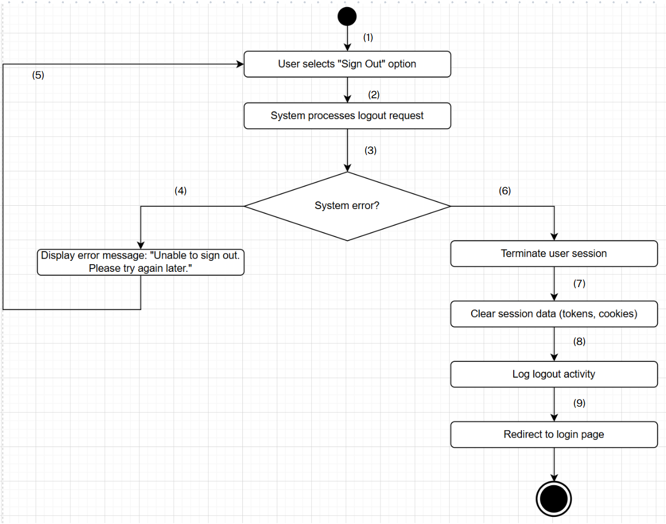

**Business Rules**

| **Step** | **BR Code(s)** | **Description / Rule Enforcement** |
| --- | --- | --- |
| (1) | BR-23, BR-25 | BR-23: Only authenticated users can initiate a sign-out action.  BR-25: Logout must be available from all user interfaces (e.g., dashboard, settings). |
| (2) | BR-23, BR-24 | BR-23: Only authenticated users can initiate a sign-out action.  BR-24: The system must securely terminate the session and clear all sensitive data. |
| (3) | BR-23, BR-24 | BR-23: Only authenticated users can initiate a sign-out action.  BR-24: The system must securely terminate the session and clear all sensitive data. |
| (6) | BR-23, BR-24 | BR-23: Only authenticated users can initiate a sign-out action.  BR-24: The system must securely terminate the session and clear all sensitive data. |
| (7) | BR-24 | BR-24: The system must securely terminate the session and clear all sensitive data. |
| (8) | BR-24 | BR-24: The system must securely terminate the session and clear all sensitive data. |
| (9) | BR-24 | BR-24: The system must securely terminate the session and clear all sensitive data. |

### UC 12: Register.

| **Use Case Specification** | | | |
| --- | --- | --- | --- |
| **Use Case ID and Name:** | UC-12 Register | | |
| **Created By:** | Cao Minh Tuấn | **Date Created:** | June-02, 2025 |
| **Primary Actor:** | Guest | **Secondary Actors:** | Admin |
| **Trigger:** | User wants to create new account | | |
| **Description:** | This use case allows a new user to create an account in the system by providing required personal information such as username, password, and email. The system validates the input data, checks for uniqueness, and creates the account if all conditions are met. A confirmation email may be sent to verify the user’s email address. | | |
| **Preconditions:** | **PRE-1:** User does not have an account in the system (not registered or not logged in).  **PRE-2:** The system is accessible (server is up and running, database is available).  **PRE-3:** The registration form is working and displaying correctly on the user interface. | | |
| **Post–conditions:** | **POST-1**:A new user account is created and stored in the system.  **POST-2**:The user receives a confirmation email (optional).  **POST-3**:The user can now log in using the registered credentials.  **POST-4**: If registration fails, an appropriate error message is displayed, and no account is created**.** | | |
| **Normal Flow:** | 1. The user accesses the registration page 2. The user enters the required information (e.g., username, password, email, etc.). 3. The user clicks the "Register" (Submit) button. 4. The system validates the input data (format, required fields, length, etc.). 5. The system checks the uniqueness of the username and email in the database. 6. If the data is valid and does not already exist, the system creates a new account and saves the user information. 7. The system sends a confirmation email (if applicable). 8. The system notifies the user of successful registration and redirects to the login page or homepage. | | |
| **Alternative Flows:** | **1-AF: User inputs invalid or incomplete data**  a. The system detects missing or incorrectly formatted fields (e.g., invalid email format, password too short).  b. The system displays appropriate error messages indicating which fields need correction.  c. The user corrects the input and resubmits.  **2-AF: Username or email already exists**  a. The system finds that the entered username or email is already registered.  b. The system notifies the user that the username/email is taken and prompts to enter a different one.  c. The user provides a new username/email and resubmits.  **3-AF: Confirmation email fails to send (optional)**  a. The system creates the account successfully but encounters an error sending the confirmation email.  b. The system notifies the user that the account is created but email confirmation may be delayed.  c. The user can still log in but may need to verify email later.  **4-AF: System or database failure**  a. The system encounters an unexpected error (e.g., database down) during registration.  b. The system displays an error message: "Registration failed. Please try again later."  c. The use case ends without creating an account. | | |
| **Exceptions:** | **1-EF: System or database failure during registration**   * If the system cannot connect to the database or encounters an unexpected error while creating the account, * The system displays an error message:  *"Registration failed due to a system error. Please try again later."* * The registration process is aborted, and no account is created.   **2-EF: Network failure during submission**   * If the user’s network connection is lost while submitting the registration form, * The system notifies the user that submission failed due to connection issues, * The user is prompted to retry once the network is restored.   **3-EF: Email service unavailable (if email confirmation is required)**   * If the email server is down or unreachable when sending confirmation, * The system logs the failure and informs the user that email confirmation may be delayed, * The account is still created but marked as unverified until email confirmation is completed. | | |
| **Priority:** | **High** | | |
| **Frequency of Use:** | **Medium to Low** | | |
| **Business Rules:** | * **BR-19:** Users must have an account with a unique email/username and password, or a linked Gmail account. * **BR-20:** The system must enforce password complexity and account security (e.g., multi-factor authentication if enabled). * **BR-26:** The user must agree to the terms of service before completing the registration. * **BR-27:** The account must require email verification to activate the account (email confirmation is mandatory). * **BR-28:** Unverified accounts will not be allowed to log in or will have limited privileges | | |
| **Other Information:** | The system may provide CAPTCHA verification to prevent automated or bot registrations.  Password strength meter can be implemented to guide users in creating strong passwords.  Optional fields such as phone number or address may be included but are not mandatory.  The registration page should be responsive and accessible on different devices (mobile, tablet, desktop).  Future enhancements could include social media login integration (Google, Facebook, etc.). | | |
| **Assumptions:** | * The user has access to a device with internet connection to reach the registration page. * The user can provide valid and accurate personal information during registration. * The system’s email service is operational for sending confirmation emails. * The system database is available and responsive to store user data. * The registration form interface works correctly across supported browsers and devices. * Users understand and accept the terms and conditions of the service before registering. | | |

**Activities Flow**

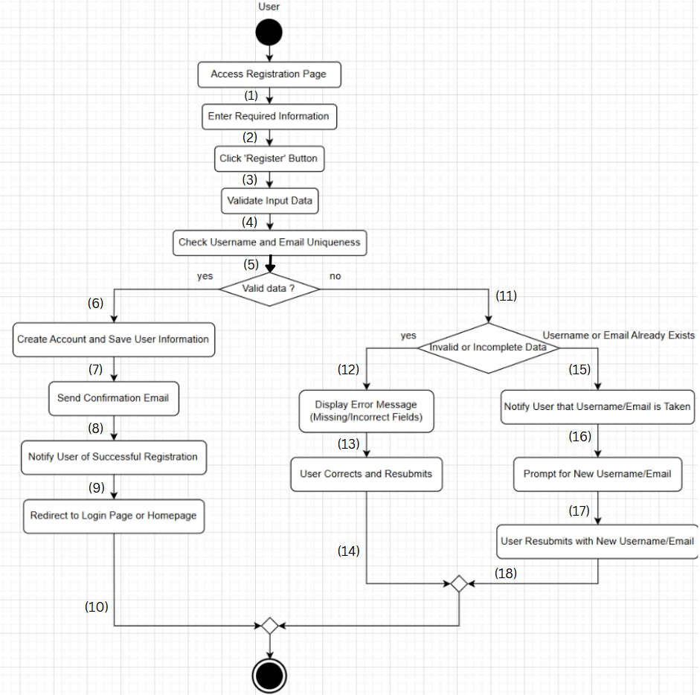

**Business Rules**

| **Step** | **BR Code(s)** | **Description / Rule Enforcement** |
| --- | --- | --- |
| (1) | BR-19, BR-26 | BR-19: Users must provide a unique email/username and password, or have a linked Gmail account to complete registration.  BR-26: The user must agree to the terms of service before completing the registration. |
| (2) | BR-20, BR-26 | BR-20: The system must enforce password complexity and account security (e.g., multi-factor authentication if enabled).  BR-26: The user must agree to the terms of service before completing the registration. |
| (3) | BR-20 | BR-20: The system must enforce password complexity and account security. |
| (4) | BR-19 | BR-19: The system checks if the email/username provided is unique. |
| (5) | BR-19 | BR-19: The system checks if the email/username is unique. If not, the user must provide a new one |
| (6) | BR-27 | BR-27: After account creation, the system sends an email verification to activate the account. |
| (7) | BR-27 | BR-27: The system must send a confirmation email to verify the user's email. |
| (8) | BR-28 | BR-28: The user is notified of successful registration only after email verification. Unverified accounts will have limited privileges. |
| (9) | BR-28 | BR-28: The system will restrict unverified accounts from logging in or using the system fully. |
| (10) | BR-19 | BR-19: If the email/username is not unique, the user is prompted to correct the data and resubmit. |

### 

### UC 13: Forgot Password

| **Use Case Specification** | | | |
| --- | --- | --- | --- |
| **Use Case ID and Name:** | UC-13 Forgot Password | | |
| **Created By:** | Cao Minh Tuấn | **Date Created:** | June-02, 2025 |
| **Primary Actor:** | Registered User (User already has an account) | **Secondary Actors:** | Email Service |
| **Trigger:** | The user clicks on the "Forgot Password" link on the login page. | | |
| **Description:** | This use case allows a registered user (Doctor, Patient, or Store Manager) who has forgotten their password to securely reset it. The user initiates the password recovery process, verifies their identity via email or SMS, and sets a new password to regain access to their account. | | |
| **Preconditions:** | * **PRE-1:** The user has an existing account in the system with a valid registered email or phone number. * **PRE-2:** The user is not logged in to the system. * **PRE-3:** The system is accessible (server is up and running, email service is available). * **PRE-4:** The user has access to the email or phone number linked to the account. | | |
| **Post–conditions:** | * **POST-1:** The user's password is successfully reset, and the new password is stored in the system. * **POST-2:** The user can log in using the new password. * **POST-3:** If the password reset fails, the system displays an appropriate error message, and no password change occurs. | | |
| **Normal Flow:** | 1.The user accesses the "Forgot Password" page from the login screen.  2.The user enters their registered email address or phone number.  3.The user clicks the "Submit" button to initiate the password reset process.  4.The system verifies that the email or phone number is associated with an existing account.  5.If the email/phone number is valid, the system sends a password reset link or an OTP to the provided contact method.  6.The user receives the reset link or OTP.  7.The user clicks the reset link (if applicable) or enters the OTP on the system’s password reset page. 8.The user enters a new password (and confirms it). 9.The system validates the new password (checks for strength, length, and required characters). 10.If the new password is valid, the system updates the user's password and confirms the change. 11.The system redirects the user to the login page with a notification that the password has been successfully reset. | | |
| **Alternative Flows:** | **1-AF: Invalid or incomplete email/phone number**   * a. The system detects that the entered email or phone number does not exist in the database. * b. The system displays an error message: "No account found with this email/phone number." * c. The user is prompted to re-enter their details or register if they don’t have an account.   **2-AF: Invalid OTP or expired reset link**   * a. The user enters an incorrect OTP or an expired reset link. * b. The system displays an error message: "Invalid OTP or expired link. Please try again." * c. The user is prompted to request a new reset link or OTP.   **3-AF: New password does not meet requirements**   * a. The user enters a new password that does not meet the required criteria (e.g., password is too short or lacks a special character). * b. The system displays an error message explaining the password requirements. * c. The user corrects the password and resubmits.   **4-AF: Email service is unavailable**   * a. The system encounters an issue when sending the reset email (e.g., email server is down). * b. The system logs the failure and informs the user that the email may be delayed. * c. The user is advised to retry the password reset later. | | |
| **Exceptions:** | **1-EF: Network failure during submission**   * If the user’s network connection is lost while submitting the password reset request,  The system notifies the user that submission failed due to connection issues.  The user is prompted to retry once the network is restored.   **2-EF: System or database failure**   * If the system encounters an error while verifying the user’s email/phone number or updating the password,  The system displays an error message: "Password reset failed due to a system error. Please try again later."  No changes are made to the user’s account.   **3-EF: OTP expiration**   * If the OTP has expired before the user can use it,  The system displays a message: "OTP has expired. Please request a new one."  The user is prompted to request a new OTP.. | | |
| **Priority:** | **High** | | |
| **Frequency of Use:** | **Medium to Low** | | |
| **Business Rules:** | **BR-29:** The user must provide a valid email address or phone number associated with an existing account. **BR-20: T**he system must enforce password complexity and account security (e.g., multi-factor authentication if enabled).  **BR-30:** Password reset links and OTPs must expire after a set time (e.g., 30 minutes). **BR-31:** If the reset link is used, it can only be used once. | | |
| **Other Information:** | The system may implement CAPTCHA verification to prevent automated password reset requests.  Password reset requests can be limited to a certain number of attempts per day to prevent abuse.  The system may log all password reset requests for auditing and security purposes.  The user should be notified via email about the password reset request for additional security. | | |
| **Assumptions:** | * The user has access to a device with an internet connection to request the password reset. * The user can provide the correct email or phone number linked to their account. * The email service is operational to send password reset links or OTPs. * The system’s database and user data are available and accessible during the reset process. | | |

**Activities Flow**

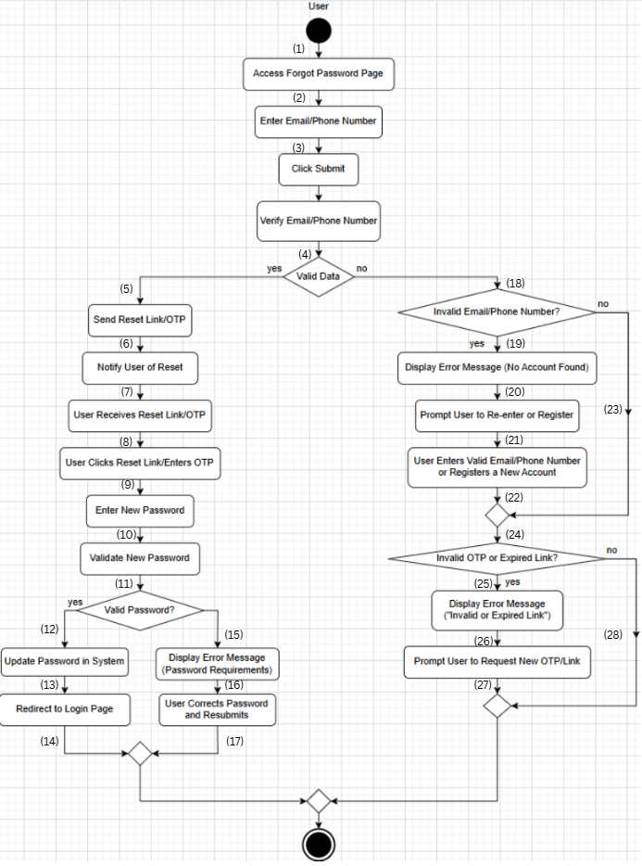

**Business Rules**

| **Step** | **BR Code(s)** | **Description / Rule Enforcement** |
| --- | --- | --- |
| (2)–(4) | BR-29 | The user must provide a valid email address or phone number associated with an existing account. |
| (5)–(7) | BR-29, BR-30 | BR-29: The user must provide a valid email or phone number associated with an existing account.  BR-30: Password reset links and OTPs must expire after a set time (e.g., 30 minutes). |
| (8)–(9) | BR-29, BR-30, BR-31 | BR-29: Valid contact info must be provided.  BR-30: Reset links/OTPs must expire in a set time.  BR-31: Reset links can only be used once. |
| (10)–(12) | BR-20, BR-30, BR-31 | BR-20: Enforce password complexity and MFA (if enabled).  BR-30: Reset links/OTPs must expire in a set time.  BR-31: Reset links can only be used once. |
| (13)–(14) | BR-20 | Enforce password complexity and account security (e.g., multi-factor authentication if enabled). |

### 

### UC 14: View Profile

| **Use Case Specification** | | | |
| --- | --- | --- | --- |
| **Use Case ID and Name:** | UC-14 View Profile | | |
| **Created By:** | Cao Minh Tuấn | **Date Created:** | June-02, 2025 |
| **Primary Actor:** | Doctor, Patient, Store Manager, Admin | **Secondary Actors:** | System (for retrieving and displaying profile information) |
| **Trigger:** | User wants to view their profile information. | | |
| **Description:** | This use case allows the user (Doctor, Patient, Store Manager, Admin) to view their profile details, including personal information, appointment history, treatment records, and order history (if applicable). The system displays the data from the user’s profile stored in the database. | | |
| **Preconditions:** | * **PRE-1:** The user is logged into the system with valid credentials. * **PRE-2:** The user has a registered profile in the system. * **PRE-3:** The system is accessible (server is up and running). | | |
| **Post–conditions:** | * **POST-1:** The user’s profile information is displayed on the screen. * **POST-2:** The user can review and update their profile if necessary (depending on role). * **POST-3:** If the user is an Admin, they may have the ability to view other users' profiles. | | |
| **Normal Flow:** | 1.The user logs into the system with valid credentials.  2.The user navigates to the profile section.  3.The system retrieves the user's profile data (personal details, appointment history, etc.).  4.The system displays the profile information on the screen.  5.The user reviews the displayed profile information.  6.The system allows the user to update the profile if applicable (for editable fields like contact information). | | |
| **Alternative Flows:** | **1-AF: User does not have profile information**   * a. If the user has not completed their profile, the system displays a message: "Your profile is incomplete. Please update your details." * b. The user is prompted to fill in the missing information.   **2-AF: User cannot access profile**   * a. If the system detects an issue with loading the profile (e.g., system error or missing data), it displays an error message: "Unable to load your profile. Please try again later." * b. The user is notified of the error and can attempt to access the profile again later. | | |
| **Exceptions:** | **1-EF: System Error**   * If the system encounters an error while retrieving or displaying the profile,  The system displays an error message: "Error loading profile. Please try again later."  The use case ends without displaying the profile information.   **2-EF: Unauthorized Access**   * If the user attempts to access another user's profile (for non-Admin users),  The system displays a message: "You do not have permission to view this profile."  The use case ends without displaying any profile information. | | |
| **Priority:** | **Medium** | | |
| **Frequency of Use:** | **High** | | |
| **Business Rules:** | * **BR-32:** The user can only view their own profile, except for Admin users, who can view all user profiles. * **BR-33:** Admins should have the ability to view and edit other users’ profiles for management purpose. | | |
| **Other Information:** | The profile page should be responsive and accessible across different devices (mobile, tablet, desktop).  Some profile data may be protected and require additional security measures, such as role-based access control. | | |
| **Assumptions:** | * The user has a valid account and is authenticated before accessing their profile. * The profile data is stored correctly in the system and is retrievable when needed. | | |

**Activities Flow**

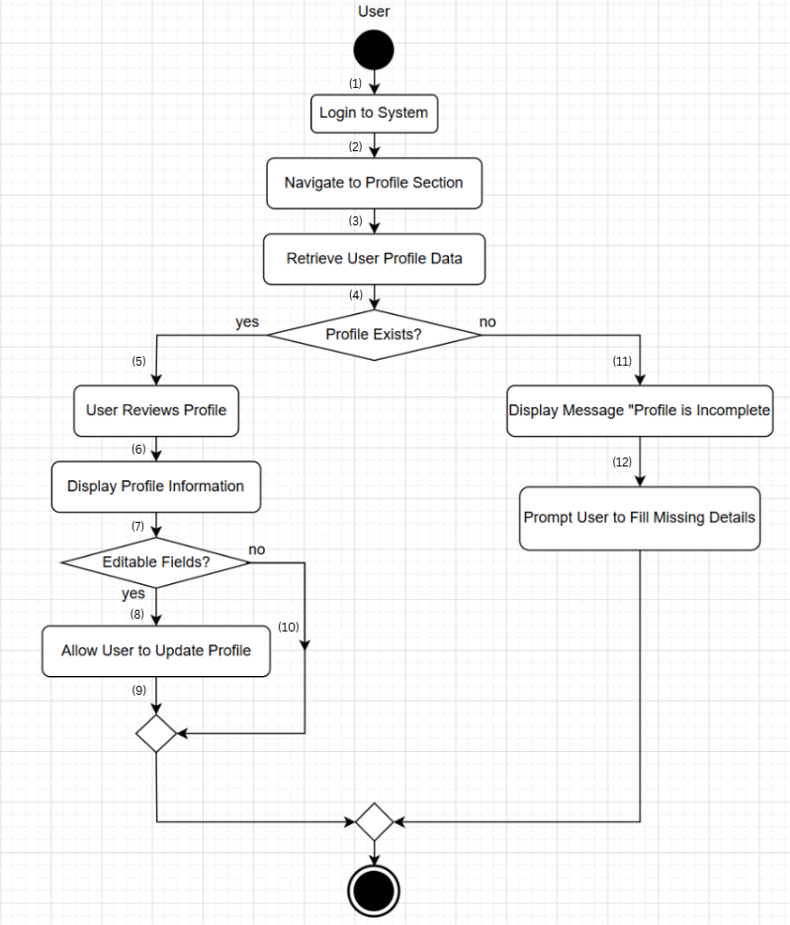

**Business Rules**

| **Step** | **BR Code(s)** | **Description / Rule Enforcement** |
| --- | --- | --- |
| (1), (2), (3) | BR-32 | BR-32: Only authenticated users can log into the system to access their own profile. Admin users have broader access to profiles. |
| (7), (9) | BR-33 | BR-33: Admins can edit the profile of any user. Regular users can only edit their own profile. |

### UC 15: Change Password

| **Use Case Specification** | | | |
| --- | --- | --- | --- |
| **Use Case ID and Name:** | UC-15 Change Password | | |
| **Created By:** | Cao Minh Tuấn | **Date Created:** | June-02, 2025 |
| **Primary Actor:** | Doctor, Patient, Store Manager, Admin | **Secondary Actors:** | System (for verifying old password, validating the new one, and updating the database) |
| **Trigger:** | User wants to change their password for security or personal reasons. | | |
| **Description:** | This use case allows the user (Doctor, Patient, Store Manager, Admin) to change their password after logging into the system. The system ensures that the new password meets security criteria (e.g., minimum length, inclusion of special characters) and updates the user’s credentials in the database. | | |
| **Preconditions:** | * **PRE-1:** The user is logged into the system with valid credentials. * **PRE-2:** The user has access to their profile settings. * **PRE-3:** The system is accessible (server is up and running). * **PRE-4:** The user knows their current password (for security verification). | | |
| **Post–conditions:** | * **POST-1:** The user’s password is updated in the system. * **POST-2:** The user is notified that the password has been successfully changed. * **POST-3:** The user may be logged out automatically after the password change for security reasons, requiring them to log in again with the new password. | | |
| **Normal Flow:** | 1. The user navigates to the "Change Password" section in their account settings. 2. The system prompts the user to enter their current password. 3. The user enters their current password. 4. The system verifies that the current password is correct. 5. The user enters a new password and confirms it. 6. The system validates the new password (e.g., checks if it meets length and complexity requirements). 7. If the new password is valid, the system updates the password in the database. 8. The system notifies the user that the password has been successfully changed. 9. The user may be prompted to log in again with the new password. | | |
| **Alternative Flows:** | **1-AF: Incorrect current password**   * a. The user enters an incorrect current password. * b. The system displays an error message: "The current password is incorrect. Please try again." * c. The user is prompted to re-enter the correct current password.   **2-AF: New password does not meet criteria**   * a. The user enters a new password that does not meet the required criteria (e.g., password is too short, lacks special characters). * b. The system displays an error message: "The new password does not meet the required criteria. Please ensure it meets the minimum length and includes a special character." * c. The user corrects the password and resubmits.   **3-AF: Password change fails due to system error**   * a. The system encounters an error while updating the password (e.g., database connection issue). * b. The system displays an error message: "There was an error changing your password. Please try again later." * c. The user is prompted to retry the password change. | | |
| **Exceptions:** | **1-EF: User is unable to access the system**   * If the user is not logged in or their session expires while trying to change the password,  The system displays a message: "You must be logged in to change your password."  The use case ends without updating the password.   **2-EF: Network failure during password change**   * If there is a network issue during the password change process,  The system notifies the user that the request failed due to connection issues and prompts the user to retry once the network is restored. | | |
| **Priority:** | **High** | | |
| **Frequency of Use:** | **Medium** | | |
| **Business Rules:** | * **BR-1:** Only users with the role of "admin" or "receptionist" can view all appointments. * **BR-2:** Appointment data must be updated in real-time. * **BR-18:** The system must ensure appointment details are updated in real-time. * **BR-20:** The new password must meet the system’s security criteria (e.g., minimum length of 6 characters, must contain at least one digit and one special character). * **BR-34:** The user must provide the correct current password to change their password. | | |
| **Other Information:** | * The password change page should include guidelines for creating strong passwords to enhance security. * If the user forgets their password, they should be able to use the "Forgot Password" feature to reset it before attempting to change it. | | |
| **Assumptions:** | * The user has access to their account and knows their current password. * The user’s internet connection is stable during the password change process. * The system’s password change functionality is operational and secure. | | |

**Activities Flow**

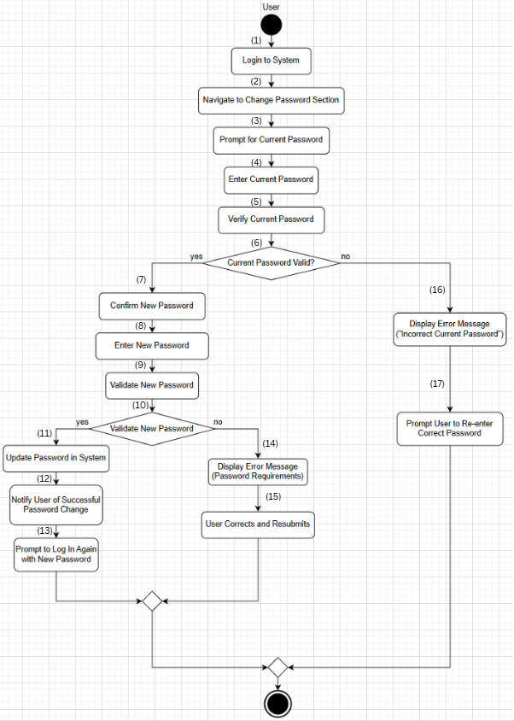

**Business Rules**

| **Step** | **BR Code(s)** | **Description / Rule Enforcement** |
| --- | --- | --- |
| (1) | BR-34 | The user must provide the correct current password to change their password. |
| (2) | BR-1 | Only users with the role of "admin" or "receptionist" can view all appointments. |
| (5) | BR-18 | The system must ensure appointment details are updated in real-time. |
| (8) | BR-20 | The system must enforce password complexity and account security (e.g., multi-factor authentication if enabled). |
| (12) | BR-2 | Appointment data must be updated in real-time. |

### UC 16: Delete Account

| **Use Case Specification** | | | |
| --- | --- | --- | --- |
| **Use Case ID and Name:** | UC-16 Delete Account | | |
| **Created By:** | Cao Minh Tuấn | **Date Created:** | June-02, 2025 |
| **Primary Actor:** | Doctor, Patient, Store Manager | **Secondary Actors:** | System (for verifying the account deletion request and updating the database) |
| **Trigger:** | Users decide to delete their account for personal reasons. | | |
| **Description:** | This use case allows the user (Doctor, Patient, Store Manager) to permanently delete their account from the system. The system will verify the user’s identity before proceeding with the deletion. Once the account is deleted, all personal data and associated information will be removed from the system. | | |
| **Preconditions:** | * **PRE-1:** The user is logged into the system with valid credentials. * **PRE-2:** The user has a registered account in the system. * **PRE-3:** The system is accessible (server is up and running). * **PRE-4:** The user has been informed that deleting the account is permanent and irreversible. | | |
| **Post–conditions:** | * **POST-1:** The user's account is permanently deleted from the system. * **POST-2:** All associated personal data (appointments, medical records, orders, etc.) is removed from the database. * **POST-3:** The user is logged out, and they can no longer access the system. * **POST-4:** If the account deletion fails, the system displays an error message, and no changes are made. | | |
| **Normal Flow:** | 1.The user navigates to the "Account Settings" page.  2.The user selects the "Delete Account" option.  3.The system prompts the user for confirmation to delete the account.  4.The user confirms the deletion request.  5.The system verifies the user's identity (may involve re-entering their password for security).  6.The system deletes the user's account and all associated data from the database.  7.The system logs the user out and displays a confirmation message that the account has been deleted.  8.The user is redirected to the homepage or a page confirming that their account is deleted. | | |
| **Alternative Flows:** | **1-AF: User does not confirm deletion**   * a. The user is prompted with a confirmation message to delete the account. * b. The user decides not to delete the account and cancels the action. * c. The system returns to the account settings page without deleting the account.   **2-AF: User is not authorized to delete the account**   * a. If the user tries to delete an account without appropriate permissions (for example, an admin trying to delete a non-own account without specific rights), * b. The system displays a message: "You are not authorized to delete this account." * c. The use case ends without any changes.   **3-AF: Account deletion fails due to system error**   * a. The system encounters an issue (e.g., database failure or server error) while attempting to delete the account. * b. The system displays an error message: "Account deletion failed. Please try again later." * c. The user is notified of the failure, and the account remains intact. | | |
| **Exceptions:** | **1-EF: User cannot log in to delete account**   * If the user cannot access the account settings page due to an issue with their session or login,  The system displays a message: "You must be logged in to delete your account."  The use case ends without deleting the account.   **2-EF: Network failure during account deletion**   * If there is a network failure during the account deletion process,  The system displays a message: "Network error. Please try again later."  The user is asked to retry the deletion process once the network is restored. | | |
| **Priority:** | **High** | | |
| **Frequency of Use:** | **Low (as users typically delete accounts less frequently)** | | |
| **Business Rules:** | * **BR-19**: Users must have an account with a unique email/username and password, or a linked Gmail account. * **BR-20**: The system must enforce password complexity and account security (e.g., multi-factor authentication if enabled). * **BR-23**: Only authenticated users can initiate a sign-out action. * **BR-24**: The system must securely terminate the session and clear all sensitive data. * **BR-25**: Logout must be available from all user interfaces (e.g., dashboard, settings). * **BR-29**: The user must provide a valid email address or phone number associated with an existing account. * **BR-34**: The user must provide the correct current password to change their password. * **BR-35**: Only the user who owns the account can delete it (except in cases where Admin has specific permissions). * **BR-36**: Once deleted, the account can be restored for 30 days before being permanently deleted. * **BR-37**: If the deletion process fails due to a system or network issue, the user must be informed and allowed to retry. | | |
| **Other Information:** | The system should provide a warning about the permanence of the deletion before the user proceeds.  The user should be able to download their data (if required) before proceeding with the account deletion.  A confirmation email or message could be sent to the user confirming their account deletion. | | |
| **Assumptions:** | * The user has access to their account and is authenticated before attempting to delete it. * The system is configured to handle account deletions and clean up related data securely. * The user has been informed about the consequences of deleting their account. | | |

**Activities Flow**

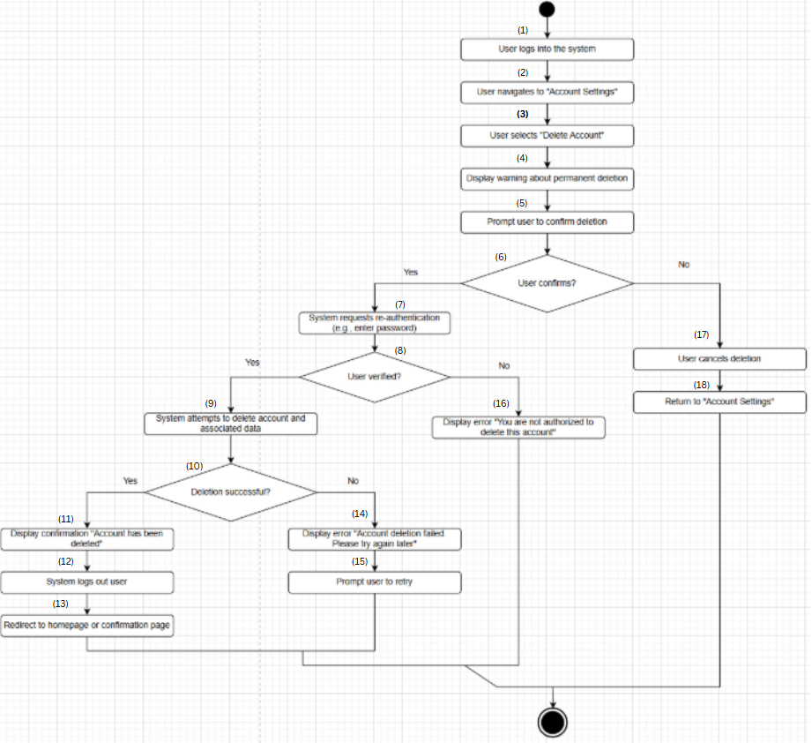

**Business Rules**

| **Step** | **BR Code(s)** | **Description / Rule Enforcement** |
| --- | --- | --- |
| (1) | BR-19, BR-20, BR-23 | BR-19: Users must have an account with a unique email/username and password, or a linked Gmail account.  BR-20: The system must enforce password complexity and account security (e.g., multi-factor authentication if enabled).  BR-23: Only authenticated users can initiate a sign-out action. |
| (7) | BR-29, BR-34 | BR-29: The user must provide a valid email address or phone number associated with an existing account.  BR-34: The user must provide the correct current password to change their password. |
| (10) | BR-35 | BR-35: Only the user who owns the account can delete it (except in cases where Admin has specific permissions). |
| (11), (12) | BR-24, BR-25, BR-36 | BR-24: The system must securely terminate the session and clear all sensitive data.  BR-25: Logout must be available from all user interfaces (e.g., dashboard, settings).  BR-36: Once deleted, the account can be restored for 30 days before being permanently deleted. |
| (14) | BR-37 | BR-37: If the deletion process fails due to a system or network issue, the user must be informed and allowed to retry. |

### UC 17: Update Profile

| **Use Case Specification** | | | |
| --- | --- | --- | --- |
| **Use Case ID and Name:** | UC-17 Update Profile | | |
| **Created By:** | Cao Minh Tuấn | **Date Created:** | June-02, 2025 |
| **Primary Actor:** | Doctor, Patient, Store Manager, Admin | **Secondary Actors:** | System (for verifying the account deletion request and updating the database) |
| **Trigger:** | User wants to update their profile information. | | |
| **Description:** | This use case allows the user (Doctor, Patient, Store Manager, Admin) to update their personal profile information such as name, contact details, address, and other relevant information. The system validates the updated data and stores it in the database. The user can update their profile for personal or professional reasons. | | |
| **Preconditions:** | * **PRE-1:** The user is logged into the system with valid credentials. * **PRE-2:** The user has a registered profile in the system. * **PRE-3:** The system is accessible (server is up and running). * **PRE-4:** The user has access to the profile settings page. | | |
| **Post–conditions:** | * **POST-1:** The user’s profile is updated in the system with the new data. * **POST-2:** The system confirms that the profile has been successfully updated. * **POST-3:** The updated profile data is now accessible in the user's account. | | |
| **Normal Flow:** | 1. The user navigates to the "Profile Settings" page from their account. 2. The system displays the user’s current profile information. 3. The user makes necessary changes to the profile fields (e.g., name, email, phone number, etc.). 4. The user clicks the "Save" or "Update" button to submit the changes. 5. The system validates the updated data (e.g., checks for valid email format, phone number, and required fields). 6. If the data is valid, the system updates the user's profile information in the database. 7. The system displays a confirmation message: "Profile updated successfully." 8. The user can view the updated profile information on the same page. | | |
| **Alternative Flows:** | **1-AF: User submits invalid data**   * a. The user enters invalid data (e.g., an invalid email format, phone number). * b. The system detects the invalid data and displays an error message: "Please enter valid information for the fields marked in red." * c. The user corrects the data and resubmits the profile update.   **2-AF: User cancels profile update**   * a. The user decides not to save the changes and cancels the update. * b. The system discards the changes and returns the user to the previous page or profile settings.   **3-AF: System error during profile update**   * a. The system encounters an error while updating the profile (e.g., database failure or server issue). * b. The system displays an error message: "There was an issue updating your profile. Please try again later." * c. The user is prompted to retry the update. | | |
| **Exceptions:** | **1-EF: User is not authenticated**   * If the user is not logged in or their session expires while trying to update the profile,  The system displays a message: "You must be logged in to update your profile."  The use case ends without updating the profile.   **2-EF: Network failure during profile update**   * If the system encounters a network issue while submitting the updated data,  The system displays a message: "Network error. Please try again later."  The user is prompted to retry the update once the network connection is restored. | | |
| **Priority:** | **Medium** | | |
| **Frequency of Use:** | **High** | | |
| **Business Rules:** | * **BR-19**: Users must have an account with a unique email/username and password, or a linked Gmail account. * **BR-20**: The system must enforce password complexity and account security (e.g., multi-factor authentication if enabled). * **BR-23**: Only authenticated users can initiate a sign-out action. * **BR-38**: Only the profile owner (or an Admin with management rights) is allowed to update the profile. * **BR-39**: Updated data must be validated (format checks, required fields, etc.). * **BR-127**: If the system fails to retrieve data, it must display a clear error and allow retry. | | |
| **Other Information:** | * The profile update page should include guidelines to help the user input correct and valid data (e.g., password requirements, valid email format). * Some fields may be editable only by certain roles (e.g., Admin may be able to edit more fields for other users, but a patient can only update their personal information). | | |
| **Assumptions:** | * The user has valid credentials to log in and update their profile. * The profile data is correctly stored in the database and can be retrieved and updated when needed. * The system performs necessary security checks to ensure that only authorized users can update their profiles. | | |

**Activities Flow**

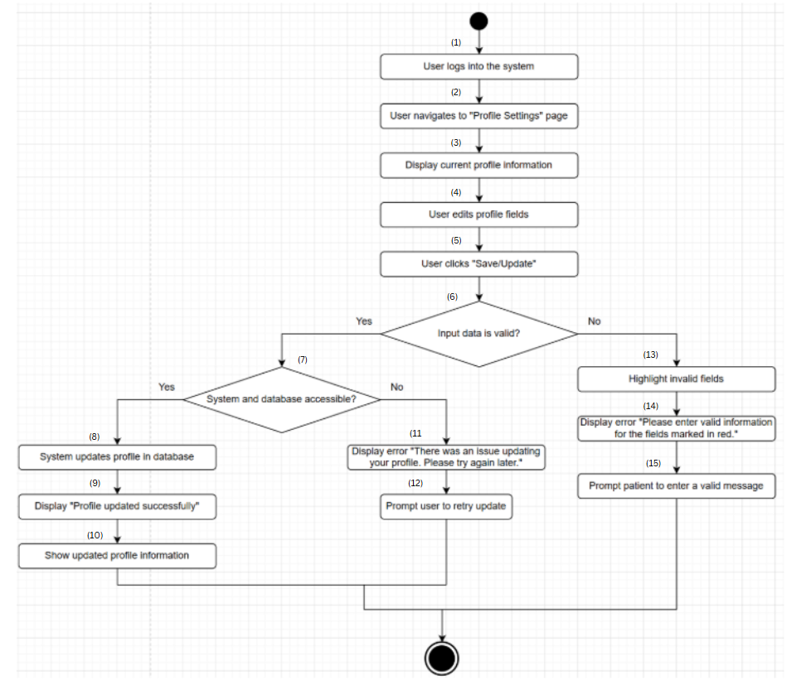

**Business Rules**

| **Step** | **BR Code(s)** | **Description / Rule Enforcement** |
| --- | --- | --- |
| (1) | BR-19, BR-20, BR-23 | BR-19: Users must have an account with a unique email/username and password, or a linked Gmail account.  BR-20: The system must enforce password complexity and account security (e.g., MFA).  BR-23: Only authenticated users can initiate a sign-out action. |
| (7) | BR-38, BR-39 | BR-38: Only the profile owner (or an Admin with management rights) is allowed to update the profile.  BR-39: Updated data must be validated (format checks, required fields, etc.). |
| (11) | BR-127 | BR-127: If the system fails to retrieve data, it must display a clear error and allow retry. |
| (13), (14) | BR-39 | BR-39: Updated data must be validated (format checks, required fields, etc.). |

### UC 18: Send message

| **Use Case Specification** | | | |
| --- | --- | --- | --- |
| **Use Case ID and Name:** | UC-18 Send message | | |
| **Created By:** | Cao Minh Tuấn | **Date Created:** | June-02, 2025 |
| **Primary Actor:** | Patient | **Secondary Actors:** | Store Manager, Receptionist who can contact with patients |
| **Trigger:** | The patient( or Store Manager/ Receptionist) indicates that he/she wants to send a message to the store manager/ Receptionist ( Patient) for assistance or inquiries related to products, orders, or services. | | |
| **Description:** | This use case allows a patient to send a message to the store manager via the system. The message can be about product inquiries, order status, or other service-related issues. The system facilitates communication between the patient and store manager, allowing for effective customer service and support. | | |
| **Preconditions:** | * **PRE-1:** The patient/Store Manager/ Receptionist is logged into the system with valid credentials. * **PRE-2:** The system is accessible (server is up and running). * **PRE-3:** The Patient/Store Manager/ Receptionist has access to the messaging interface for sending messages to the store manager. | | |
| **Post–conditions:** | * **POST-1:** The message from the actors is successfully sent to the store manager. * **POST-2:** The receiver receives the message and is notified to respond. * **POST-3:** The system records the message and logs it for future reference. | | |
| **Normal Flow** | 1. **Login**: The user (Patient, Store Manager, or Receptionist) logs into the system with valid credentials. 2. **Navigate to "Message" Section**: The user navigates to the "Message" section via the main menu or dashboard. 3. **Display Messaging Interface**: The system displays the messaging interface, which includes:    1. **List of available recipients** (based on the sender's role):       1. If the sender is a **Patient**: they can select **Store Manager** or **Receptionist**.       2. If the sender is a **Store Manager** or **Receptionist**: they can select **Patient**.    2. A text box to compose the message. 4. **Select Recipient and Compose Message**: The user selects a recipient from the list and enters the message content. 5. **Send Message**: The user clicks the "Send" button to submit the message. 6. **Validate Message**: The system validates the message based on the following criteria:    1. The message must not be empty.    2. The message must not exceed the character limit (e.g., 1000 characters).    3. The message must not contain inappropriate content (if a content filter is in place). 7. **Send Message and Notify**: If the message is valid, the system sends the message to the recipient and notifies them via the system (or email/SMS if configured). 8. **Confirm Successful Sending**: The system displays a confirmation to the sender that the message has been sent successfully.   . | | |
| **Alternative Flows:** | **1-AF: User Submits an Empty Message**   * **Occurs at**: After step 4 in the Normal Flow, the user clicks "Send" without entering any content. * **Action**:   + The system displays an error message: **"Message cannot be empty. Please enter a valid message."**   + The user is prompted to enter a message. * **Continue**: Return to step 4 in the Normal Flow.   **2-AF: System Error During Message Sending**   * **Occurs at**: After step 6 in the Normal Flow, if the system encounters an error (e.g., database failure). * **Action**:   + The system displays an error message: **"Message sending failed due to a system error. Please try again later."**   + The system may temporarily save the message content to prevent the user from having to retype it. * **Continue**: The user is prompted to try sending the message again later. | | |
| **Exceptions:** | **1-EF: Network Failure During Message Submission**   * **Occurs at**: During step 7 in the Normal Flow, if there is a network failure. * **Action**:   + The system displays a message: **"Network error. Please check your connection and try again."**   + The system may temporarily save the message and automatically attempt to resend it once the connection is restored (if configured). * **Continue**: The user is prompted to try again when the connection is stable. | | |
| **Priority:** | **Medium** | | |
| **Frequency of Use:** | **Medium to Low (based on patient interaction with the store manager)** | | |
| **Business Rules:** | * **BR-19**: Users must have an account with a unique email/username and password, or a linked Gmail account. * **BR-20**: The system must enforce password complexity and account security (e.g., multi-factor authentication if enabled). * **BR-23**: Only authenticated users can initiate a sign-out action. * **BR-40**: The system must ensure that the message is successfully delivered to the receptionist (applies to recipient in this context). * **BR-42**: The User should be notified when a new message is received (applies to recipient notification). * **BR-127**: If the system fails to retrieve data, it must display a clear error and allow retry. | | |
| **Other Information:** | * The messaging interface should be simple and user-friendly to ensure patients can easily send messages. * Notifications should be sent to the store manager immediately upon receiving a new message, and patients should be notified when the store manager replies. | | |
| **Assumptions:** | * The user has internet access and a valid account to log in. * The receiver has access to the messaging system to read and respond to messages. * The system’s messaging functionality is operational and secure. | | |

**Activities Flow**

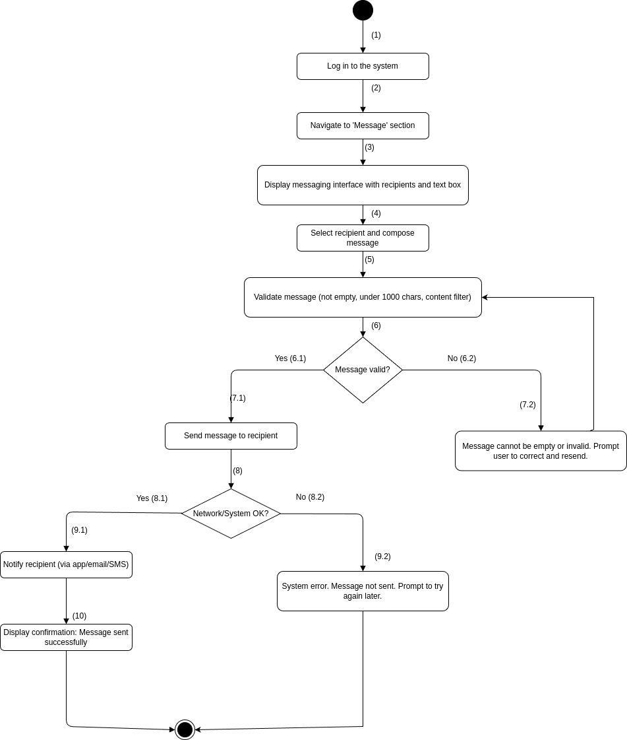

| **Step** | **BR Code(s)** | **Description / Rule Enforcement** |
| --- | --- | --- |
| (1) | BR-19, BR-20, BR-23 | BR-19: Users must have an account with a unique email/username and password, or a linked Gmail account.  BR-20: The system must enforce password complexity and account security (e.g., multi-factor authentication if enabled).  BR-23: Only authenticated users can initiate a sign-out action. |
| (7.1) | BR-40 | - The system must ensure the message is successfully delivered to the intended recipient (e.g., receptionist). |
| (9.1) | BR-42 | - The recipient (e.g., receptionist) should receive a notification (in-app, email, or SMS) when a new message arrives. |
| (9.2) | BR-127 | - If the system encounters an error (e.g., data retrieval fails), it must show a clear error and allow the user to retry. |

### UC 19: Chat with ChatBox

| **Use Case Specification** | | | |
| --- | --- | --- | --- |
| **Use Case ID and Name:** | UC-19 Chat with ChatBox | | |
| **Created By:** | Cao Minh Tuấn | **Date Created:** | June-02, 2025 |
| **Primary Actor:** | Patient, Guest | **Secondary Actors:** | System (for managing the conversation, delivering responses) |
| **Trigger:** | User wants to interact with the ChatBox for quick inquiries or assistance. | | |
| **Description:** | This use case allows the user (Patient, Guest) to engage with the ChatBox for automated assistance or inquiries. The ChatBox provides responses to frequently asked questions, basic service information, or guides the user to relevant sections of the website, such as scheduling, product information, or medical service details. | | |
| **Preconditions:** | * **PRE-1**: The user is logged into the system (for registered users). * **PRE-2**: The ChatBox feature is accessible on the user’s screen (in the appropriate section of the website). * **PRE-3**: The system is accessible (server is up and running). | | |
| **Post–conditions:** | **POST-1**: The user receives automated responses from the ChatBox.  **POST-2**: If the ChatBox is unable to answer the user’s query, the user may be redirected to a human agent (optional, depending on system design).  **POST-3**: The system logs the conversation for future reference or analysis | | |
| **Normal Flow** | 1. The user navigates to the website’s ChatBox section. 2. The ChatBox interface appears on the screen, offering an option to start a conversation. 3. The user types a message (e.g., a question or request for information) and clicks "Send" or presses enter. The system processes the input and responds with an automated message, which may include information about services, scheduling, products, etc. 4. The user reads the response and can continue the conversation by asking more questions. 5. The system continues to process user inputs and provide responses accordingly. 6. The conversation ends when the user closes the ChatBox or no further interaction is needed. | | |
| **Alternative Flows:** | **1-AF: User asks a question outside predefined scope**   * a. The user asks a question that the ChatBox is not programmed to answer (e.g., complex medical advice). * b. The system responds: "I'm sorry, I cannot answer that question. Would you like to contact a human representative?" * c. The user may choose to be redirected to a human representative (if applicable), or the ChatBox will suggest other queries.   **2-AF: User requests support during working hours**   * a. If the ChatBox is configured to escalate certain inquiries to live support during business hours, * b. The system will automatically offer the option to connect with a human representative. | | |
| **Exceptions:** | **1-EF: ChatBox fails to load**   * If the ChatBox fails to load due to a system error or network issue,  The system displays a message: "Sorry, the ChatBox is currently unavailable. Please try again later."  The use case ends without initiating the conversation.   **2-EF: Network failure during conversation**   * If there is a network issue during the conversation,  The system displays an error message: "Network error. Please check your connection and try again."  The user is prompted to reconnect once the network is restored.   **3-EF: Invalid input by user**   * If the user enters a message that the system cannot process (e.g., unsupported characters),  The system displays an error message: "I’m sorry, I couldn’t understand that. Please try again with a different question." | | |
| **Priority:** | **Medium** | | |
| **Frequency of Use:** | **High (since it provides quick, automated help to users)** | | |
| **Business Rules:** | * **BR-19**: Users must have an account with a unique email/username and password, or a linked Gmail account. * **BR-20**: The system must enforce password complexity and account security (e.g., multi-factor authentication if enabled). * **BR-23**: Only authenticated users can initiate a sign-out action. * **BR-43**: The ChatBox should respond to common queries related to services, appointment scheduling, and product inquiries. * **BR-44**: If the ChatBox cannot answer a question, it should escalate the issue appropriately (e.g., offering to connect the user with a human representative). | | |
| **Other Information:** | * The ChatBox should have a friendly and conversational tone, designed to enhance the user experience. * The system may be programmed with predefined scripts, allowing for quick and accurate responses to frequently asked questions (FAQs). * The ChatBox may also use artificial intelligence (AI) or machine learning for more advanced queries in the future. | | |
| **Assumptions:** | * The user has internet access to interact with the ChatBox. * The ChatBox is integrated with the system’s FAQ database and can respond with accurate information. * The system is capable of logging and analyzing user interactions for improvement. | | |

**Activities Flow**

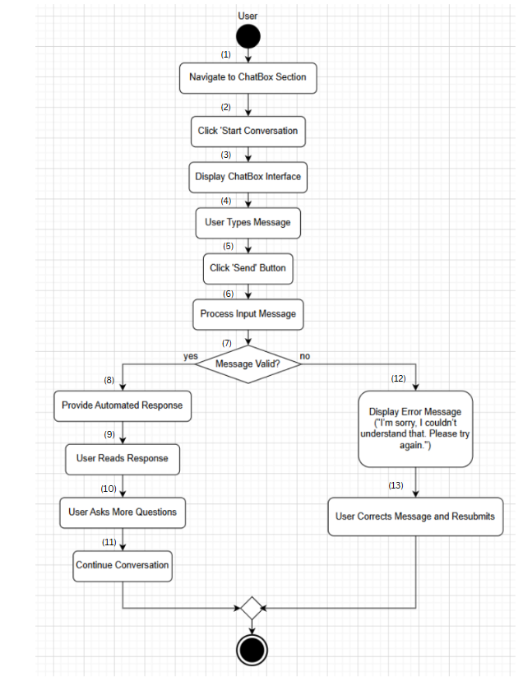

**Business Rules**

| Step | BR Code(s) | Description / Rule Enforcement |
| --- | --- | --- |
| (1) | BR-19, BR-20, BR-23 | BR-19: Users must have an account with a unique email/username and password, or a linked Gmail account.  BR-20: The system must enforce password complexity and account security (e.g., MFA).  BR-23: Only authenticated users can initiate a sign-out action. |
| (8) | BR-43 | BR-43: The ChatBox should respond to common queries related to services, appointment scheduling, and product inquiries. |
| (12) | BR-44 | BR-44: If the ChatBox cannot answer a question, it should escalate the issue appropriately (e.g., offering to connect the user with a human representative). |

### UC 20 Search for services

| **Use Case Specification** | | | |
| --- | --- | --- | --- |
| **Use Case ID and Name:** | UC-20 Search for services | | |
| **Created By:** | Cao Minh Tuấn | **Date Created:** | June-02, 2025 |
| **Primary Actor:** | Patient, Guest | **Secondary Actors:** | System (for retrieving and displaying services) |
| **Trigger:** | User wants to search for a specific medical service provided by the clinic. | | |
| **Description:** | This use case allows the user (Patient, Guest) to search for available medical services on the clinic's website. The system processes the search query, retrieves relevant services, and displays them to the user. This helps patients or guests find the services they need based on keywords or filters. | | |
| **Preconditions:** | * **PRE-1**: The user is logged into the system (for registered users) or accessing the system as a guest. * **PRE-2**: The system is accessible (server is up and running). * **PRE-3**: The user has access to the search interface on the website. | | |
| **Post–conditions:** | * **POST-1**: The user sees a list of services that match their search criteria. * **POST-2**: The system provides relevant information about each service (e.g., service name, description, price, etc.). * **POST-3**: If no services match the search, the system displays a message: "No services found for your query. Please try again with different keywords." | | |
| **Normal Flow** | 1. The user navigates to the "Search for Services" section on the website. 2. The user enters a search keyword or phrase in the search box (e.g., "eye check-up," "glasses fitting"). 3. The system processes the search query and checks for relevant services in the database. 4. The system displays a list of services matching the search criteria, including basic details (e.g., service name, brief description, price). 5. The user can click on a service to view more\ detailed information about it (e.g., full description, available time slots, booking options). | | |
| **Alternative Flows:** | **1-AF: User enters an empty search query**   * a. The user submits the search without entering a query. * b. The system displays an error message: "Please enter a valid search term." * c. The user is prompted to enter a valid search term.   **2-AF: No services match the search**   * a. The system finds no services matching the search criteria. * b. The system displays a message: "No services found for your query. Please try again with different keywords."   **3-AF: User applies filters during the search**   * a. The user applies filters (e.g., service category, price range, availability). * b. The system processes the filters and displays a refined list of services based on the applied filters. | | |
| **Exceptions:** | **1-EF: System or database failure**   * If the system encounters an error (e.g., database failure) while processing the search,  The system displays an error message: "There was an issue with the search. Please try again later."  The use case ends without displaying any results.   **2-EF: Invalid input in search query**   * If the user enters invalid characters or unsupported symbols in the search query,  The system displays a message: "Invalid search query. Please remove any special characters and try again." | | |
| **Priority:** | **Medium** | | |
| **Frequency of Use:** | **High (due to the need for users to find medical services quickly)** | | |
| **Business Rules:** | * **BR-19:** Users must have an account with a unique email/username and password, or a linked Gmail account. * **BR-20:** The system must enforce password complexity and account security (e.g., multi-factor authentication if enabled). * **BR-23:** Only authenticated users can initiate a sign-out action. * **BR-46:** The system must process search queries efficiently and return relevant services from the database. * **BR-48:** The system must handle empty search queries gracefully and prompt the user to provide a valid input. * **BR-49:** Only services marked as "active" in the database are displayed. * **BR-51:** Detailed information must comply with healthcare regulations (e.g., accurate cost and duration, no misleading information). | | |
| **Other Information:** | * The search interface should be user-friendly, with auto-suggestions or auto-completions where possible. * The search results should be displayed clearly, with options to refine the results using filters. * If the system offers a wide variety of services, consider adding pagination or a "load more" button to avoid overwhelming the user with too many results at once. | | |
| **Assumptions:** | * The user has internet access to interact with the search feature. * The system has a well-maintained and indexed database of services. * The user is able to enter queries and view the search results without errors. | | |

**Activities Flow**

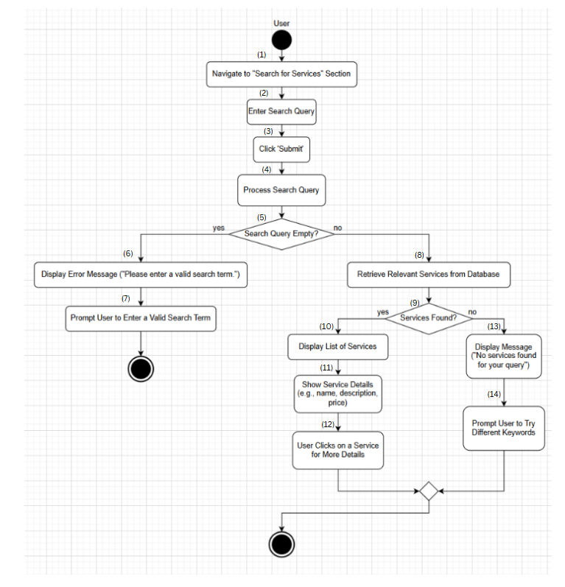

**Business Rules**

| **Step** | **BR Code(s)** | **Description / Rule Enforcement** |
| --- | --- | --- |
| (1) | BR-19, BR-20, BR-23 | BR-19: Users must have an account with a unique email/username and password, or a linked Gmail account.  BR-20: The system must enforce password complexity and account security (e.g., MFA).  BR-23: Only authenticated users can initiate a sign-out action. |
| (5), (6), (7) | BR-48 | BR-48: The system must handle empty search queries gracefully and prompt the user to provide a valid input. |
| (8) | BR-46, BR-49 | BR-46: The system must process search queries efficiently and return relevant services from the database.  BR-49: Only services marked as "active" are displayed. |
| (10), (11) | BR-51 | BR-51: Detailed service information must comply with healthcare regulations (e.g., accurate cost and duration, no misleading information). |

### UC 21: View service list.

| **Use Case Specification** | | | |
| --- | --- | --- | --- |
| **Use Case ID and Name:** | UC-21 View service list | | |
| **Created By:** | Nguyễn Phạm Hoàng Minh | **Date Created:** | June-02, 2025 |
| **Primary Actor:** | Patient, Guest | **Secondary Actors:** | None |
| **Trigger:** | The user selects the "Services" option from the system’s menu or homepage. | | |
| **Description:** | This use case allows a user (Patient or Guest) to view a list of available medical services with basic details, such as service name and description, on the system. | | |
| **Preconditions:** | **PRE-1:** The system must be operational and accessible (e.g., website is online).  **PRE-2:** The medical service list must be populated with up-to-date information in the system’s database.  **PRE-3:** The user must have access to the platform (e.g., via a web browser or mobile app). | | |
| **Post–conditions:** | **POST-1**: The user successfully views the list of available medical services with basic details. | | |
| **Normal Flow:** | 1. The user accesses the system (e.g., website). 2. The user navigates to the "Services" or "Medical Services" section. 3. The system retrieves the list of available medical services from the database. 4. The system displays the list of services, including basic details for each (e.g., service name, brief description, and optionally, price or availability). 5. The user browses the list to review the services. 6. The user exits the section or selects a service for further details (if applicable). | | |
| **Alternative Flows:** | **23.1-AF**: No services available  a. At step 3 of the Normal Flow, if no services are available in the database, the system displays a message: "No services available to display."  b. The use case ends.  **23.2-AF**: System error  a. At step 3 of the Normal Flow, if the system encounters an error while retrieving the service list (e.g., database connection issue), the system displays an error message: "Unable to load services. Please try again later."  b. The user acknowledges the error message and may retry or exit the section. | | |
| **Exceptions:** | **23-EF**: System failure or network error  At any time, if the system cannot connect to the database or there is a network issue, it displays an error message: "Unable to load services. Please try again later." | | |
| **Priority:** | **High** | | |
| **Frequency of Use:** | **High** (used frequently by Guests exploring services and occasionally by Patients). | | |
| **Business Rules:** | **BR-49** Only services marked as "active" in the database are displayed.  **BR-50:** Service details must comply with healthcare regulations (e.g., no misleading information).  **BR-52:** Guests and Patients have the same level of access to the service list and detail (no authentication required). | | |
| **Other Information:** | The service list data is used to inform users and may be used for analytics (subject to privacy regulations). | | |
| **Assumptions:** | * Patients and Guests are familiar with navigating the system’s interface. * The system supports real-time service list retrieval. | | |

**Activities Flow**

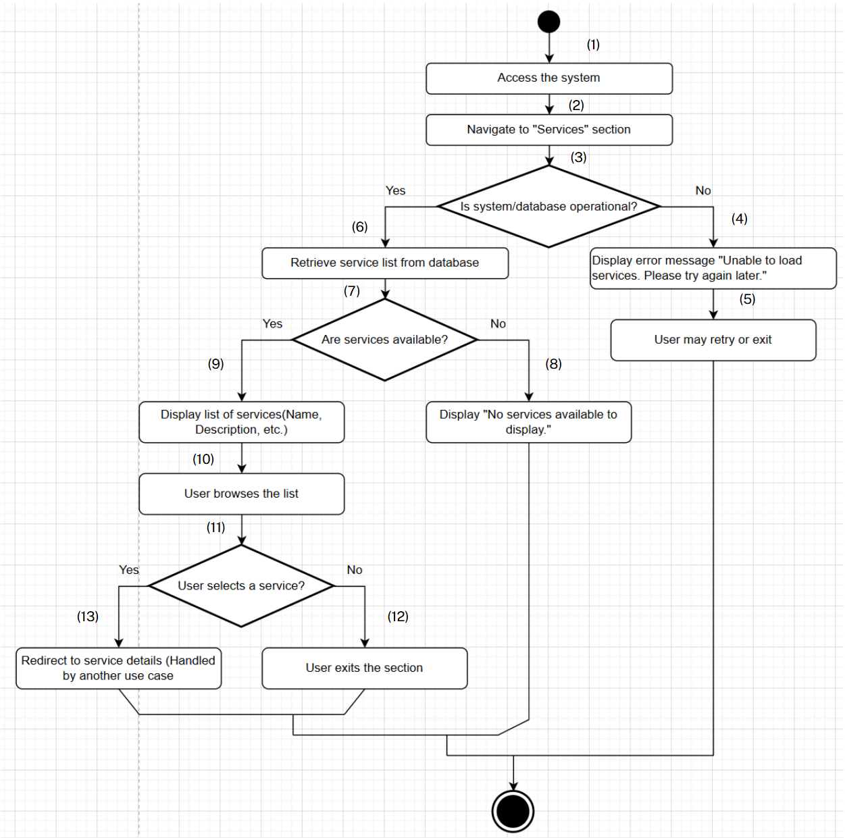

**Business Rules**

| **Step** | **BR Code(s)** | **Description** |
| --- | --- | --- |
| (6), (8) | BR-49 | Only services marked as "active" in the database are displayed. |
| (11) | BR-50 | Service details must comply with healthcare regulations (e.g., no misleading information). |
| (1)–(11) | BR-52 | Guests and Patients have the same level of access to the service list and detail (no authentication required). |

### UC 22: View service details.

| **Use Case Specification** | | | |
| --- | --- | --- | --- |
| **Use Case ID and Name:** | UC-22 View service details | | |
| **Created By:** | Nguyễn Phạm Hoàng Minh | **Date Created:** | June-02, 2025 |
| **Primary Actor:** | Patient, Guest | **Secondary Actors:** | None |
| **Trigger:** | The user selects a specific service from the service list to view detailed information. | | |
| **Description:** | This use case allows a user (Patient or Guest) to view detailed information about a specific medical service, including details such as cost, duration, and other relevant information. | | |
| **Preconditions:** | **PRE-1**: The system must be operational and accessible (e.g., website is online).  **PRE-2**: The service list has been displayed (per UC-23), and the user has selected a specific service.  **PRE-3**: Detailed information for the service is updated and available in the system’s database. | | |
| **Post–conditions:** | **POST-1**: The user successfully views the detailed information of the selected medical service. | | |
| **Normal Flow:** | 1. The user accesses the service list (per UC-23). 2. The user selects a specific service from the list (e.g., clicks on the service name). 3. The system retrieves the detailed information of the selected service from the database. 4. The system displays the service details, including information such as cost, duration, detailed description, and other relevant details (e.g., conditions or requirements). 5. The user reviews the detailed information of the service. 6. The user exits the details page or proceeds with a further action (e.g., booking an appointment, if applicable). | | |
| **Alternative Flows:** | **24.1-AF**: No detailed information available  a. At step 3 of the Normal Flow, if no detailed information is available for the selected service in the database, the system displays a message: "No detailed information available for this service."  b. The user returns to the service list or exits the section.  **24.2-AF**: System error  a. At step 3 of the Normal Flow, if the system encounters an error while retrieving the details (e.g., database connection issue), the system displays an error message: "Unable to load details. Please try again later."  b. The user acknowledges the error message and may retry or return to the service list. | | |
| **Exceptions:** | **24-EF**: System or network failure  At any time, if the system cannot connect to the database or there is a network issue, it displays an error message: "Unable to load details. Please try again later." | | |
| **Priority:** | **High** | | |
| **Frequency of Use:** | **High** (frequently used by Guests and Patients seeking more information about services). | | |
| **Business Rules:** | **BR-50**: Only services marked as "active" in the database are displayed.  **BR-51**: Detailed information must comply with healthcare regulations (e.g., accurate cost and duration, no misleading information).  **BR-52:**  Guests and Patients have the same level of access to the service list and detail (no authentication required). | | |
| **Other Information:** | Service detail data is used to inform users and may be utilised for user behaviour analytics (subject to privacy regulations). | | |
| **Assumptions:** | * Patients and Guests are familiar with navigating the system’s interface. * The system supports real-time retrieval of service details. | | |

**Activities Flow**

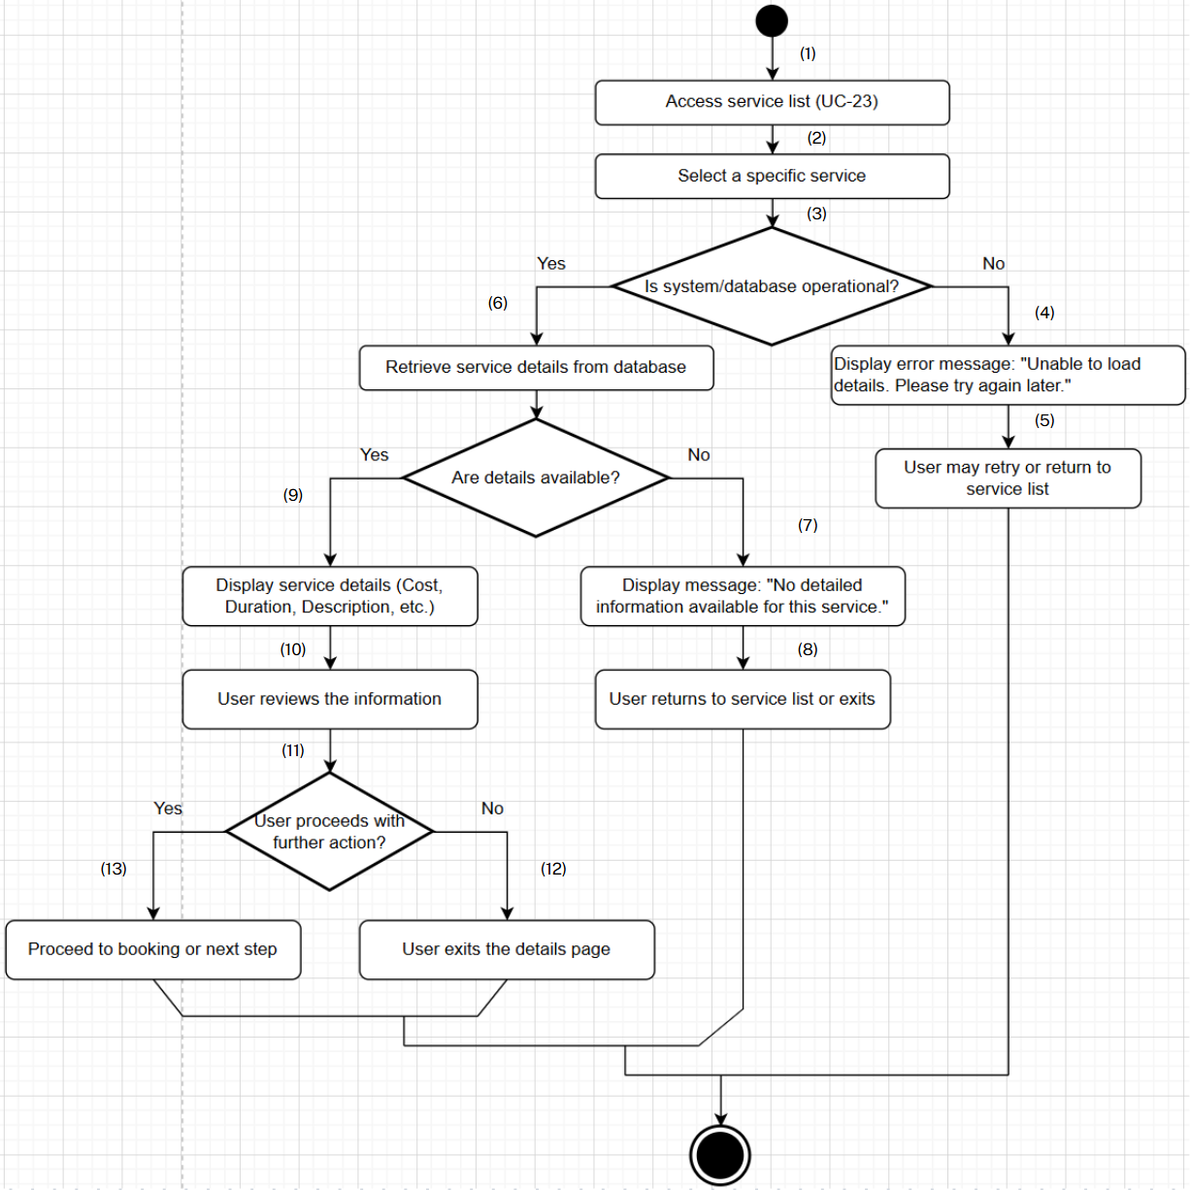

**Business Rules**

| **Step** | **BR Code(s)** | **Description** |
| --- | --- | --- |
| (6) | BR-50 | Only services marked as "active" in the database are displayed. |
| (9) | BR-51 | Detailed information must comply with healthcare regulations (e.g., accurate cost and duration, no misleading information). |
| (1)–(11) | BR-52 | Guests and Patients have the same level of access to the service list and detail (no authentication required). |

### UC 23: Give service feedback.

| **Use Case Specification** | | | |
| --- | --- | --- | --- |
| **Use Case ID and Name:** | UC-23 Give service feedback | | |
| **Created By:** | Nguyễn Phạm Hoàng Minh | **Date Created:** | June-02, 2025 |
| **Primary Actor:** | Patient | **Secondary Actors:** | None |
| **Trigger:** | The patient selects the "Feedback" option after receiving a medical service. | | |
| **Description:** | This use case allows a patient to submit feedback or a rating for a medical service they have received, which is then stored in the system for future reference. | | |
| **Preconditions:** | **PRE-1**: The patient is logged into the system.  **PRE-2**: The patient has a history of medical services received in the system.  **PRE-3**: The system must be operational and accessible (website). | | |
| **Post–conditions:** | **POST-1**: The feedback is successfully submitted and stored in the system.  **POST-2**: The feedback is associated with the correct medical service.  **POST-3**: The patient receives a confirmation of the feedback submission. | | |
| **Normal Flow:** | 1. The patient initiates the "Give Service Feedback" use case by selecting the "Feedback" option in the system (e.g., from a menu). 2. The system displays a list of medical services the patient has received. 3. The patient selects a service to provide feedback on. 4. The patient enters a rating (e.g., 1-5 stars) and an optional comment. 5. The patient submits the feedback. 6. The system saves the feedback to the database. 7. The system displays a confirmation message: "Feedback submitted successfully." | | |
| **Alternative Flows:** | **25.1-AF**: No service history available  a. At step 2 of the Normal Flow, if the patient has no history of received services, the system displays a message: "No services found to provide feedback."  b. The use case ends.  **25.2-AF**: System error during submission  a. At step 6 of the Normal Flow, if the system encounters an error while saving the feedback (e.g., database connection issue), the system displays an error message: "Unable to submit feedback. Please try again later."  b. The patient acknowledges the error message and may retry or exit the section. | | |
| **Exceptions:** | **25-EF**: System or network failure  At any time, if the system cannot connect to the database or there is a network issue, it displays an error message: "Unable to submit feedback. Please try again later." | | |
| **Priority:** | **Medium** | | |
| **Frequency of Use:** | **Medium** (used occasionally by patients after receiving services, impacts satisfaction tracking). | | |
| **Business Rules:** | **BR-53** Only patients who have received a service can provide feedback.  **BR-54** Feedback must include a rating; comments are optional.  **BR-55**: Feedback must be associated with the correct service in the database. | | |
| **Other Information:** | Feedback data is used to improve service quality and monitor performance (subject to privacy regulations). | | |
| **Assumptions:** | * Patients are familiar with the feedback interface. * The system supports real-time feedback submission. | | |

**Activities Flow**

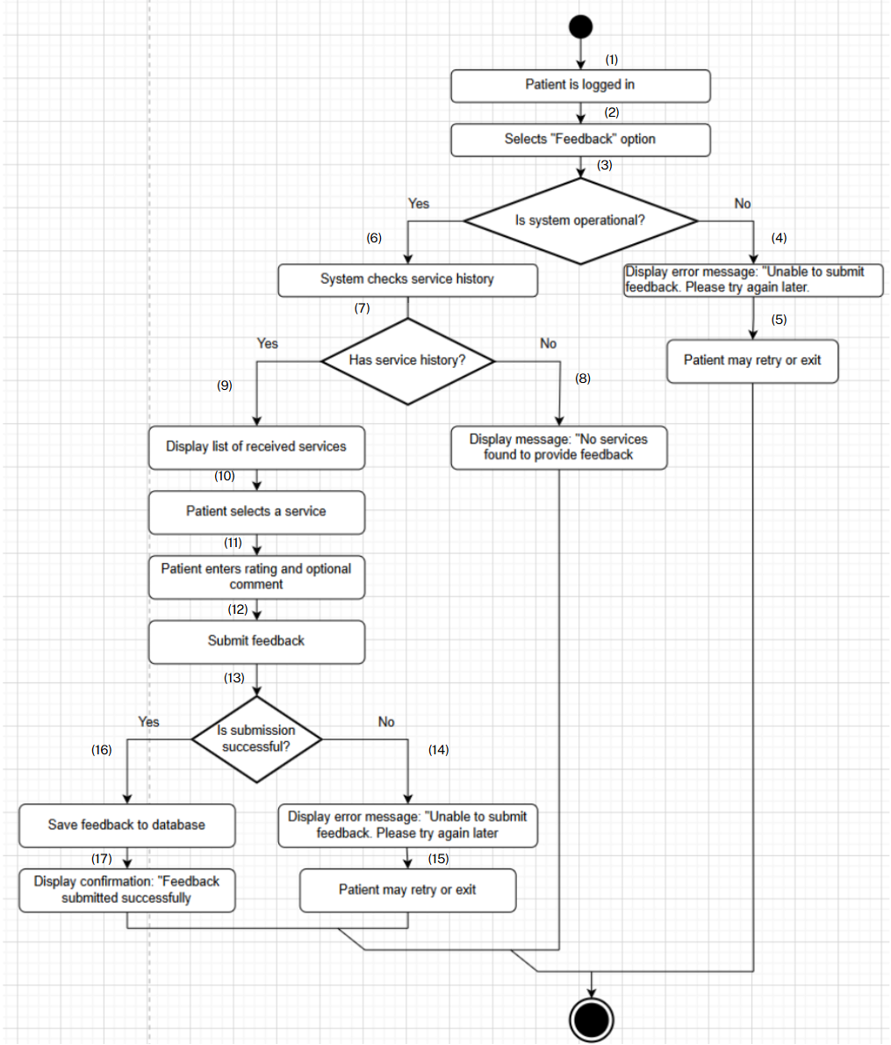

**Business Rules**

| **Step** | **BR Code(s)** | **Description** |
| --- | --- | --- |
| (7) | BR-53 | Only patients who have received a service can provide feedback. |
| (11) | BR-54 | Feedback must include a rating; comments are optional. |
| (12), (16) | BR-55 | Feedback must be associated with the correct service in the database. |

### UC 24: Download medical records (PDF).

| **Use Case Specification** | | | |
| --- | --- | --- | --- |
| **Use Case ID and Name:** | UC-24 Download medical records (PDF) | | |
| **Created By:** | Nguyễn Phạm Hoàng Minh | **Date Created:** | June-02, 2025 |
| **Primary Actor:** | Patient | **Secondary Actors:** | None |
| **Trigger:** | The patient selects the option to download their medical records from the system. | | |
| **Description:** | This use case allows a patient to download their medical records in PDF format for personal use or record-keeping purposes. | | |
| **Preconditions:** | **PRE-1**: The patient is logged into the system.  **PRE-2**: The patient has existing medical records stored in the system.  **PRE-3**: The system must be operational and accessible (e.g., website is online). | | |
| **Post–conditions:** | **POST-1**: The patient successfully downloads the medical records in PDF format.  **POST-2**: The system logs the download action (if applicable, e.g., for auditing purposes).  **POST-3**: The downloaded PDF contains accurate and up-to-date medical record data. | | |
| **Normal Flow:** | 1. The patient logs into the system and navigates to the "Medical Records" section. 2. The patient selects the option to download their medical records. 3. The system generates a PDF file containing the patient’s medical records. 4. The system prompts the patient to download the PDF file. 5. The patient downloads and saves the PDF file to their device. 6. The system confirms the successful download with a message: "Medical records downloaded successfully." | | |
| **Alternative Flows:** | **26.1-AF**: No medical records available  a. At step 2 of the Normal Flow, if the patient has no medical records, the system displays a message: "No medical records available to download."  b. The use case ends.  **26.2-AF**: System error during generation  a. At step 3 of the Normal Flow, if the system encounters an error while generating the PDF (e.g., server issue), the system displays an error message: "Unable to generate PDF. Please try again later."  b. The patient acknowledges the error and may retry or exit the section. | | |
| **Exceptions:** | **26-EF**: System or network failure  At any time, if the system cannot connect to the database or there is a network issue, it displays an error message: "Unable to generate PDF. Please try again later." | | |
| **Priority:** | **High** | | |
| **Frequency of Use:** | **Medium** (used occasionally by patients needing access to their records). | | |
| **Business Rules:** | **BR-56**: Only patients with authenticated access can access and download their medical records.  **BR-57**: The record must include all relevant medical data (e.g., diagnosis, treatment history) and comply with privacy regulations.  **BR-58:**  The system must encrypt the PDF file during download to ensure data security. | | |
| **Other Information:** | Downloaded medical records are intended for personal use and must adhere to healthcare privacy laws (e.g., HIPAA or local regulations). | | |
| **Assumptions:** | * The patient is familiar with downloading files from the system. * The system supports PDF generation and secure file transfer. | | |

**Activities Flow**

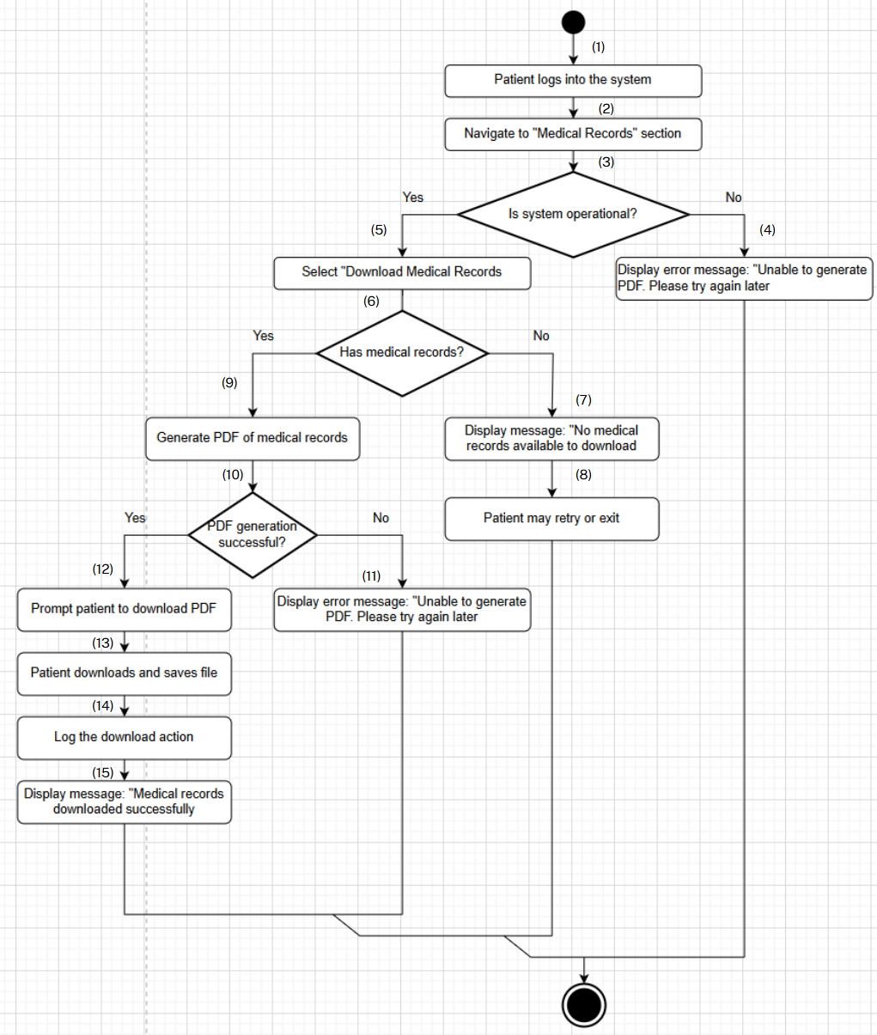

**Business Rules**

| **Step** | **BR Code(s)** | **Description** |
| --- | --- | --- |
| (1) | BR-56 | Only patients with authenticated access can access and download their medical records. |
| (9) | BR-56, BR-57, BR-58 | BR-56: Only patients with authenticated access can access and download their medical records.  BR-57: The record must include all relevant medical data (e.g., diagnosis, treatment history) and comply with privacy regulations.  BR-58: The system must encrypt the PDF file during download to ensure data security. |
| (13) | BR-56, BR-58 | BR-56: Only patients with authenticated access can access and download their medical records.  BR-58: The system must encrypt the PDF file during download to ensure data security. |

### UC 25: View medical records.

| **Use Case Specification** | | | |
| --- | --- | --- | --- |
| **Use Case ID and Name:** | UC 25: View medical records | | |
| **Created By:** | Nguyễn Phạm Hoàng Minh | **Date Created:** | June-02, 2025 |
| **Primary Actor:** | Patient | **Secondary Actors:** | None |
| **Trigger:** | The patient selects the option to view their medical records from the system. | | |
| **Description:** | This use case allows a patient to view their medical records, including details such as diagnosis, treatment history, and other relevant medical information. | | |
| **Preconditions:** | **PRE-1**: The patient is logged into the system.  **PRE-2**: The patient has existing medical records stored in the system.  **PRE-3**: The system must be operational and accessible (e.g., website is online). | | |
| **Post–conditions:** | **POST-1**: The patient successfully views their medical records.  **POST-2**: The displayed medical records are accurate and up-to-date. | | |
| **Normal Flow:** | 1. The patient logs into the system and navigates to the "Medical Records" section. 2. The patient selects the option to view their medical records. 3. The system retrieves the patient’s medical records from the database. 4. The system displays the medical records, including details such as diagnosis, treatment history, and other relevant information. 5. The patient reviews their medical records. 6. The patient exits the section or proceeds with a related action (e.g., downloading the records as per UC-26). | | |
| **Alternative Flows:** | **27.1-AF**: No medical records available  a. At step 3 of the Normal Flow, if the patient has no medical records, the system displays a message: "No medical records available to view."  b. The use case ends.  **27.2-AF**: System error during retrieval  a. At step 3 of the Normal Flow, if the system encounters an error while retrieving the records (e.g., database connection issue), the system displays an error message: "Unable to load medical records. Please try again later."  b. The patient acknowledges the error and may retry or exit the section. | | |
| **Exceptions:** | **27-EF**: System or network failure  At any time, if the system cannot connect to the database or there is a network issue, it displays an error message: "Unable to load details. Please try again later." | | |
| **Priority:** | **High** | | |
| **Frequency of Use:** | **Medium** (used occasionally by patients needing to review their medical history). | | |
| **Business Rules:** | **BR-56**: Only patients with authenticated access can view and dowload their medical records.  **BR-57**: The record must include all relevant medical data (e.g., diagnosis, treatment history) and comply with privacy regulations. | | |
| **Other Information:** | Medical record data is used to inform patients and must adhere to privacy and security standards. | | |
| **Assumptions:** | * The patient is familiar with navigating the system’s interface. * The system supports secure retrieval and display of medical records. | | |

**Activities Flow**

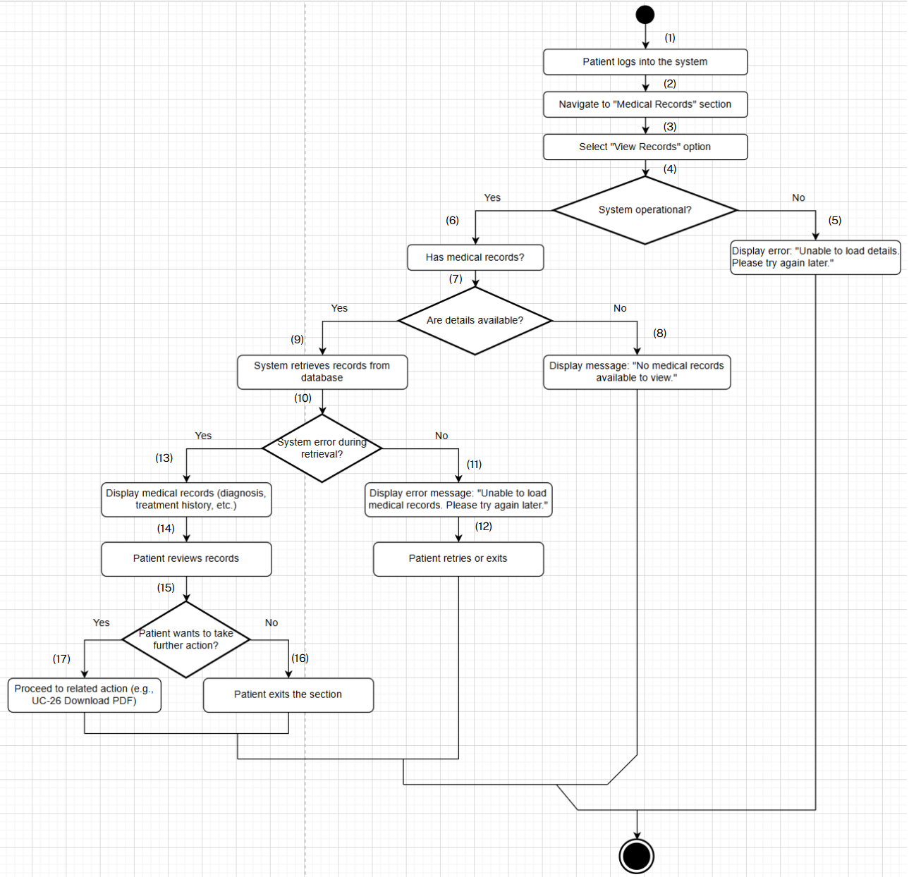

**Business Rules**

| **Step** | **BR Code(s)** | **Description** |
| --- | --- | --- |
| (1) | BR-56 | Only patients with authenticated access can view and download their medical records. |
| (3) | BR-56 | Only patients with authenticated access can view and download their medical records. |
| (9) | BR-56, BR-57 | BR-56: Only patients with authenticated access can view and download their medical records.  BR-57: The record must include all relevant medical data (e.g., diagnosis, treatment history) and comply with privacy regulations. |
| (13) | BR-56, BR-57 | BR-56: Only patients with authenticated access can view and download their medical records.  BR-57: The record must include all relevant medical data (e.g., diagnosis, treatment history) and comply with privacy regulations. |
| (17) | BR-56 | Only patients with authenticated access can view and download their medical records. |

### UC 26: Cancel a service appointment.

| **Use Case Specification** | | | |
| --- | --- | --- | --- |
| **Use Case ID and Name:** | UC 26: Cancel a service appointment | | |
| **Created By:** | Nguyễn Phạm Hoàng Minh | **Date Created:** | June-02, 2025 |
| **Primary Actor:** | Patient | **Secondary Actors:** | None |
| **Trigger:** | The patient selects the option to cancel a booked appointment from the system. | | |
| **Description:** | This use case allows a patient to cancel a previously booked appointment for a medical service, ensuring the appointment is removed from the system. | | |
| **Preconditions:** | **PRE-1**: The patient is logged into the system.  **PRE-2**: The patient has at least one booked appointment for a medical service in the system.  **PRE-3**: The system must be operational and accessible (e.g., website is online).  **PRE-4**: The appointment cancellation window is still open (e.g., cancellation is allowed based on time or policy). | | |
| **Post–conditions:** | **POST-1**: The appointment is successfully canceled and removed from the system.  **POST-2**: The patient receives a confirmation of the cancellation.  **POST-3**: The system updates the availability of the medical service slot (if applicable). | | |
| **Normal Flow:** | 1. The patient logs into the system and navigates to the "My Appointments" section. 2. The system displays a list of the patient’s booked appointments. 3. The patient selects an appointment to cancel. 4. The system prompts the patient to confirm the cancellation (e.g., "Are you sure you want to cancel this appointment?"). 5. The patient confirms the cancellation. 6. The system removes the appointment from the database and updates the service schedule. 7. The system displays a confirmation message: "Appointment canceled successfully." | | |
| **Alternative Flows:** | **28.1-AF**: No booked appointments  a. At step 2 of the Normal Flow, if the patient has no booked appointments, the system displays a message: "No appointments found to cancel."  b. The use case ends.  **28.2-AF**: Cancellation window closed  a. At step 3 of the Normal Flow, if the appointment cannot be canceled due to a time restriction (e.g., less than 24 hours before the appointment), the system displays a message: "Cancellation window has closed. Please contact support to cancel."  b. The use case ends.  3-AF: System error during cancellation  a. At step 6 of the Normal Flow, if the system encounters an error while canceling the appointment (e.g., database issue), the system displays an error message: "Unable to cancel appointment. Please try again later."  b. The patient acknowledges the error and may retry or exit the section. | | |
| **Exceptions:** | **28-EF**: System or network failure  At any time, if the system cannot connect to the database or there is a network issue, it displays an error message: "Unable to cancel appointment. Please try again later." | | |
| **Priority:** | **High** | | |
| **Frequency of Use:** | **Medium** (used occasionally by patients needing to cancel appointments). | | |
| **Business Rules:** | **BR-59**: Only patients with authenticated access can cancel their appointments.  **BR-60**: Cancellations must adhere to the healthcare provider’s policy (e.g., a minimum notice period).  **BR-61**: The system must notify relevant staff or update schedules after a cancellation. | | |
| **Other Information:** | Canceled appointments may be logged for auditing purposes and to improve scheduling processes (subject to privacy regulations). | | |
| **Assumptions:** | * The patient is familiar with navigating the system’s interface. * The system supports real-time updates to appointment schedules. | | |

**Activities Flow**

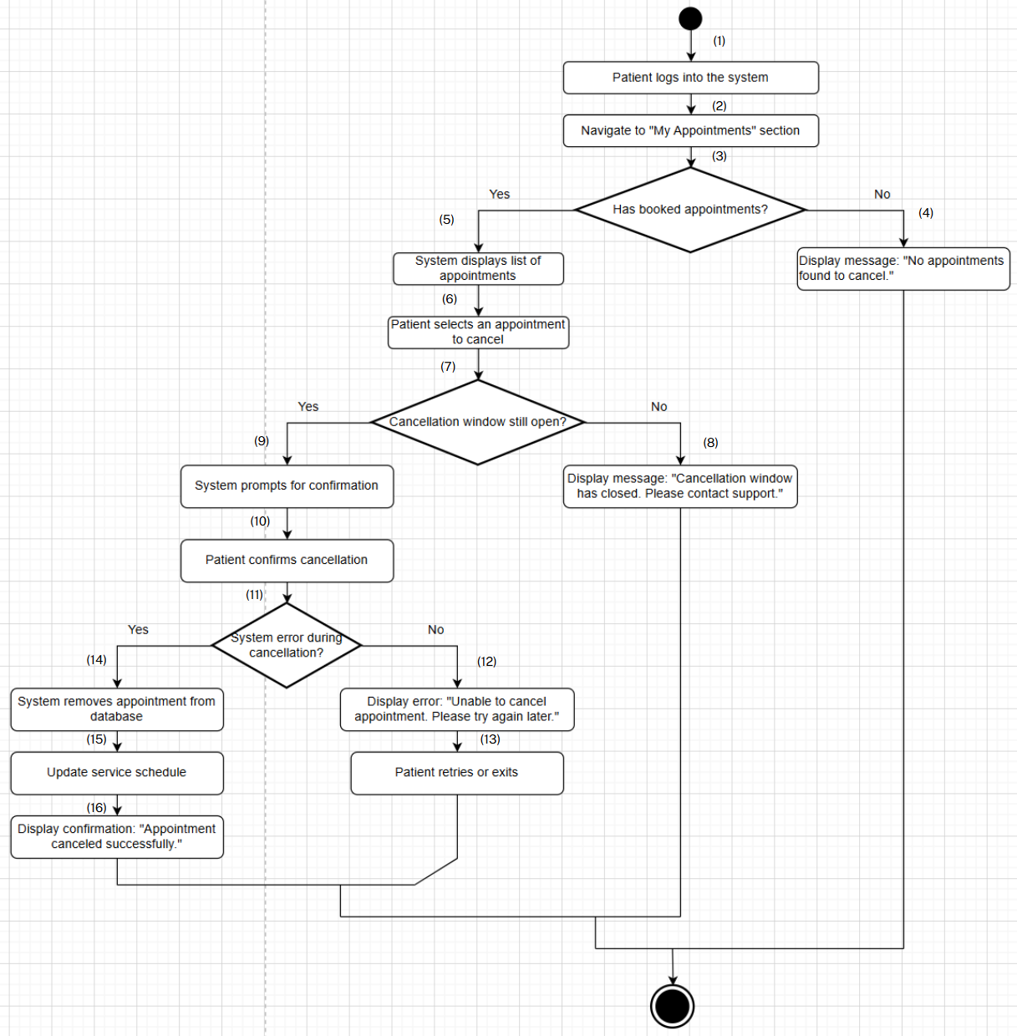

**Business Rules**

| **Step** | **BR Code(s)** | **Description** |
| --- | --- | --- |
| (1) | BR-59 | Only patients with authenticated access can cancel their appointments. |
| (3) | BR-59 | Only patients with authenticated access can cancel their appointments. |
| (5) | BR-59 | Only patients with authenticated access can cancel their appointments. |
| (6) | BR-59, BR-60 | BR-59: Only patients with authenticated access can cancel their appointments.  BR-60: Cancellations must adhere to the healthcare provider’s policy (e.g., a minimum notice period). |
| (7) | BR-59, BR-60 | BR-59: Only patients with authenticated access can cancel their appointments.  BR-60: Cancellations must adhere to the healthcare provider’s policy (e.g., a minimum notice period). |
| (9) | BR-59, BR-60 | BR-59: Only patients with authenticated access can cancel their appointments.  BR-60: Cancellations must adhere to the healthcare provider’s policy (e.g., a minimum notice period). |
| (10) | BR-59 | Only patients with authenticated access can cancel their appointments. |
| (14) | BR-59 | Only patients with authenticated access can cancel their appointments. |
| (15) | BR-59, BR-61 | BR-59: Only patients with authenticated access can cancel their appointments.  BR-61: The system must notify relevant staff or update schedules after a cancellation. |
| (16) | BR-59, BR-61 | BR-59: Only patients with authenticated access can cancel their appointments.  BR-61: The system must notify relevant staff or update schedules after a cancellation. |

### UC 27: Order products.

| **Use Case Specification** | | | |
| --- | --- | --- | --- |
| **Use Case ID and Name:** | UC 27: Order products | | |
| **Created By:** | Nguyễn Phạm Hoàng Minh | **Date Created:** | June-02, 2025 |
| **Primary Actor:** | Patient | **Secondary Actors:** | None |
| **Trigger:** | The patient selects the option to order medical products from the system’s store. | | |
| **Description:** | This use case allows a patient to place an order for medical products available in the system’s store, including selection, review, and confirmation of the order. | | |
| **Preconditions:** | **PRE-1**: The patient is logged into the system.  **PRE-2**: The system’s store contains available medical products with updated inventory.  **PRE-3**: The system must be operational and accessible (e.g., website is online). | | |
| **Post–conditions:** | **POST-1**: The patient successfully places an order for the selected medical products.  **POST-2**: The system logs the order details and updates the inventory.  **POST-3**: The patient receives a confirmation of the order (e.g., order number or email notification). | | |
| **Normal Flow:** | 1. The patient logs into the system and navigates to the "Shop" or "Products" section. 2. The system displays a list of available medical products with details (e.g., name, price, description). 3. The patient selects one or more products to order and adds them to the cart. 4. The patient reviews the cart and proceeds to checkout. 5. The system prompts the patient to confirm the order (e.g., payment details, shipping address). 6. The patient confirms the order and submits it. 7. The system processes the order, updates the inventory, and displays a confirmation message: "Order placed successfully. Your order number is [number]." | | |
| **Alternative Flows:** | **29.1-AF**: No products available  a. At step 2 of the Normal Flow, if no products are available in the store, the system displays a message: "No products available to order."  b. The use case ends.  **29.2-AF**: Insufficient inventory  a. At step 3 of the Normal Flow, if the selected product has insufficient stock, the system displays a message: "Insufficient stock for [product]. Please adjust your order."  b. The patient adjusts the order or cancels the selection and proceeds accordingly.  **29.3-AF**: System error during processing  a. At step 7 of the Normal Flow, if the system encounters an error while processing the order (e.g., payment failure), the system displays an error message: "Unable to process order. Please try again later."  b. The patient acknowledges the error and may retry or exit the section. | | |
| **Exceptions:** | **29-EF**: System or network failure  At any time, if the system cannot connect to the database or there is a network issue, it displays an error message: "Unable to process order. Please try again later." | | |
| **Priority:** | **High** | | |
| **Frequency of Use:** | **Medium** (used occasionally by patients needing medical supplies). | | |
| **Business Rules:** | **BR-62**: Only patients with authenticated access can place orders.  **BR-63**: Orders must reflect real-time inventory availability.  **BR-64**: The system must comply with payment and shipping regulations (e.g., secure transactions). | | |
| **Other Information:** | Order data is used for inventory management and may be subject to privacy and transaction regulations. | | |
| **Assumptions:** | * The patient is familiar with the store interface and checkout process. * The system supports secure payment and order processing. | | |

**Activities Flow**

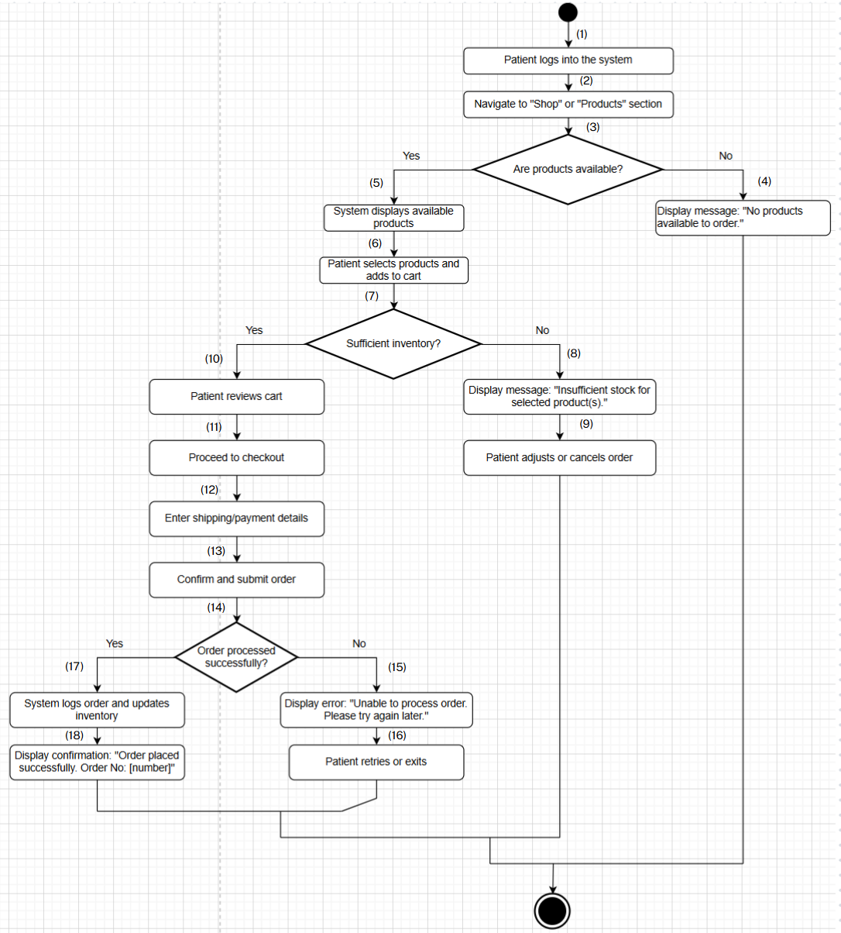

**Business Rules**

| **Step** | **BR Code(s)** | **Description** |
| --- | --- | --- |
| (1) | BR-62 | Only patients with authenticated access can place orders. |
| (3) | BR-62 | Only patients with authenticated access can place orders. |
| (5) | BR-62, BR-63 | BR-62: Only patients with authenticated access can place orders.  BR-63: Orders must reflect real-time inventory availability. |
| (6) | BR-62, BR-63 | BR-62: Only patients with authenticated access can place orders.  BR-63: Orders must reflect real-time inventory availability. |
| (7) | BR-62, BR-63 | BR-62: Only patients with authenticated access can place orders.  BR-63: Orders must reflect real-time inventory availability. |
| (10) | BR-62 | Only patients with authenticated access can place orders. |
| (11) | BR-62 | Only patients with authenticated access can place orders. |
| (12) | BR-62, BR-64 | BR-62: Only patients with authenticated access can place orders.  BR-64: The system must comply with payment and shipping regulations (e.g., secure transactions). |
| (13) | BR-62, BR-64 | BR-62: Only patients with authenticated access can place orders.  BR-64: The system must comply with payment and shipping regulations (e.g., secure transactions). |
| (14) | BR-62 | Only patients with authenticated access can place orders. |
| (17) | BR-62, BR-63 | BR-62: Only patients with authenticated access can place orders.  BR-63: Orders must reflect real-time inventory availability. |
| (18) | BR-62 | Only patients with authenticated access can place orders. |

### UC 28: Search products.

| **Use Case Specification** | | | |
| --- | --- | --- | --- |
| **Use Case ID and Name:** | UC 28: Search products | | |
| **Created By:** | Nguyễn Phạm Hoàng Minh | **Date Created:** | June-02, 2025 |
| **Primary Actor:** | Patient | **Secondary Actors:** | None |
| **Trigger:** | The patient selects the search option and enters keywords or selects a category in the store section. | | |
| **Description:** | This use case allows a patient to search for medical products in the store using keywords or categories, enabling them to find relevant items for purchase or review. | | |
| **Preconditions:** | **PRE-1**: The patient is logged into the system with valid credentials.  **PRE-2**: The store contains a catalog of medical products with searchable data (e.g., keywords, categories).  **PRE-3**: The system must be operational and accessible (e.g., website is online). | | |
| **Post–conditions:** | **POST-1**: The patient successfully views a list of products matching the search criteria.  **POST-2**: The displayed results are accurate and up-to-date based on the store inventory. | | |
| **Normal Flow:** | 1. The patient navigates to the "Shop" or "Products" section of the system. 2. The patient enters a keyword or selects a category in the search field. 3. The system processes the search request and retrieves matching products from the database. 4. The system displays a list of products that match the search criteria, including details (e.g., name, description). 5. The patient reviews the search results and may refine the search or select a product for further details. 6. The patient exits the search or proceeds with an action (e.g., adding to cart per UC-33). | | |
| **Alternative Flows:** | **30.1-AF**: No matching products  a. At step 3 of the Normal Flow, if no products match the search criteria, the system displays a message: "No products found matching your search."  b. The patient may refine the search or exit the section.  **30.2-AF**: System error during search  a. At step 3 of the Normal Flow, if the system encounters an error while processing the search (e.g., database issue), the system displays an error message: "Unable to perform search. Please try again later."  b. The patient acknowledges the error and may retry or exit the section. | | |
| **Exceptions:** | **30-EF**: System or network failure  At any time, if the system cannot connect to the database or there is a network issue, it displays an error message: "Unable to perform search. Please try again later." | | |
| **Priority:** | **Medium** | | |
| **Frequency of Use:** | **Medium** (used regularly by Patients to find specific medical products, though limited to authenticated users). | | |
| **Business Rules:** | **BR-65**: The search function is available only to Patients who are logged into the system.  **BR-66**: Search results must reflect real-time inventory availability.  **BR-67**: The system must support multiple search methods (e.g., keywords, categories).  **BR-68**: Search activity may be linked to the patient’s profile for personalized recommendations. | | |
| **Other Information:** | Search data is used to analyze patient purchasing patterns and improve store functionality (subject to privacy regulations). | | |
| **Assumptions:** | * The patient is authenticated and has a registered account with the system. * The patient is familiar with the store’s search interface and expects personalized results based on their profile. | | |

**Activities Flow**

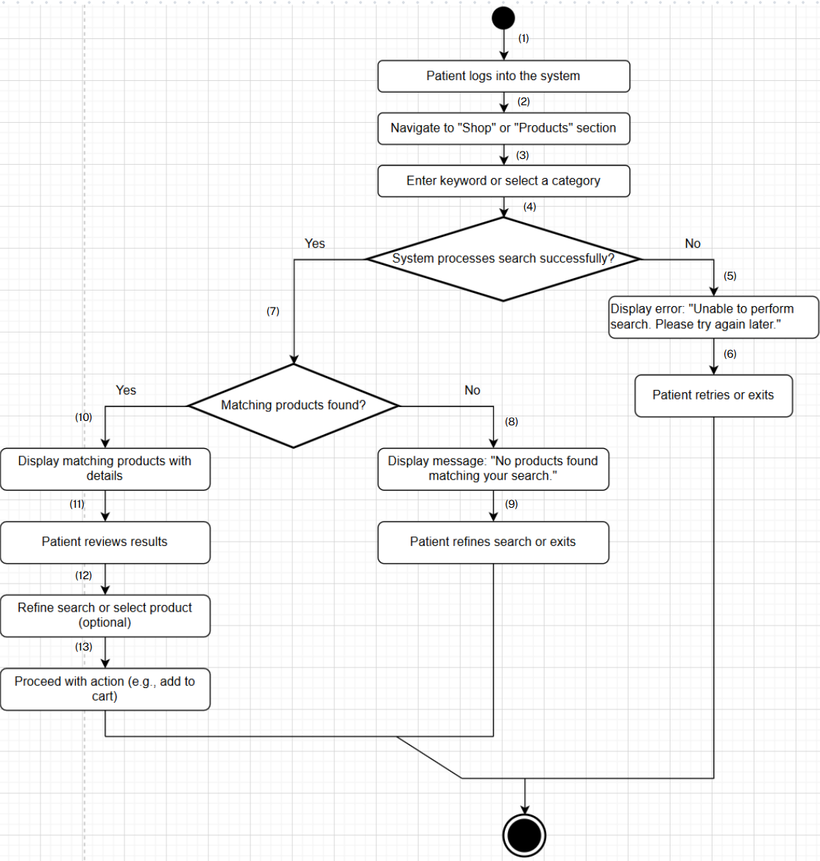

**Business Rules**

| **Step** | **BR Code(s)** | **Description** |
| --- | --- | --- |
| (1) | BR-65 | The search function is available only to Patients who are logged into the system. |
| (2) | BR-65 | The search function is available only to Patients who are logged into the system. |
| (3) | BR-65, BR-67 | BR-65: The search function is available only to Patients who are logged into the system.  BR-67: The system must support multiple search methods (e.g., keywords, categories). |
| (4) | BR-65, BR-67 | BR-65: The search function is available only to Patients who are logged into the system.  BR-67: The system must support multiple search methods (e.g., keywords, categories). |
| (7) | BR-65, BR-66, BR-68 | BR-65: The search function is available only to Patients who are logged into the system.  BR-66: Search results must reflect real-time inventory availability.  BR-68: Search activity may be linked to the patient’s profile for personalized recommendations. |
| (10) | BR-65, BR-66, BR-68 | BR-65: The search function is available only to Patients who are logged into the system.  BR-66: Search results must reflect real-time inventory availability.  BR-68: Search activity may be linked to the patient’s profile for personalized recommendations. |
| (11) | BR-65, BR-66, BR-68 | BR-65: The search function is available only to Patients who are logged into the system.  BR-66: Search results must reflect real-time inventory availability.  BR-68: Search activity may be linked to the patient’s profile for personalized recommendations. |
| (12) | BR-65, BR-68 | BR-65: The search function is available only to Patients who are logged into the system.  BR-68: Search activity may be linked to the patient’s profile for personalized recommendations. |
| (13) | BR-65, BR-68 | BR-65: The search function is available only to Patients who are logged into the system.  BR-68: Search activity may be linked to the patient’s profile for personalized recommendations. |

### UC 29: View product list.

| **Use Case Specification** | | | |
| --- | --- | --- | --- |
| **Use Case ID and Name:** | UC 29: View product list | | |
| **Created By:** | Nguyễn Phạm Hoàng Minh | **Date Created:** | June-02, 2025 |
| **Primary Actor:** | Patient | **Secondary Actors:** | None |
| **Trigger:** | The patient selects the option to view the product list from the store section. | | |
| **Description:** | This use case allows a patient to view a list of available medical products in the shop, including basic details such as name, price, and description, to facilitate purchasing decisions. | | |
| **Preconditions:** | **PRE-1**: The patient is logged into the system with valid credentials.  **PRE-2**: The store contains a catalog of medical products with updated inventory.  **PRE-3**: The system must be operational and accessible (e.g., website is online). | | |
| **Post–conditions:** | **POST-1**: The patient successfully views the list of available medical products.  **POST-2**: The displayed product list is accurate and reflects the current inventory. | | |
| **Normal Flow:** | 1. The patient navigates to the "Shop" or "Products" section of the system. 2. The system retrieves the list of available medical products from the database. 3. The system displays the product list, including basic details for each product (e.g., name, price, description). 4. The patient browses the product list to review the available items. 5. The patient exits the section or proceeds with an action (e.g., searching products per UC-30 or adding to cart per UC-33). | | |
| **Alternative Flows:** | **31.1-AF**: No products available  a. At step 2 of the Normal Flow, if no products are available in the store, the system displays a message: "No products available to display."  b. The use case ends.  **31.2-AF**: System error during retrieval  a. At step 2 of the Normal Flow, if the system encounters an error while retrieving the product list (e.g., database issue), the system displays an error message: "Unable to load product list. Please try again later."  b. The patient acknowledges the error and may retry or exit the section. | | |
| **Exceptions:** | **31-EF**: System or network failure  At any time, if the system cannot connect to the database or there is a network issue, it displays an error message: "Unable to load product list. Please try again later." | | |
| **Priority:** | **Medium** | | |
| **Frequency of Use:** | **Medium** (used regularly by Patients to explore store offerings, but limited to authenticated users). | | |
| **Business Rules:** | **BR-69:** Only products marked as "active" and in stock are displayed.  **BR-70**: The system must ensure the product list is updated in real-time.  **BR-71:** The product list may be tailored based on the patient’s medical history or preferences (if applicable). | | |
| **Other Information:** | Product list data is used to inform patients and may be analyzed to improve store offerings for Patients (subject to privacy regulations). | | |
| **Assumptions:** | * The patient is authenticated and has a registered account with the system. * The patient is browsing the store with the intent to purchase medical products relevant to their needs. | | |

**Activities Flow**

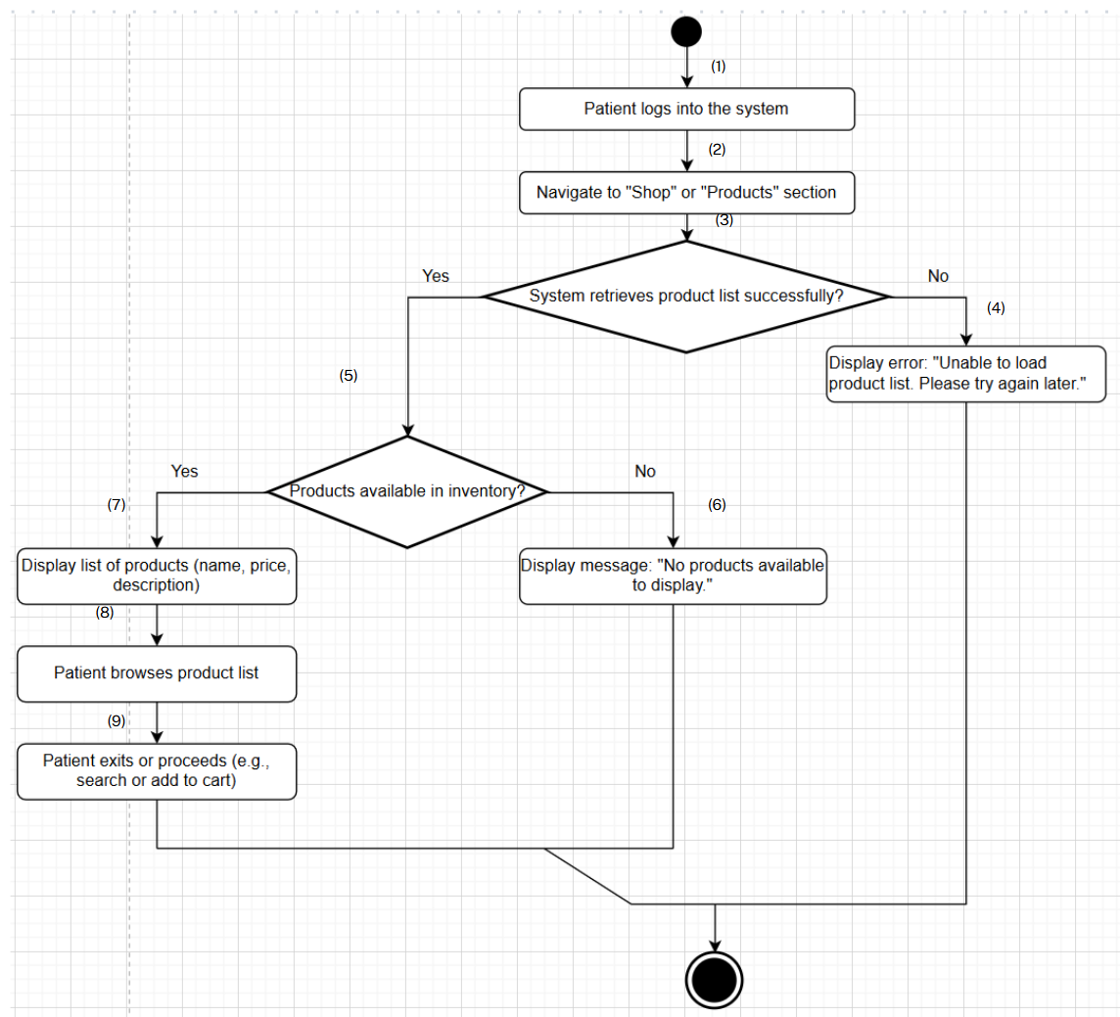

**Business Rules**

| **Step** | **BR Code(s)** | **Description** |
| --- | --- | --- |
| (1) | BR-69, BR-70 | BR-69: Only products marked as "active" and in stock are displayed.  BR-70: The system must ensure the product list is updated in real-time. |
| (2) | BR-69, BR-70 | BR-69: Only products marked as "active" and in stock are displayed.  BR-70: The system must ensure the product list is updated in real-time. |
| (3) | BR-69, BR-70 | BR-69: Only products marked as "active" and in stock are displayed.  BR-70: The system must ensure the product list is updated in real-time. |
| (5) | BR-69, BR-70, BR-71 | BR-69: Only products marked as "active" and in stock are displayed.  BR-70: The system must ensure the product list is updated in real-time.  BR-71: The product list may be tailored based on the patient’s medical history or preferences (if applicable). |
| (7) | BR-69, BR-70, BR-71 | BR-69: Only products marked as "active" and in stock are displayed.  BR-70: The system must ensure the product list is updated in real-time.  BR-71: The product list may be tailored based on the patient’s medical history or preferences (if applicable). |
| (8) | BR-69, BR-70, BR-71 | BR-69: Only products marked as "active" and in stock are displayed.  BR-70: The system must ensure the product list is updated in real-time.  BR-71: The product list may be tailored based on the patient’s medical history or preferences (if applicable). |
| (9) | BR-69, BR-70, BR-71 | BR-69: Only products marked as "active" and in stock are displayed.  BR-70: The system must ensure the product list is updated in real-time.  BR-71: The product list may be tailored based on the patient’s medical history or preferences (if applicable). |

### UC 30: View product details.

| **Use Case Specification** | | | |
| --- | --- | --- | --- |
| **Use Case ID and Name:** | UC 30: View product details | | |
| **Created By:** | Nguyễn Phạm Hoàng Minh | **Date Created:** | June-02, 2025 |
| **Primary Actor:** | Patient | **Secondary Actors:** | None |
| **Trigger:** | The patient selects a specific product from the product list to view detailed information. | | |
| **Description:** | This use case allows a patient to view detailed information about a specific medical product in the store, including details such as price, description, and other relevant information, to make informed purchasing decisions. | | |
| **Preconditions:** | **PRE-1**: The patient is logged into the system with valid credentials.  **PRE-2**: The product list has been displayed (per UC-31), and the patient has selected a specific product.  **PRE-3**: Detailed information for the product is updated and available in the system’s database.  **PRE-4**: The system must be operational and accessible (e.g., website is online). | | |
| **Post–conditions:** | **POST-1**: The patient successfully views the detailed information of the selected medical product.  **POST-2**: The displayed product details are accurate and reflect the current inventory. | | |
| **Normal Flow:** | 1. The patient accesses the product list (per UC-31). 2. The patient selects a specific product from the list (e.g., clicks on the product name). 3. The system retrieves the detailed information of the selected product from the database. 4. The system displays the product details, including information such as price, description, and other relevant details (e.g., stock availability). 5. The patient reviews the detailed information of the product. 6. The patient exits the details page or proceeds with a further action (e.g., adding to cart per UC-33). | | |
| **Alternative Flows:** | **32.1-AF**: No detailed information available  a. At step 3 of the Normal Flow, if no detailed information is available for the selected product in the database, the system displays a message: "No detailed information available for this product."  b. The patient returns to the product list or exits the section.  **32.2-AF**: System error during retrieval  a. At step 3 of the Normal Flow, if the system encounters an error while retrieving the details (e.g., database connection issue), the system displays an error message: "Unable to load product details. Please try again later."  b. The patient acknowledges the error and may retry or return to the product list. | | |
| **Exceptions:** | **32-EF**: System or network failure  At any time, if the system cannot connect to the database or there is a network issue, it displays an error message: "Unable to load product details. Please try again later." | | |
| **Priority:** | **Medium** | | |
| **Frequency of Use:** | **Medium** (used regularly by Patients seeking more information about products, but limited to authenticated users). | | |
| **Business Rules:** | **BR-69**: Only details of products marked as "active" and in stock are displayed.  **BR-70**: The system must ensure that product details are updated in real-time.  **BR-71**: Product details may include personalized recommendations based on the patient’s medical history (if applicable). | | |
| **Other Information:** | Product detail data is used to inform patients and may be analyzed to improve store offerings for Patients (subject to privacy regulations). | | |
| **Assumptions:** | * The patient is authenticated and has a registered account with the system. * The patient is viewing product details to make an informed decision about a purchase. | | |

**Activities Flow**

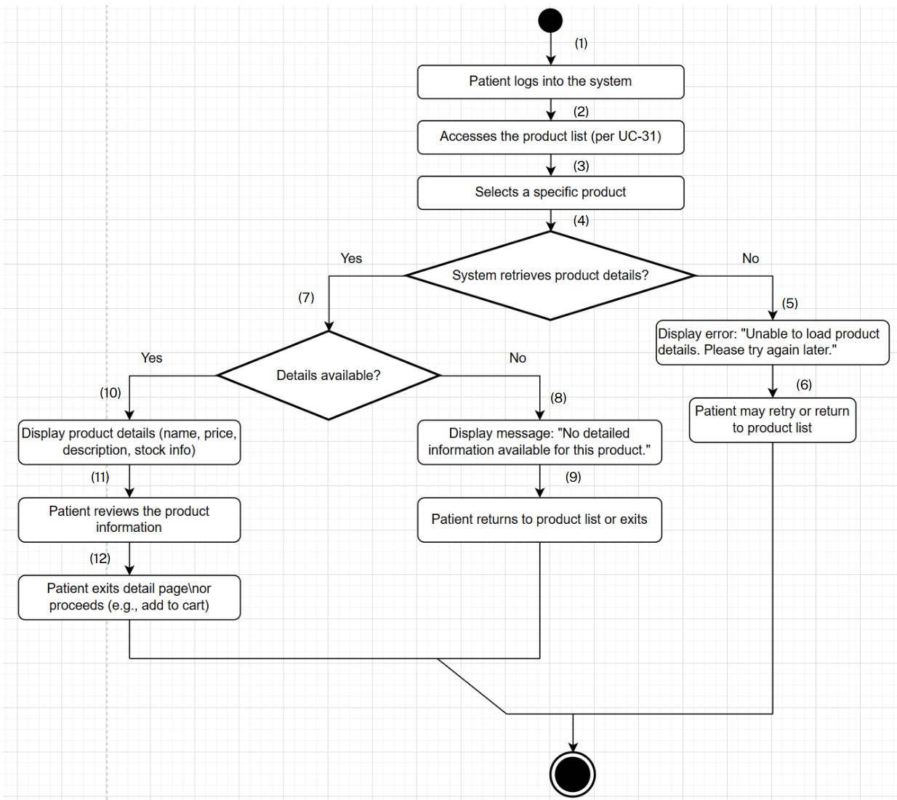

**Business Rules**

| **Step** | **BR Code(s)** | **Description / Rule Enforcement** |
| --- | --- | --- |
| (1) | BR-69, BR-70 | BR-69: Only details of products marked as "active" and in stock are displayed.  BR-70: The system must ensure that product details are updated in real-time. |
| (2) | BR-69, BR-70 | BR-69: Only details of products marked as "active" and in stock are displayed.  BR-70: The system must ensure that product details are updated in real-time. |
| (3) | BR-69, BR-70 | BR-69: Only details of products marked as "active" and in stock are displayed.  BR-70: The system must ensure that product details are updated in real-time. |
| (4) | BR-69, BR-70 | BR-69: Only details of products marked as "active" and in stock are displayed.  BR-70: The system must ensure that product details are updated in real-time. |
| (7) | BR-69, BR-70, BR-71 | BR-69: Only details of products marked as "active" and in stock are displayed.  BR-70: The system must ensure that product details are updated in real-time.  BR-71: Product details may include personalized recommendations based on the patient’s medical history (if applicable). |
| (10) | BR-69, BR-70, BR-71 | BR-69: Only details of products marked as "active" and in stock are displayed.  BR-70: The system must ensure that product details are updated in real-time.  BR-71: Product details may include personalized recommendations based on the patient’s medical history (if applicable). |
| (11) | BR-69, BR-70, BR-71 | BR-69: Only details of products marked as "active" and in stock are displayed.  BR-70: The system must ensure that product details are updated in real-time.  BR-71: Product details may include personalized recommendations based on the patient’s medical history (if applicable). |
| (12) | BR-69, BR-70, BR-71 | BR-69: Only details of products marked as "active" and in stock are displayed.  BR-70: The system must ensure that product details are updated in real-time.  BR-71: Product details may include personalized recommendations based on the patient’s medical history (if applicable). |

### 

### UC 31: Add products to cart.

| **Use Case Specification** | | | |
| --- | --- | --- | --- |
| **Use Case ID and Name:** | UC 31: Add products to cart | | |
| **Created By:** | Nguyễn Phạm Hoàng Minh | **Date Created:** | June-02, 2025 |
| **Primary Actor:** | Patient | **Secondary Actors:** | None |
| **Trigger:** | The patient selects the option to add a product to their shopping cart from the product list or details page. | | |
| **Description:** | This use case allows a patient to add selected medical products to their shopping cart for later purchase, enabling them to review and manage items before checkout. | | |
| **Preconditions:** | **PRE-1**: The patient is logged into the system.  **PRE-2**: The product list or product details are displayed (per UC-31 or UC-32), and the patient has selected a product.  **PRE-3**: The system must be operational and accessible (e.g., website is online).  **PRE-4**: The selected product has sufficient stock available. | | |
| **Post–conditions:** | **POST-1**: The selected product is successfully added to the patient’s shopping cart.  **POST-2**: The system updates the cart and reflects the new total (e.g., quantity, price).  **POST-3**: The patient receives a confirmation of the addition (e.g., a cart update notification). | | |
| **Normal Flow:** | 1. The patient navigates to the product list (per UC-31) or product details (per UC-32). 2. The patient selects a product and clicks the "Add to Cart" option. 3. The system checks the product’s availability and adds it to the patient’s shopping cart. 4. The system updates the cart display, showing the added product and updated total. 5. The system notifies the patient with a message: "Product added to cart successfully." 6. The patient continues shopping or proceeds to the cart to review or checkout (per UC-29). | | |
| **Alternative Flows:** | **33.1-AF**: Insufficient stock  a. At step 3 of the Normal Flow, if the selected product has insufficient stock, the system displays a message: "Insufficient stock for [product]. Please adjust your selection."  b. The patient adjusts the quantity or cancels the action and may try again.  **33.2-AF**: System error during addition  a. At step 3 of the Normal Flow, if the system encounters an error while adding the product (e.g., database issue), the system displays an error message: "Unable to add product to cart. Please try again later."  b. The patient acknowledges the error and may retry or exit the section. | | |
| **Exceptions:** | **33-EF**: System or network failure  At any time, if the system cannot connect to the database or there is a network issue, it displays an error message: "Unable to add product to cart. Please try again later." | | |
| **Priority:** | **Medium** | | |
| **Frequency of Use:** | **High** (frequently used by Guests and Patients seeking more information about services).High (frequently used by Patients during the shopping process). | | |
| **Business Rules:** | **BR-72:** The cart must reflect real-time inventory availability.  **BR-73**: The system must limit the quantity added based on stock levels. | | |
| **Other Information:** | Cart data is used to facilitate the purchase process and may be analyzed for user behavior (subject to privacy regulations). | | |
| **Assumptions:** | * The patient is familiar with the cart functionality in the store interface. * The system supports real-time cart updates and inventory checks. | | |

**Activities Flow**

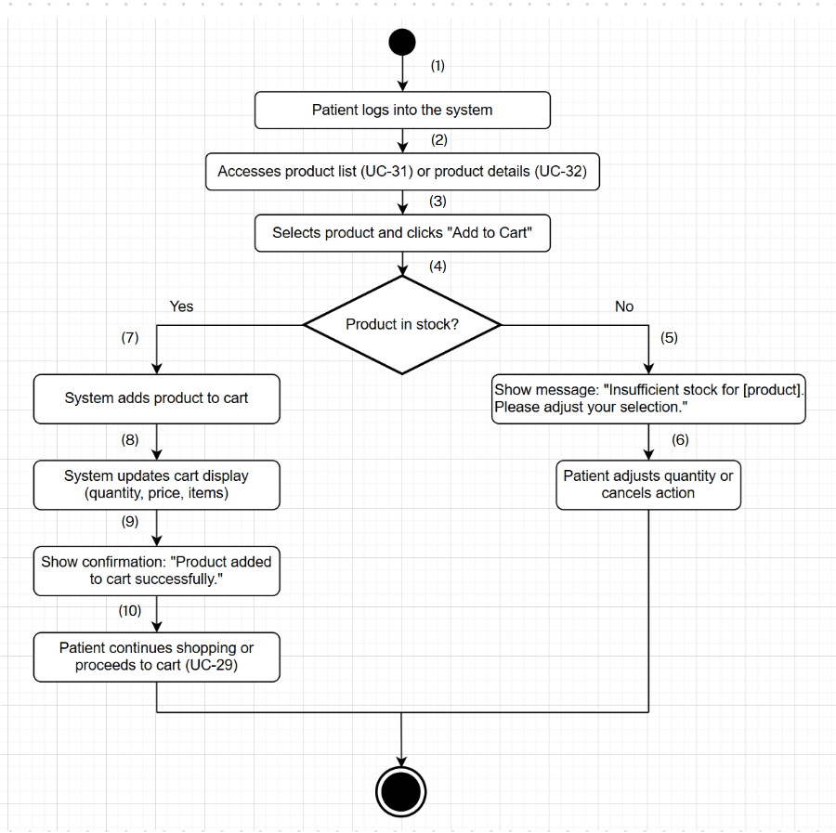

**Business Rules**

| **Step** | **BR Code(s)** | **Description / Rule Enforcement** |
| --- | --- | --- |
| (1) | BR-72, BR-73 | BR-72: The cart must reflect real-time inventory availability.  BR-73: The system must limit the quantity added based on stock levels. |
| (2) | BR-72, BR-73 | BR-72: The cart must reflect real-time inventory availability.  BR-73: The system must limit the quantity added based on stock levels. |
| (3) | BR-72, BR-73 | BR-72: The cart must reflect real-time inventory availability.  BR-73: The system must limit the quantity added based on stock levels. |
| (4) | BR-72, BR-73 | BR-72: The cart must reflect real-time inventory availability.  BR-73: The system must limit the quantity added based on stock levels. |
| (7) | BR-72, BR-73 | BR-72: The cart must reflect real-time inventory availability.  BR-73: The system must limit the quantity added based on stock levels. |
| (8) | BR-72 | BR-72: The cart must reflect real-time inventory availability. |
| (9) | BR-72 | BR-72: The cart must reflect real-time inventory availability. |

### UC 32:Delete products from cart

| **Use Case Specification** | | | |
| --- | --- | --- | --- |
| **Use Case ID and Name:** | UC 32: Delete products from cart | | |
| **Created By:** | Nguyễn Văn An | **Date Created:** | June-1, 2025 |
| **Primary Actor:** | Patient | **Secondary Actors:** |  |
| **Trigger:** | The patient indicates that he/she wants to remove products from their shopping cart. | | |
| **Description:** | The **"Delete products from cart"** use case represents the process in which a **patient** remove products from their shopping cart before completing the purchase. The patient selects a product and deletes it from the cart.. | | |
| **Preconditions:** | **PRE-1**: The patient is logged into the system.  **PRE-2**: The patient's shopping cart contains products. | | |
| **Post–conditions:** | POST-1: The product is successfully removed from the patient's shopping cart. | | |
| **Normal Flow:** | 1. The patient initiates the "Delete products from cart" use case by selecting the "Cart" menu on the system. 2. The system displays the current shopping cart contents. 3. The patient selects a product to remove. 4. The patient clicks "Remove" or "Delete." 5. The system removes the product from the cart. 6. The system displays a confirmation message: "Product removed from cart." | | |
| **Alternative Flows:** | **1-AF:** Empty cart  a. If the cart is empty, the system displays a message: "Your cart is empty."  b. The use case ends: | | |
| **Exceptions:** | 1-EF: Cart update failure  If the system fails to update the cart (e.g., due to database issues), it displays an error message: "Unable to remove product from cart. Please try again later." | | |
| **Priority:** | **Medium** | | |
| **Frequency of Use:** | **Medium** (used occasionally when adjusting cart contents). | | |
| **Business Rules:** | **BR-74:** Only the patient can modify their own cart.  **BR-75:** Removed products are immediately available for other users. | | |
| **Other Information:** | Cart modifications do not affect inventory until checkout. | | |
| **Assumptions:** | Patients are familiar with the cart management interface.  The system supports real-time cart updates. | | |

**Activities Flow**

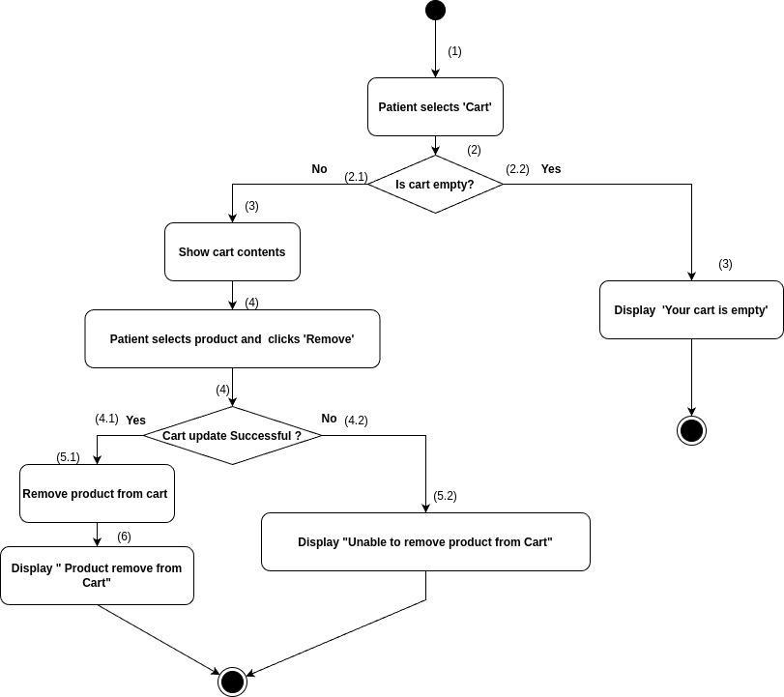

**Business Rules**

| **Step(s)** | **BR Code(s)** | **Description / Rule Enforcement** |
| --- | --- | --- |
| (1–4) | BR-74 | Only the patient is allowed to view and modify their own shopping cart. |
| (5) | BR-75 | Removed products become immediately available for other users. |

### UC 33: View order status

| **Use Case Specification** | | | |
| --- | --- | --- | --- |
| **Use Case ID and Name:** | UC 33: View order status | | |
| **Created By:** | Nguyễn Văn An | **Date Created:** | June-1, 2025 |
| **Primary Actor:** | Patient | **Secondary Actors:** |  |
| **Trigger:** | The patient indicates that he/she wants to check the status of their product orders. | | |
| **Description:** | The **"View order status"** use case represents the process in which a **patient** check the status of their product orders (e.g., "Processing," "Shipped"). The patient selects an order and views its current status. | | |
| **Preconditions:** | **PRE-1**: The patient is logged into the system.  **PRE-2**: The patient has placed at least one order. | | |
| **Post–conditions:** | **POST-1**: The order status is successfully displayed to the patient. | | |
| **Normal Flow:** | 1. The patient initiates the "View order status" use case by selecting the "Order History" menu on the system. 2. The system displays a list of the patient's orders. 3. The patient selects an order to view its status. 4. The system displays the current status of the selected order.. | | |
| **Alternative Flows:** | **1-AF:** No orders found  a. If the patient has no orders, the system displays a message: "No orders found."  b. The use case ends. | | |
| **Exceptions:** | **1-EF:** Data retrieval failure  If the system fails to retrieve the order status (e.g., due to database issues), it displays an error message: "Unable to load order status. Please try again later." | | |
| **Priority:** | **High** | | |
| **Frequency of Use:** | **Medium** (used regularly to track order progress). | | |
| **Business Rules:** | **BR-76:** Only the patient can view their own order status.  **BR-77:** Order status must be up-to-date and accurate. | | |
| **Other Information:** | Order status is updated in real-time by the system. | | |
| **Assumptions:** | Patients are familiar with the order history interface.  The system supports real-time status updates. | | |

**Activities Flow**

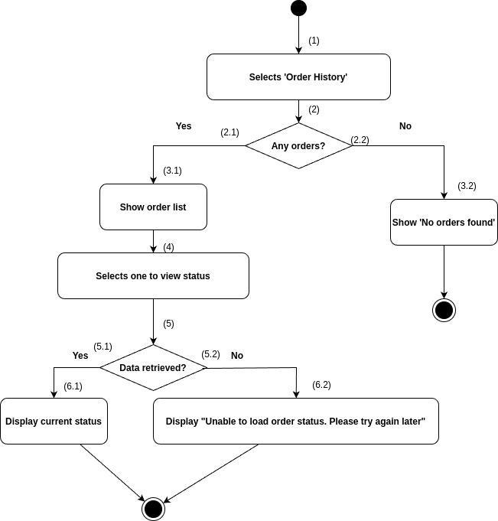

| **Step(s)** | **BR Code(s)** | **Description / Rule Enforcement** |
| --- | --- | --- |
| (1–3) | BR-76 | Only the patient can view their own order history and status. |
| -4 | BR-77 | The order status displayed must be real-time, up-to-date, and accurate |

### UC 34: View order detail

| **Use Case Specification** | | | |
| --- | --- | --- | --- |
| **Use Case ID and Name:** | UC 34: View order details | | |
| **Created By:** | Nguyễn Văn An | **Date Created:** | June-1, 2025 |
| **Primary Actor:** | Patient | **Secondary Actors:** |  |
| **Trigger:** | The patient indicates that he/she wants to view detailed information about a specific order. | | |
| **Description:** | The **"View Order details"** use case represents the process in which a **patient** view detailed information about their orders, including items, quantities, and total cost. The patient selects an order and views its details. | | |
| **Preconditions:** | **PRE-1**: The patient is logged into the system.  **PRE-2**: The patient has placed at least one order. | | |
| **Post–conditions:** | **POST-1**: The order details are successfully displayed to the patient. | | |
| **Normal Flow:** | 1. The patient initiates the "View order details" use case by selecting the "Order History" menu on the system. 2. The system displays a list of the patient's orders. 3. The patient selects an order to view its details. 4. The system displays the order details, including items, quantities, and total cost. | | |
| **Alternative Flows:** | **1-AF:** No orders found  a. If the patient has no orders, the system displays a message: "No orders found."  b. The use case ends. | | |
| **Exceptions:** | **1-EF:** Data retrieval failure  If the system fails to retrieve the order details (e.g., due to database issues), it displays an error message: "Unable to load order details. Please try again later." | | |
| **Priority:** | **High** | | |
| **Frequency of Use:** | Medium (used regularly to review order information). | | |
| **Business Rules:** | **BR-78:** Only the patient can view their own order details.  **BR-79** Order details must be accurate and complete. | | |
| **Other Information:** | Order details are displayed in a read-only format. | | |
| **Assumptions:** | Patients are familiar with the order history interface.  The system supports secure data retrieval. | | |

**Activities Flow**

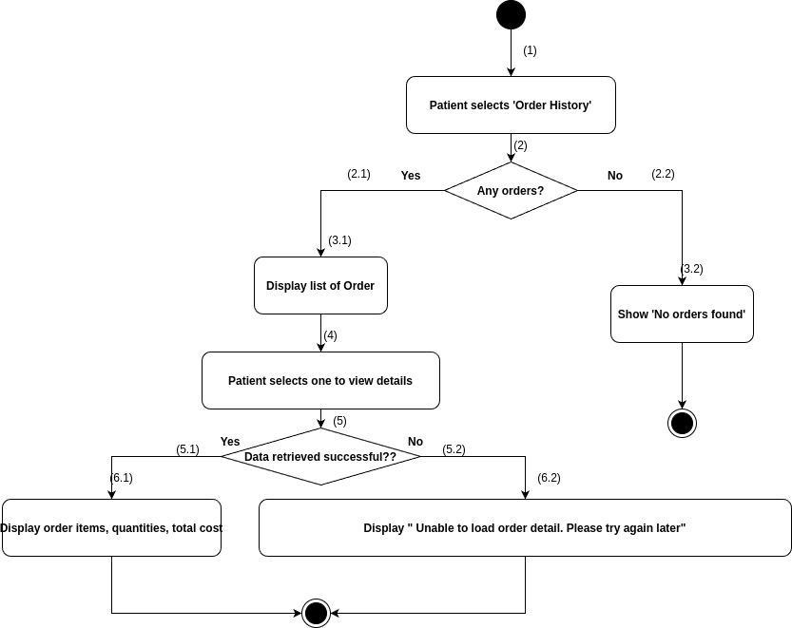

| **Step(s)** | **BR Code(s)** | **Description / Rule Enforcement** |
| --- | --- | --- |
| (1–3) | BR-78 | Only the patient can view the list of their own orders and select one for detail view. |
| (4) | BR-79 | Order details (items, quantities, total cost) must be complete and accurate. |

### UC 35: Give order feedback

### 

| **Use Case Specification** | | | |
| --- | --- | --- | --- |
| **Use Case ID and Name:** | UC 35: Give order feedback | | |
| **Created By:** | Nguyễn Văn An | **Date Created:** | June-1, 2025 |
| **Primary Actor:** | Patient | **Secondary Actors:** |  |
| **Trigger:** | The patient indicates that he/she wants to submit feedback or a rating for a completed product order. | | |
| **Description:** | The **"Create an Order"** use case represents the process in which a **patient** submit feedback or ratings for a completed product order. The patient selects the order, provides a rating and comment, and submits the feedback. | | |
| **Preconditions:** | **PRE-1**: The patient is logged into the system.  **PRE-2**: The patient has at least one completed order | | |
| **Post–conditions:** | **POST-1**: The feedback is successfully submitted and stored in the system.  **POST-2**: The feedback is associated with the correct order. | | |
| **Normal Flow:** | 1. The patient initiates the "Give order feedback" use case by selecting the "Order Feedback" menu on the system. 2. The system displays a list of completed orders. 3. The patient selects an order to provide feedback on. 4. The patient enters a rating (e.g., 1-5 stars) and an optional comment. 5. The patient submits the feedback. 6. The system saves the feedback to the database.” 7. The system displays a confirmation message: "Feedback submitted successfully. | | |
| **Alternative Flows:** | **1-AF:** No completed orders  a. If the patient has no completed orders, the system displays a message: "No orders available for feedback."  b. The use case ends. | | |
| **Exceptions:** | **1-EF:** Network or database failure  If the system cannot connect to the database (e.g., due to network issues), it displays an error message: "Unable to submit feedback. Please try again later." | | |
| **Priority:** | **Medium** | | |
| **Frequency of Use:** | Medium (used occasionally after order completion). | | |
| **Business Rules:** | **BR-80** Only patients with completed orders can provide feedback.  **BR-81:** Feedback must include a rating; comments are optional. | | |
| **Other Information:** | Feedback data is used to improve product and service quality. | | |
| **Assumptions:** | Patients are familiar with the feedback interface.  The system supports real-time feedback submission. | | |

**Activities Flow**

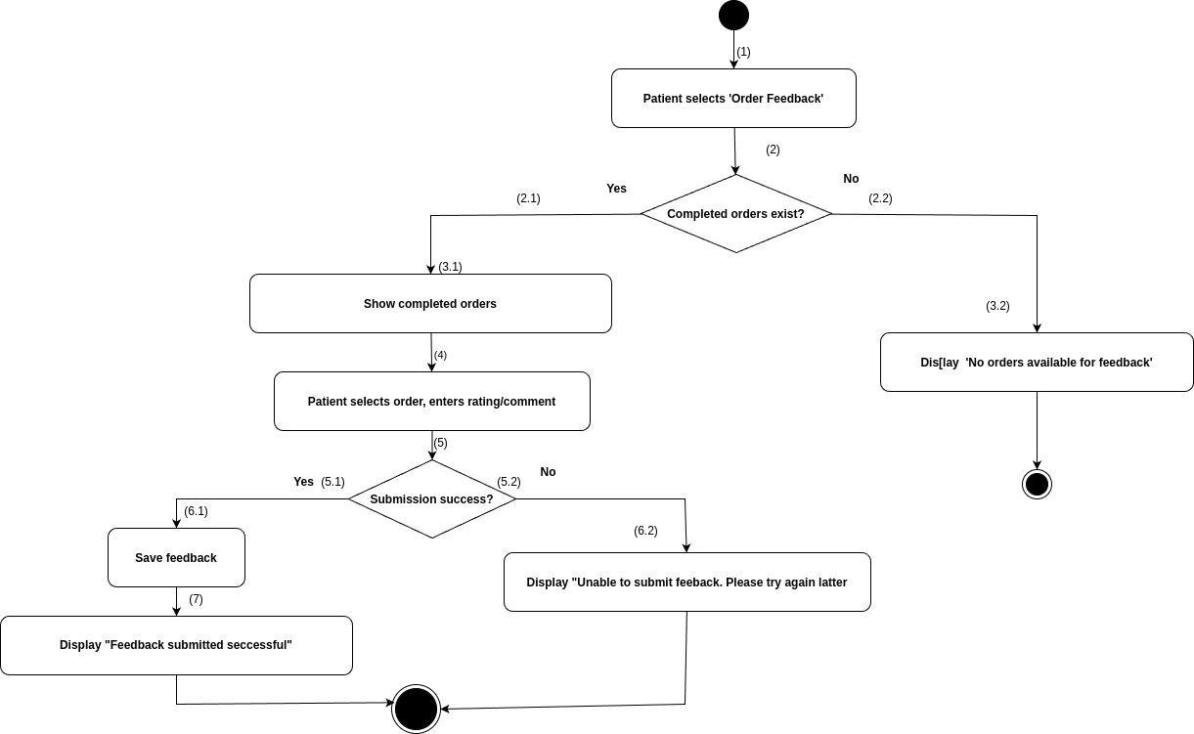

| **Step(s)** | **BR Code(s)** | **Description / Rule Enforcement** |
| --- | --- | --- |
| (2) | BR-80 | Only completed orders are listed for feedback. |
| (4) | BR-81 | Feedback must include a rating (e.g., 1–5 stars); comment is optional. |

### UC 36: View order List

| **Use Case Specification** | | | |
| --- | --- | --- | --- |
| **Use Case ID and Name:** | UC 36: View order List | | |
| **Created By:** | Nguyễn Văn An | **Date Created:** | June-1, 2025 |
| **Primary Actor:** | Store Manager | **Secondary Actors:** |  |
| **Trigger:** | The Store Manager indicates that he/she wants to view a list of all product orders placed by patients. | | |
| **Description:** | The **"Store Manager"** use case represents the process in which a **Store Manager** view a list of all product orders placed by patients. The Manager selects the option to view the order list and reviews the details. | | |
| **Preconditions:** | **PRE-1**: The Store Manager is logged into the system with appropriate authorization.  **PRE-2**: There are orders in the system. | | |
| **Post–conditions:** | **POST-1**: The list of product orders is successfully displayed to the Store Manager. | | |
| **Normal Flow:** | 1. The Store Manager initiates the "View order list" use case by selecting the "Order List" menu on the system. 2. The system retrieves the list of all product orders from the database. 3. The system displays the order list, including order ID, patient name, and status. 4. The Store Manager reviews the order list. | | |
| **Alternative Flows:** | **1-AF**: No orders found  a. If there are no orders, the system displays a message: "No orders found."  b. The use case ends. | | |
| **Exceptions:** | **1-EF:** Data retrieval failure  If the system fails to retrieve the order list (e.g., due to database issues), it displays an error message: "Unable to load order list. Please try again later." | | |
| **Priority:** | **High** | | |
| **Frequency of Use:** | High (used regularly to manage orders). | | |
| **Business Rules:** |  | | |
| **Other Information:** | The order list supports filtering by status or date | | |
| **Assumptions:** | The Store Manager is trained to use the order management interface.  The system supports real-time order data retrieval. | | |

**Activities Flow**

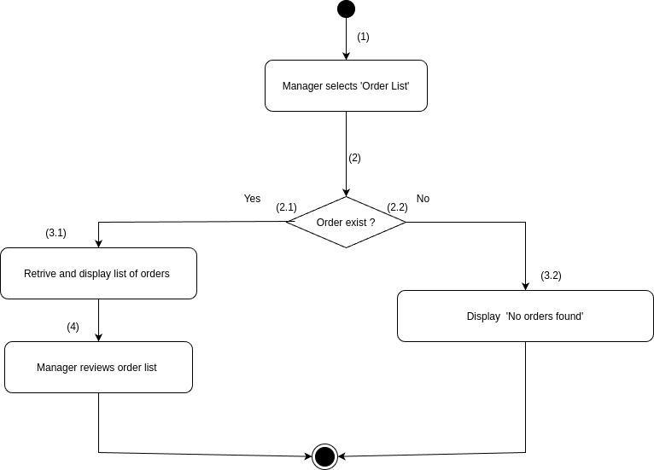

### UC 37: Update order status

| **Use Case Specification** | | | |
| --- | --- | --- | --- |
| **Use Case ID and Name:** | UC 37: Update order status | | |
| **Created By:** | Nguyễn Văn An | **Date Created:** | June-1, 2025 |
| **Primary Actor:** | Patient | **Secondary Actors:** |  |
| **Trigger:** | The patient indicates that he/she wants to update the status of product orders. | | |
| **Description:** | The **"Update Order status"** use case represents the process in which a **Stroe Manager** update the status of product orders (e.g., "Shipped," "Delivered"). The Manager selects an order and changes its status. | | |
| **Preconditions:** | **PRE-1**: The Store Manager is logged into the system with appropriate authorization.  **PRE-2**: There are orders in the system that can be updated. | | |
| **Post–conditions:** | **POST-1**: The order status is successfully updated in the system.  **POST-2**: A notification is sent to the patient (if applicable). | | |
| **Normal Flow:** | 1. The Store Manager initiates the "Update order status" use case by selecting the "Order List" menu on the system. 2. The system displays the list of product orders. 3. The Store Manager selects an order to update. 4. The Store Manager selects a new status (e.g., "Shipped," "Delivered"). 5. The Store Manager confirms the status change. [39.1-AF] 6. The system updates the order status in the database. 7. The system sends a notification to the patient. 8. The system displays a confirmation message: "Order status updated successfully." | | |
| **Alternative Flows:** | **39.1-AF:** Invalid status change  a. If the new status is invalid (e.g., from "Delivered" to "Processing"), the system displays a message: "Invalid status change."  b. The Store Manager selects a valid status.  c. Return to Step 4 of Normal Flow. | | |
| **Exceptions:** | **39.1-EF**: Update failure  If the system fails to update the status (e.g., due to database issues), it displays an error message: "Unable to update order status. Please try again later." | | |
| **Priority:** | **High** | | |
| **Frequency of Use:** | High (used regularly to manage order fulfillment). | | |
| **Business Rules:** | **BR-82**: Only the Store Manager can update order status.  **BR-83:** Status changes must follow a predefined workflow (e.g., Processing → Shipped → Delivered). | | |
| **Other Information:** | Status updates trigger notifications to patients. | | |
| **Assumptions:** | The Store Manager is trained to manage order statuses.  The system supports real-time status updates. | | |

**Activities Flow**

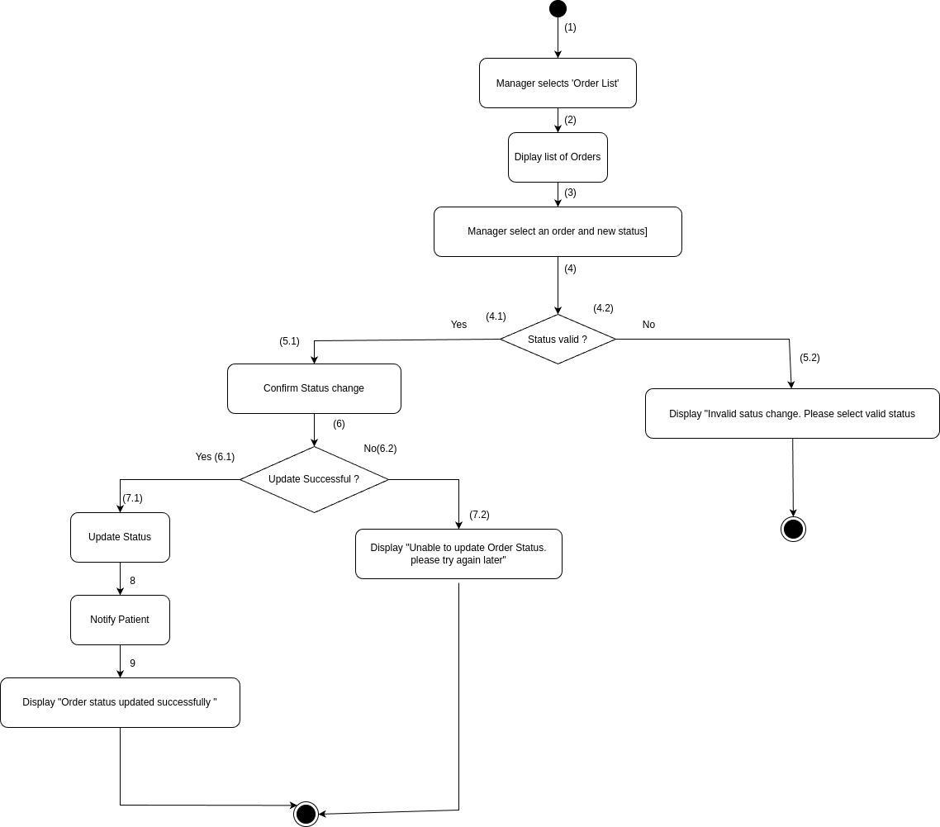

| **Step(s)** | **BR Code(s)** | **Description / Rule Enforcement** |
| --- | --- | --- |
| (1–3) | BR-82 | Only the Store Manager, after logging in with proper authorization, can access and update order status. |
| (4–5) | BR-83 | Status change must follow the allowed workflow (e.g., cannot move backward from “Delivered” to “Processing”). |

### UC 38: Add products to store

| **Use Case Specification** | | | |
| --- | --- | --- | --- |
| **Use Case ID and Name:** | UC 38: Add products to store | | |
| **Created By:** | Nguyễn Văn An | **Date Created:** | June-1, 2025 |
| **Primary Actor:** | Patient | **Secondary Actors:** |  |
| **Trigger:** | A Store Manager wants to add new products to the store’s inventory | | |
| **Description:** | The **“Add product to Store"** use case represents the process in which a Store Manager add new products to the store’s inventory. The Manager enters product details and submits the addition. | | |
| **Preconditions:** | **PRE-1**: The Store Manager is logged into the system with appropriate authorization.  **PRE-2**: The system database is connected and functioning. | | |
| **Post–conditions:** | **POST-1**: The new product is successfully added to the store’s inventory. | | |
| **Normal Flow:** | 1. The Store Manager initiates the "Add products to store" use case by selecting the "Add Product" menu on the system. 2. The system displays a form for entering product details. 3. The Store Manager enters details (e.g., name, price, description, quantity). 4. The Store Manager submits the form. 5. The system validates the input and adds the product to the database. 6. The system displays a confirmation message: "Product added successfully." | | |
| **Alternative Flows:** | **1-AF:** Duplicate product  a. If the product name already exists, the system displays a message: "Product already exists."  b. The Store Manager can edit the details or cancel.  c. Return to Step 3 of Normal Flow. | | |
| **Exceptions:** | **1-EF:** Database failure  If the system fails to save the product (e.g., due to database issues), it displays an error message: "Unable to add product. Please try again later." | | |
| **Priority:** | **High** | | |
| **Frequency of Use:** | Medium (used periodically to update inventory). | | |
| **Business Rules:** | **BR-84:** Only the Store Manager can add products to the store.  **BR-85:** Each product must have a unique name. | | |
| **Other Information:** | Added products are immediately available for purchase. | | |
| **Assumptions:** | The Store Manager is trained to enter product details.  The system supports real-time inventory updates. | | |

**Activities Flow**

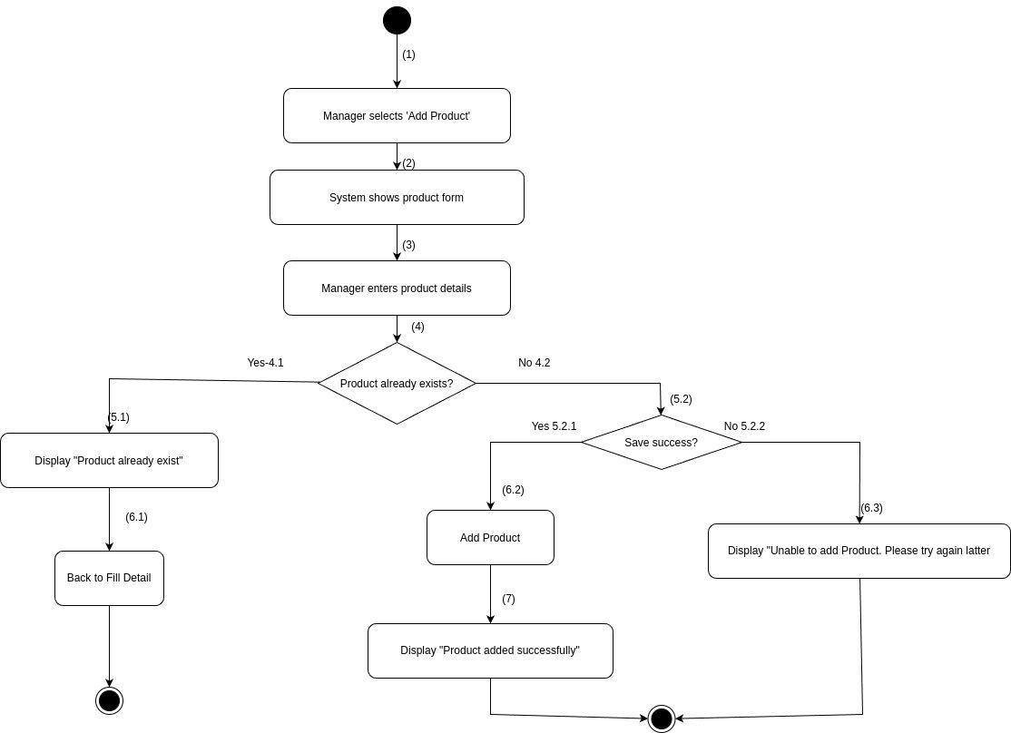

| **Step(s)** | **BR Code(s)** | **Description / Rule Enforcement** |
| --- | --- | --- |
| (1–3) | BR-84 | Only Store Managers with appropriate authorization can access the product entry form and input product details. |
| (5) | BR-85 | The system must ensure each product has a unique name before adding it to the inventory. |

### UC 39: Delete Products in store

| **Use Case Specification** | | | |
| --- | --- | --- | --- |
| **Use Case ID and Name:** | UC 39: Delete Products in store | | |
| **Created By:** | Nguyễn Văn An | **Date Created:** | June-1, 2025 |
| **Primary Actor:** | Store Manager | **Secondary Actors:** |  |
| **Trigger:** | The patient indicates that he/she wants to remove products from the store’s inventory.. | | |
| **Description:** | The **"Delete product in Store"** use case represents the process in which a **Store Manger** remove products from the store’s inventory. The Manager selects a product and confirms its deletion. | | |
| **Preconditions:** | **PRE-1**: The Store Manager is logged into the system with appropriate authorization.  **PRE-2**: There are products in the store’s inventory. | | |
| **Post–conditions:** | **POST-1**: The product is successfully removed from the store’s inventory. | | |
| **Normal Flow:** | 1. The Store Manager initiates the "Delete products from store" use case by selecting the "Product List" menu on the system. 2. The system displays the list of products. 3. The Store Manager selects a product to delete. 4. The Store Manager confirms the deletion. 5. The system removes the product from the database. 6. The system displays a confirmation message: "Product deleted successfully." | | |
| **Alternative Flows:** | **1-AF:** Product in use  a. If the product is part of an active order, the system displays a message: "Product cannot be deleted due to active orders."  b. The use case ends. | | |
| **Exceptions:** | **1-EF:** Database failure  If the system fails to delete the product (e.g., due to database issues), it displays an error message: "Unable to delete product. Please try again later." | | |
| **Priority:** | **High** | | |
| **Frequency of Use:** | Low (used occasionally to manage outdated products). | | |
| **Business Rules:** | **BR-86:** Only the Store Manager can delete products from the store.  **BR-87:** Products with active orders cannot be deleted. | | |
| **Other Information:** | Deleted products are removed from the product list immediately. | | |
| **Assumptions:** | Patients are familiar with the order history interface.  The system supports real-time status updates. | | |

**Activities Flow**

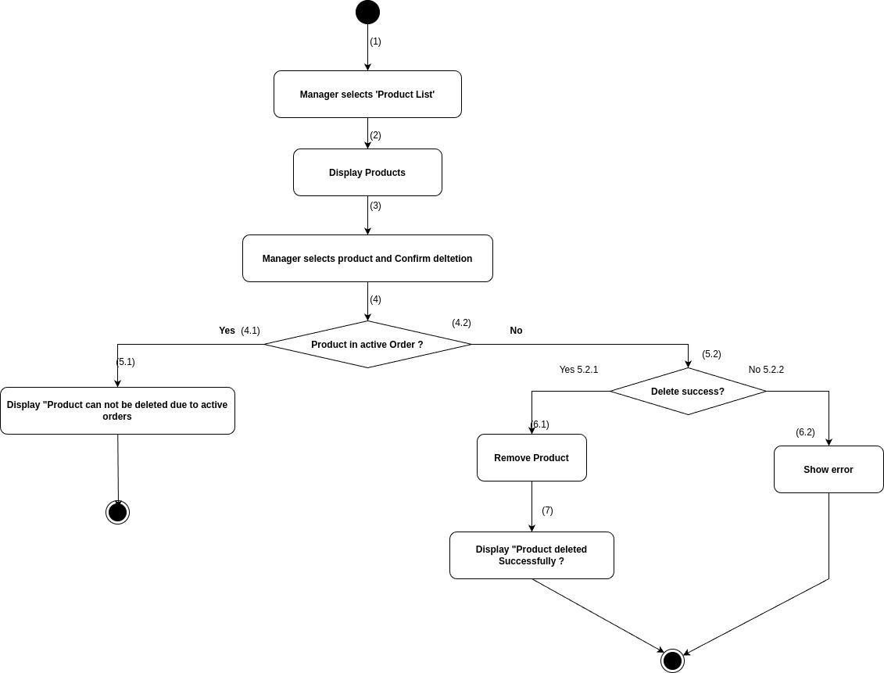

| **Step(s)** | **BR Code(s)** | **Description / Rule Enforcement** |
| --- | --- | --- |
| (1–3) | BR-86 | Only the Store Manager with proper authorization can view and choose products to delete. |
| AF-1 (a) | BR-87 | Products associated with active orders cannot be deleted. System must block deletion in such cases. |

### UC 40: Edit product detail

| **Use Case Specification** | | | |
| --- | --- | --- | --- |
| **Use Case ID and Name:** | UC 40: Edit product detail | | |
| **Created By:** | Nguyễn Văn An | **Date Created:** | June-1, 2025 |
| **Primary Actor:** | Store Manger | **Secondary Actors:** |  |
| **Trigger:** | The Store Manger indicates that he/she wants toupdate details of a product. | | |
| **Description:** | The **"Edit Product Detail"** use case represents the process in which a store manager update details of a product (e.g., price, description). The Manager selects a product and modifies its details. | | |
| **Preconditions:** | **PRE-1**: The Store Manager is logged into the system with appropriate authorization.  **PRE-2**: There are products in the store’s inventory.must be present and associated with the patient’s profile. | | |
| **Post–conditions:** | **POST-1**: The product details are successfully updated in the system | | |
| **Normal Flow:** | 1. The Store Manager initiates the "Edit product details" use case by selecting the "Product List" menu on the system. 2. The system displays the list of products. 3. The Store Manager selects a product to edit. 4. The system displays the current product details. 5. The Store Manager updates the details (e.g., price, description). 6. The Store Manager submits the changes. 7. The system saves the updated details to the database. 8. The system displays a confirmation message: "Product details updated successfully." | | |
| **Alternative Flows:** | **1-AF:** Invalid input  a. If the updated details are invalid (e.g., negative price), the system displays a message: "Invalid input. Please try again."  b. The Store Manager corrects the input.  c. Return to Step 5 of Normal Flow. | | |
| **Exceptions:** | 1-EF: Database failure  If the system fails to save the changes (e.g., due to database issues), it displays an error message: "Unable to update product details. Please try again later." | | |
| **Priority:** | **High** | | |
| **Frequency of Use:** | Medium (used periodically to update product information). | | |
| **Business Rules:** | **BR-88:** Only the Store Manager can edit product details.  **BR-89:** Updated details must comply with system validation rules (e.g., positive price). | | |
| **Other Information:** | Edited products are immediately reflected in the store. | | |
| **Assumptions:** | The Store Manager is trained to edit product details.  The system supports real-time inventory updates. | | |

**Activities Flow**

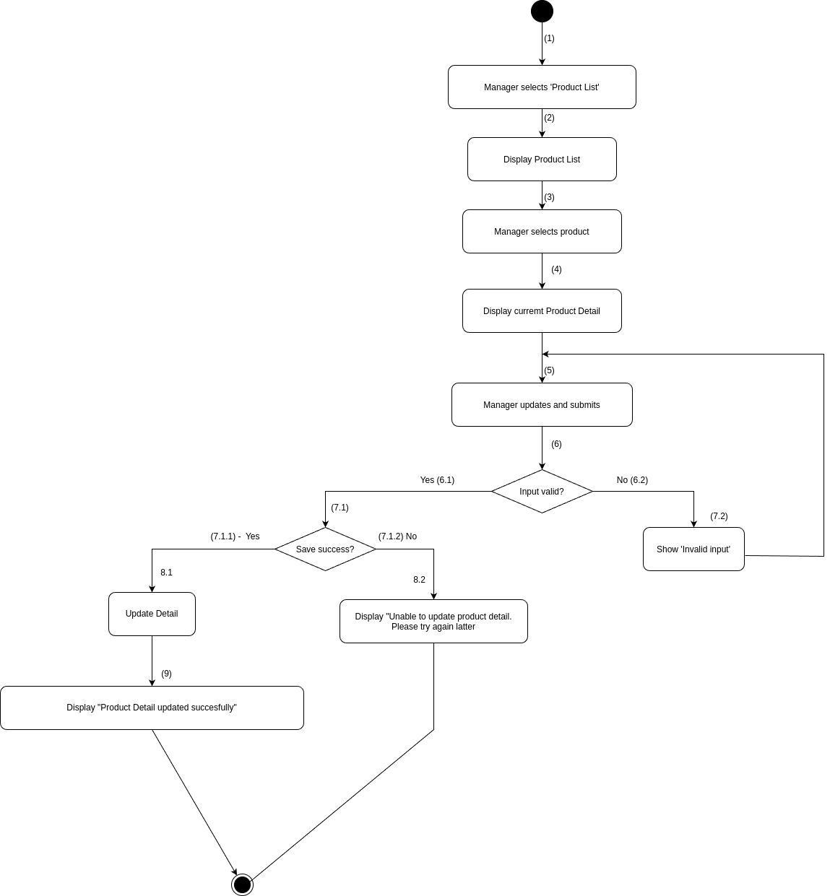

| **Step(s)** | **BR Code(s)** | **Description / Rule Enforcement** |
| --- | --- | --- |
| (1–3) | BR-88 | Only Store Managers with appropriate permissions can access and initiate product editing. |
| (5–6) | BR-89 | Updated product details must meet validation criteria (e.g., price must be positive). |

### UC 41: View order status

| **Use Case Specification** | | | |
| --- | --- | --- | --- |
| **Use Case ID and Name:** | UC 41: View order status | | |
| **Created By:** | Nguyễn Văn An | **Date Created:** | June-1, 2025 |
| **Primary Actor:** | Store Manager | **Secondary Actors:** |  |
| **Trigger:** | The patient indicates that he/she wants to view feedback or ratings submitted by patients for products. | | |
| **Description:** | The **"View feedback on products"** use case represents the process in which a **store manger** view feedback or ratings submitted by patients for products. The Manager selects the option to view feedback and reviews the comments and ratings. | | |
| **Preconditions:** | **PRE-1**: The Store Manager is logged into the system with appropriate authorization.  PRE-2: There is feedback available in the system. | | |
| **Post–conditions:** | **POST-1**: The Order is stored in the system  **POST-2**: Payment is recorded.  **POST-3**: Inventory is updated | | |
| **Normal Flow:** | 1. The Store Manager initiates the "View feedback on products" use case by selecting the "Product Feedback" menu on the system. 2. The system retrieves the list of feedback from the database. 3. The system displays the feedback, including product name, rating, and comments. 4. The Store Manager reviews the feedback. | | |
| **Alternative Flows:** | **1-AF:** No feedback available:  a. If there is no feedback, the system displays a message: "No feedback found."  b. The use case ends. | | |
| **Exceptions:** | **1-EF:**Data retrieval failure:  If the system fails to retrieve the feedback (e.g., due to database issues), it displays an error message: "Unable to load feedback. Please try again later." | | |
| **Priority:** | **Medium** | | |
| **Frequency of Use:** | Medium (used periodically to monitor product quality). | | |
| **Business Rules:** | **BR-90:** Feedback must be associated with a valid product. | | |
| **Other Information:** | Feedback is displayed in a read-only format. | | |
| **Assumptions:** | The Store Manager is trained to interpret feedback.  The system supports real-time feedback retrieval. | | |

**Activities Flow**

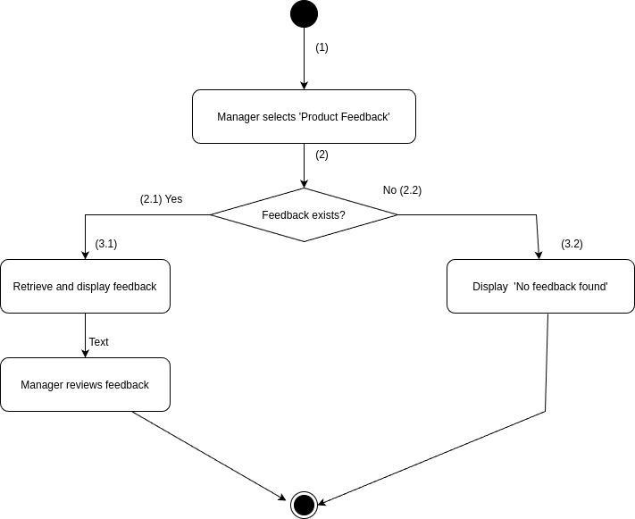

| **Step(s)** | **BR Code(s)** | **Description / Rule Enforcement** |
| --- | --- | --- |
| (2–3) | BR-90 | The system must ensure that all feedback displayed is linked to a valid product. |

### UC 42: Delete Feedback on Products

| **Use Case Specification** | | | |
| --- | --- | --- | --- |
| **Use Case ID and Name:** | UC 42: Delete Feedback on Products | | |
| **Created By:** | Nguyễn Văn An | **Date Created:** | June-1, 2025 |
| **Primary Actor:** | Store Manager | **Secondary Actors:** |  |
| **Trigger:** | The patient indicates that he/she wants to remove inappropriate or irrelevant product feedback. | | |
| **Description:** | The **"Delete feedback on products"** use case represents the process in which a **store manger** emove inappropriate or irrelevant product feedback. The Manager selects the feedback and confirms its deletion. | | |
| **Preconditions:** | PRE-1: The Store Manager is logged into the system with appropriate authorization.  PRE-2: There is feedback available in the system. | | |
| **Post–conditions:** | POST-1: The feedback is successfully removed from the system. | | |
| **Normal Flow:** | 1. The Store Manager initiates the "Delete feedback on products" use case by selecting the "Product Feedback" menu on the system. 2. The system displays the list of feedback. 3. The Store Manager selects a feedback to delete. 4. The Store Manager confirms the deletion. 5. The system removes the feedback from the database. 6. The system displays a confirmation message: "Feedback deleted successfully." | | |
| **Alternative Flows:** | **1-AF:** No feedback available:  a. If there is no feedback, the system displays a message: "No feedback found."  b. The use case ends. | | |
| **Exceptions:** | **1-EF:**Data retrieval failure:  If the system fails to retrieve the feedback (e.g., due to database issues), it displays an error message: "Unable to load feedback. Please try again later." | | |
| **Priority:** | **Medium** | | |
| **Frequency of Use:** | Low (used occasionally to manage feedback). | | |
| **Business Rules:** | **BR-91:** Only the Store Manager can delete product feedback.  **BR-92:** Deleted feedback is permanently removed from the system. | | |
| **Other Information:** | Deletion is irreversible and should be used with caution. | | |
| **Assumptions:** | The Store Manager is trained to identify inappropriate feedback.  The system supports secure feedback management. | | |

**Activities Flow**

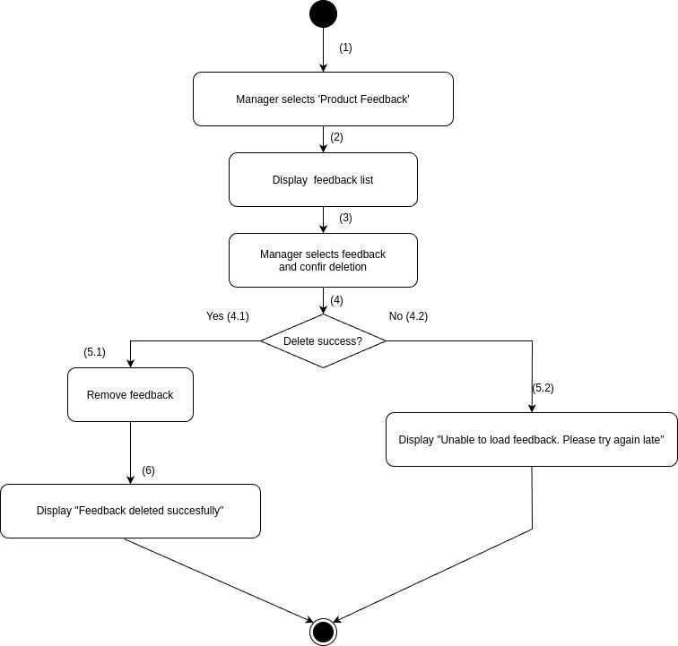

| **Step(s)** | **BR Code(s)** | **Description / Rule Enforcement** |
| --- | --- | --- |
| (1–3) | BR-91 | Only the Store Manager can access and select feedback to delete. |
| (5) | BR-92 | Deleted feedback must be permanently removed from the system. |

### UC 43: Ban User Account

| **Use Case Specification** | | | |
| --- | --- | --- | --- |
| **Use Case ID and Name:** | UC 43: Ban User Account | | |
| **Created By:** | Trần Thế Lượng | **Date Created:** | June 2, 2025 |
| **Primary Actor:** | Admin | **Secondary Actors:** |  |
| **Trigger:** | The administrator wants to ban a user account due to violations of system policies or upon request from upper management. | | |
| **Description:** | The "Ban User Accounts" use case describes the process in which an Admin disables a user account to prevent further access to the system. The Admin accesses the account management module, selects the account to be banned, and confirms the action. Once confirmed, the system deactivates the account and ensures that the user can no longer log in. The action is logged for audit and tracking purposes. | | |
| **Preconditions:** | **PRE-1**: The Admin is logged into the system with proper access rights.  **PRE-2**: The target user account exists in the system. | | |
| **Post–conditions:** | **POST-1**: The user account is deactivated and cannot be used to log in.  **POST-2**: The action is logged in the system for auditing. | | |
| **Normal Flow:** | 1. Admin accesses the "User Account Management" section.  2. Admin views the list of user accounts.  3. Admin selects the target user account.  4. System displays the account’s details..  5. Admin clicks the "Ban" or "Deactivate" button..  6. System prompts for confirmation.  7. Admin confirms the action.  8. System deactivates the account and updates the account status.  9. System logs the action with timestamp, admin ID, and reason (if provided).  10. Admin sees a success notification. | | |
| **Alternative Flows:** | **1-AF**: Account Already Banned If the selected account is already banned, the system notifies the Admin and disables the ban action.  Return to Step 2 of the Normal Flow. | | |
| **Exceptions:** | **1-EF**: System Communication Error  If the system is unable to process the request due to technical issues (e.g., database error or network outage), an error message is shown. The Admin may try again later or contact technical support. | | |
| **Priority:** | **Medium** | | |
| **Frequency of Use:** | **Medium** (used as needed for user management and enforcement) | | |
| **Business Rules:** | **BR-93**: Only Admins with appropriate permissions can ban user accounts.  **BR-94**: Banned users must not be allowed to log in under any circumstances.  **BR-95**: All banning actions must be recorded in the audit trail, including timestamp and the Admin who performed the action.  **BR-101**: Email must be unique in the system.  **BR-35**: Only the user who owns the account can delete it (except in cases where Admin has specific permissions). | | |
| **Other Information:** | * The system may support optional reasons for banning, select able from a predefined list or entered manually. * Banned users can be optionally notified via email or in-app message. * The interface may include search, filter, and export options for user account lists. * Admins may unban users if proper authorization is granted. | | |
| **Assumptions:** | · The system has a dedicated interface for account status management.  · The Admin understands the implications of banning user accounts and follows internal procedures before doing so. | | |

**Activities Flow**

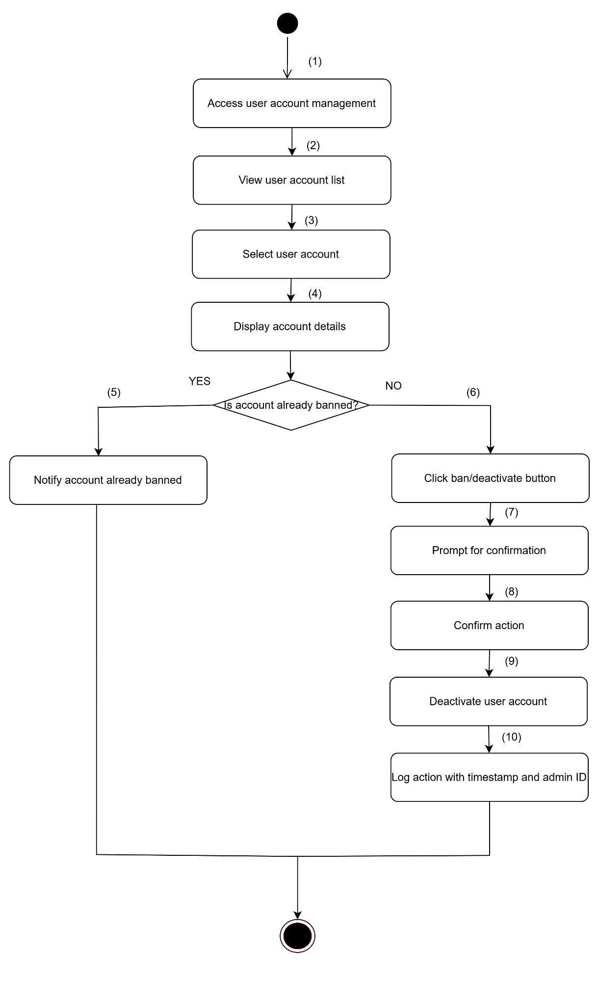

**Business Rules**

| **Step** | **BR Code(s)** | **Description** |
| --- | --- | --- |
| (1) | BR-93 | Only Admins with appropriate permissions can ban user accounts. |
| (5) | BR-94 | Banned users must not be allowed to log in under any circumstances. |
| (10) | BR-95 | All banning actions must be recorded in the audit trail, including timestamp and the Admin who performed the action. |
| (2), (3) | BR-101 | Email must be unique in the system. |
| (9) | BR-35 | Only the user who owns the account can delete it (except in cases where Admin has specific permissions). |

### UC 44: Create Service

| **Use Case Specification** | | | |
| --- | --- | --- | --- |
| **Use Case ID and Name:** | UC 44: Create Service | | |
| **Created By:** | Trần Thế Lượng | **Date Created:** | June 2, 2025 |
| **Primary Actor:** | Admin | **Secondary Actors:** |  |
| **Trigger**: | The Admin wants to add a new medical service to the system for use by doctors and patients. | | |
| **Description**: | This use case allows the Admin to create and register a new medical service (e.g., general consultation, laboratory test) in the system. The Admin inputs the service name, description, category, price, and any additional configuration. Once submitted, the service becomes available for selection in bookings and treatment records. | | |
| **Preconditions**: | **PRE-1**: Admin is logged into the system.  **PRE-2**: Admin has appropriate permissions to manage services. | | |
| **Post–conditions:** | **POST-1**: The new medical service is stored in the system.  **POST-2**: The service is available for use in bookings and treatments. | | |
| **Normal Flow:** | 1. Admin logs into the system.  2. Admin navigates to the “Medical Services” management section.  3. Admin selects “Add New Service.”  4. Admin fills in required fields (name, price, type, description, etc.).  5. Admin submits the form.  6. The system validates the input.  7. The system saves the service to the database.  8. A success message is displayed. | | |
| **Alternative Flows:** | **1-AF**: Missing or invalid input  a. The system highlights missing or invalid fields.  b. Admin corrects the input and resubmits. | | |
| **Exceptions**: | **1-EF**: Database error or system failure  The system shows: “Unable to create service. Please try again later.” | | |
| **Priority**: | **Medium** | | |
| **Frequency of Use:** | **Medium** (used when services are updated or added) | | |
| **Business Rules:** | **BR-96**: Service names must be unique.  **BR-97**: All services must include a valid price and category.  **BR-98**: Only Admins can create or modify services. | | |
| **Other Information:** | * Support for categorizing services (e.g., diagnosis, testing). * May include optional fields such as duration or insurance coverage. | | |
| **Assumptions:** | * The Admin has full access to the service management module. * The system is connected to a live database during creation. | | |

**Activities Flow**

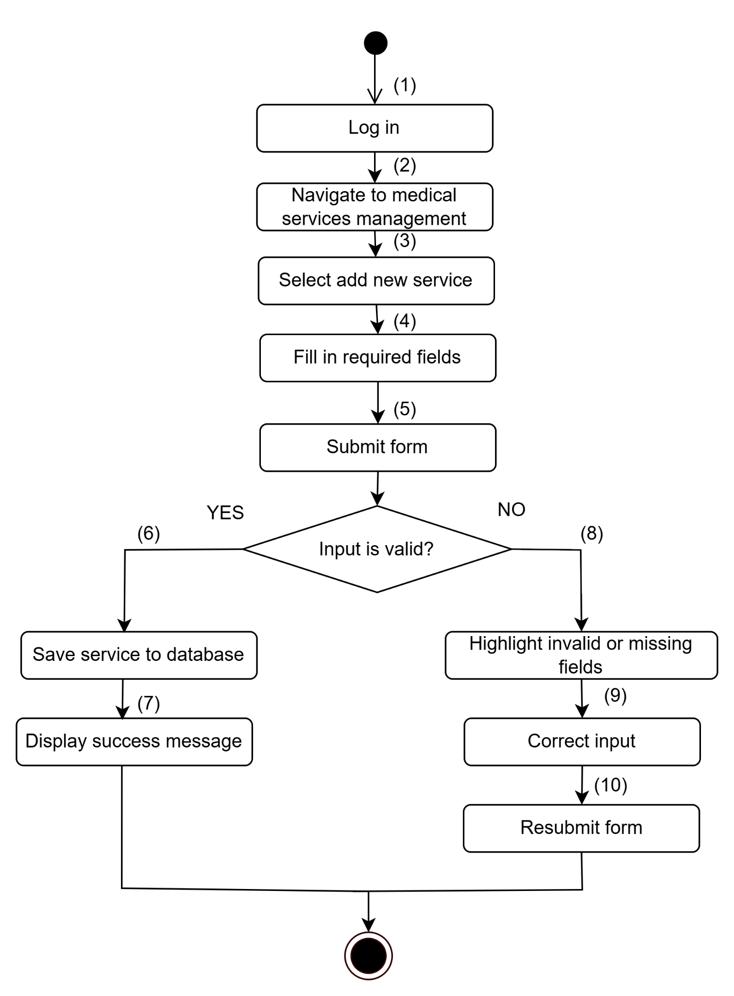

**Business Rules**

| **Step** | **BR Code(s)** | **Description** |
| --- | --- | --- |
| (4) | BR-96 | Service names must be unique. |
| (4) | BR-94 | All services must include a valid price and category. |
| (3) | BR-95 | Only Admins can create or modify services. |

### UC 45: Delete Medical Services

| **Use Case Specification** | | | |
| --- | --- | --- | --- |
| **Use Case ID and Name:** | UC 45: Delete Medical Services | | |
| **Created By:** | Trần Thế Lượng | **Date Created:** | June 2, 2025 |
| **Primary Actor:** | Admin | **Secondary Actors:** |  |
| **Trigger**: | The Admin wants to delete an existing medical service from the system that is no longer in use or valid. | | |
| **Description**: | This use case allows the Admin to remove an existing medical service from the system. The Admin selects a service from the list, reviews its details, and confirms the deletion. The system then removes the service, provided it is not linked to active appointments or patient records. | | |
| **Preconditions:** | **PRE-1**: Admin is logged into the system.  **PRE-2**: The service exists in the system.  **PRE-3**: The service is not currently used in any upcoming appointment or active treatment. | | |
| **Post–conditions:** | **POST-1**: The selected medical service is removed from the system.  **POST-2**: The service no longer appears in service selection lists. | | |
| **Normal Flow:** | 1. Admin logs into the system.  2. Admin navigates to the “Medical Services” management page.  3. Admin searches and selects the service to delete.  4. System shows a confirmation prompt.  5. Admin confirms deletion.  6. System checks for usage conflicts.  7. If there are no conflicts, the system deletes the service.  8. A confirmation message is displayed. | | |
| **Alternative Flows:** | **1-AF**: Service is in use  a. The system detects that the service is linked to existing appointments or records. b. The system displays: "This service cannot be deleted as it is currently in use." c. The use case ends. | | |
| **Exceptions**: | **1-EF**: System/database failure  The system shows: "Failed to delete service. Please try again later." | | |
| **Priority:** | **Medium** | | |
| **Frequency of Use:** | **Low to Medium** (only used during service lifecycle changes) | | |
| **Business Rules:** | **BR-99**: Services currently in use cannot be deleted.  **BR-100**: Deletion actions must be logged with timestamp and admin ID. | | |
| **Other Information:** | Consider using soft-delete (mark as inactive) instead of permanent deletion. | | |
| **Assumptions:** | * Admin has access to full service management rights. * Services are validated for dependencies before deletion. | | |

**Activities Flow**

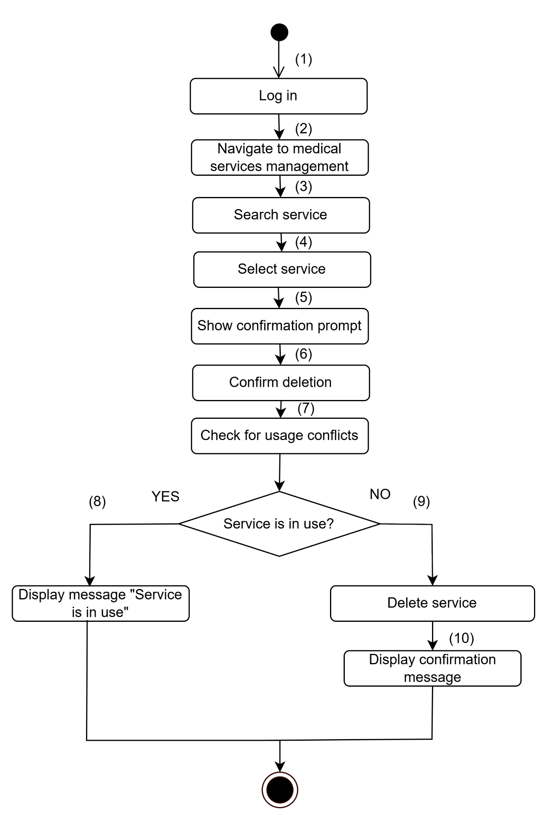

**Business Rules**

| **Step** | **BR Code(s)** | **Description** |
| --- | --- | --- |
| (8) | BR-99 | Services currently in use cannot be deleted. |
| (9) | BR-100 | Deletion actions must be logged with timestamp and admin ID. |

### UC 46: Create Staff

| **Use Case Specification** | | | |
| --- | --- | --- | --- |
| **Use Case ID and Name:** | UC 46: Create Staff | | |
| **Created By:** | Trần Thế Lượng | **Date Created:** | June 2, 2025 |
| **Primary Actor:** | Admin | **Secondary Actors:** |  |
| **Trigger:** | The Admin wants to create a new staff account in the system to grant access for work-related tasks. | | |
| **Description:** | This use case allows the Admin to add a new staff member into the system. The Admin provides personal and professional details such as name, role, contact information, and system login credentials. The system validates and stores the data, then creates an account for the staff. | | |
| **Preconditions:** | **PRE-1**: Admin is logged into the system.  **PRE-2**: The required fields for staff creation are prepared (e.g., name, email, role). | | |
| **Post–conditions:** | **POST-1**: A new staff profile and login account are successfully created.  **POST-2**: The staff member is now visible in the staff management list. | | |
| **Normal Flow:** | 1. Admin logs into the system.  2. Admin navigates to “Staff Management.”  3. Admin clicks “Create New Staff.”  4. Admin enters required information (e.g., name, email, phone, position, role).  5. Admin submits the form.  6. The system validates input data.  7. The system creates the new staff account.  8. A confirmation message is displayed. | | |
| **Alternative Flows:** | **1-AF**: Missing or invalid input  a. The system detects missing or invalid data (e.g., invalid email).  b. The system highlights the fields and shows an error message: "Please enter valid information."  c. Admin corrects the input and resubmits. | | |
| **Exceptions:** | **1-EF**: System or database error  The system shows: "Unable to create a staff account. Please try again later." | | |
| **Priority:** | **High** | | |
| **Frequency of Use:** | **Medium** (used mainly when onboarding new staff members) | | |
| **Business Rules:** | **BR-101**: Email must be unique in the system.  **BR-102**: Admin can assign roles (e.g., Doctor, Nurse, Receptionist, Pharmacist).  **BR-103**: Passwords must meet the security policy. | | |
| **Other Information:** | A welcome email can be automatically sent to the staff upon creation. | | |
| **Assumptions:** | * Admin has permission to manage staff accounts. * Network and database services are operational. | | |

**Activities Flow**

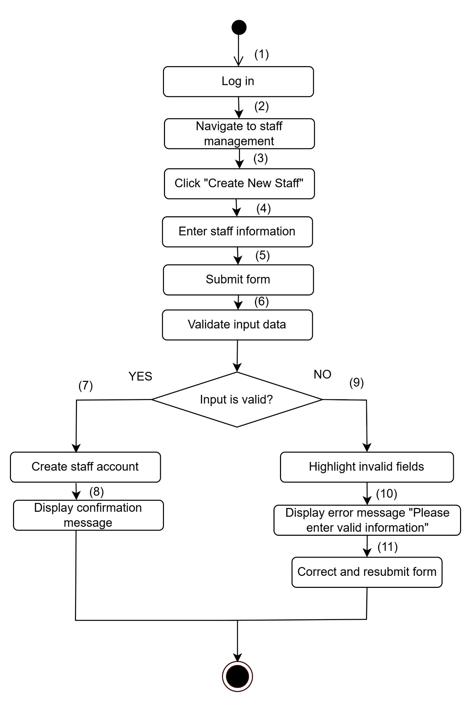

**Business Rules**

| **Step** | **BR Code(s)** | **Description** |
| --- | --- | --- |
| (4) | BR-101 | Email must be unique in the system. |
| (7) | BR-102 | Admin can assign roles (e.g., Doctor, Nurse, Receptionist, Pharmacist). |
| (4) | BR-103 | Passwords must meet the security policy. |

### UC 47: Delete Staff

| **Use Case Specification** | | | |
| --- | --- | --- | --- |
| **Use Case ID and Name:** | UC 47: Delete Staff | | |
| **Created By:** | Trần Thế Lượng | **Date Created:** | June 2, 2025 |
| **Primary Actor:** | Admin | **Secondary Actors:** |  |
| **Trigger:** | The Admin decides to remove a staff member who no longer works at the clinic. | | |
| **Description:** | This use case allows the Admin to delete an existing staff account from the system. The Admin selects the staff member from the staff list and confirms the deletion. The system removes the staff profile and revokes access. | | |
| **Preconditions:** | **PRE-1**: Admin is logged into the system.  **PRE-2**: The staff member exists in the system. | | |
| **Post–conditions:** | **POST-1**: The staff account is removed from the system.  **POST-2**: The deleted staff member no longer has system access. | | |
| **Normal Flow:** | 1. Admin logs into the system.  2. Admin navigates to “Staff Management.”  3. Admin selects the staff member to delete.  4. Admin clicks “Delete” and confirms the action.  5. The system deletes the staff account.  6. A success message is displayed. | | |
| **Alternative Flows:** | **1-AF**: Attempt to delete currently active staff  a. The system shows a warning: "The selected staff member is currently assigned to active tasks."  b. Admin must reassign tasks before deletion. | | |
| **Exceptions**: | **1-EF**: System or database error  The system displays: "Error deleting staff. Please try again later." | | |
| **Priority**: | **High** | | |
| **Frequency of Use:** | **Low** (only used during staff off boarding or cleanup) | | |
| **Business Rules:** | **BR-104**: Only Admins can delete staff accounts.  **BR-105**: Staff linked to ongoing appointments or tasks must be reassigned before deletion. | | |
| **Other Information:** | Deletion may be soft-delete for audit purposes. | | |
| **Assumptions:** | * Admin has permission to manage and delete staff. * Staff data is correctly maintained and referenced. | | |

**Activities Flow**

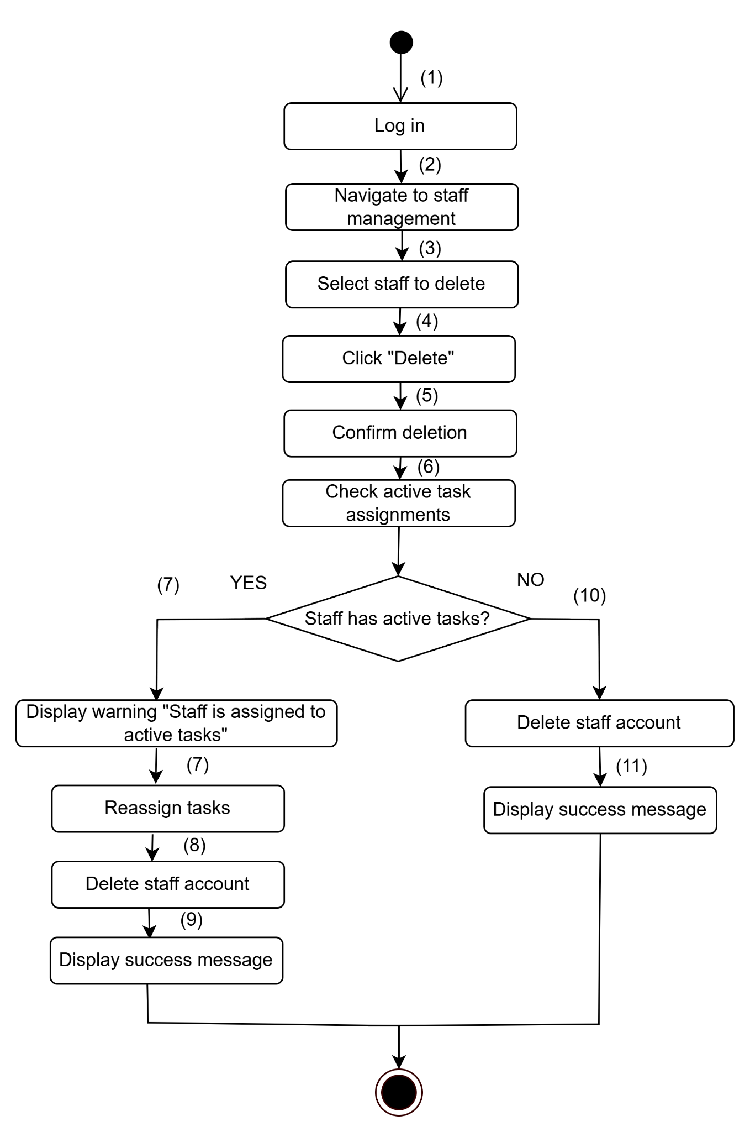

**Business Rules**

| **Step** | **BR Code(s)** | **Description** |
| --- | --- | --- |
| (4) | BR-104 | Only Admins can delete staff accounts. |
| (7) | BR-105 | Staff linked to ongoing appointments or tasks must be reassigned before deletion. |

### UC 48: View Appointment Reports

| **Use Case Specification** | | | |
| --- | --- | --- | --- |
| **Use Case ID and Name:** | UC 48: View Appointment Report | | |
| **Created By:** | Trần Thế Lượng | **Date Created:** | June 2, 2025 |
| **Primary Actor:** | Admin | **Secondary Actors:** |  |
| **Trigger:** | The Admin wants to analyze and monitor appointment data across the clinic. | | |
| **Description:** | This use case allows the Admin to view reports about patient appointments, such as total appointments per day/week/month, appointment status distribution, and doctor workload. These reports assist in administrative decision-making and performance monitoring. | | |
| **Preconditions:** | **PRE-1**: Admin is logged into the system.  **PRE-2**: Appointment data exists in the system. | | |
| **Post–conditions:** | **POST-1**: Appointment report is displayed on screen.  **POST-2**: Admin can export or filter the report if needed. | | |
| **Normal Flow:** | 1. Admin logs into the system.  2. Admin navigates to “Reports” > “Appointment Reports.”  3. Admin selects filters (date range, doctor, service).  4. System generates and displays the appointment report.  5. Admin can view, print, or export the report. | | |
| **Alternative Flows:** | **1-AF**: No appointment data for selected filter  a. System displays: "No appointment data found for selected criteria."  b. Admin may change filter options. | | |
| **Exceptions:** | **1-EF**: Report generation failure due to system error  System shows: "Unable to generate report. Please try again later." | | |
| **Priority:** | **Medium** | | |
| **Frequency of Use:** | **Medium** (used weekly or monthly for operational review) | | |
| **Business Rules:** | **BR-106**: Only Admin can access and view full reports. **BR-107**: Report data must reflect real-time updates. | | |
| **Other Information:** | Export options (Excel/PDF) are available. | | |
| **Assumptions:** | The system has access to complete and up-to-date appointment records. | | |

**Activities Flow**

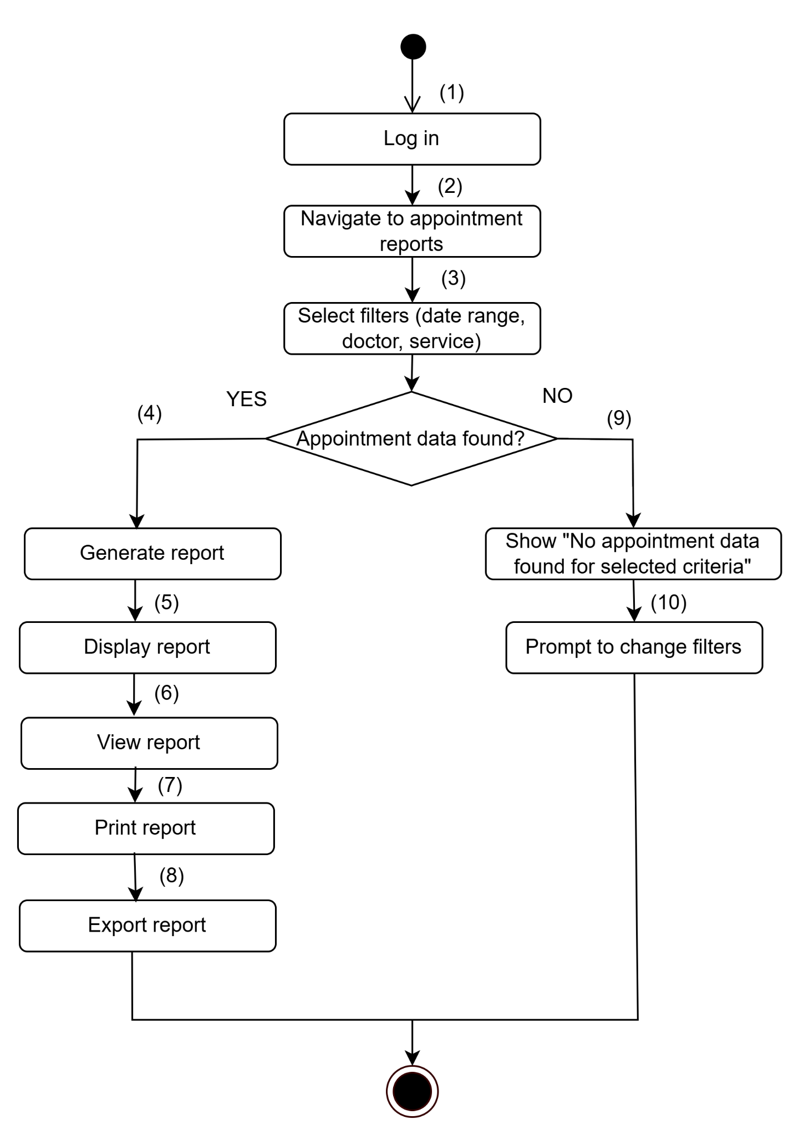

**Business Rules**

| **Step** | **BR Code(s)** | **Description** |
| --- | --- | --- |
| (2), (3) | BR-106 | Only Admin can access and view full reports. |
| (4) | BR-107 | Report data must reflect real-time updates. |

### UC 49: View Products Sales Statistics

| **Use Case Specification** | | | |
| --- | --- | --- | --- |
| **Use Case ID and Name:** | UC 49: View Products Sales Statistics | | |
| **Created By:** | Trần Thế Lượng | **Date Created:** | June 2, 2025 |
| **Primary Actor:** | Admin | **Secondary Actors:** | Store Manager |
| **Trigger:** | The Admin wants to review sales performance of medical products. | | |
| **Description:** | This use case enables the Admin to view statistical reports of product sales, including quantity sold, revenue generated, and top-selling products. It supports data analysis for inventory planning and business decision-making. | | |
| **Preconditions:** | **PRE-1**: Admin is logged into the system.  **PRE-2**: Product sales data exists in the system. | | |
| **Post–conditions:** | **POST-1**: Sales statistics are displayed successfully.  **POST-2**: Admin can export or filter data for reporting purposes. | | |
| **Normal Flow:** | 1. Admin logs into the system.  2. Admin navigates to “Reports” > “Product Sales Statistics.”  3. Admin selects a date range or specific product category.  4. System retrieves and displays sales data with charts/tables.  5. Admin can filter, sort, print, or export the report. | | |
| **Alternative Flows:** | **1-AF**: No sales data for the selected range  a. System displays message: “No product sales data available for the selected period.” b. Admin can adjust the filter and retry. | | |
| **Exceptions:** | **1-EF**: Data retrieval error due to system issue  System shows: “Failed to load sales statistics. Please try again later.” | | |
| **Priority:** | **Medium** | | |
| **Frequency of Use:** | **Medium** (e.g., weekly or monthly for analysis) | | |
| **Business Rules:** | **BR-108**: Sales data must be synchronized with completed orders. | | |
| **Other Information:** | Export to Excel or PDF is supported. | | |
| **Assumptions:** | Sales transactions are logged correctly and available in the database. | | |

**Activities Flow**

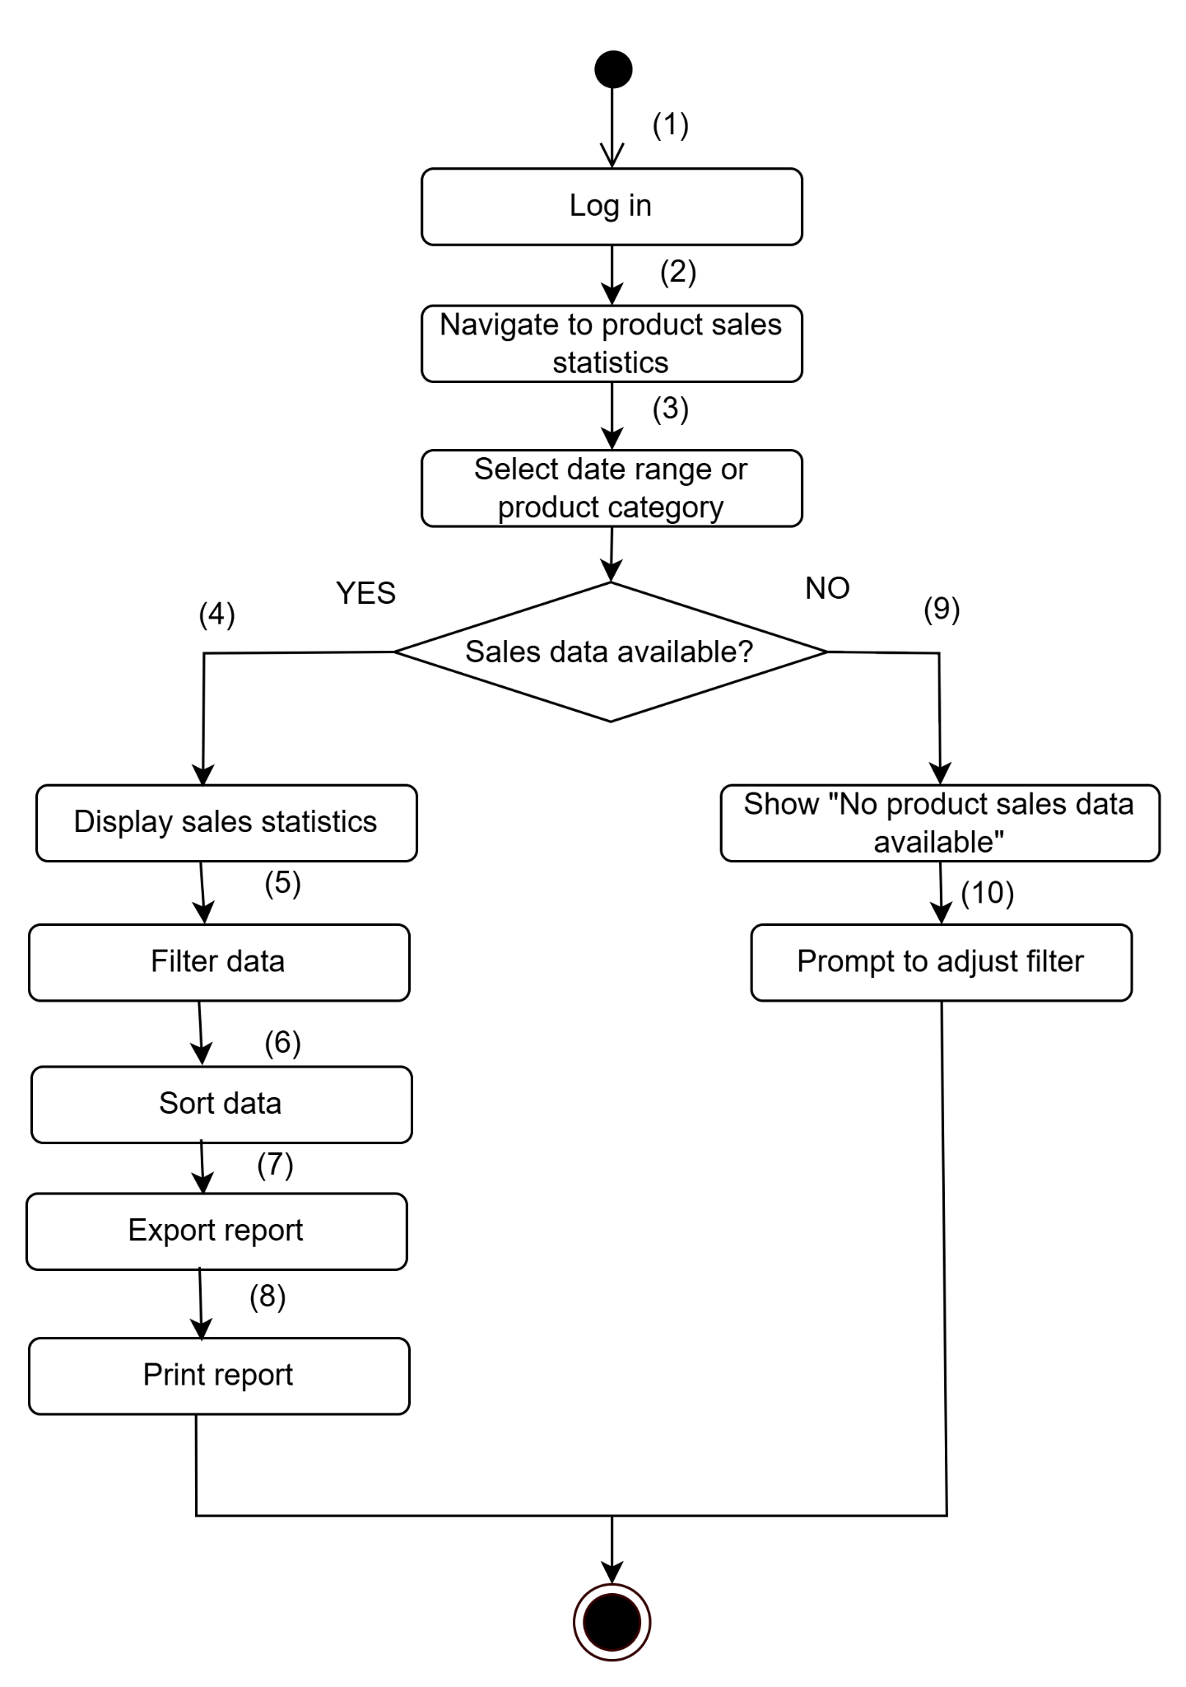

**Business Rules**

| **Step** | **BR Code(s)** | **Description** |
| --- | --- | --- |
| (4), (7) | BR-108 | Sales data must be synchronized with completed orders. |

### UC 50: Create Patient Records

| **Use Case Specification** | | | |
| --- | --- | --- | --- |
| **Use Case ID and Name:** | UC 50: Create Patient Records | | |
| **Created By:** | Trần Thế Lượng | **Date Created:** | June 2, 2025 |
| **Primary Actor:** | Doctor | **Secondary Actors:** |  |
| **Trigger:** | A doctor needs to create a new patient record after initial examination or upon patient registration. | | |
| **Description:** | This use case allows a doctor to create a new patient record in the system, including essential personal information, medical history, diagnosis, and initial treatment plan. This data is stored for future reference and ongoing treatment. | | |
| **Preconditions:** | **PRE-1**: Doctor is logged into the system.  **PRE-2**: The patient is registered or present in the clinic. | | |
| **Post–conditions:** | **POST-1**: A new patient record is created and stored in the system.  **POST-2**: Patient data becomes accessible to authorized medical staff. | | |
| **Normal Flow:** | 1. Doctor logs into the system. 2. Doctor navigates to “Patient Management” > “Create New Record.” 3. Doctor fills in patient details:   • Name, age, gender, contact  • Medical history  • Current symptoms/diagnosis  • Initial treatment plan   1. Doctor submits the form. 2. System saves the record and confirms creation. | | |
| **Alternative Flows:** | 1-AF: Required fields are missing  a. System prompts doctor to complete all mandatory fields before submission. | | |
| **Exceptions:** | **1-EF**: System error or database failure  System shows: “Failed to create patient record. Please try again later.” | | |
| **Priority:** | **High** | | |
| **Frequency of Use:** | **High** (used for each new patient or first-time visit) | | |
| **Business Rules:** | **BR-109**: Only authorized doctors can create new patient records.  **BR-110**: Patient ID must be unique and auto-generated by the system. | | |
| **Other Information:** | Templates can be used to speed up data entry. | | |
| **Assumptions:** | Doctors are trained to input complete and accurate data. | | |

**Activities Flow**

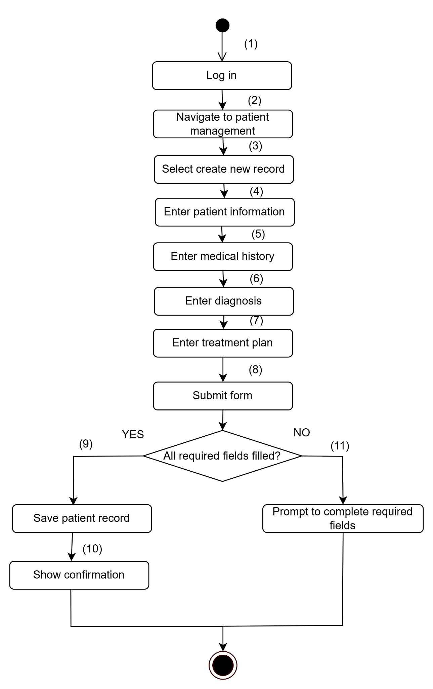

**Business Rules**

| **Step** | **BR Code(s)** | **Description** |
| --- | --- | --- |
| (3) | BR-109 | Only authorized doctors can create new patient records. |
| (9) | BR-110 | Patient ID must be unique and auto-generated by the system. |

### UC 51: View Service Feedback

| **Use Case Specification** | | | |
| --- | --- | --- | --- |
| **Use Case ID and Name:** | UC 51: View Service Feedback | | |
| **Created By:** | Trần Thế Lượng | **Date Created:** | June 2, 2025 |
| **Primary Actor:** | Doctor | **Secondary Actors:** |  |
| **Trigger:** | A doctor wants to review patient feedback on medical services they have provided. | | |
| **Description:** | This use case allows doctors to view feedback or ratings submitted by patients regarding medical services. Feedback includes comments, ratings, and service experience to help doctors improve care quality. | | |
| **Preconditions:** | **PRE-1**: Doctor is logged into the system.  **PRE-2**: Feedback data has been submitted by patients. | | |
| **Post–conditions:** | **POST-1**: The doctor successfully views available feedback. | | |
| **Normal Flow:** | 1. Doctor logs into the system.  2. Doctor navigates to the “Feedback” or “Service Review” section.  3. The system displays a list of feedback items related to the doctor’s services.  4. Doctor reads individual feedback entries.  5. Doctor may filter feedback by date, rating, or service. | | |
| **Alternative Flows:** | **1-AF**: No feedback available  a. The system shows the message: “No feedback found.”  b. The use case ends. | | |
| **Exceptions:** | **1-EF**: Feedback loading error  System shows: “Unable to load feedback. Please try again later.” | | |
| **Priority:** | **Medium** | | |
| **Frequency of Use:** | **Medium** (used occasionally for quality review) | | |
| **Business Rules:** | **BR-111**: Doctors can only view feedback related to services they provided.  **BR-112**: Feedback cannot be edited or deleted by doctors. | | |
| **Other Information:** | Feedback may be anonymized to protect patient identity. | | |
| **Assumptions:** | Feedback is stored securely and updated in real time. | | |

**Activities Flow**

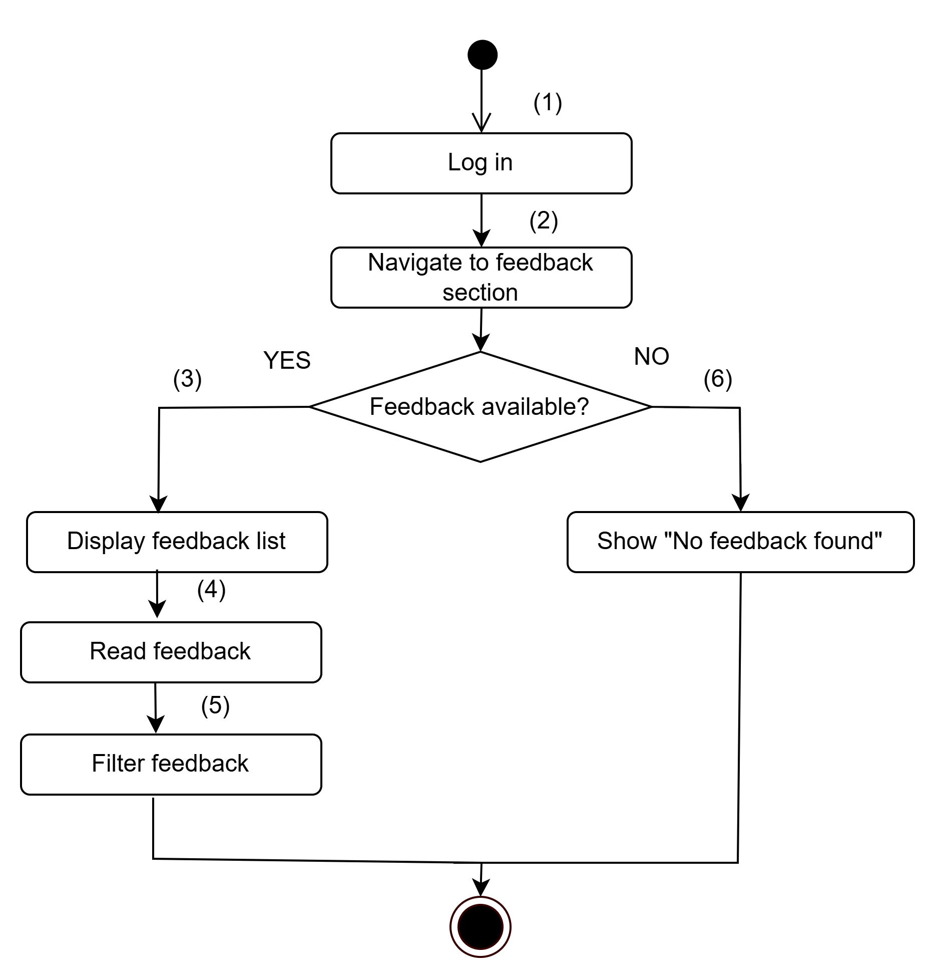

**Business Rules**

| **Step** | **BR Code(s)** | **Description** |
| --- | --- | --- |
| (3), (4) | BR-111 | Doctors can only view feedback related to services they provided. |
| (4), (5) | BR-112 | Feedback cannot be edited or deleted by doctors. |

### UC 52: Update Patient Records

| Use Case Specification | | | |
| --- | --- | --- | --- |
| **Use Case ID and Name:** | UC 52: Update Patient Records | | |
| **Created By:** | Trần Thế Lượng | **Date Created:** | June 2, 2025 |
| **Primary Actor:** | Doctor | **Secondary Actors:** |  |
| **Trigger:** | The doctor needs to update or add information to a patient’s medical record after consultation or treatment. | | |
| **Description:** | This use case describes how a doctor accesses and modifies a patient's existing medical record. The doctor can update diagnoses, prescriptions, treatment notes, and test results. These updates help maintain accurate and current patient health information. | | |
| **Preconditions:** | **PRE-1**: The doctor is authenticated and logged into the system.  **PRE-2**: The patient has an existing medical record in the system. | | |
| **Post–conditions:** | **POST-1**: The updated patient record is saved successfully in the system.  **POST-2**: A timestamp and doctor’s ID are recorded with the update. | | |
| **Normal Flow:** | 1. The doctor logs into the system.  2. The doctor searches for the patient’s profile using ID or name.  3. The system displays the existing patient record.  4. The doctor selects the section to update (e.g., diagnosis, prescription).  5. The doctor enters updated information.  6. The doctor reviews and confirms the changes.  7. The system saves the updated record and shows a confirmation. | | |
| **Alternative Flows:** | **1-AF**: No existing patient record found  a. The system displays: “No medical record found for this patient.”  b. The doctor may choose to create a new record (if authorized). | | |
| **Exceptions:** | **1-EF**: System error while saving record  The system displays: “Failed to update record. Please try again.” | | |
| **Priority:** | **High** | | |
| **Frequency of Use:** | **High** (used daily in consultations and follow-ups) | | |
| **Business Rules:** | **BR-113**: Only doctors can update medical records. **BR-114**: All updates must be logged with user ID and timestamp. **BR-115**: The system must maintain version history for audit purposes. | | |
| **Other Information:** | Fields like patient ID, name, and DOB are non-editable to prevent data corruption. | | |
| **Assumptions:** | The doctor is using a secure, clinic-approved device with authorized access. | | |

**Activities Flow**

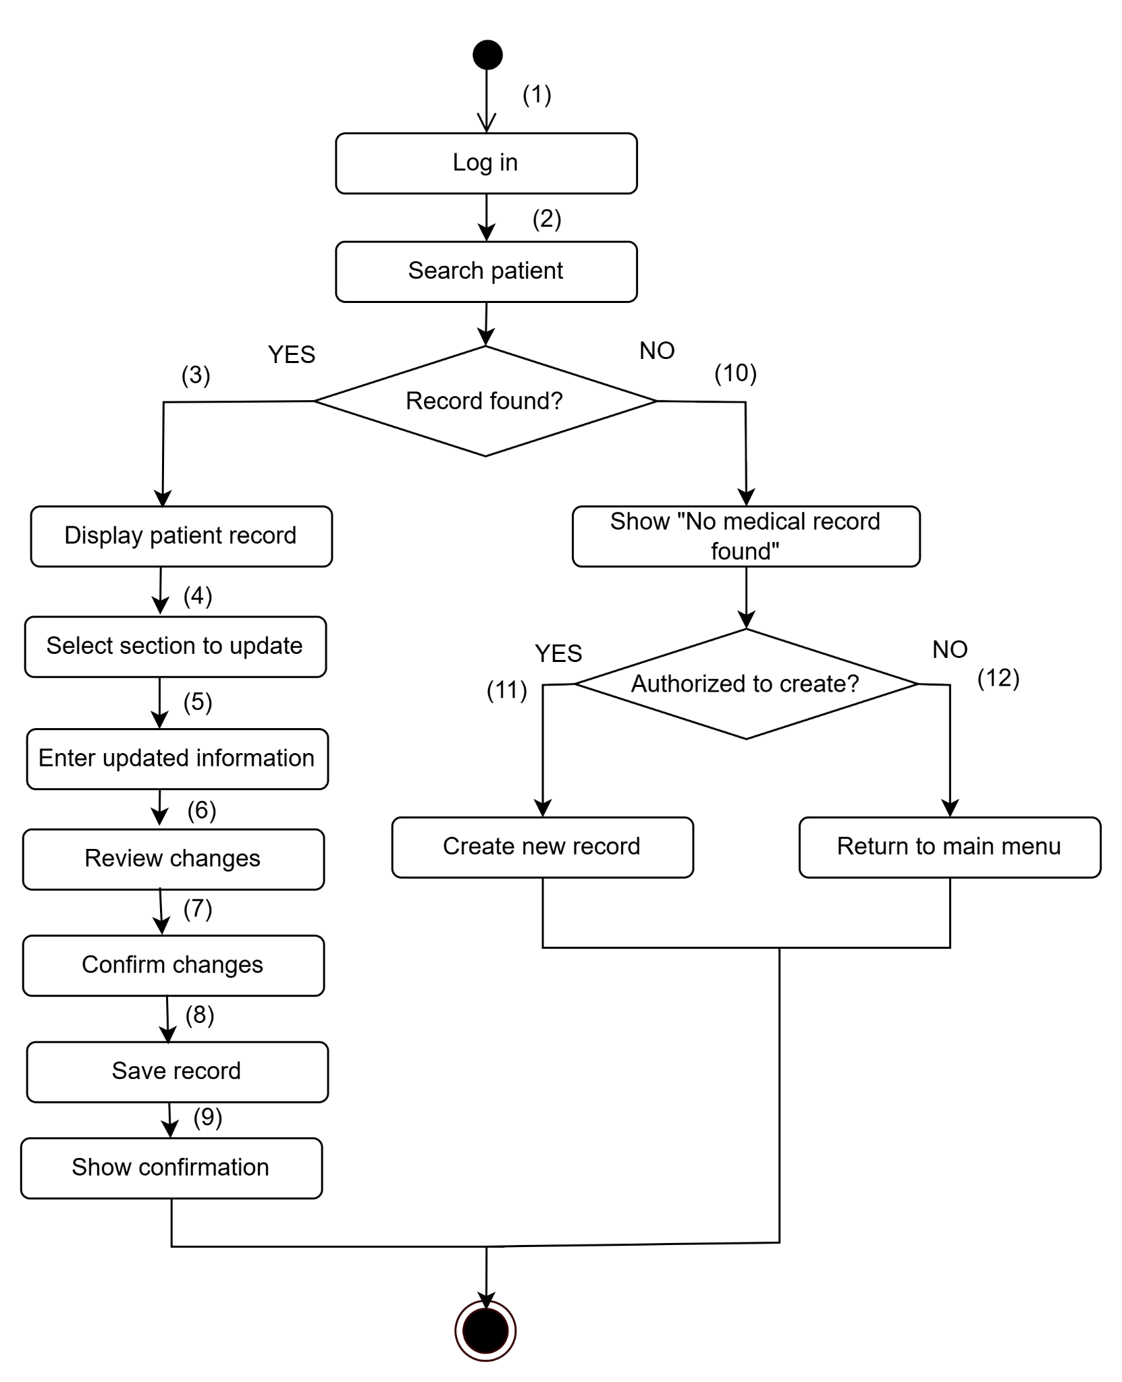

**Business Rules**

| **Step** | **BR Code(s)** | **Description** |
| --- | --- | --- |
| (4), (5) | BR-113 | Only doctors can update medical records. |
| (8) | BR-114 | All updates must be logged with user ID and timestamp. |
| (8) | BR-115 | The system must maintain version history for audit purposes. |

### UC 53: View Patient Record History

| **Use Case Specification** | | | |
| --- | --- | --- | --- |
| **Use Case ID and Name:** | UC 53: View Patient Record History | | |
| **Created By:** | Trần Thế Lượng | **Date Created:** | June 2, 2025 |
| **Primary Actor:** | Doctor | **Secondary Actors:** |  |
| **Trigger:** | The doctor wants to review the medical history of a patient before consultation or treatment. | | |
| **Description:** | This use case allows the doctor to access and view a patient’s complete medical record history, including past diagnoses, prescriptions, lab results, treatments, and updates made by authorized personnel. It supports clinical decision-making and continuity of care. | | |
| **Preconditions:** | **PRE-1**: The doctor is logged into the system with proper credentials.  **PRE-2**: The patient has a medical record stored in the system. | | |
| **Post–conditions:** | **POST-1**: The patient’s full medical history is displayed.  **POST-2**: The doctor can browse by date, visit, or category (e.g., diagnosis, treatment). | | |
| **Normal Flow:** | 1. The doctor logs into the system. 2. The doctor searches for a specific patient by ID or name. 3. The system locates and displays the patient’s profile. 4. The doctor clicks on “Medical History” or equivalent option. 5. The system shows a chronological list of records including visit dates and record types. 6. The doctor selects a record to view detailed information. 7. The system displays the selected record. | | |
| **Alternative Flows:** | **1-AF**: No medical history available  a. The system displays: “No historical records found for this patient.”  b. The doctor may choose to create an initial record if needed. | | |
| **Exceptions:** | **1-EF**: System or database failure  The system displays: “Unable to load patient history. Please try again later.” | | |
| **Priority:** | **High** | | |
| **Frequency of Use:** | **Medium to High** (commonly used before or during appointments) | | |
| **Business Rules:** | **BR-116**: Only authorized doctors can view full record history. **BR-117**: Patients have read-only access if permitted by role settings. **BR-118**: The system must prevent modification of historical entries. | | |
| **Other Information:** | Historical records may include filters by time range, treatment type, or visit reason. | | |
| **Assumptions:** | The doctor is using a secure terminal with stable system access, and patient data is up-to-date. | | |

**Activities Flow**

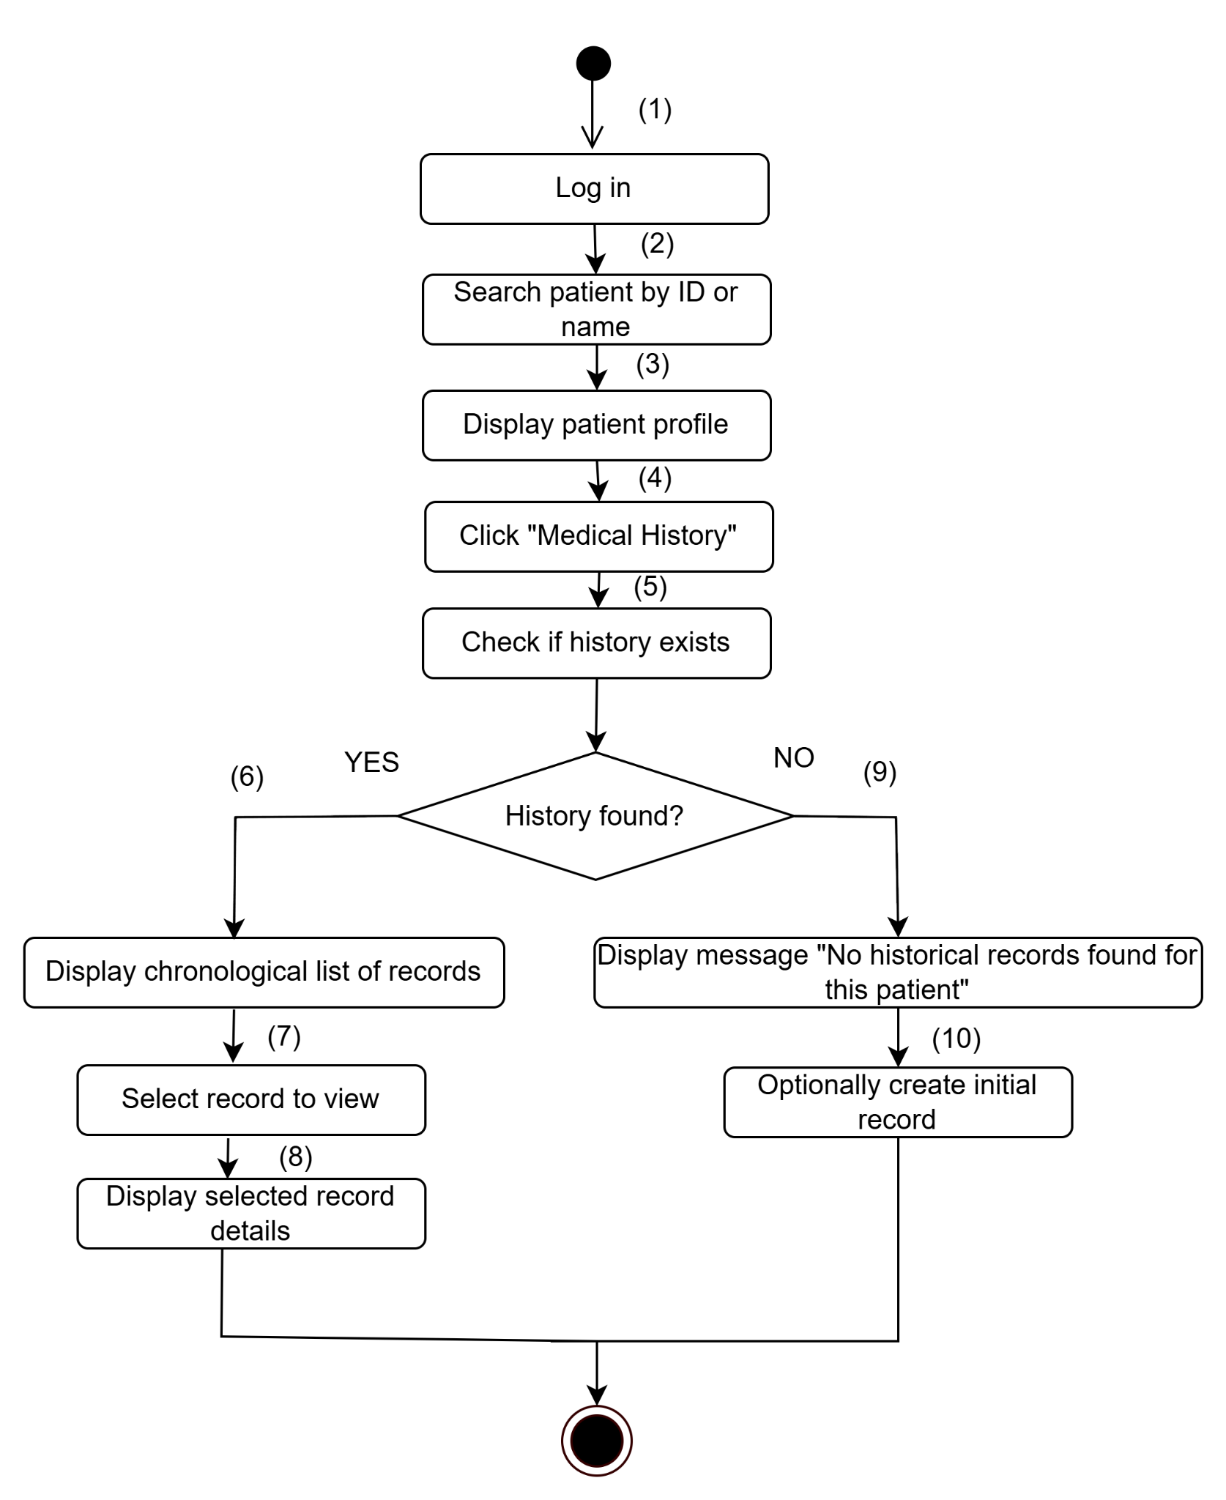

**Business Rules**

| **Step** | **BR Code(s)** | **Description** |
| --- | --- | --- |
| (4), (5), (6) | BR-116 | Only authorized doctors can view full record history. |
| (3), (8) | BR-117 | Patients have read-only access if permitted by role settings. |
| (6), (8) | BR-118 | The system must prevent modification of historical entries. |

### UC 54: Give Appointment for Re-examination

| Use Case Specification | | | |
| --- | --- | --- | --- |
| **Use Case ID and Name:** | UC 54: Give Appointment for Re-examination | | |
| **Created By:** | Trần Thế Lượng | **Date Created:** | June 2, 2025 |
| **Primary Actor:** | Doctor | **Secondary Actors:** | Patient, Receptionist |
| **Trigger:** | The doctor decides that the patient needs a follow-up or re-examination and wants to schedule the next appointment. | | |
| **Description:** | This use case allows a doctor to schedule a follow-up (re-examination) appointment for a patient after a consultation or treatment. The appointment includes the date, time, assigned service, and any special notes. The patient may receive confirmation or reminders through the system. | | |
| **Preconditions:** | **PRE-1**: The doctor is logged into the system.  **PRE-2**: The patient has an active record in the system.  **PRE-3**: A previous appointment or treatment session has been completed. | | |
| **Post–conditions:** | **POST-1**: A re-examination appointment is created and saved.  **POST-2**: The patient is notified of the appointment details. | | |
| **Normal Flow:** | 1. The doctor logs into the system. 2. The doctor opens the patient’s medical record. 3. The doctor selects “Schedule Re-examination” or similar option. 4. The system prompts for date, time, medical service, and optional notes. 5. The doctor fills in the re-examination details and confirms. 6. The system saves the new appointment and links it to the patient’s profile. 7. The patient is notified (e.g., via system notification, SMS, or email). | | |
| **Alternative Flows:** | **1-AF**: Selected time slot is unavailable  a. The system displays: “Selected slot is already booked.”  b. The doctor selects a different time or date.  c. Return to Step 5 of Normal Flow. | | |
| **Exceptions:** | **1-EF**: System error or database connection failure  The system displays: “Unable to schedule an appointment at this time. Please try again later.” | | |
| **Priority:** | **High** | | |
| **Frequency of Use:** | **Medium** (used after most treatments requiring follow-up) | | |
| **Business Rules:** | **BR-119**: Only doctors can schedule re-examinations. **BR-120**: Time slots must not conflict with other appointments. **BR-121**: Patients must be notified once the re-examination is scheduled. | | |
| **Other Information:** | Reminders can be auto-generated 1 day before the appointment. | | |
| **Assumptions:** | The system calendar is up-to-date and synchronized with other bookings. | | |

**Activities Flow**

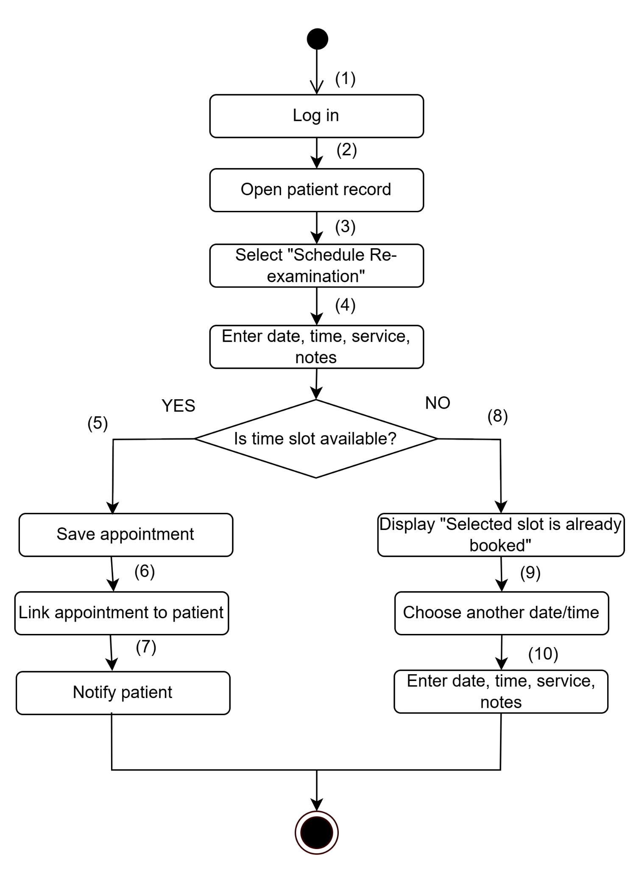

**Business Rules**

| **Step** | **BR Code(s)** | **Description** |
| --- | --- | --- |
| (3) | BR-119 | Only doctors can schedule re-examinations. |
| (5) | BR-120 | Time slots must not conflict with other appointments. |
| (7) | BR-121 | Patients must be notified once the re-examination is scheduled. |

### UC 55: Add Service During Appointment

| Use Case Specification | | | |
| --- | --- | --- | --- |
| **Use Case ID and Name:** | UC 55: Add Service During Appointment | | |
| **Created By:** | Trần Thế Lượng | **Date Created:** | June 2, 2025 |
| **Primary Actor:** | Doctor | **Secondary Actors:** | Receptionist |
| **Trigger:** | During an ongoing appointment, the doctor identifies the need for additional medical services (e.g., eye imaging, pressure test) and decides to add them based on the diagnosis or patient condition. | | |
| **Description:** | This use case enables a doctor to add additional services to an ongoing appointment. These services are selected based on clinical needs and are appended to the current session, so they can be scheduled or executed immediately if time permits, or assigned to a follow-up session. | | |
| **Preconditions:** | **PRE-1:** The doctor is logged into the system with valid credentials.  **PRE-2:** There is an ongoing appointment for a patient.  **PRE-3:** The system has a list of medical services that can be added dynamically. | | |
| **Post–conditions:** | **POST-1:** The selected service(s) are successfully appended to the appointment record.  **POST-2:** The billing and patient record are updated to reflect the added services. | | |
| **Normal Flow:** | 1. Doctor is in session with the patient and has access to the appointment details on the system. 2. Doctor identifies a need for an additional service. 3. Doctor clicks "Add Service" option within the appointment interface. 4. System displays a list of available medical services. 5. Doctor selects one or more services and confirms. 6. System updates the current appointment record with the selected services. 7. System reflects changes in billing and patient service history. | | |
| **Alternative Flows:** | **1-AF**: Service unavailable or fully booked  a. Doctor selects a service that is currently not available.  b. System notifies: “Selected service is currently unavailable. Please choose another time or service.”  c. Doctor may choose to assign the service to a follow-up appointment or cancel the selection. | | |
| **Exceptions:** | **1-EF**: System timeout or failure  System shows error: "Unable to add service at the moment. Please try again later." | | |
| **Priority:** | **High** | | |
| **Frequency of Use:** | **Medium** (depends on case-by-case diagnosis) | | |
| **Business Rules:** | **BR-122**: Only users with the "doctor" role can add services during appointments. **BR-123**: Services added during an appointment must be logged with timestamps and reasons. **BR-124**: Services must not be duplicated in the same session unless medically necessary and justified. | | |
| **Other Information:** | If necessary, added services can trigger real-time notifications to nurses or technicians for immediate processing. | | |
| **Assumptions:** | * The system supports real-time appointment updates. * The added services are linked to patient billing and records automatically. * The facility has enough equipment/time to handle additional services during an appointment. | | |

**Activities Flow**

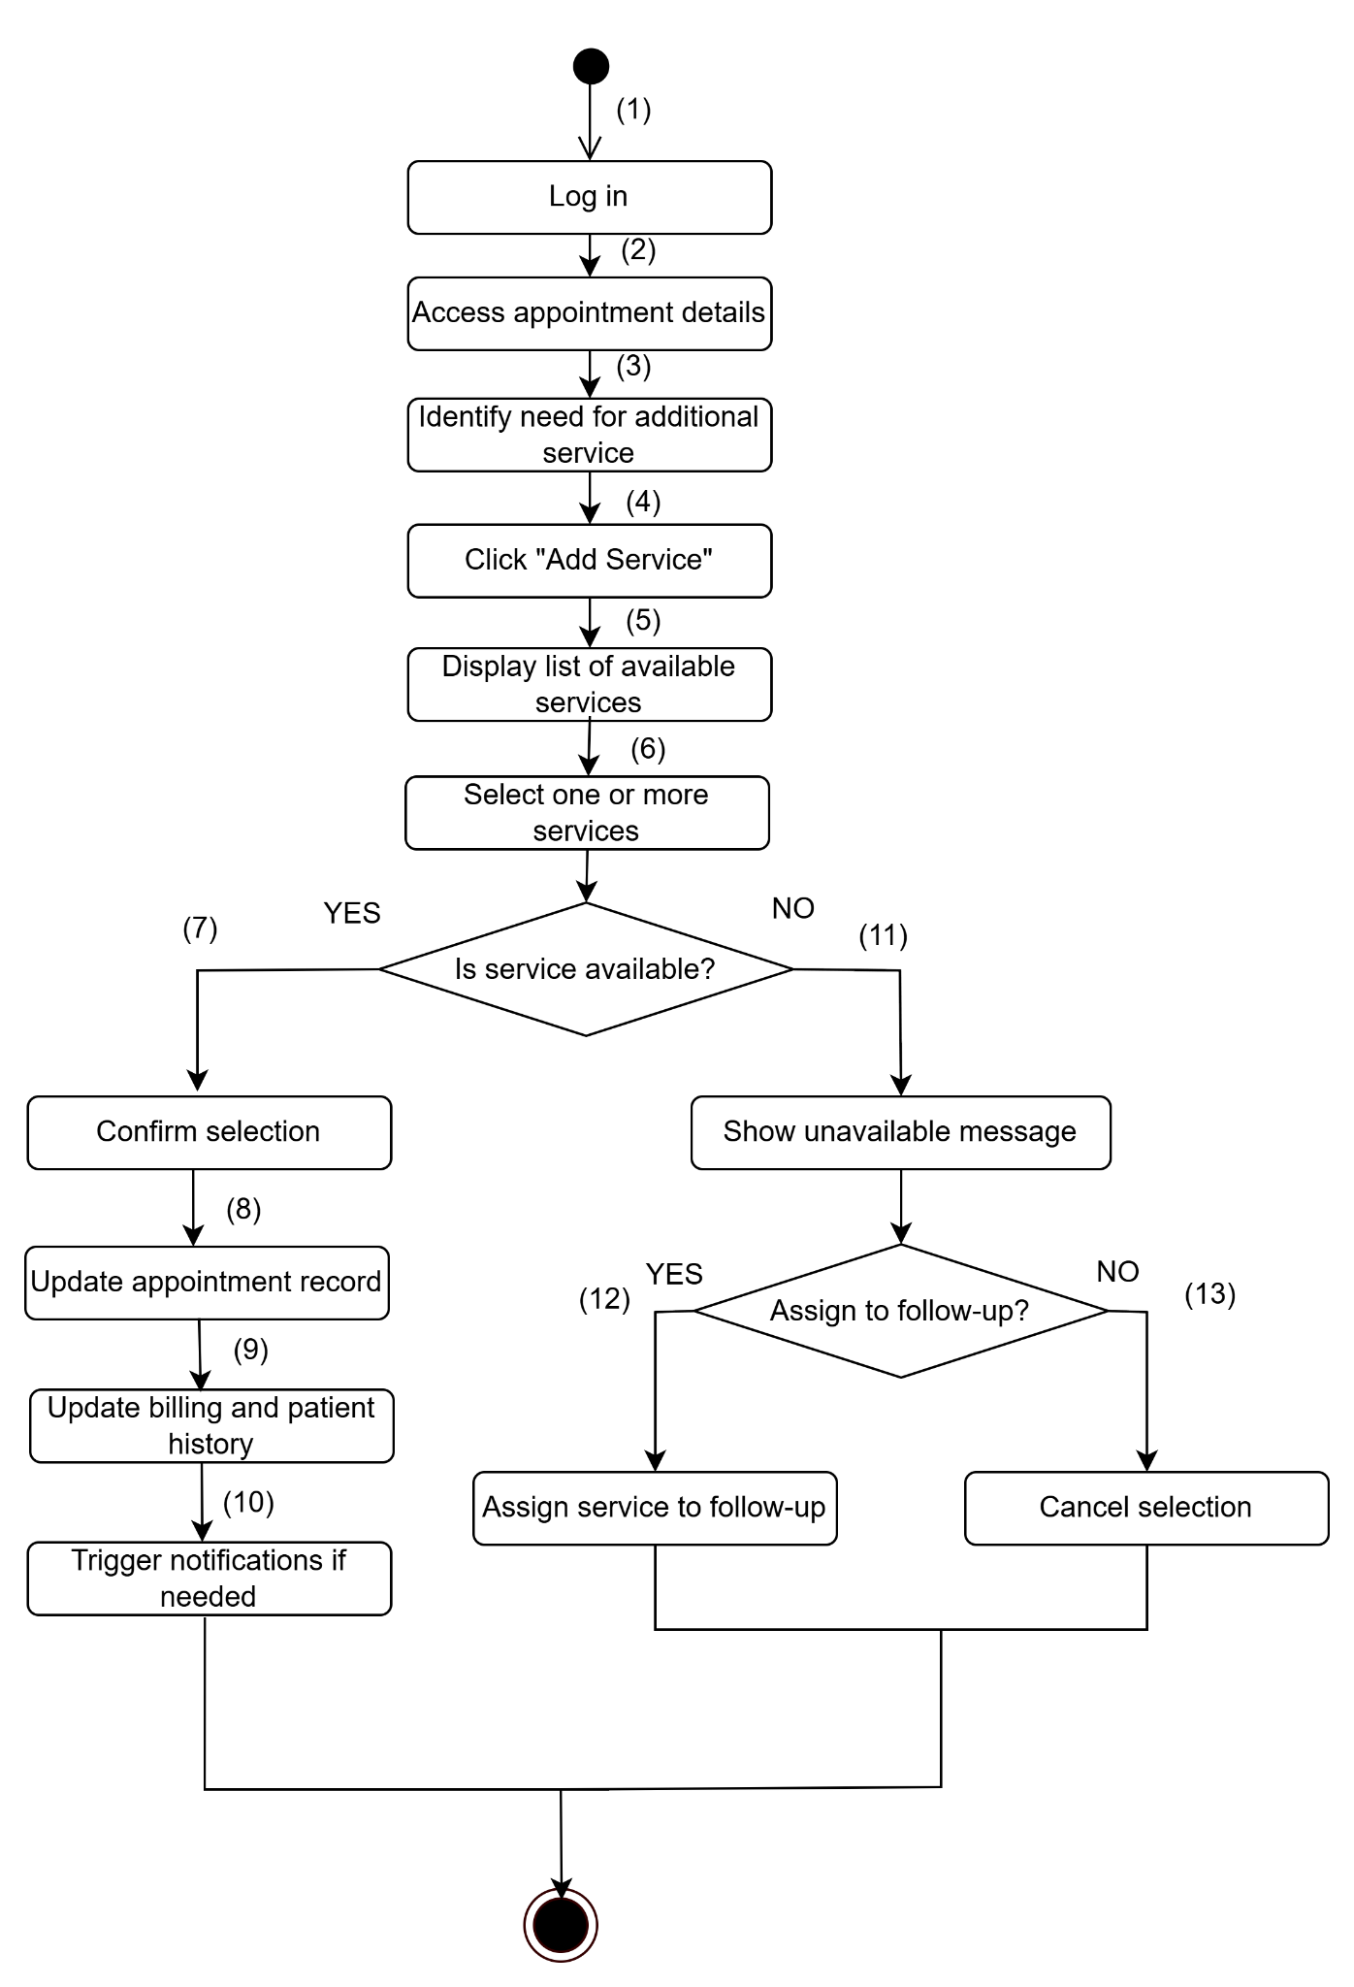

**Business Rules**

| **Step** | **BR Code(s)** | **Description** |
| --- | --- | --- |
| (4) | BR-122 | Only users with the "doctor" role can add services during appointments |
| (8), (9) | BR-123 | Services added during an appointment must be logged with timestamps and reasons. |
| (6), (7) | BR-124 | Services must not be duplicated in the same session unless medically necessary and justified. |

## 3. Functional Requirements

### 3.1 System Functional Overview

#### 3.1.1 Screens Flow

**Guest/ Patient Screen Flow**

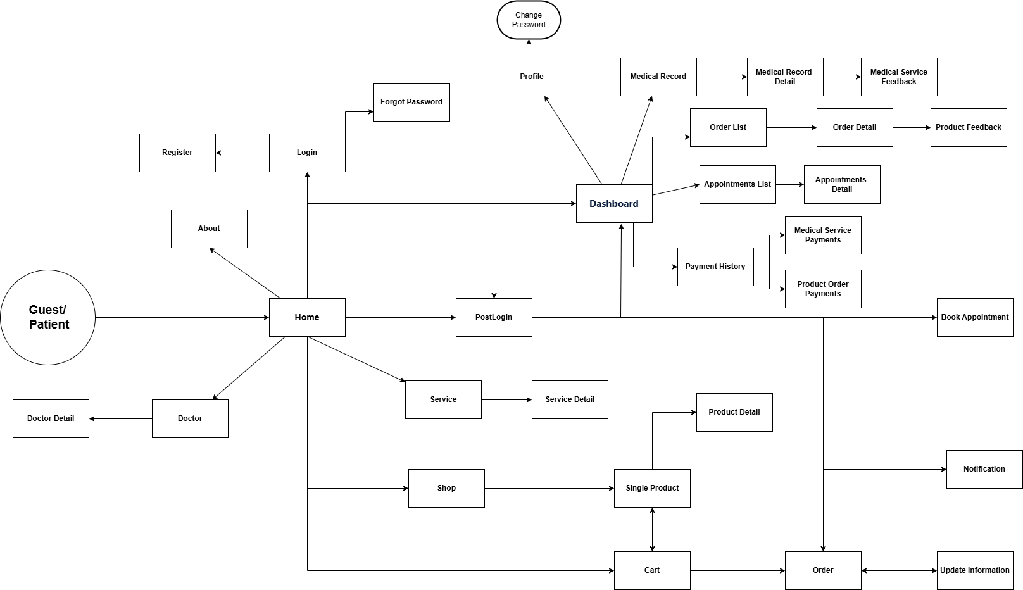

**Doctor Screen Flow**

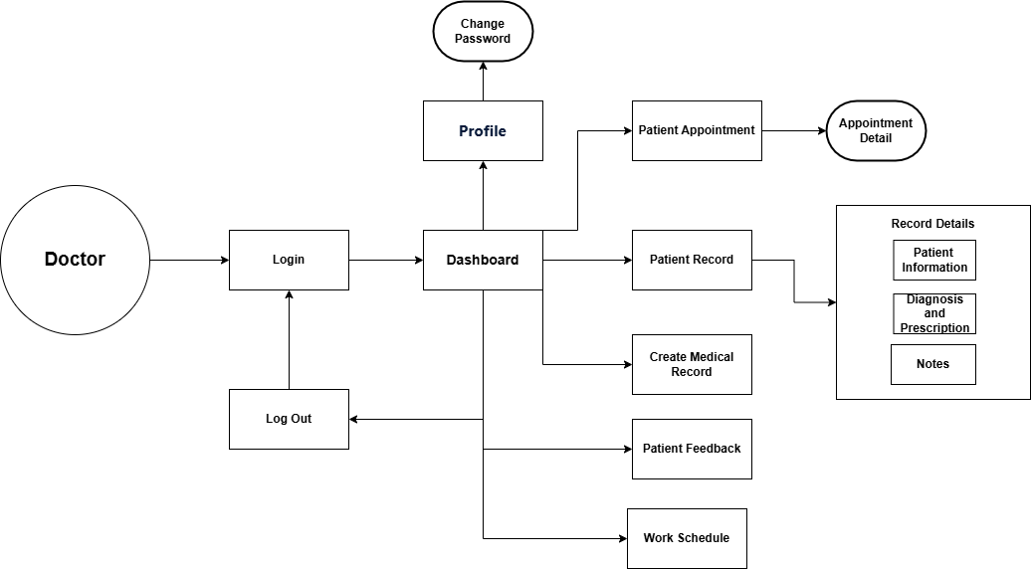

**Receptionist Screen Flow**

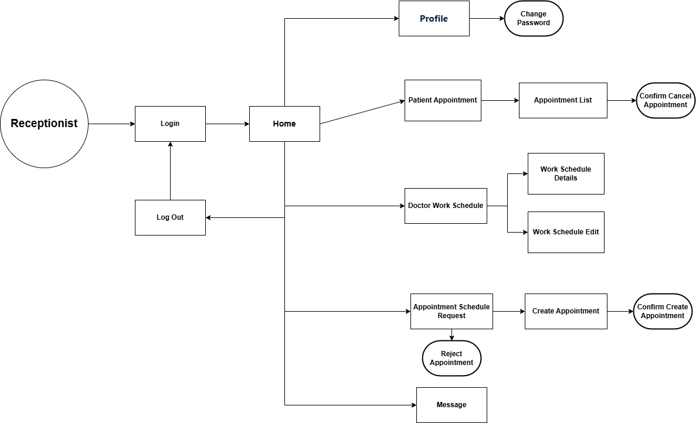

**Store Manager Screenflow**

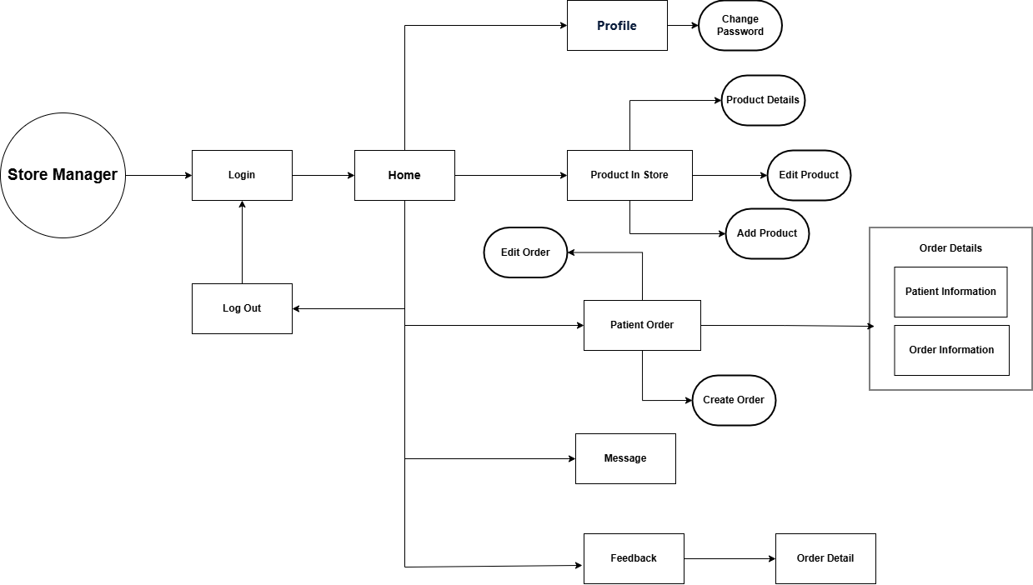

**Admin Screen Flow**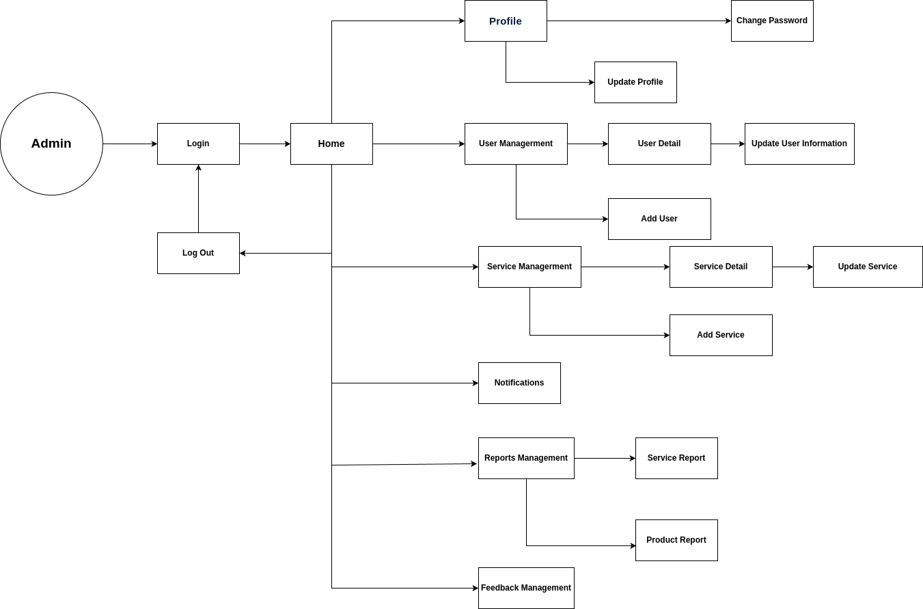

#### 3.1.2 Screen Descriptions

**Guest/ Patient Screen Flow**

| **#** | **Feature** | **Screen** | **Description** |
| --- | --- | --- | --- |
| 1 | Appointment Booking | Book Appointment | Allows patients to enter personal information, select a time slot, describe their condition, and submit a booking request. |
| 2 | Appointment Tracking | My Appointments | Displays a list of the patient’s scheduled appointments with details and allows cancellation if permitted. |
| 3 | Appointment Management | View Appointments | Enables receptionist/admin to view all appointments, filter by criteria, and access appointment details. |
| 4 | Appointment Processing | Confirm/Reject Appointment | Allows receptionists to confirm pending appointments (by selecting a doctor and adding notes) or reject them with reasons. |
| 5 | Medical Record Management | Medical Record | Allows doctors to create, update, and view medical records for each patient, including diagnosis and treatment history. |
| 6 | Product Browsing | Product List | Displays a list of available eye care products with name, price, and description for patients and guests. |
| 7 | Order Creation | Order Product | Allows patients to add selected products to a shopping cart and place an order. |
| 8 | Order Tracking | Order Status | Allows patients to track the status of their orders (e.g., processing, shipped, completed, or canceled). |
| 9 | Order Management | Manage Orders | Enables store managers to view all orders and update their status accordingly. |
| 10 | Product Management | Manage Products | Allows store managers/admins to add, edit, or delete products from the store inventory. |
| 11 | Service Feedback | Service Feedback | Enables patients to rate and provide feedback on the medical services they have received. |
| 12 | Product Feedback | Product Feedback | Enables patients to give feedback on purchased products, and allows store managers to moderate it. |
| 13 | Messaging | Message Box | Provides a messaging interface for patients to communicate with receptionists or store managers. |
| 14 | Schedule Management | Doctor Schedule | Enables admins/receptionists to create or update doctors' working schedules (days, time slots). |
| 15 | Admin Tools | Admin Dashboard | Allows administrators to manage users, services, staff accounts, and access system configurations. |
| 16 | Reports | Appointment Report | Displays statistical data for appointments (e.g., totals, status breakdowns) for administrators. |
| 17 | Reports | Sales Report | Shows product sales statistics (e.g., revenue, popular products) to help admin track performance. |

**Doctor Screen Flow**

| **#** | **Feature** | **Screen** | **Description** |
| --- | --- | --- | --- |
| 1 | Login | Login | Screen where the doctor enters login credentials to access the system. |
| 2 | Dashboard | Dashboard | The main screen after login, providing navigation to all core doctor functions. |
| 3 | View Profile | Profile | Displays the doctor's personal profile and information. |
| 4 | Change Password | Change Password | Allows the doctor to update their account password. |
| 5 | Log Out | Log Out | Logs the doctor out of the system and ends the session. |
| 6 | View Appointments | Patient Appointment | Lists all upcoming patient appointments assigned to the doctor. |
| 7 | Appointment Details | Appointment Detail | Shows detailed information about a selected appointment. |
| 8 | View Patient Records | Patient Record | Displays a list of medical records for the doctor’s patients. |
| 9 | Record Details | Record Details | Provides full medical record details including patient info, diagnosis, and notes. |
| 10 | Create Medical Record | Create Medical Record | Interface for creating a new medical record for a patient. |
| 11 | View Patient Feedback | Patient Feedback | Shows feedback or reviews submitted by patients. |
| 12 | View Work Schedule | Work Schedule | Displays the doctor’s work schedule, including shifts and availability. |

**Receptionist Screen Flow**

| **#** | **Feature** | **Screen** | **Description** |
| --- | --- | --- | --- |
| 1 | Login | Login | Screen where the receptionist enters credentials to access the system. |
| 2 | Home Navigation | Home | Main screen providing access to all receptionist features. |
| 3 | View Profile | Profile | Displays the receptionist’s personal profile and information. |
| 4 | Change Password | Change Password | Allows the receptionist to update their account password. |
| 5 | Logout | Log Out | Logs the receptionist out of the system and ends the session. |
| 6 | Manage Patient Appointments | Patient Appointment | Allows viewing of patient appointments. |
| 7 | View Appointment List | Appointment List | Displays a list of all scheduled appointments. |
| 8 | Cancel Appointment | Confirm Cancel Appointment | Confirmation screen for canceling an appointment. |
| 9 | Manage Doctor Work Schedule | Doctor Work Schedule | Main entry point to manage doctor schedules. |
| 10 | View Work Schedule Details | Work Schedule Details | Shows the current work schedule for doctors. |
| 11 | Edit Work Schedule | Work Schedule Edit | Interface for updating or editing a doctor's schedule. |
| 12 | Handle Appointment Requests | Appointment Schedule Request | Displays appointment requests from patients needing confirmation. |
| 13 | Create Appointment | Create Appointment | Allows the receptionist to create a new appointment. |
| 14 | Confirm Appointment Creation | Confirm Create Appointment | Confirmation screen after creating an appointment. |
| 15 | Reject Appointment Request | Reject Appointment | Used to reject a patient’s appointment request. |
| 16 | View Messages | Message | Shows internal messages or communication received by the receptionist. |

**Store Manager Screenflow**

| **#** | **Feature** | **Screen** | **Description** |
| --- | --- | --- | --- |
| 1 | Login | Login | Screen where the store manager enters credentials to access the system. |
| 2 | Home Navigation | Home | Main screen providing access to all store management functionalities. |
| 3 | View Profile | Profile | Displays the store manager’s personal profile and information. |
| 4 | Change Password | Change Password | Allows the store manager to update their account password. |
| 5 | Logout | Log Out | Logs the store manager out of the system and ends the session. |
| 6 | View Product List | Product in Store | Displays all medical products currently available in the store. |
| 7 | View Product Details | Product Details | Shows detailed information about a selected product. |
| 8 | Edit Product | Edit Product | Allows the store manager to modify an existing product’s information. |
| 9 | Add Product | Add Product | Interface for adding a new product to the store. |
| 10 | Manage Orders | Patient Order | Displays a list of all orders placed by patients. |
| 11 | Create Order | Create Order | Allows the store manager to create a new product order for a patient. |
| 12 | Edit Order | Edit Order | Interface for modifying existing patient orders. |
| 13 | View Order Details | Order Details | Displays full order details, including patient and order-specific information. |
| 14 | View Messages | Message | Displays internal messages received by the store manager. |
| 15 | View Feedback | Feedback | Shows feedback submitted by patients regarding orders or products. |
| 16 | View Specific Feedback | Order Detail | Shows detailed view of feedback linked to a specific order. |

**Admin Screen Flow**

| **#** | **Feature** | **Screen** | **Description** |
| --- | --- | --- | --- |
| 1 | Login | Login | Screen where the admin enters credentials to access the system. |
| 2 | Home Navigation | Home | Main dashboard that links to all admin functionalities. |
| 3 | View Profile | Profile | Displays the admin’s personal profile and information. |
| 4 | Update Profile | Update Profile | Allows the admin to update their profile details. |
| 5 | Change Password | Change Password | Allows the admin to update their account password. |
| 6 | Logout | Log Out | Logs the admin out of the system and ends the session. |
| 7 | User Management | User Management | Central area for managing user accounts. |
| 8 | View User Details | User Detail | Shows detailed information of a selected user. |
| 9 | Update User Info | Update User Information | Allows editing/updating of user details. |
| 10 | Add User | Add User | Interface to add a new user to the system. |
| 11 | Service Management | Service Management | Main area to manage the list of services offered. |
| 12 | View Service Details | Service Detail | Displays detailed information of a selected service. |
| 13 | Update Service | Update Service | Allows updating service information. |
| 14 | Add Service | Add Service | Interface for adding a new service to the system. |
| 15 | View Notifications | Notifications | Displays all system notifications relevant to the admin. |
| 16 | Report Management | Reports Management | Central screen to access system reports. |
| 17 | Service Report | Service Report | Generates and displays reports related to services. |
| 18 | Product Report | Product Report | Generates and displays reports related to medical products. |
| 19 | Feedback Management | Feedback Management | Allows the admin to view and manage user or patient feedback. |

#### 3.1.3 Screen Authorization

| **Screen** | **Patient** | **Doctor** | **Store Manager** | **Receptionist** | **Admin** |
| --- | --- | --- | --- | --- | --- |
| **Login / Register** | X | X | X | X | X |
| **Home Page** | X | X | X | X | X |
| **Book Appointment** | X |  |  |  |  |
| **My Appointments** | X | X |  |  |  |
| **Appointment Management** |  |  |  | X | X |
| Query All Data |  |  |  | X | X |
| Update Data |  |  |  | X | X |
| Reject/Confirm Appointment |  |  |  | X | X |
| **Medical Record** |  | X |  |  |  |
| Create |  | X |  |  |  |
| Update |  | X |  |  |  |
| View | X | X |  |  |  |
| **Schedule Management** |  |  |  | X | X |
| Create |  |  |  | X | X |
| Update |  |  |  | X | X |
| **Product Management** |  |  | X |  | X |
| Add Product |  |  | X |  | X |
| Edit Product |  |  | X |  | X |
| Delete Product |  |  | X |  | X |
| **Order Management** | X |  | X |  |  |
| Create Order | X |  | X |  |  |
| View Order | X |  | X |  | X |
| Update Status |  |  | X |  |  |
| **Feedback Management** | X | X | X |  |  |
| **Messaging System** | X |  | X | X |  |
| Send Message | X |  | X |  |  |
| Reply Message | X |  | X | X |  |
| **Profile Management** | X | X | X | X | X |
| Update Profile | X | X | X | X | X |
| **Admin Management Panel** |  |  |  |  | X |
| User Ban/Delete |  |  |  |  | X |
| Create Staff |  |  |  |  | X |
| Delete Staff |  |  |  |  | X |
| Create Service |  |  |  |  | X |
| Delete Service |  |  |  |  | X |
| **Report Dashboard** |  |  |  |  | X |

#### 3.1.4 Non-Screen Functions

| **#** | **Feature** | **System Function** | **Description** |
| --- | --- | --- | --- |
| 1 | Appointment Management | Appointment Reminder Service | A scheduled job that sends SMS/email reminders to patients 24 hours before their confirmed appointments. |
| 2 | Authentication | Email Verification API | Verifies user email addresses during account registration and password recovery. |
| 3 | Appointment Management | Auto-Expire Pending Appointments | A cron job that automatically cancels pending appointments after 48 hours if not confirmed by reception. |
| 4 | Product Ordering | Order Status Notification | Sends real-time email/SMS updates to patients when their product order status changes (e.g., shipped, delivered). |
| 5 | Feedback | Feedback Moderation Service | Background service that flags inappropriate feedback for review by admins or store managers. |
| 6 | Reporting | Appointment Report Generator | A backend job that aggregates appointment data (daily/weekly/monthly) and generates statistical summaries. |
| 7 | Reporting | Product Sales Report Generator | Generates revenue and product performance metrics for admins to monitor sales. |
| 8 | Chat Support | ChatBot Auto-Responder | Responds to common patient/guest queries instantly via pre-trained rules or AI. |
| 9 | System Maintenance | Data Backup Scheduler | Performs automated backups of the system database on a scheduled basis to ensure data recovery. |
| 10 | Security | Session Timeout Handler | Automatically logs out inactive users after a configured timeout period for security reasons. |

#### 3.1.5 Entity Relationship Diagram

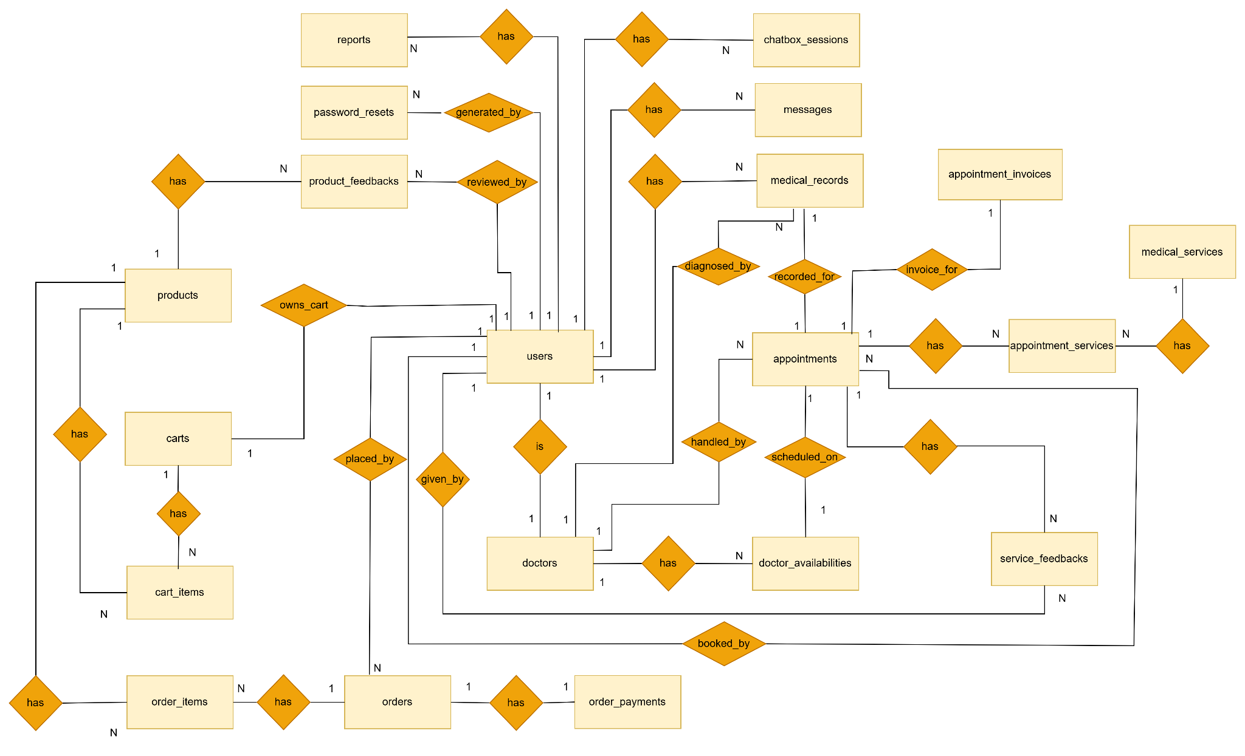

**Entities Description**

| **#** | **Entity** | **Description** |
| --- | --- | --- |
| 1 | User | Represents all users in the system including patients, doctors, receptionists, admins, etc. Includes id, username, name, email, password, role, gender, date_of_birth, phone, avatar_url, province, district, ward, address_detail, is_google_account, created_at, updated_at. |
| 2 | Doctor | Represents eye doctors with their professional and contact information. Includes: id, user_id, specialization, certification_code, certifications, years_of_experience, phone_for_services, bio, profile_image_url. |
| 3 | Doctor Availability | Stores the working schedule and availability status of doctors. Includes: id, doctor_id, available_date, hour_slot, status. |
| 4 | Medical Service | Describes the available medical services provided at the clinic. Includes: id, name, description, price, duration, image_url, created_at, updated_at. |
| 5 | Appointment | Stores patient appointment details with doctors and services. Includes: id, patient_id, doctor_id, availability_id, service_id, appointment_date, hour_slot, booking_fee, service_price, status, notes, created_at, updated_at. |
| 6 | Appointment_services | Association between appointments and medical services. Describes which medical services are assigned to each appointment. |
| 7 | Appointment Invoice | Holds billing and payment info related to appointments. Includes: id, appointment_id, total_amount, transaction_id, paid_at, created_at. |
| 8 | Medical Record | Stores diagnoses, prescriptions, and notes from a patient’s appointment. Includes: id, appointment_id, patient_id, doctor_id, diagnosis, prescription, notes, record_file_url, created_at, updated_at. |
| 9 | Service Feedback | Patient feedback and ratings for the services they received. Includes: id, appointment_id, patient_id, rating, comment, created_at. |
| 10 | Product | Medical or optical products available for purchase. Includes: id, name, description, price, stock_quantity, image_url, created_at, updated_at. |
| 11 | Product Feedback | Customer feedback and ratings for purchased products. Includes: id, product_id, patient_id, rating, comment, created_at. |
| 12 | Cart | Represents a patient’s shopping cart. Includes: id, patient_id, created_at, updated_at. |
| 13 | Cart Item | Items added to the shopping cart. Includes: id, cart_id, product_id, quantity, created_at, updated_at. |
| 14 | Order | Represents a completed product purchase by a patient. Includes: id, patient_id, total_amount, status, order_date, shipping_address, created_at, updated_at. |
| 15 | Order Item | Details of each product in an order. Includes: id, order_id, product_id, quantity, price, created_at. |
| 16 | Order Payment | Stores payment details for an order. Includes: id, order_id, amount, transaction_id, payment_status, paid_at, created_at. |
| 17 | Message | Direct message between users (e.g., patient and staff). Includes: id, sender_id, receiver_id, content, sent_at, is_read. |
| 18 | Chatbox Session | Stores session data for conversations or AI chat history. Includes: id, user_id, session_data, created_at, updated_at. |
| 19 | Password Reset | Password recovery details including tokens. Includes: id, user_id, reset_token, expires_at, created_at. |
| 20 | Report | System-generated reports for management. Includes: id, report_type, generated_by, report_data, generated_at. |

### 3.2 Appointment Management

#### 3.2.1 View My Appointments

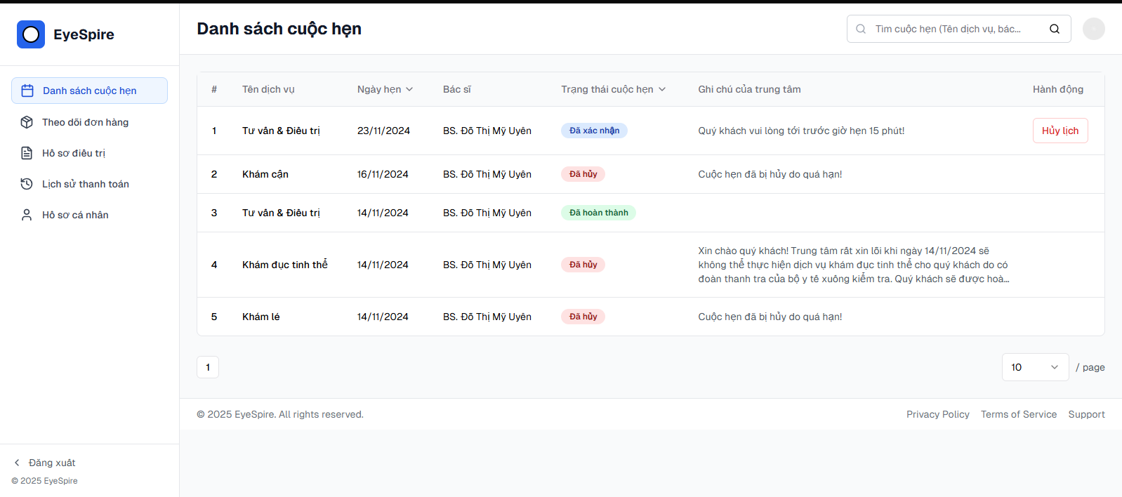

**Screen Content**

| **#** | **Component** | **Comp. Type** | **Editable** | **Mandatory** | **Default Value** | **Description** |
| --- | --- | --- | --- | --- | --- | --- |
| 1 | Screen Name | Label | No | N/A | N/A | Displays the title: “Danh sách cuộc hẹn” (“Appointment List”) |
| 2 | Search Bar | Text Input | Yes | No | Empty | Allows users to search by service name, doctor, or appointment date |
| 3 | Table | Table View | No | N/A | Populated from DB | Displays list of appointments |
| 3.1 | - ID (#) | Label | No | N/A | Auto-increment | Serial number of appointment in the list |
| 3.2 | - Service Name | Label | No | Yes | Fetched from DB | Name of the booked service (e.g., Tư vấn & Điều trị) |
| 3.3 | - Appointment Date | Label | No | Yes | Fetched from DB | The scheduled date of the appointment |
| 3.4 | - Doctor Name | Label | No | Yes | Fetched from DB | Assigned doctor’s name |
| 3.5 | - Appointment Status | Label/Badge | No | Yes | “Đã xác nhận”, “Đã hủy”… | Colored label to show current appointment status |
| 3.6 | - Center Note | Label | No | No | Optional | Any comment added by receptionist/center regarding the appointment |
| 3.7 | - Cancel Button | Button | Yes | Conditional | Only for “Confirmed” | Allows patient to cancel an appointment (if eligible) |
| 4 | Pagination Control | Dropdown + Nav | Yes | No | 10 / page | Controls how many items are shown per page |
| 5 | Sidebar - Navigation | Menu | No | N/A | Selected: Appointments | Navigation menu on the left for other features (Orders, Profile, etc.) |
| 6 | Logout Button | Link | No | No | “Đăng xuất” | Logs the user out of the system |

#### 3.2.2 View patient appointments (Doctor Dashboard Screen)

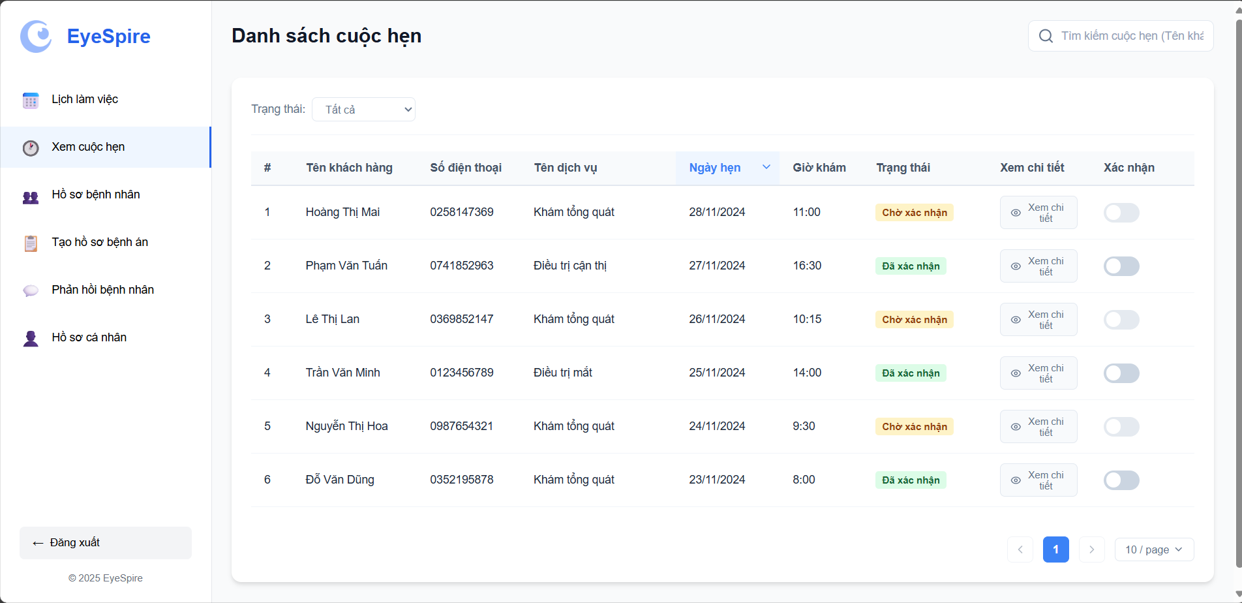

**Screen Content**

| **#** | **Component** | **Comp. Type** | **Editable** | **Mandatory** | **Default Value** | **Description** |
| --- | --- | --- | --- | --- | --- | --- |
| 1 | Screen Name | Label | No | N/A | N/A | Displays the title: “Danh sách cuộc hẹn” (“Appointment List”) |
| 2 | Logout Button | Link | No | No | “Logout” | Logs the doctor out of the system |
| 3 | Status Filter | Dropdown | Yes | No | “All” | Filter appointment by status : “Tất cả”, “Đã xác nhận”, “Chờ xác nhận”, “Hoàn thành” |
| 4 | Search Bar | Text Input | Yes | No | Empty | Allows searching for appointments by customer name |
| 5 | Appointment Table | Table View | No | N/A | Fetched from DB | Displays a list of appointments |
| 5.1 | - ID (#) | Label | No | N/A | auto-increment | Serial number of the appointment |
| 5.2 | - Customer Name | Label | No | Yes | Fetched from DB | Name of the customer (patient) |
| 5.3 | - Phone Number | Label | No | Yes | Fetched from DB | Customer's contact number |
| 5.4 | - Service Name | Label | No | Yes | Fetched from DB | Name of the booked medical service |
| 5.5 | - Appointment Date | Label | No | Yes | Fetched from DB | The scheduled appointment date |
| 5.6 | - Appointment Time | Label | No | Yes | Fetched from DB | Time of the appointment |
| 5.7 | - Status Badge | Badge/Label | No | Yes | “Pending”, “Confirmed” | Colored badge indicating current status |
| 5.8 | - View Details Button | Button | Yes | No | “View Details” | Opens a popup or page to view full appointment details |
| 5.9 | -Confirmation Toggle | Toggle Switch | Yes | Conditional | Off | Used to confirm an appointment (if allowed) |
| 6 | Pagination Control | Dropdown + Nav | Yes | No | 10 / page | Controls the number of rows per page and page navigation |

#### 3.2.3 View Patient appointment (Admin Dashboard Screen)

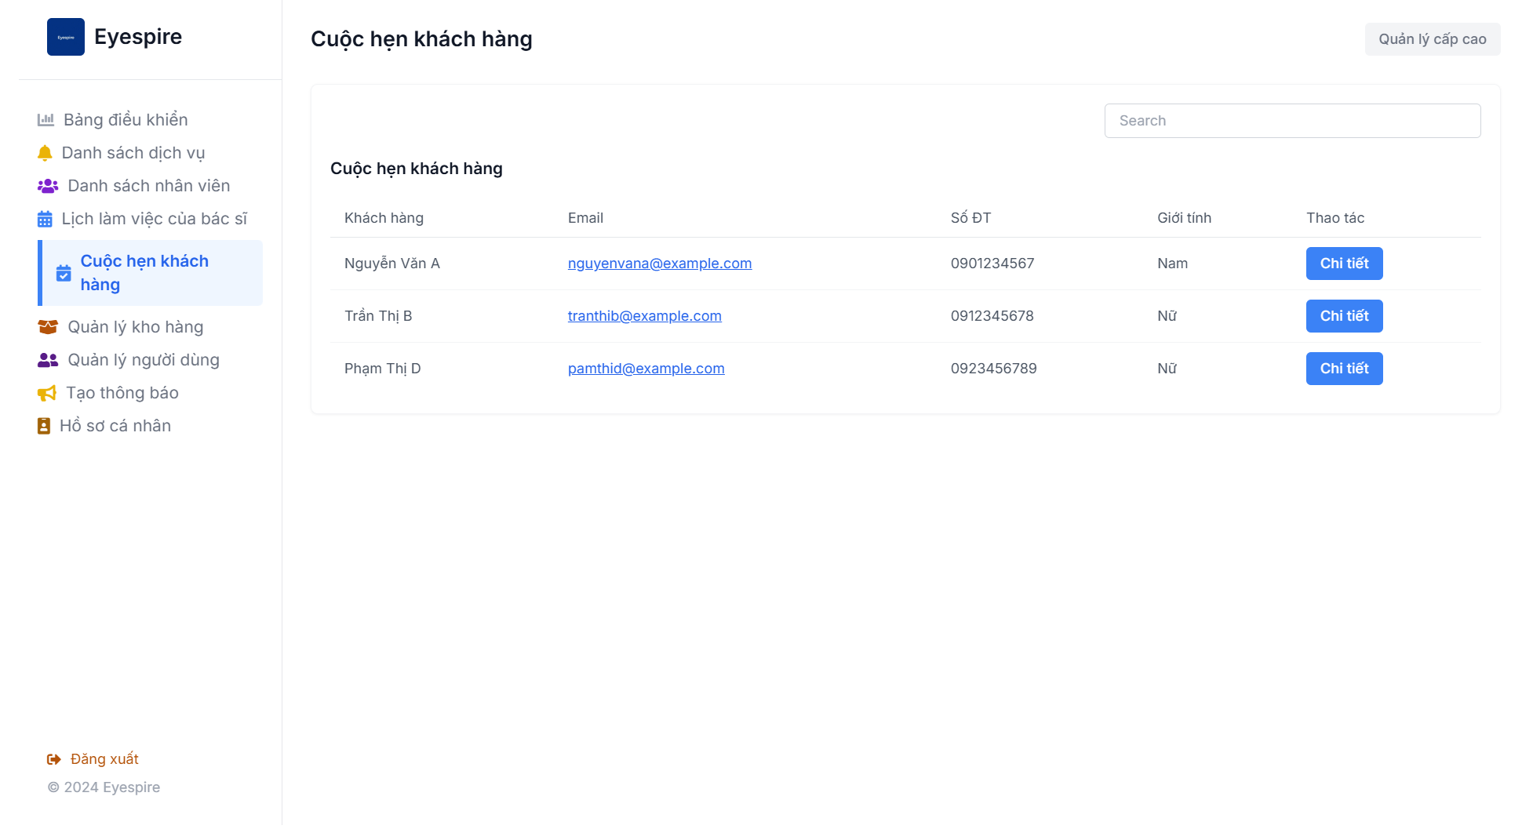

**Screen Content**

| **Component** | **Comp. Type** | **Editable** | **Mandatory** | **Default Value** | **Description** |
| --- | --- | --- | --- | --- | --- |
| Left Sidebar Menu | Sidebar Menu | No | Yes | - | Navigation menu to access other modules. |
| Screen Title | Text Label | No | Yes | "Cuộc hẹn khách hàng" | Main heading of the screen. |
| Search Box | Search Box | Yes | No | - | Allows searching customers by name, email, etc. |
| Customer List Table | Table | No | Yes | - | Displays a list of customer appointments. |
| - "Customer" Column | Table Column | No | Yes | - | Customer's full name. |
| - "Email" Column | Table Column | No | Yes | - | Customer's contact email. |
| - "Phone Number" Column | Table Column | No | Yes | - | Customer's phone number. |
| - "Gender" Column | Table Column | No | No | - | Customer's gender. |
| - "Action" Column | Table Column | No | Yes | "Chi tiết" button | Button to view detailed appointment info. |
| "Details" Button | Button | No | Yes | - | Opens customer appointment details view, can edit, delete. |
| "Logout" Button | Button | No | Yes | - | Logs out of the system. |

#### 3.2.4 View Patient appointment (Receptionist Dashboard Screen)

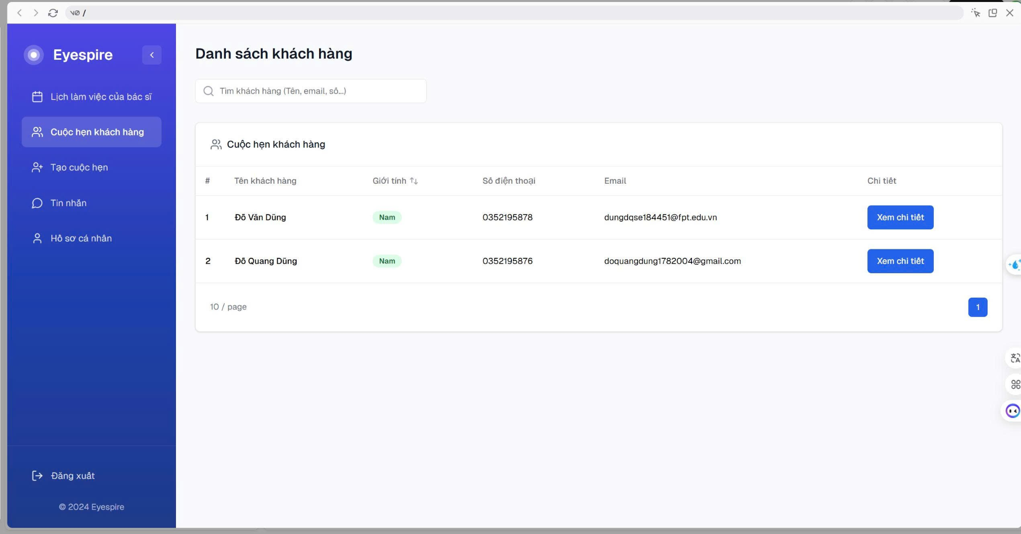

**Screen Content**

| **Component** | **Comp. Type** | **Editable** | **Mandatory** | **Default Value** | **Description** |
| --- | --- | --- | --- | --- | --- |
| Title | Text Header | No | No | Customer List | Page title |
| Search Bar | Text Input | Yes | No |  | Allows search by name, email, or phone |
| Table Header: # | Table Label | No | No | # | Auto-incremented serial number |
| Table Header: Name | Table Label | No | No | Customer Name | Full name of the customer |
| Table Header: Gender | Table Label | No | No | Gender | Displays gender with tag style |
| Table Header: Phone | Table Label | No | No | Phone Number | Customer's phone number |
| Table Header: Email | Table Label | No | No | Email Address | Customer's email address |
| Table Header: Detail | Table Label | No | No |  | Contains a detail action button |
| Detail Button | Action Button | Yes | No | View Detail | Navigates to customer appointment page, in this page appointments can be Accepted or Cancelled |
| Pagination Control | UI Element | Yes | No | Page 1 | Navigate through multiple pages (10 entries per page) |

### 3.3 Schedule Management

#### 3.3.1 View Work Schedule

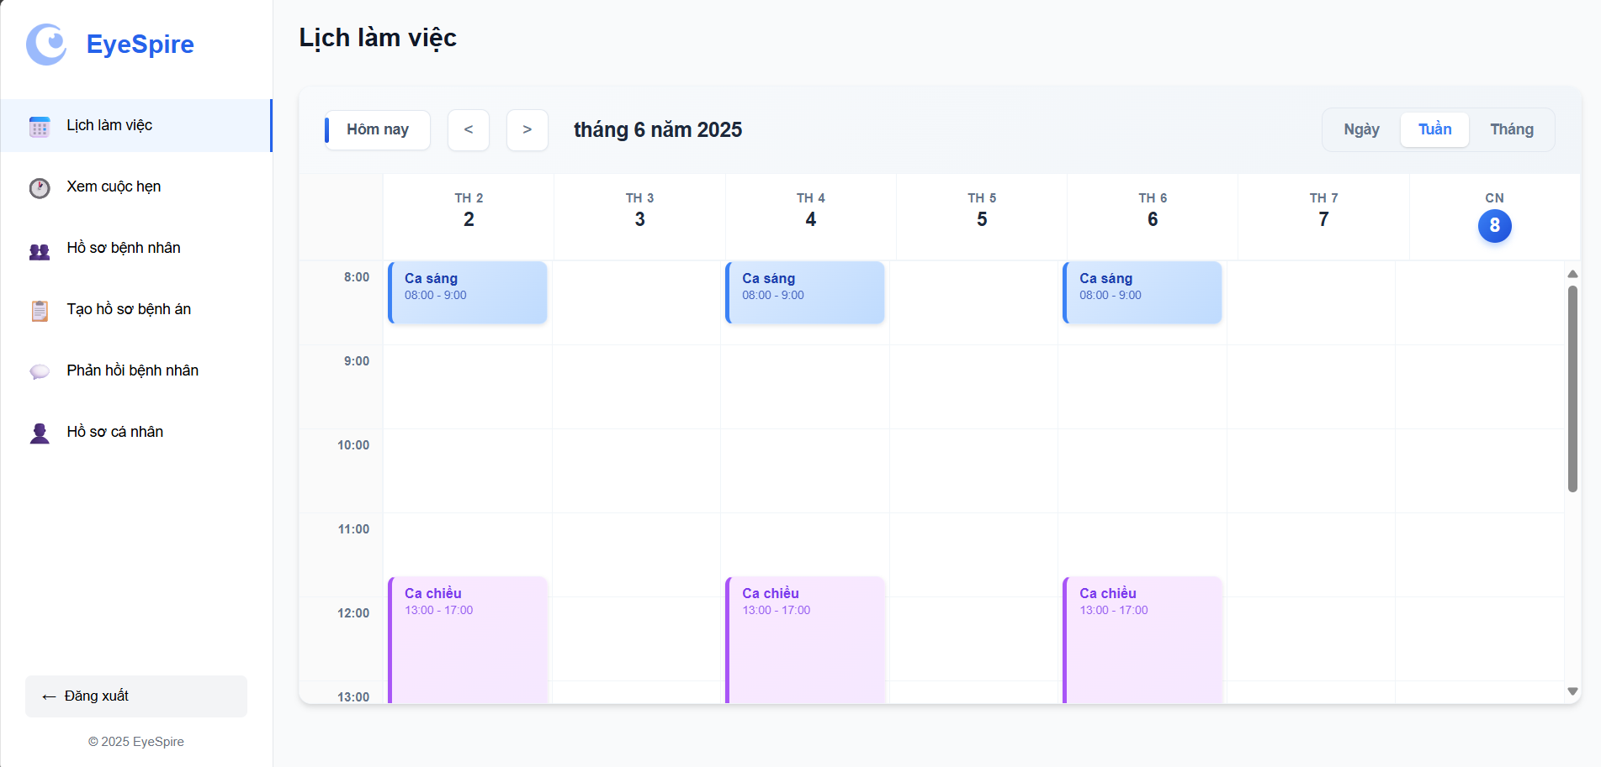

**Screen Content**

| **#** | **Component** | **Comp. Type** | **Editable** | **Mandatory** | **Default Value** | **Description** |
| --- | --- | --- | --- | --- | --- | --- |
| 1 | Screen Title | Label | No | N/A | “Work Schedule” | Displays the screen title |
| 2 | Logout Button | Button/Link | No | No | “Logout” | Signs out the user |
| 3 | Date Navigator | Button Group | Yes | No | “Today”, arrows < > | Allows users to move between days/weeks/months |
| 4 | Current Month Display | Label | No | N/A | Today | Displays the current calendar month |
| 5 | View Mode Selector | Toggle Buttons | Yes | No | “Week” selected | Switches between “Day”, “Week”, and “Month” views |
| 6 | Calendar Grid | Grid Display | No | N/A | Generated by system | Shows the doctor’s work schedule by hour and date |
| 6.1 | - Work Shifts | Schedule Blocks | Yes | Yes | “Morning: xx:xx–xx:xx”, “Afternoon: xx:xx–xx:xx” | Each block represents a work shift assigned to the doctor on a specific day |
| 7 | Scroll Bar | Vertical Scroll | Yes | No | Enabled | Allows scrolling through different hours in the day view |

#### 3.3.2 Manage Work schedule (Admin Dashboard Screen)

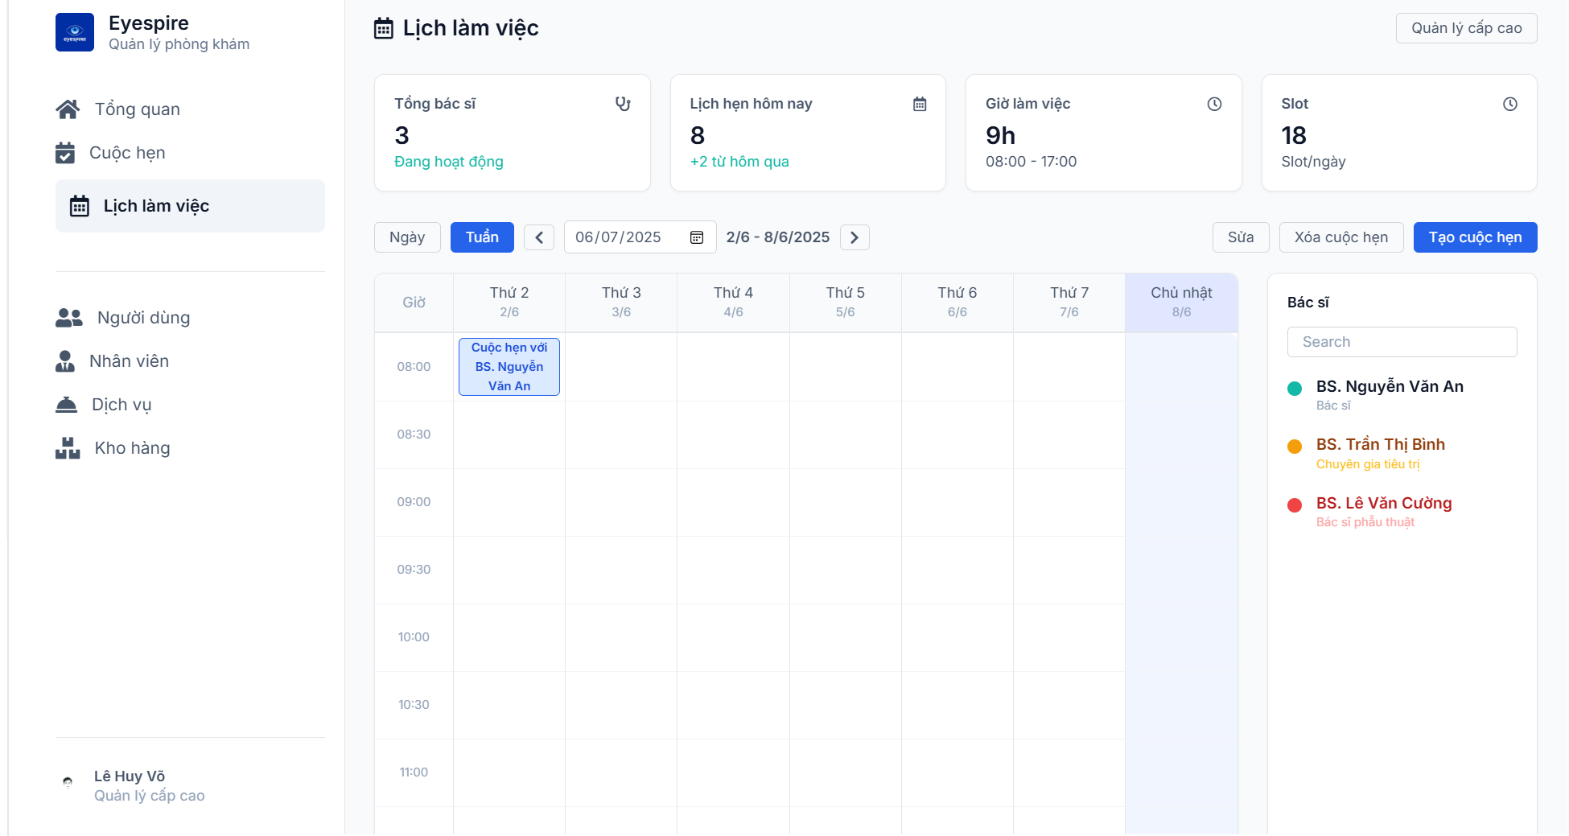

**Screen Content**

| **Component** | **Comp. Type** | **Editable** | **Mandatory** | **Default Value** | **Description** |
| --- | --- | --- | --- | --- | --- |
| Left Sidebar Menu | Sidebar Menu | No | Yes | - | Navigation menu to access other system modules. |
| Screen Title | Text Label | No | Yes | "Lịch làm việc" | Main heading of the screen. |
| Total Doctors Card | Info Card | No | Yes | 3 Active | Displays the total number of active doctors. |
| Today's Appointments Card | Info Card | No | Yes | 8 (+2 from yesterday) | Shows the number of today's appointments and comparison with yesterday. |
| Working Hours Card | Info Card | No | Yes | 9h (08:00 - 17:00) | Displays the general working hours. |
| Slot Card | Info Card | No | Yes | 18 slots/day | Shows the number of appointment slots available per day. |
| Date/Week Selector | Date Picker / Toggle | Yes | Yes | Week (2/6 - 8/6/2025) | Allows switching between daily/weekly view. |
| Calendar Table | Calendar View | Yes | Yes | - | Displays the weekly schedule with time rows and date columns. |
| Appointment Slot | Calendar Event | Yes | Yes | "Appointment with Dr. ..." | Represents scheduled appointments for doctors. |
| Doctor List | List | No | Yes | - | Lists available doctors, color-coded by specialization. |
| Doctor Search Box | Search Box | Yes | No | - | Quickly filters doctors by name. |
| "Create Appointment" Btn | Button | Yes | Yes | - | Used to create new appointments. |
| "Edit", "Delete" Buttons | Buttons | Yes | Yes | - | Edit or delete existing appointments. |

#### 3.3.3 Manage Work schedule (Receptionist Dashboard Screen)



| **Component** | **Comp. Type** | **Editable** | **Mandatory** | **Default Value** | **Description** |
| --- | --- | --- | --- | --- | --- |
| View Toggle (Day/Week) | Toggle Button | Yes | No | Week | Switch between day view and week view |
| Date Picker | Date Selector | Yes | Yes | Today’s Date | Select a specific date or range |
| Week Range Display | Text | No | No | 2/6 – 8/6/2025 | Automatically shows week span based on selected date |
| Schedule Grid | Calendar Grid | Yes | Yes |  | Displays appointments across days and time slots |
| Appointment Block | Calendar Item | Yes | Yes | Appointment Info | Clickable – shows patient + doctor info, supports drag/drop (optional) |
| Edit Appointment Button | Action Button | Yes | No | Edit | Opens modal or form to edit appointment |
| Delete Appointment Button | Action Button | Yes | No | Delete | Deletes selected appointment |
| Create Appointment Button | Action Button | Yes | No | Create Appointment | Opens new appointment creation form |
| Doctor Filter (Sidebar) | Search + List | Yes | No |  | Search and filter appointments by doctor name |
| Doctor Legend | Label + Icon | No | No | Color-coded doctors | Displays color, name, and specialty for each doctor |

### 3.4 Medical Record management

#### 3.4.1 View Medical Record

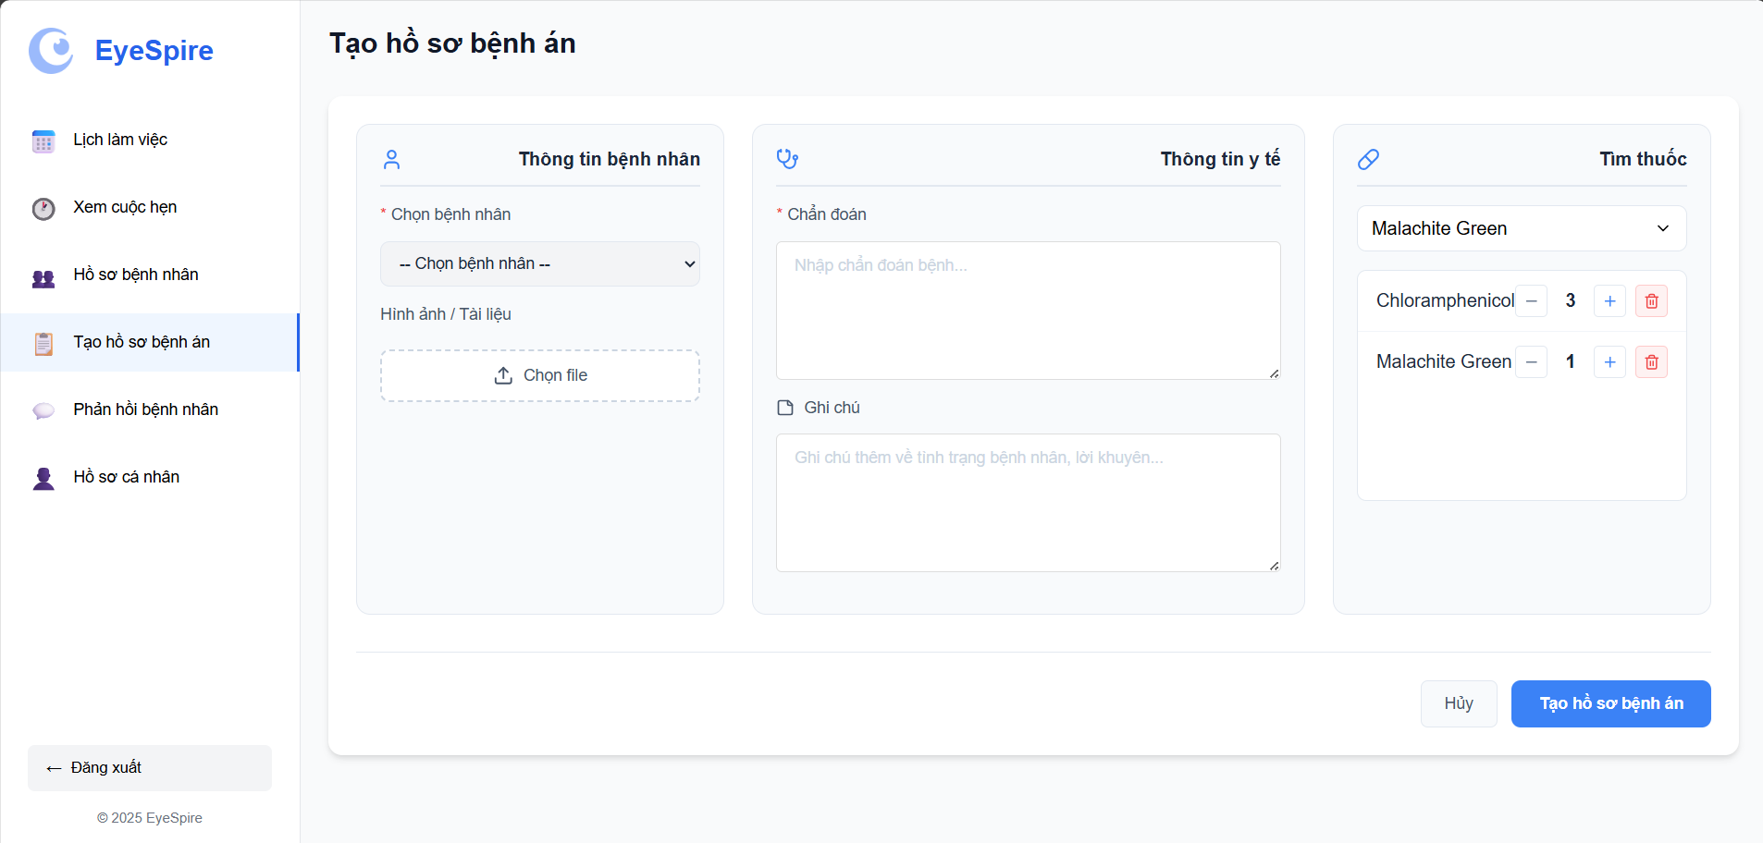

**Screen Content**

| **#** | **Component** | **Comp. Type** | **Editable** | **Mandatory** | **Default Value** | **Description** |
| --- | --- | --- | --- | --- | --- | --- |
| 1 | Screen Title | Label | No | N/A | “Create Medical Record” | Displays the screen’s main heading |
| 2 | Patient Selection | Dropdown | Yes | Yes | “-- Select patient –” | Allows selecting a registered patient |
| 3 | Image/Document Upload | Upload Field | Yes | No | Empty | Allows uploading medical images or documents |
| 4 | Diagnosis | Text Area | Yes | Yes | Empty | Field to enter the medical diagnosis |
| 5 | Notes | Text Area | Yes | No | Empty | Optional notes on patient condition or recommendations |
| 6 | Medicine Search | Dropdown with Search | Yes | No | e.g. “thuốc nhỏ mắt” | Allows searching and selecting medicine |
| 7 | Selected Medicine List | List with controls | Yes | No | Auto-updated | List of added medicines with quantity control and delete button |
| 7.1 | - Add/Remove Buttons | Buttons | Yes | No | Adjust quantity | Used to increase or decrease quantity of selected medicine |
| 7.2 | - Delete Button | Button | Yes | No | Removes item | Deletes a medicine from the list |
| 8 | Cancel Button | Button | Yes | No | “Cancel” | Aborts the creation process |
| 9 | Create Medical Record | Button | Yes | Yes | “Create Medical Record” | Submits the form and saves the medical record |

#### 

#### 3.4.2 My Medical Record

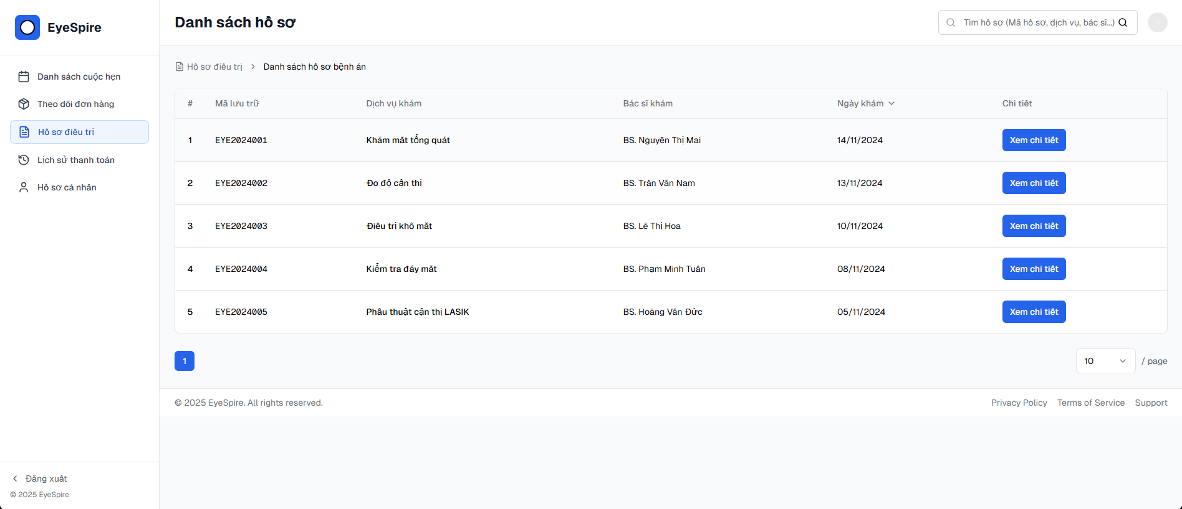

**Screen Content**

| **#** | **Component** | **Comp. Type** | **Editable** | **Mandatory** | **Default Value** | **Description** |
| --- | --- | --- | --- | --- | --- | --- |
| 1 | Screen Name | Label | No | N/A | “Danh sách hồ sơ” | Title of the screen |
| 2 | Breadcrumb | Breadcrumb | No | No | Hồ sơ điều trị > Danh sách hồ sơ bệnh án | Helps user understand navigation context |
| 3 | Search Bar | Text Input | Yes | No | Empty | Allows users to search records by code, service name, or doctor |
| 4 | Record List Table | Table | No | N/A | From DB | Displays paginated list of medical records |
| 4.1 | - Index (#) | Label | No | Yes | Auto-generated | Row number |
| 4.2 | - Record Code | Label | No | Yes | EYEyyyyxxx | Unique medical record ID (e.g., EYE2024001) |
| 4.3 | - Service Name | Label | No | Yes | From DB | Name of medical service used (e.g., “Khám mắt tổng quát”) |
| 4.4 | - Doctor Name | Label | No | Yes | From DB | Name of the doctor who examined the patient |
| 4.5 | - Exam Date | Label | No | Yes | From DB | Date of the examination (e.g., 14/11/2024) |
| 4.6 | - View Detail Button | Button | Yes | Yes | “Xem chi tiết” | Opens the detailed view of this medical record |
| 5 | Sidebar Navigation | Menu | No | N/A | “Hồ sơ điều trị” active | Contains other menu items: Cuộc hẹn, Đơn hàng, Hồ sơ cá nhân, etc. |
| 6 | Logout Button | Button/Link | No | No | “Đăng xuất” | Logs the user out |
| 7 | Pagination Controls | Dropdown/Control | Yes | No | 10/page | Sets how many records per page |
| 8 | Footer | Text/Footer | No | No | © 2025 EyeSpire… | Shows copyright and policy links |

### 3.5 Patient management

#### 3.5.1 Patient Records Screen

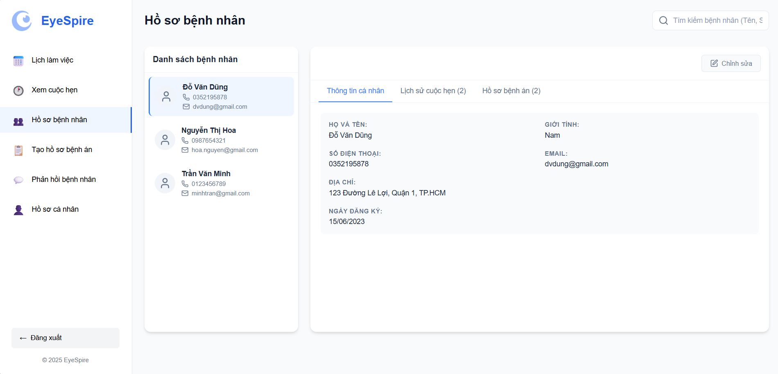

**Screen Content**

| **#** | **Component** | **Comp. Type** | **Editable** | **Mandatory** | **Default Value** | **Description** |
| --- | --- | --- | --- | --- | --- | --- |
| 1 | Screen Title | Label | No | N/A | “Patient Records” | Displays the title of the screen |
| 2 | Search Box | Text Input | Yes | No | Empty | Allows searching patients by name, phone, or email |
| 3 | Patient List Panel | List | Yes | No | Auto-loaded | Shows all registered patients (name, phone, email) |
| 4 | Patient Basic Info | Panel Display | No | N/A | Auto-filled on selection | Summary info for selected patient |
| 5 | Tabs Section | Tab Navigation | Yes | No | “Personal Info” selected | Switch between details: Personal Info, Appointment History, Medical Records |
| 5.1 | Personal Info Tab | Tab Content | Yes | No | Auto-filled | Shows name, gender, phone, email, address, registration date |
| 5.2 | Appointment History Tab | Tab Content | Yes | No | Empty / Populated | Shows past appointments (if any) |
| 5.3 | Medical Records Tab | Tab Content | Yes | No | Empty / Populated | Shows previously created medical records |
| 6 | Edit Button | Button | Yes | No | “Edit” | Allows modifying patient's personal info |

### 3.6 Order Tracking

#### 3.6.1 View My Orders

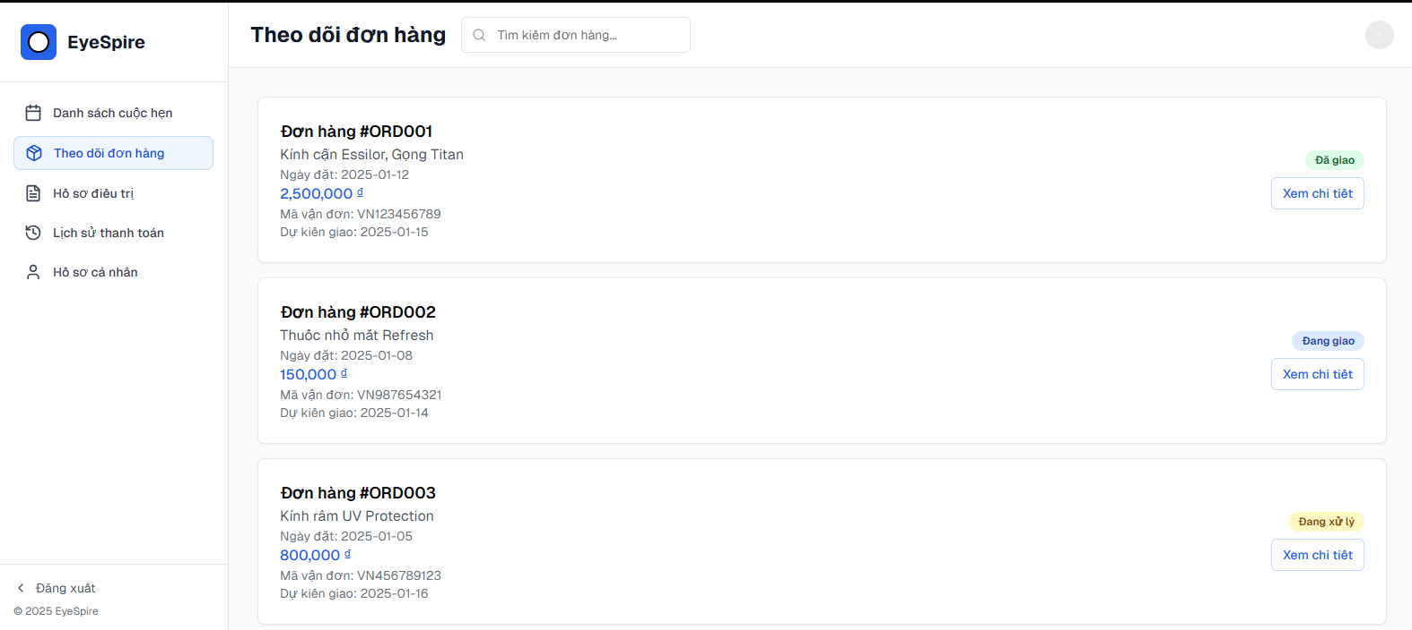

**Screen Content**

| **#** | **Component** | **Comp. Type** | **Editable** | **Mandatory** | **Default Value** | **Description** |
| --- | --- | --- | --- | --- | --- | --- |
| 1 | Screen Name | Label | No | N/A | N/A | Displays the title: **“Theo dõi đơn hàng”** (“Track My Orders”) |
| 2 | Search Bar | Text Input | Yes | No | Empty | Allows users to search by order ID or product name |
| 3 | Order Card List | Card List | No | N/A | From DB | Displays all user orders in card format |
| 3.1 | - Order ID (#ORDxxx) | Label | No | Yes | Auto-generated | Unique identifier of the order |
| 3.2 | - Product Name | Label | No | Yes | From DB | Main product in the order (e.g., “Kính cận Essilor, Gọng Titan”) |
| 3.3 | - Order Date | Label | No | Yes | From DB | The date when the order was placed |
| 3.4 | - Price | Label | No | Yes | From DB | Total price of the order (formatted, e.g., “2,500,000 đ”) |
| 3.5 | - Tracking Code | Label | No | No | From DB | Shipping/tracking code (e.g., “VN123456789”) |
| 3.6 | - Estimated Delivery | Label | No | No | From DB | Estimated delivery date (e.g., “2025-01-15”) |
| 3.7 | - Order Status Badge | Label/Badge | No | Yes | “Đang xử lý”, etc. | Colored label showing status: “Đang xử lý”, “Đang giao”, “Đã giao” |
| 3.8 | - View Detail Button | Button | Yes | Yes | N/A | Opens the full order detail screen |
| 4 | Sidebar - Navigation | Menu | No | N/A | “Theo dõi đơn hàng” | Left navigation menu with icons: Appointments, Orders, Profiles, etc. |
| 5 | Logout Button | Link/Button | No | No | “Đăng xuất” | Logs the user out of the system |

### 3.7 User management

#### 3.7.1 View users

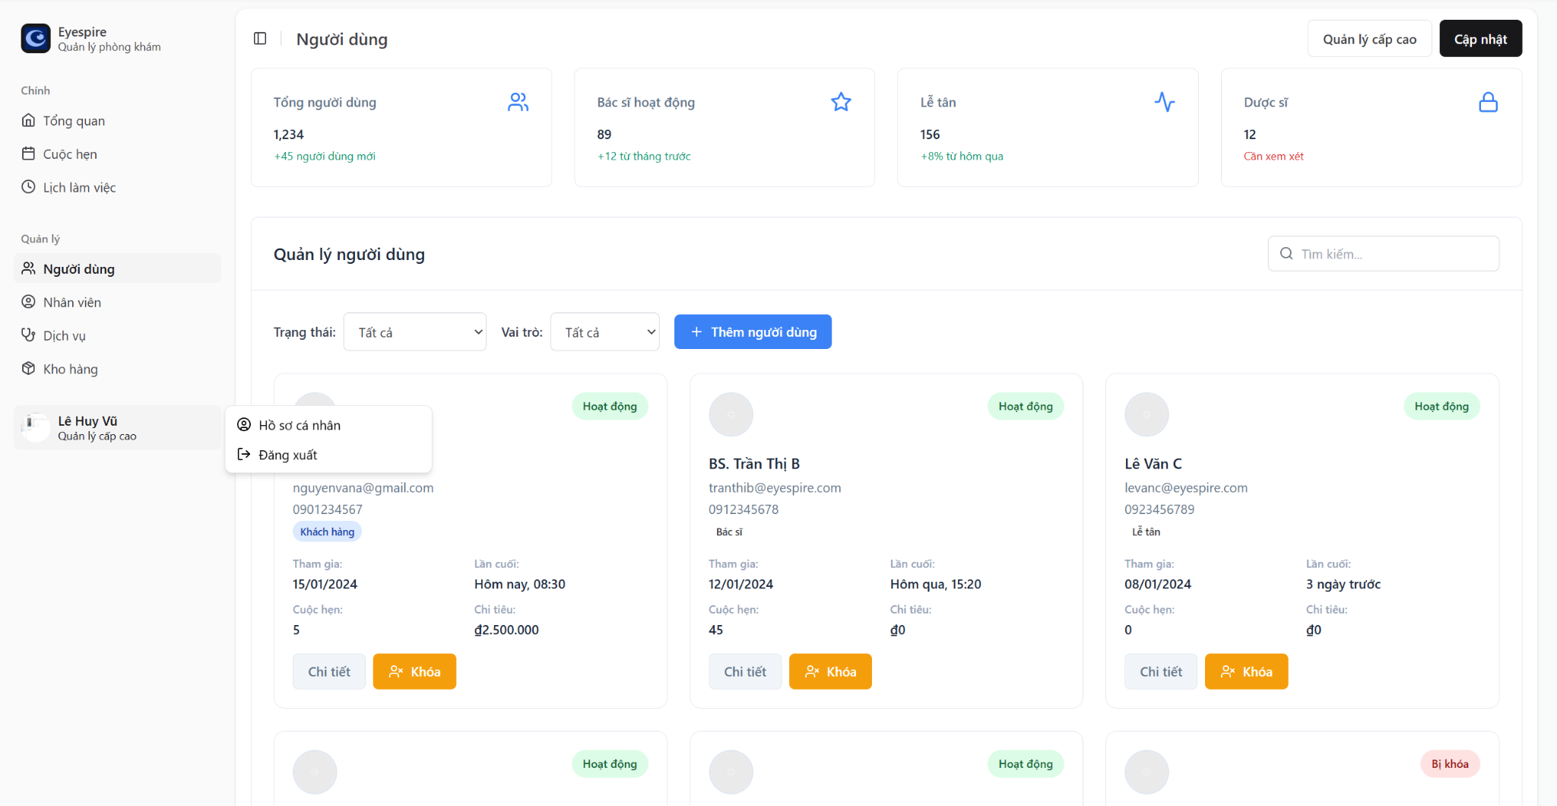

**Screen Content**

| **Component** | **Component Type** | **Editable** | **Mandatory** | **Default Value** | **Description** |
| --- | --- | --- | --- | --- | --- |
| Left Sidebar Menu | Sidebar Menu | No | Yes | - | Navigation to system modules. |
| Screen Title | Text Label | No | Yes | "Users" | Main heading of the screen. |
| Total Users | Info Card | No | Yes | 1,234 (+45 new users) | Total number of users. |
| Active Doctors | Info Card | No | Yes | 89 (+12 from last month) | Number of currently active doctors. |
| Receptionists | Info Card | No | Yes | 156 (+8% from yesterday) | Total active receptionists. |
| Pharmacists | Info Card | No | Yes | 12 (Needs review) | Number of pharmacists pending verification. |
| "Update" Button | Button | Yes | Yes | - | Updates the user list or information. |
| "Advanced Management" Btn | Button | No | No | - | Opens advanced (admin-level) management. |
| Status Filter | Dropdown | Yes | No | All | Filters user list by status (active, locked…). |
| Role Filter | Dropdown | Yes | No | All | Filters user list by role (doctor, customer, receptionist…). |
| "+ Add User" Button | Button | Yes | Yes | - | Adds a new user. |
| User Search Box | Search Box | Yes | No | - | Quickly finds users by name/email. |
| User Card | User Card | Yes | Yes | - | Displays user info: name, email, phone, role, etc. |
| "Details" Button | Button | Yes | Yes | - | Opens user profile for full details. |
| "Lock/Unlock" Button | Toggle Button | Yes | Yes | - | Toggles account status between active/locked. |
| User Status Label | Status Label | No | Yes | “Active” / “Locked” | Indicates current user account status. |
| User Menu (Bottom left) | Dropdown Menu | Yes | Yes | Profile / Logout | Shown when clicking on the logged-in user's name. |

### 3.8 Payment History

#### 3.8.1 My payment history

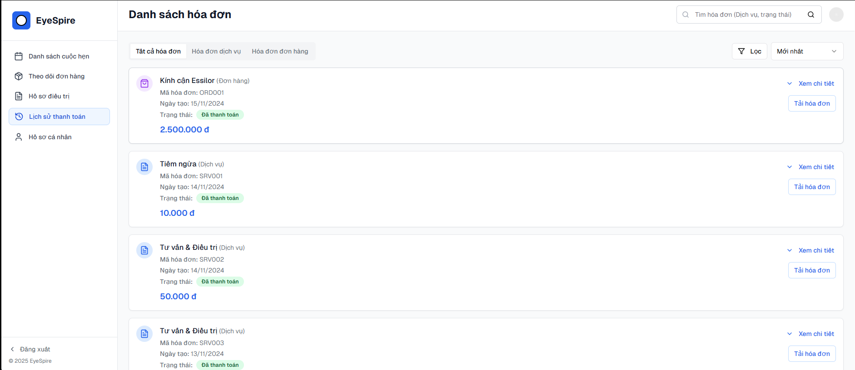

**Screen Content**

| **#** | **Component** | **Comp. Type** | **Editable** | **Mandatory** | **Default Value** | **Description** |
| --- | --- | --- | --- | --- | --- | --- |
| 1 | Screen Title | Label | No | N/A | “Danh sách hóa đơn” | Title of the screen |
| 2 | Tabs | Tab Controller | Yes | No | Tab 1 selected | Tabs: Tất cả hóa đơn / Hóa đơn dịch vụ / Hóa đơn đơn hàng |
| 3 | Search Bar | Text Input | Yes | No | Empty | Search by invoice code, type, or status |
| 4 | Filter Dropdown | Dropdown Button | Yes | No | Mới nhất | Allows sorting or filtering (by time, amount, etc.) |
| 5 | Invoice Card | Card View | No | N/A | From DB | Each card displays invoice info |
| 5.1 | – Service/Product Name | Label | No | Yes | Fetched from DB | Displayed as bold title |
| 5.2 | – Invoice Code | Label | No | Yes | e.g., SRV001, ORD001 | Unique identifier of invoice |
| 5.3 | – Created Date | Label | No | Yes | e.g., 14/11/2024 | Date invoice was created |
| 5.4 | – Status | Badge Label | No | Yes | “Đã thanh toán” | Status indicator (only “paid” shown here) |
| 5.5 | – Amount | Label | No | Yes | Currency format | Total value of the invoice |
| 5.6 | – View Details Button | Button | Yes | No | Collapsed | Show full invoice detail |
| 5.7 | – Download Invoice | Button | Yes | No | Enabled | Allows user to export invoice PDF |
| 6 | Sidebar Navigation | Menu | No | N/A | Highlighted item | “Lịch sử thanh toán” selected |
| 7 | Logout Button | Link | No | No | “Đăng xuất” | Logs the user out |

### 3.9 Store Management

#### 3.9.1 View Product List

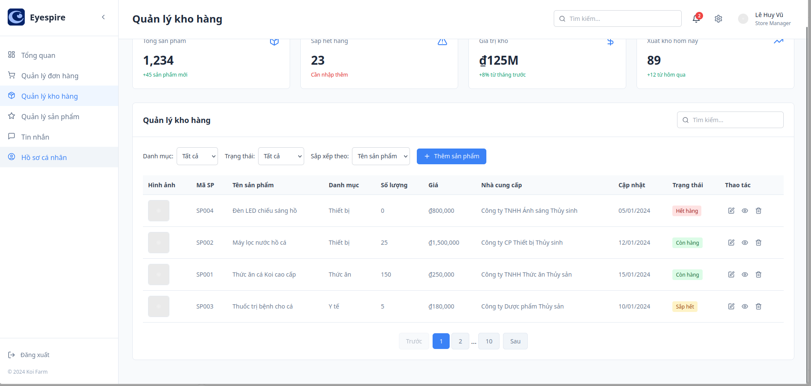

**Screen Content**

| **#** | **Component** | **Comp. Type** | **Editable** | **Mandatory** | **Default Value** | **Description** |
| --- | --- | --- | --- | --- | --- | --- |
| 1 | Page Title | Text | No | Yes | "Order management" | Displays the main heading for the page. |
| 2 | Search and Filters Section | Group | No | Yes | - | Contains search bar, filter dropdowns, and add button. |
| 2.1 | Search Bar | Input | Yes | No | "" | Allows users to search for specific orders by keywords. |
| 2.2 | Filter Dropdown | Dropdown | Yes | No | "All Status" | Lets users filter orders by status (e.g., all, pending, shipped). |
| 2.3 | Add Order Button | Button | No | No | - | Opens a modal to add a new order. |
| 3 | Order List Table | Table | No | Yes | - | Displays a list of orders with detailed information. |
| 3.1 | Order ID Column | Text | No | Yes | - | Shows the unique order ID. |
| 3.2 | Customer Name Column | Text | No | Yes | - | Displays the customer’s name. |
| 3.3 | Product Column | Text | No | Yes | - | Lists the ordered products. |
| 3.4 | Quantity Column | Text | No | Yes | - | Shows the number of items in the order. |
| 3.5 | Price Column | Text | No | Yes | - | Displays the price of the order. |
| 3.6 | Status Column | Badge/Text | No | Yes | - | Indicates the order status (e.g., pending, shipped, delivered). |
| 3.7 | Edit Button | Button | No | No | - | Opens an edit order modal. |

#### 3.9.2 View Order List

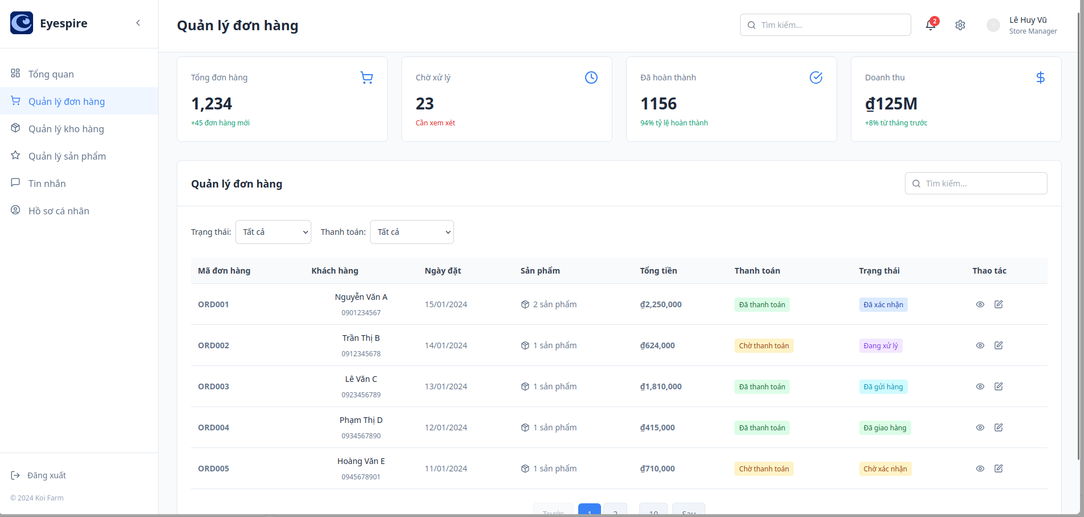

**Screen Content**

| **#** | **Component** | **Comp. Type** | **Editable** | **Mandatory** | **Default Value** | **Description** |
| --- | --- | --- | --- | --- | --- | --- |
| 1 | Navigation Bar | Sidebar menu | No | No | Navigation links | Links to other screens (Overview, Inventory, Orders, etc.) |
| 2 | Statistics Cards | Cards (label) | No | No | Calculated data | Dashboard summary (Total orders, Processing, Completed, Revenue) |
| 3 | Order Table |  |  |  |  |  |
| 3.1 | Order ID | Text (label) | No | Yes | Generated ID | Unique order identifier |
| 3.2 | Customer Name | Text (label) | No | Yes | Customer name | Name of the customer |
| 3.3 | Phone Number | Text (label) | No | Yes | Customer phone | Contact number of the customer |
| 3.4 | Order Date | Date (label) | No | Yes | Order date | Date the order was placed |
| 3.5 | Product Summary | Text (label) | No | Yes | No. of products | Quick overview of ordered products |
| 3.6 | Total Price | Currency (label) | No | Yes | Order total | Total value of the order |
| 3.7 | Payment Status | Label/Tag | No | Yes | Status label | Current payment status (Paid, Unpaid) |
| 3.8 | Order Status | Label/Tag | No | Yes | Status label | Current order status (Confirmed, Processing, Shipped, Delivered, etc.) |
| 3.9 | Action Buttons | Buttons (icon) | No | No | View/Edit/Delete | Actions for viewing, editing, deleting orders |
| 4 | Search Bar | Input (search) | Yes | No | Empty | Search by order ID, customer, etc. |
| 5 | Filter Dropdowns | Dropdown | Yes | No | "All" selected | Filter by order/payment status |

### 3.10 Message

#### 3.10.1 Send Message (Store manager Dashboard screen)

### Screen Content

| **#** | **Component** | **Comp. Type** | **Editable** | **Mandatory** | **Default Value** | **Description** |
| --- | --- | --- | --- | --- | --- | --- |
| 1 | Search bar (Tìm cuộc trò chuyện…) | Text Input | Yes | No |  | Used to search for specific conversations. |
| 2.1 | Message list (Danh sách tin nhắn) | List View | No | No |  | Displays all conversations categorized by user roles (e.g., customers, employees, groups). |
| 2.2 | Message thread | Chat Window | Yes | No |  | Displays the full conversation with a selected user. |
| 2.3 | Reply input field | Text Input | Yes | Yes |  | Used to reply to messages in the conversation. |
| 2.4 | Send message button | Button | No | Yes |  | Sends the typed message to the selected recipient. |
| 2.5 | Chat filter tabs (Tất cả, Khách hàng, Nhân viên, Nhóm) | Tabs | No | No | All | Filters message list by user group. |
| 2.6 | Statistics boxes (Tổng tin nhắn, Cuộc trò chuyện, Chưa đọc, Thời gian phản hồi) | Info Cards | No | No |  | Displays high-level metrics for chat management. |
| 2.7 | Message status icon (Online/Offline dot) | Status Indicator | No | No |  | Shows whether the user is currently active or not. |
| 2.8 | Message action buttons (Call, Video, Search, More) | Icons | No | No |  | Allows additional actions like call, video call, search or more options within a chat. |

#### 3.10.2 Send Message (Receptionist Dashboard screen)

#### 

### 

### Screen Content

| **Component** | **Comp. Type** | **Editable** | **Mandatory** | **Default Value** | **Description** |
| --- | --- | --- | --- | --- | --- |
| Total Messages | Info Card | No | No | e.g., 1,234 | Displays total messages count (with indicator for new messages) |
| Total Conversations | Info Card | No | No | e.g., 156 | Total number of active conversations |
| Unread Messages | Info Card | No | No | e.g., 23 | Shows number of unread messages requiring response |
| Avg. Response Time | Info Card | No | No | e.g., 2.5 min | Displays average response time across conversations |
| Search Conversations | Search Bar | Yes | No |  | Filters the message list based on keyword or contact name |
| Conversation Tabs | Tabs | Yes | No | All | Filter by group: All, Customer, Staff, Group |
| Contact List | Conversation List | Yes | Yes |  | Lists conversations (name, preview, time, unread count) |
| Message Thread | Chat Interface | Yes | Yes |  | Displays full conversation with selected contact |
| Message Bubble (in/out) | Chat Message | Yes | Yes |  | Shows text content with timestamp and sender alignment |
| Chat Tools (top right) | Icon Buttons | Yes | No | Phone, Menu | Allows additional actions like call, video call, search or more options within a chat. |

### 3.11 Feedback

#### 3.11.1 View Product FeedBack

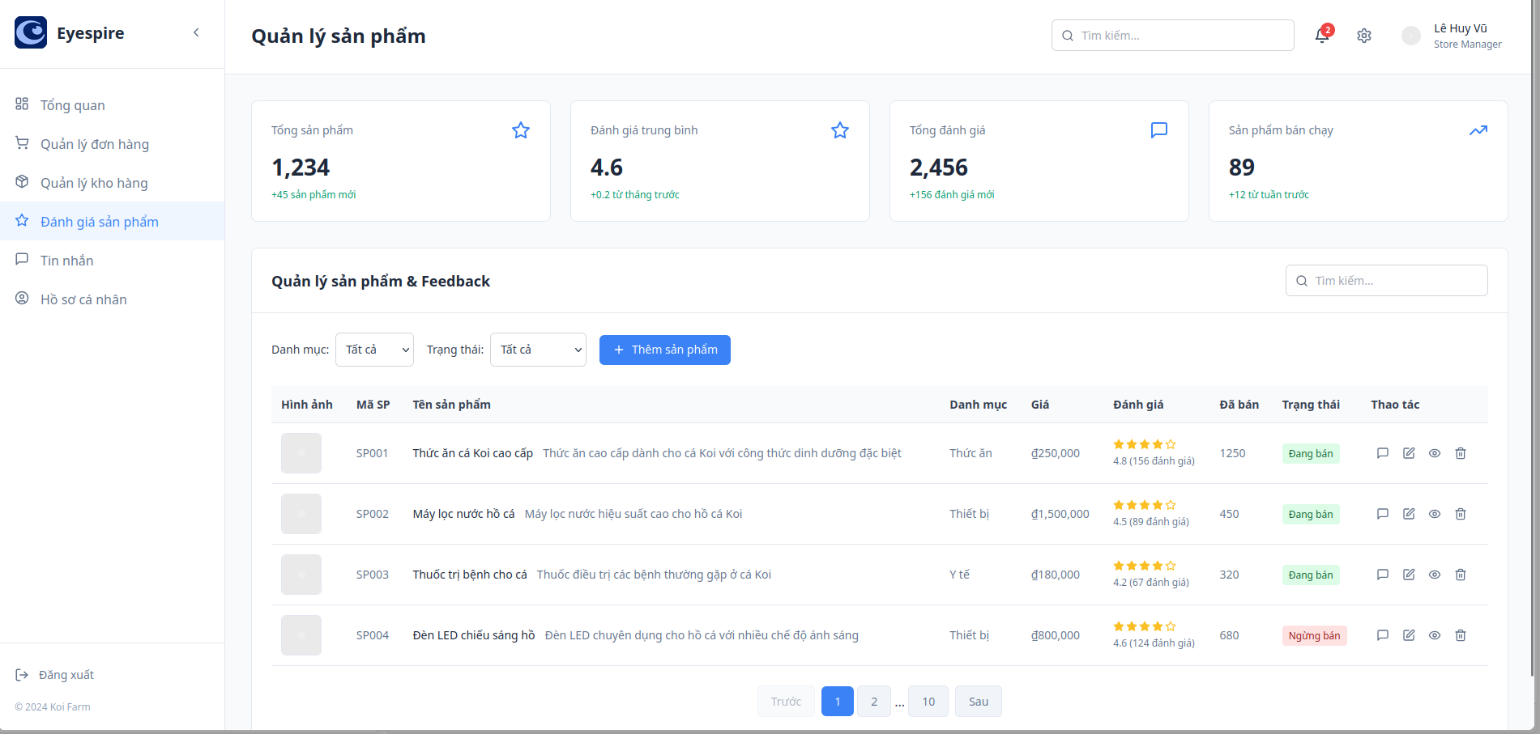

**Screen Content**

| **#** | **Component** | **Comp. Type** | **Editable** | **Mandatory** | **Default Value** | **Description** |
| --- | --- | --- | --- | --- | --- | --- |
| 1 | Category (Dropdown) | Dropdown | Yes | No | Yes / No / All | Filter products by category |
| 2 | Status (Dropdown) | Dropdown | Yes | No | Yes / No / All | Filter products by sale status |
| 3 | Add Product | Button | No | No | - | Opens form to add new product |
| 4 | Search Bar | Text Input | Yes | No | - | Search products by name, ID, or description |
| 5 | Product List Table | Data Table | No | No | - | Displays product list based on filters |
| 5.1 | → Column: Image | Image Thumbnail | No | No | Placeholder | Product thumbnail image |
| 5.2 | → Column: Product Code | Text | No | Yes | SP001, SP002, ... | Unique product identifier |
| 5.3 | → Column: Product Name | Text | Yes | Yes | Specific name | Name and short description of product |
| 5.4 | → Column: Category | Text | No | Yes | Food, Equipment, etc. | Product classification |
| 5.5 | → Column: Price | Currency Text | Yes | Yes | Specific price (VND) | Selling price of product |
| 5.6 | → Column: Rating | Rating Display | No | No | Avg. rating + total count | Average customer rating and total reviews |
| 5.7 | → Column: Sold Quantity | Numeric Display | No | No | Total units sold | Number of units sold |
| 5.8 | → Column: Status | Status Tag | Indirectly | Yes | On Sale / Off Sale | Current availability status |
| 5.9 | → Icon: Feedback | Icon Button | Yes | No | - | View user feedback for the product |
| 5.10 | → Icon: Edit Product | Icon Button | Yes | No | - | Open form to edit product details |
| 5.11 | → Icon: View Details | Icon Button | Yes | No | - | View full product details |
| 5.12 | → Icon: Delete Product | Icon Button | Yes | No | - | Remove product from the system |
| 6 | Pagination | Pagination Control | Yes | No | Page 1 | Navigation control for product list pages |

#### 3.11.2 Customer Feedback Screen

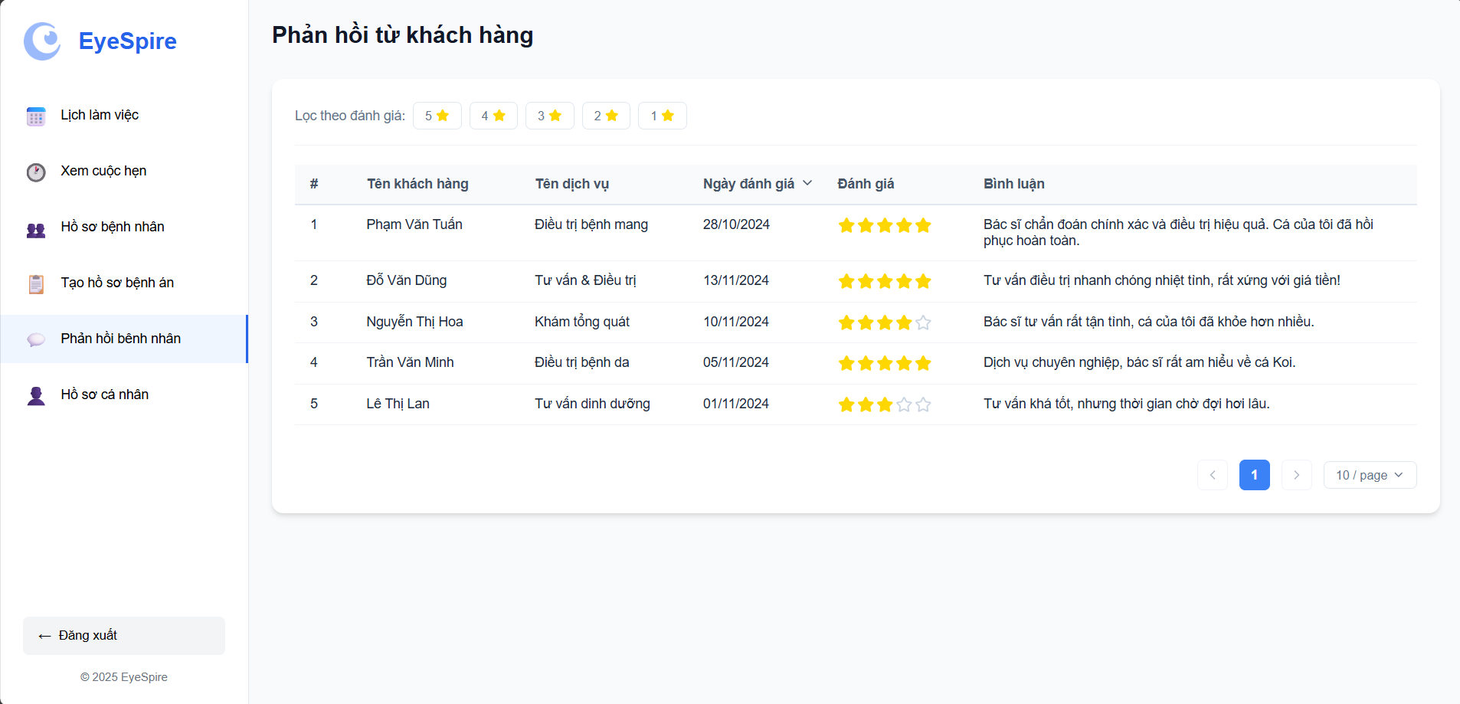

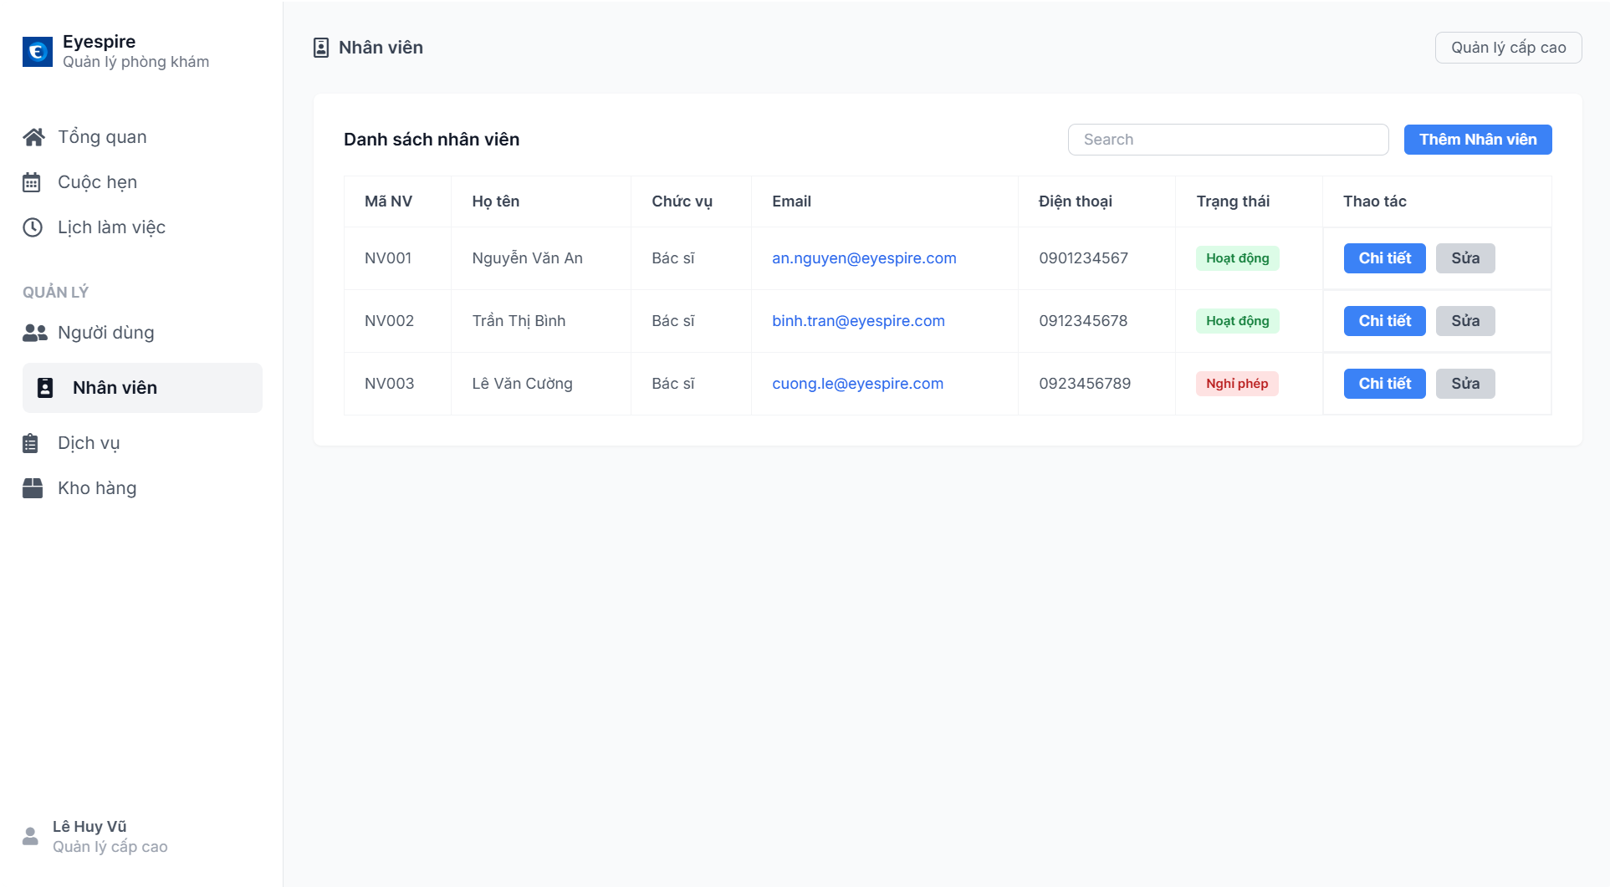

| **#** | **Component** | **Comp. Type** | **Editable** | **Mandatory** | **Default Value** | **Description** |
| --- | --- | --- | --- | --- | --- | --- |
| 1 | Screen Title | Label | No | N/A | “Customer Feedback” | Displays screen heading |
| 2 | Rating Filter | Radio/Selectable Icons | Yes | No | None selected | Filters feedbacks by rating (1 to 5 stars) |
| 3 | Feedback Table | Table Display | No | N/A | Auto-loaded | Displays all customer feedback entries |
| 3.1 | # (Index) | Auto Number | No | N/A | Auto-incremented | Feedback row index |
| 3.2 | Customer Name | Text | No | Yes | From database | Name of the customer who gave feedback |
| 3.3 | Service Name | Text | No | Yes | From database | Name of service used |
| 3.4 | Review Date | Date | No | Yes | From database | Date when the feedback was submitted |
| 3.5 | Rating | Star Icons | No | Yes | From database | 1–5 star rating |
| 3.6 | Comment | Text | No | Yes | From database | Customer’s written feedback |
| 4 | Pagination Control | Buttons + Dropdown | Yes | No | “10/page” | Navigate pages of feedback entries |

### 3.12 Personnel management

#### 3.12.1 View personnels



**Screen Content**

| **Component** | **Component Type** | **Editable** | **Mandatory** | **Default Value** | **Description** |
| --- | --- | --- | --- | --- | --- |
| Left Sidebar Menu | Sidebar Menu | No | Yes | - | Navigation to other system modules. |
| Screen Title | Text Label | No | Yes | "Staff" | Title of the screen. |
| Search Box | Search Box | Yes | No | "Search" | Search for staff by name, ID, email, etc. |
| “Add Staff” Button | Button | Yes | Yes | - | Opens form to add a new staff member. |
| Staff List Table | Table | No | Yes | - | Displays list of staff members in tabular format. |
| "Staff ID" Column | Table Column | No | Yes | NV001, NV002,... | Unique identifier for staff. |
| "Full Name" Column | Table Column | No | Yes | Nguyễn Văn An,... | Staff's full name. |
| "Position" Column | Table Column | Yes | Yes | Doctor / Receptionist,... | Current role of the staff member. |
| "Email" Column | Table Column | Yes | Yes | an.nguyen@eyespire.com,... | Contact email of the staff. |
| "Phone Number" Column | Table Column | Yes | Yes | 0901234567,... | Contact number of the staff. |
| "Status" Column | Status Label | Yes | Yes | Active / On Leave,... | Current working status. |
| "Actions" Column | Action Buttons | Yes | Yes | “Details”, “Edit” buttons | View or edit staff details. |
| “Details” Button | Button | Yes | Yes | - | Opens detailed view of the staff member. |
| “Edit” Button | Button | Yes | Yes | - | Opens staff edit form. |

### 3.13 Service management

#### 3.13.1 View Services

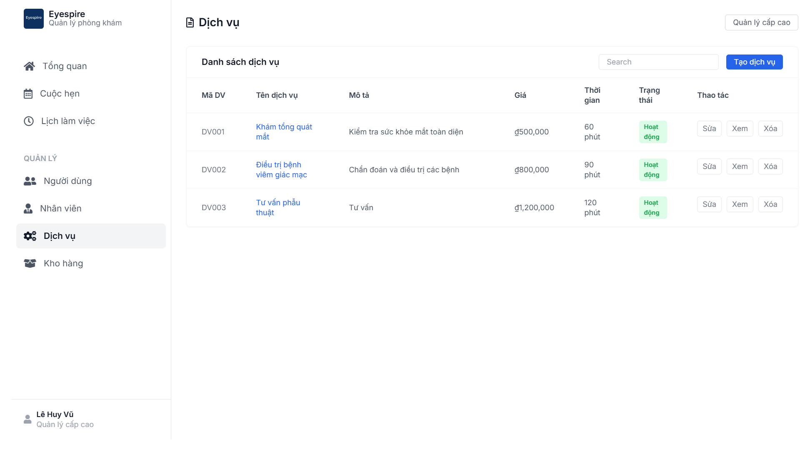

**Screen Content**

| **Component** | **Component Type** | **Editable** | **Mandatory** | **Default Value** | **Description** |
| --- | --- | --- | --- | --- | --- |
| Left Sidebar Menu | Sidebar Menu | No | Yes | - | Navigation to other system modules. |
| Screen Title | Text Label | No | Yes | "Services" | Main title of the screen. |
| Search Box | Search Box | Yes | No | "Search" | Search for services by name, code,... |
| “Create Service” Button | Button | Yes | Yes | - | Opens form to add a new service. |
| Services Table | Table | No | Yes | - | Displays the list of services. |
| "Service Code" Column | Table Column | No | Yes | DV001, DV002,... | Unique code for the service. |
| "Service Name" Column | Table Column | Yes | Yes | Eye Exam,... | The name of the service. |
| "Description" Column | Table Column | Yes | Yes | Brief summary | Function or purpose of the service. |
| "Price" Column | Table Column | Yes | Yes | ₫500,000,... | Cost of the service. |
| "Duration" Column | Table Column | Yes | Yes | 60 minutes,... | Average time to complete the service. |
| "Status" Column | Status Label | Yes | Yes | Active / Inactive | Current availability status. |
| "Actions" Column | Action Buttons | Yes | Yes | “Edit”, “View”, “Delete” | User actions on individual services. |
| “Edit” Button | Button | Yes | Yes | - | Opens the edit form for the service. |
| “View” Button | Button | Yes | Yes | - | Opens the service detail view. |
| “Delete” Button | Button | Yes | Yes | - | Deletes the service (confirmation may be required). |

### 3.14 Statistics

#### 3.14.1 View statistics

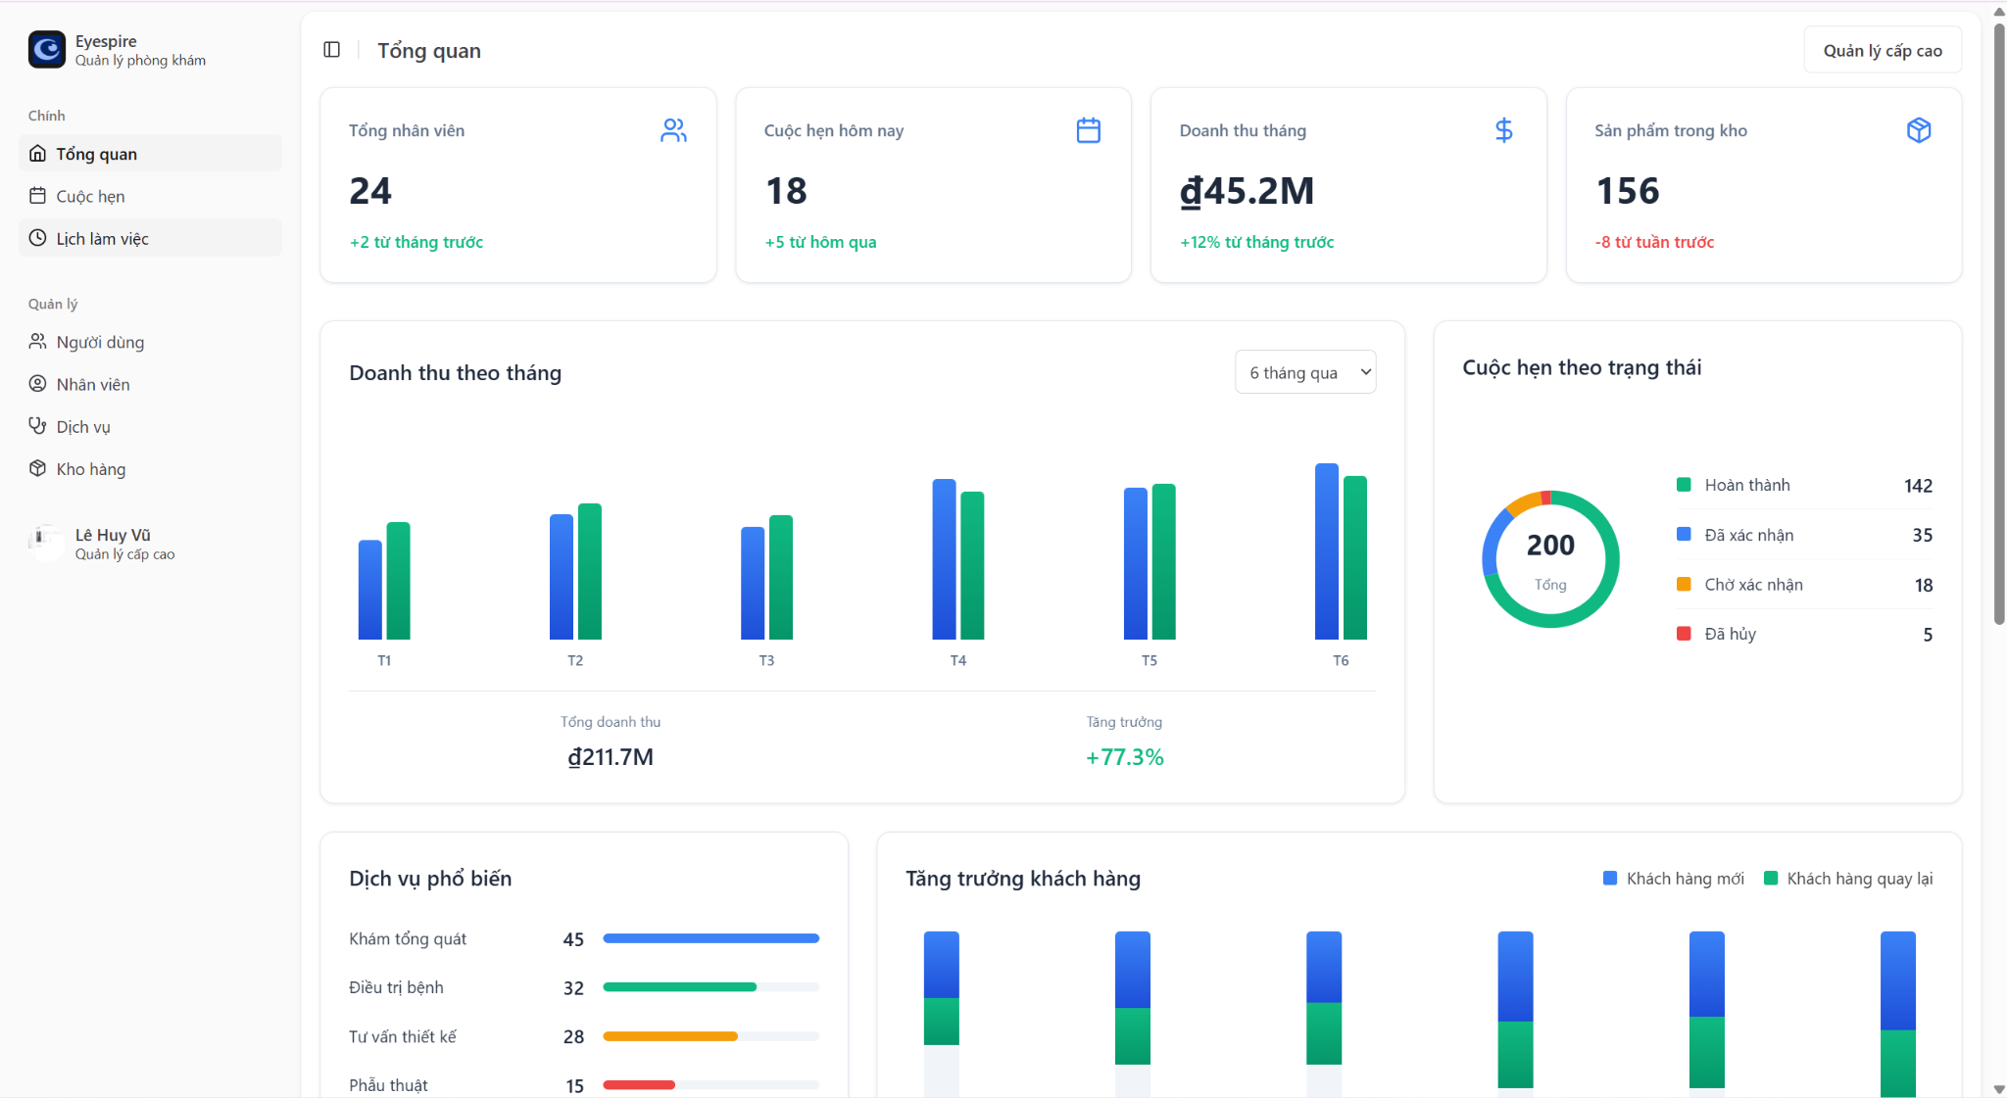

**Screen Content**

| **Component** | **Component Type** | **Editable** | **Mandatory** | **Default Value** | **Description** |
| --- | --- | --- | --- | --- | --- |
| Left Sidebar Menu | Sidebar Menu | No | Yes | - | Navigates to other modules. |
| Screen Title | Text Label | No | Yes | "Overview" | Main title of the overview screen. |
| Total Employees | Card Number | No | Yes | 24 (+2 from last month) | Current number of staff. |
| Appointments Today | Card Number | No | Yes | 18 (+5 from yesterday) | Total number of today's appointments. |
| Revenue This Month | Card Number | No | Yes | ₫45.2M (+12%) | Revenue for the current month. |
| Products in Inventory | Card Number | No | Yes | 156 (-8 from last week) | Number of items in inventory. |
| Revenue by Month | Bar Chart | No | Yes | T1–T6 | Monthly revenue comparison. |
| Time Filter (dropdown) | Dropdown Filter | Yes | Yes | “Last 6 months” | Filter analytics by time period. |
| Total Revenue | Text + Number | No | Yes | ₫211.7M | Cumulative revenue over the filtered period. |
| Revenue Growth | Text + % | No | Yes | +77.3% | Growth percentage compared to previous period. |
| Appointments by Status | Donut Chart | No | Yes | 200 (status breakdown) | Appointment status breakdown. |
| Popular Services | Bar Chart | No | Yes | Top 4 services | Most frequently used services. |
| Customer Growth | Stacked Bar Chart | No | Yes | New vs Returning customers | Growth comparison of customer types. |

### 3.15 Personal Profile

#### 3.15.1 Personal Profile Screen (Doctor)

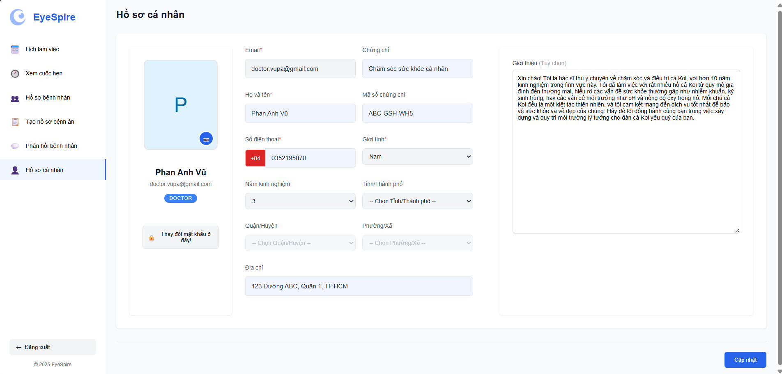

**Screen Content**

| **#** | **Component** | **Comp. Type** | **Editable** | **Mandatory** | **Default Value** | **Description** |
| --- | --- | --- | --- | --- | --- | --- |
| 1 | Screen Title | Label | No | N/A | “Personal Profile” | Displays heading |
| 2 | Sidebar Menu | Menu | No | N/A | “Personal Profile” selected | Navigation panel |
| 3 | Avatar | Image Upload (icon) | Yes | No | User initials or blank | Allows doctor to upload a profile picture |
| 4 | Name & Role Display | Label/Text | No | Yes | From database | Doctor's full name and role badge (e.g. DOCTOR) |
| 5 | Email | Text (read-only) | No | Yes | From login | User's registered email address |
| 6 | Certificate | Text | Yes | Yes | e.g., “Chăm sóc sức khỏe cá nhân” | Medical/Health-related certificate |
| 7 | Certificate Code | Text | Yes | Yes | e.g., ABC-GSH-WH5 | Verification code for the certificate |
| 8 | Full Name | Text | Yes | Yes | e.g., Phan Anh Vũ | Full name of the user |
| 9 | Phone Number | Phone Input | Yes | Yes | e.g., +84 352195870 | Editable phone number field |
| 10 | Gender | Dropdown | Yes | Yes | “Nam” (Male) | Gender selection |
| 11 | Years of Experience | Dropdown | Yes | Yes | e.g., “3” | Professional experience |
| 12 | City/Province | Dropdown | Yes | Yes | None selected | Dynamic dropdown for province |
| 13 | District | Dropdown | Yes | Yes | None | Depends on selected province |
| 14 | Ward/Commune | Dropdown | Yes | Yes | None | Depends on selected district |
| 15 | Address | Text | Yes | No | e.g., “123 Đường ABC… | Freeform address field |
| 16 | Bio/Introduction | Textarea | Yes | No | Optional | Self-description by the doctor |
| 17 | Password Change Link | Button | Yes | No | “Thay đổi mật khẩu ở đây!” | Redirects to password update screen |
| 18 | Update Button | Button | Yes | No | “Cập nhật” | Saves updated profile information |

#### 3.15.2 Personal Profile Screen (Receptionist)

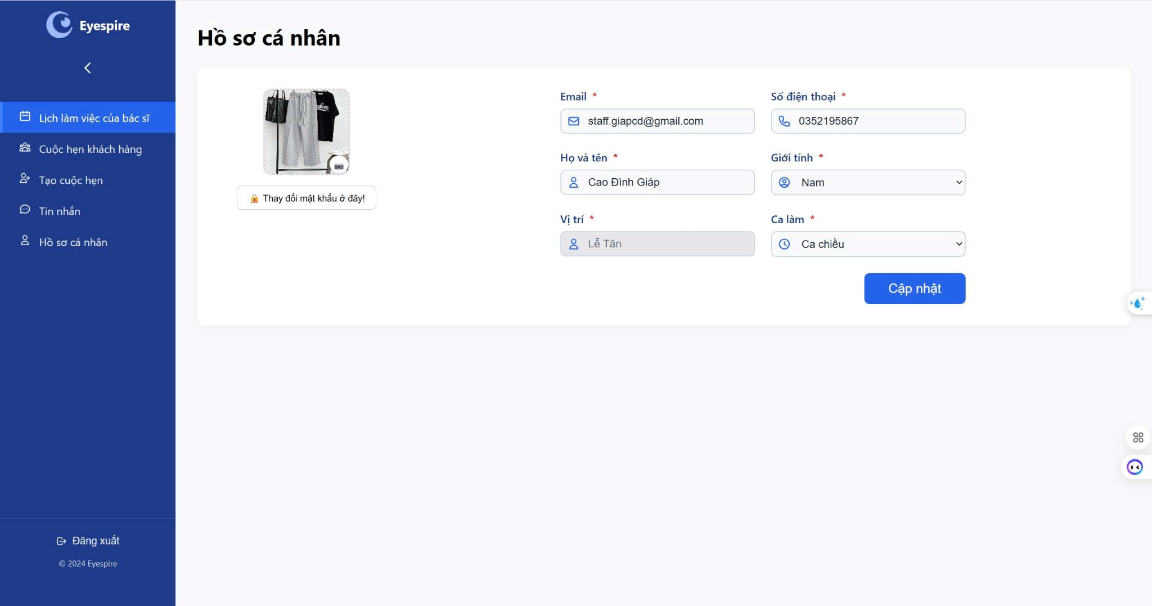

**Screen Content**

| Component | Comp. Type | Editable | Mandatory | Default Value | Description |
| --- | --- | --- | --- | --- | --- |
| Profile Picture | Image Upload | Yes | No | N/A | Displays and allows uploading avatar |
| Email | Text Field | No | Yes | staff.giapcd@gmail.com | User's email address |
| Full Name | Text Field | Yes | Yes | Cao Đình Giáp | User's full name |
| Phone Number | Text Field | Yes | Yes | 0352195867 | User's contact number |
| Gender | Dropdown | Yes | Yes | Nam | Select gender |
| Position | Text Field | No | Yes | Lễ Tân | User’s role or position (non-editable) |
| Work Shift | Dropdown | Yes | Yes | Ca chiều | Select user’s working shift |
| Change Password Note | Label/Button | Yes | No | "🔒 Thay đổi mật khẩu ở đây!" | Button or hint to change password |
| Update Button | Button | N/A | N/A | "Cập nhật" | Save the updated profile info |

#### 3.15.3 Personal Profile Screen (Admin)

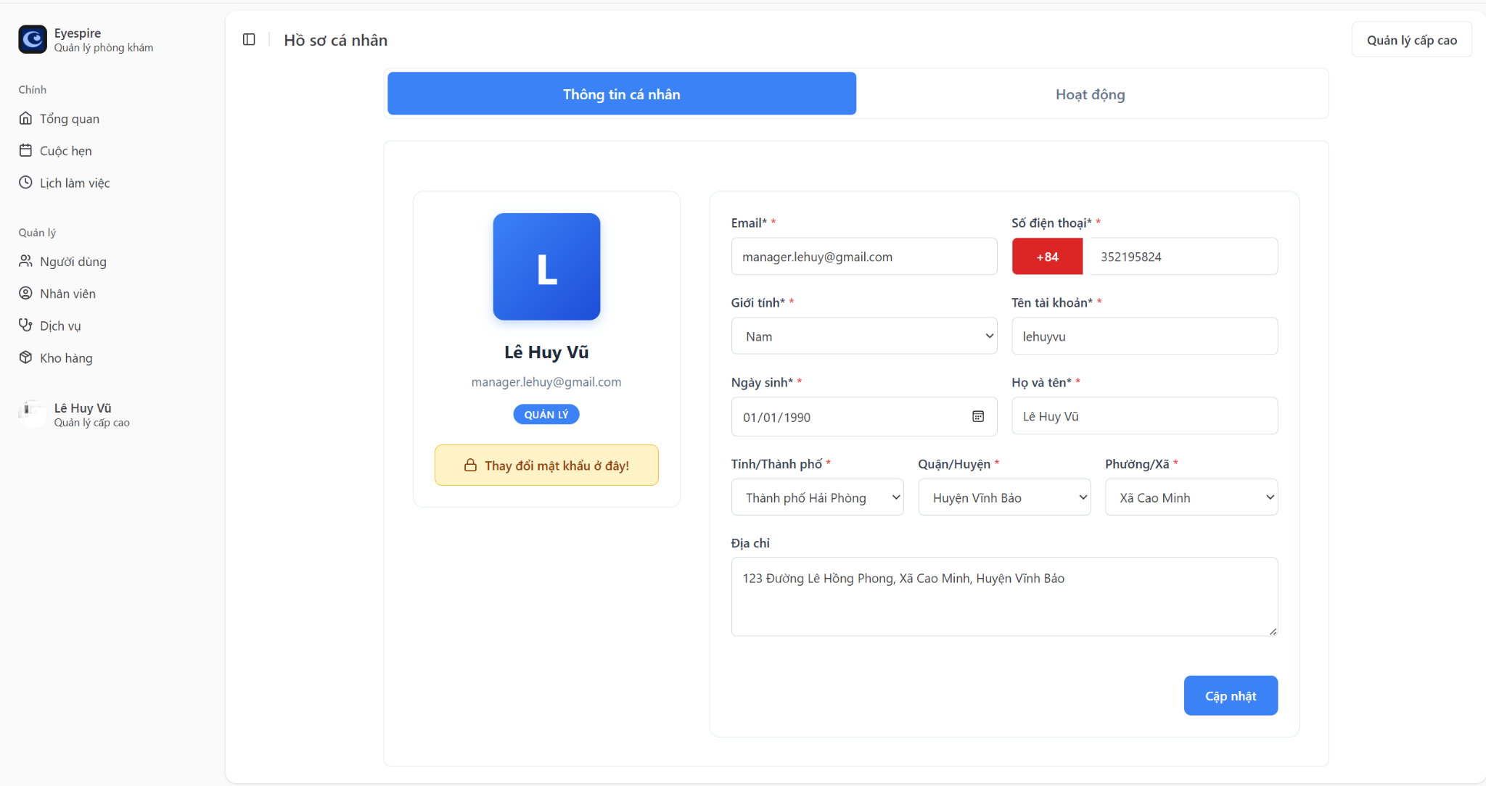

**Screen Content**

| **Component** | **Comp. Type** | **Editable** | **Mandatory** | **Default Value** | **Description** |
| --- | --- | --- | --- | --- | --- |
| Profile Avatar | Image/Letter | No | No | First letter of name | Default avatar shown as first character of name |
| Full Name Display | Text Display | No | Yes | Lê Huy Vũ | Shown under avatar |
| Role Tag | Label | No | No | "QUẢN LÝ" | Displays the user’s role |
| Email | Text Field | No | Yes | manager.lehuy@gmail.com | User's email address |
| Phone Code | Prefix Field | No | Yes | +84 | Phone country code |
| Phone Number | Text Field | Yes | Yes | 352195824 | User’s local phone number |
| Gender | Dropdown | Yes | Yes | Nam | Select gender |
| Date of Birth | Date Picker | Yes | Yes | 01/01/1990 | Select user’s date of birth |
| Username | Text Field | No | Yes | lehuyvu | User account username |
| Full Name (Edit) | Text Field | Yes | Yes | Lê Huy Vũ | Editable name input |
| Province/City | Dropdown | Yes | Yes | Thành phố Hải Phòng | Administrative city selection |
| District | Dropdown | Yes | Yes | Huyện Vĩnh Bảo | Administrative district selection |
| Ward | Dropdown | Yes | Yes | Xã Cao Minh | Administrative ward selection |
| Address | Textarea | Yes | No | 123 Đường Lê Hồng Phong… | Full address input |
| Change Password Button | Button/Labe | Yes | No | Thay đổi mật khẩu ở đây! | Button to redirect/change password |
| Update Button | Button | N/A | N/A | Cập nhật | Confirms and saves updates |

## 4. Non-Functional Requirements

### 4.1 External Interfaces

The Eyespire system will interface with the following external entities:

* **Users (via Web Browsers)** Users access the system through modern browsers (Chrome, Edge, Firefox, Safari). The UI must be responsive and accessible on both desktop and mobile devices.
* **SMS/Email Notification Services** Integration with external APIs (e.g., Twilio, SendGrid) to send appointment reminders and order status updates.
* **Gmail Authentication API** Supports OAuth 2.0 for user login via Gmail.
* **Database System** The system interacts with PostgreSQL for storing appointments, user accounts, product data, and medical records.
* **Payment Gateway (Future Version)** Will integrate with third-party services like VNPay or PayOS to process online payments.

### 4.2 Quality Attributes

#### 4.2.1 Usability

* The system shall require **no more than 1 hour** of training for regular users (patients).
* Power users (e.g., receptionist/admin) shall reach proficiency in under **3 hours** of training.
* The UI shall follow usability best practices aligned with **Google’s Material Design** and **WCAG 2.1** accessibility guidelines.
* Patients shall be able to complete an appointment booking in **under 2 minutes** under typical network conditions.

#### 4.2.2 Reliability

* **Availability:** The system shall be available **99.5% of the time**, excluding scheduled maintenance.
* **MTBF (Mean Time Between Failures):** At least **500 hours**.
* **MTTR (Mean Time To Repair):** Less than **2 hours** during business hours.
* **Accuracy:** Appointment time slots and inventory stock updates shall reflect real-time data with **100% transactional accuracy**.
* **Defect Rate:**
  + Critical bugs: ≤ **0.5 bugs per KLOC**
  + Significant bugs: ≤ **1.0 bugs per KLOC**
  + Minor bugs: ≤ **2.0 bugs per KLOC** Definitions:
  + *Critical*: Complete failure or data loss (e.g., failure to save appointment)
  + *Significant*: Non-blocking logic errors (e.g., incorrect status shown)
  + *Minor*: Cosmetic/UI inconsistencies (e.g., label misalignment)

#### 4.2.3 Performance

* **Response Time:**
  + Appointment booking confirmation: ≤ **2 seconds**
  + Medical record retrieval: ≤ **1.5 seconds**
  + Product list loading: ≤ **3 seconds**
* **Throughput:** The system shall support at least **100 concurrent users**, with peak load capability of **500 appointments processed/hour**.
* **Capacity:**
  + Registered Users: up to **100,000**
  + Stored Appointments: up to **1 million**
  + Product Inventory: up to **10,000 items**
* **Resource Utilization:**
  + Web application shall not exceed **70% CPU usage** under normal load.
  + Memory consumption per session shall not exceed **100MB**.

## 5. Requirement Appendix

### 5.1 Business Rules

| **ID** | **Rule Definition** |
| --- | --- |
| BR-1 | Only users with the role of "admin" or "receptionist" can view all appointments. |
| BR-2 | Appointment data must be updated in real time. |
| BR-3 | Completed or cancelled appointments cannot be modified (unless the user has special permissions). |
| BR-4 | Only users with the role of “receptionist” can reject appointments. |
| BR-5 | Once rejected, appointments cannot be modified without special permissions |
| BR-6 | Only receptionists or admins can update appointment details. |
| BR-7 | Appointments that are completed or canceled can only be modified with special rights. |
| BR-8 | The assignment of a doctor must align with the doctor’s schedule. |
| BR-9 | The selected doctor to confirm the appointment must be available at the designated time |
| BR-10 | Only Admin/ Receptionist is permitted to modify a doctor’s schedule. |
| BR-11 | Changes must not conflict with existing appointments (unless an override is allowed). |
| BR-12 | Only admins or receptionists can create Doctor’s schedules. |
| BR-13 | Duplicate scheduling with an existing schedule is not allowed. |
| BR-14 | Filters must be applied in real time. |
| BR-15 | Only admin or receptionist roles can use the filtering function. |
| BR-16 | Patients can choose date/time, doctor or service. |
| BR-17 | Appointments must be marked "Pending" until reviewed by the receptionist. |
| BR-18 | The system must ensure appointment details are updated in real-time. |
| BR-19 | Users must have an account with a unique email/username and password, or a linked Gmail account. |
| BR-20 | The system must enforce password complexity and account security (e.g., multi-factor authentication if enabled). |
| BR-21 | Access rights are role-based (Doctor, Patient, Store Manager) and restrict users to their designated functionalities. |
| BR-22 | Gmail authentication must comply with the Gmail Authentication Service’s security protocols. |
| BR-23 | Only authenticated users can initiate a sign-out action. |
| BR-24 | The system must securely terminate the session and clear all sensitive data. |
| BR-25 | Logout must be available from all user interfaces (e.g., dashboard, settings) |
| BR-26 | The user must agree to the terms of service before completing the registration. |
| BR-27 | The account must require email verification to activate the account (email confirmation is mandatory). |
| BR-28 | Unverified accounts will not be allowed to log in or will have limited privileges |
| BR-29 | The user must provide a valid email address or phone number associated with an existing account. |
| BR-30 | Password reset links and OTPs must expire after a set time (e.g., 30 minutes). |
| BR-31 | If the reset link is used, it can only be used once. |
| BR-32 | The user can only view their own profile, except for Admin users, who can view all user profiles. |
| BR-33 | Admins should have the ability to view and edit other users’ profiles for management purposes. |
| BR-34 | The user must provide the correct current password to change their password. |
| BR-35 | Only the user who owns the account can delete it (except in cases where Admin has specific permissions). |
| BR-36 | Once deleted, the account can be restored for 30 days before being permanently deleted. |
| BR-37 | If the deletion process fails due to a system or network issue, the user must be informed and allowed to retry. |
| BR-38 | Only the profile owner (or an Admin with management rights) is allowed to update the profile. |
| BR-39 | Updated data must be validated (format checks, required fields, etc.). |
| BR-40 | The system must ensure that the message is successfully delivered to the receptionist. |
| BR-41 | The user must be able to reply; two-way messaging support is essential |
| BR-42 | The User should be notified when a new message is received. |
| BR-43 | The ChatBox should respond to common queries related to services, appointment scheduling, and product inquiries. |
| BR-44 | If the ChatBox cannot answer a question, it should escalate the issue appropriately (e.g., offering to connect the user with a human representative). |
| BR-45 | The system should log all ChatBox interactions for analysis, training purposes, or future reference. |
| BR-46 | The system must process search queries efficiently and return relevant services from the database. |
| BR-47 | The system should allow for basic keyword search and may support advanced search filters (e.g., price range, category). |
| BR-48 | The system must handle empty search queries gracefully and prompt the user to provide a valid input. |
| BR-49 | Only services marked as "active" in the database are displayed. |
| BR-50 | Service details must comply with healthcare regulations (e.g., no misleading information) |
| BR-51 | Detailed information must comply with healthcare regulations (e.g., accurate cost and duration, no misleading information). |
| BR-52 | Guests and Patients have the same level of access to the service list and detail (no authentication required). |
| BR-53 | Only patients who have received a service can provide feedback. |
| BR-54 | Feedback must include a rating; comments are optional. |
| BR-55 | Feedback must be associated with the correct service in the database. |
| BR-56 | Only patients with authenticated access can access and download their medical records. |
| BR-57 | The record must include all relevant medical data (e.g., diagnosis, treatment history) and comply with privacy regulations. |
| BR-58 | The system must encrypt the PDF file during download to ensure data security. |
| BR-59 | Only patients with authenticated access can cancel their appointments. |
| BR-60 | Cancellations must adhere to the healthcare provider’s policy (e.g., a minimum notice period). |
| BR-61 | The system must notify relevant staff or update schedules after a cancellation. |
| BR-62 | Only patients with authenticated access can place orders. |
| BR-63 | Orders must reflect real-time inventory availability. |
| BR-64 | The system must comply with payment and shipping regulations (e.g., secure transactions) |
| BR-65 | The search function is available only to Patients who are logged into the system. |
| BR-66 | Search results must reflect real-time inventory availability. |
| BR-67 | The system must support multiple search methods (e.g., keywords, categories). |
| BR-68 | Search activity may be linked to the patient’s profile for personalized recommendations. |
| BR-69 | Only products marked as "active" and in stock are displayed. |
| BR-70 | The system must ensure the product list is updated in real-time. |
| BR-71 | The product list may be tailored based on the patient’s medical history or preferences (if applicable). |
| BR-72 | The cart must reflect real-time inventory availability. |
| BR-73 | The system must limit the quantity added based on stock levels. |
| BR-74 | Only the patient can modify their own cart. |
| BR-75 | Removed products are immediately available for other users. |
| BR-76 | Only the patient can view their own order status. |
| BR-77 | Order status must be up-to-date and accurate. |
| BR-78 | Only the patient can view their own order details. |
| BR-79 | Order details must be accurate and complete |
| BR-80 | Only patients with completed orders can provide feedback. |
| BR-81 | Feedback must include a rating; comments are optional. |
| BR-82 | Only the Store Manager can update order status. |
| BR-83 | Status changes must follow a predefined workflow (e.g., Processing → Shipped → Delivered). |
| BR-84 | Only the Store Manager can add products to the store. |
| BR-85 | Each product must have a unique name. |
| BR-86 | Only the Store Manager can delete products from the store. |
| BR-87 | Products with active orders cannot be deleted. |
| BR-88 | Only the Store Manager can edit product details. |
| BR-89 | Updated details must comply with system validation rules (e.g., positive price). |
| BR-90 | Feedback must be associated with a valid product. |
| BR-91 | Only the Store Manager can delete product feedback. |
| BR-92 | Deleted feedback is permanently removed from the system. |
| BR-93 | Only Admins with appropriate permissions can ban user accounts. |
| BR-94 | Banned users must not be allowed to log in under any circumstances. |
| BR-95 | All banning actions must be recorded in the audit trail, including timestamp and the Admin who performed the action. |
| BR-96 | Service names must be unique. |
| BR-97 | All services must include a valid price and category. |
| BR-98 | Only Admins can create or modify services. |
| BR-99 | Services currently in use cannot be deleted. |
| BR-100 | Deletion actions must be logged with timestamp and admin ID |
| BR-101 | Email must be unique in the system. |
| BR-102 | Admin can assign roles (e.g., Doctor, Nurse, Receptionist, Pharmacist). |
| BR-103 | Passwords must meet the security policy. |
| BR-104 | Only Admins can delete staff accounts. |
| BR-105 | Staff linked to ongoing appointments or tasks must be reassigned before deletion. |
| BR-106 | Only Admin can access and view full reports. |
| BR-107 | Report data must reflect real-time updates. |
| BR-108 | Sales data must be synchronized with completed orders. |
| BR-109 | Only authorized doctors can create new patient records. |
| BR-110 | Patient ID must be unique and auto-generated by the system. |
| BR-111 | Doctors can only view feedback related to services they provided. |
| BR-112 | Feedback cannot be edited or deleted by doctors. |
| BR-113 | Only doctors can update medical records. |
| BR-114 | All updates must be logged with user ID and timestamp. |
| BR-115 | The system must maintain version history for audit purposes. |
| BR-116 | Only authorized doctors can view full record history. |
| BR-117 | Patients have read-only access if permitted by role settings. |
| BR-118 | The system must prevent modification of historical entries. |
| BR-119 | Only doctors can schedule re-examinations. |
| BR-120 | Time slots must not conflict with other appointments. |
| BR-121 | Patients must be notified once the re-examination is scheduled. |
| BR-122 | Only users with the "doctor" role can add services during appointments. |
| BR-123 | Services added during an appointment must be logged with timestamps and reasons. |
| BR-124 | Services must not be duplicated in the same session unless medically necessary and justified. |
| BR-125 | Only authenticated patients can view their own appointments. |
| BR-126 | If no appointments are scheduled, the system must inform the patient with an appropriate message. |
| BR-127 | If the system fails to retrieve data, it must display a clear error and allow retry. |
| BR-128 | Patients can freely exit the appointment view section or navigate back to previous sections without affecting session or data. |

### 5.2 Common Requirements

| **ID** | **Common Requirement Description** |
| --- | --- |
| CR-01 | All system time must follow the clinic’s local timezone (UTC+7). |
| CR-02 | All actions must be logged with timestamp and user ID for auditing. |
| CR-03 | Only authenticated users may access protected areas of the system. |
| CR-04 | All sensitive data (e.g., passwords, patient info) must be encrypted in transit. |
| CR-05 | Form inputs must validate required fields and acceptable formats (e.g., dates). |
| CR-06 | Every user must have a unique email address or Gmail account for login. |
| CR-07 | All drop-down lists must auto-populate from DB with the latest available data. |
| CR-08 | Interfaces must be responsive on desktop and mobile (WCAG 2.1 compatible). |

### 5.3 Application Messages List

| **#** | **Message Code** | **Message Type** | **Context** | **Content** |
| --- | --- | --- | --- | --- |
| 1 | MSG01 | Inline | No appointments/orders found after filtering | No results found. / Không tìm thấy kết quả phù hợp. |
| 2 | MSG02 | In red, under textbox | Missing required field during input | This field is required. / Trường này là bắt buộc. |
| 3 | MSG03 | Toast message | Successful appointment booking | Appointment created successfully. / Đặt lịch khám thành công. |
| 4 | MSG04 | Toast message | Successful order placement | Order placed successfully. / Đặt đơn hàng thành công. |
| 5 | MSG05 | Toast message | Feedback submitted | Thank you for your feedback! / Cảm ơn bạn đã gửi đánh giá. |
| 6 | MSG06 | Toast message | Appointment cancelled | Appointment cancelled successfully. / Hủy lịch khám thành công. |
| 7 | MSG07 | In red, under input | Invalid email format | Please enter a valid email. / Vui lòng nhập đúng định dạng email. |
| 8 | MSG08 | Inline | Login failed | Incorrect email or password. / Email hoặc mật khẩu không chính xác. |
| 9 | MSG09 | Toast message | Profile updated successfully | Profile updated. / Cập nhật thông tin cá nhân thành công. |
| 10 | MSG10 | Inline | System or server error | Cannot connect to server. / Không thể kết nối đến hệ thống. |
| 11 | MSG11 | Toast message | Invoice downloaded | Invoice downloaded. / Tải hóa đơn thành công. |
| 12 | MSG12 | Inline | Attempt to cancel completed/invalid appointment | Cannot cancel this appointment. / Không thể hủy lịch khám này. |
| 13 | MSG13 | Toast message | Password changed successfully | Password changed. / Đổi mật khẩu thành công. |
| 14 | MSG14 | In red, under input | Field exceeds max length | Exceeds maximum length. / Vượt quá độ dài cho phép. |
| 15 | MSG15 | Toast message | Email confirmation sent | A confirmation email has been sent to {email}. / Đã gửi email xác nhận đến {email}. |

### 5.4 Other Requirements

| **ID** | **Other Requirement Description** |
| --- | --- |
| OR-01 | The system must comply with Vietnam’s data privacy regulations for healthcare data. |
| OR-02 | Third-party integrations (SMS, email, payment gateways) must conform to respective API limits. |
| OR-03 | Scheduled maintenance must be announced 24 hours in advance to all users. |
| OR-04 | Passwords must comply with security policy (min 8 chars, upper/lowercase, number, special). |
| OR-05 | Only authorized Admins can access audit trails and system logs. |
| OR-06 | The system must support both Vietnamese and English languages. |